**Create 2 REST services: one that allows to register a user and the other one that displays the details of a registered user.**

**Requirements:**

- Entity User Fields:

* Id
* firstName (mandatory)
* lastName (mandatory)
* birthdate (mandatory)
* address (mandatory)
* activeUser (optional)

- activeUser is the optional field and it has a default value as false;

- JavaDoc is under dox folder.

- Unit test done on services and controller using Mocks

- Validation of Address and if the user is Adult, I created two annotation under Validation package.

**Bonuses:**

- mongodb is used as a non-relational database

- [Lien vers Swagger](http://localhost:8989/swagger-ui.html#/user-controller)

# Diagramme de classe

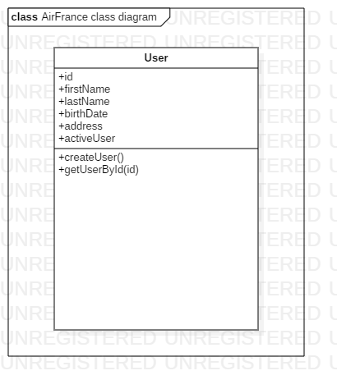

# Diagramme de cas d’utilisation

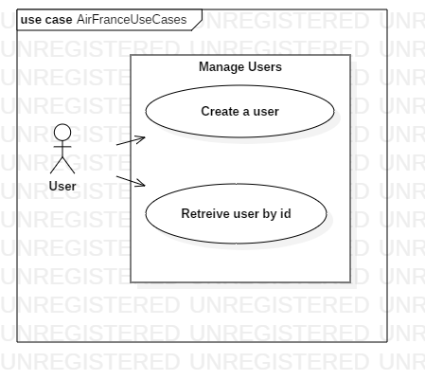

# Architecture

