**TBA Case User Guide**

Version 1.0

Version History

|  |  |  |  |  |
| --- | --- | --- | --- | --- |
| Version | Author | Reviewer | Date | Comment |
| 1 | Hamid Sahlolbey |  | 12/06/2019 | Initial Document |

1. Preface

This system is a vehicle movement simulation & control system. The user is able to create vehicles and then ask them to move in a direction with a specified speed and in specified duration.

2. How to enter system console?

This is the first step to enter and use the system. You should enter the following link into your browser to see system console. It is assumed that you installed and run the system on your local machine.

http://localhost:8080/console.html

you will see a web page like the following picture

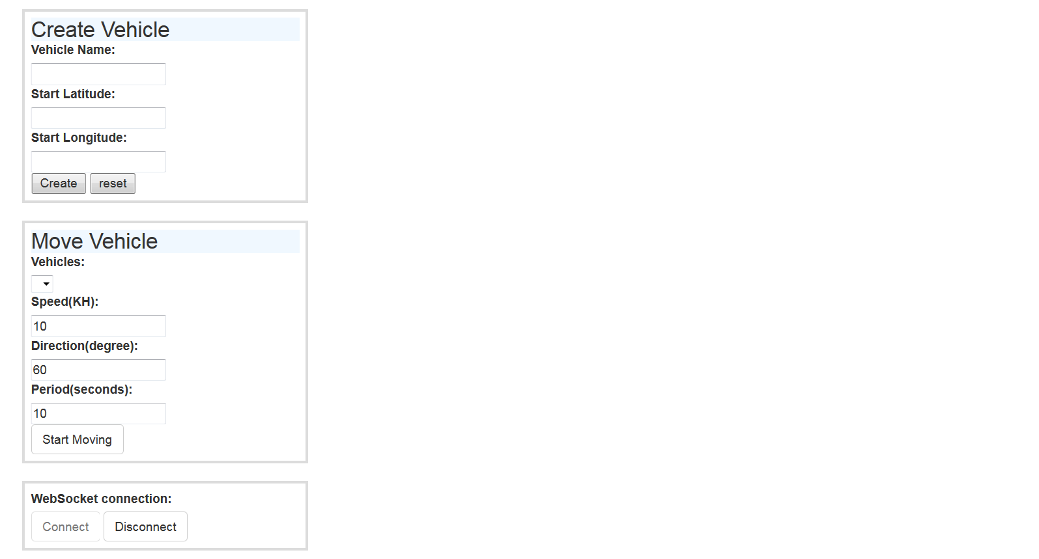

3. Create Vehicle

In the "Create Vehicle" form enter a vehicle name and its current position(Latitude,Longitude) then click on "Create" button. The system creates a vehicle for you and adds it "Move Vehicle" vehicles drop down.

You can add any number of vehicles to the system.

4. Move Vehicle

In the "Move Vehicle" form you can select a vehicle form drop down box and enter speed, direction and period for it. After entering movement attributes you can click on "Start Moving" button and the system simulate the movement by logging vehicle positions during movement on the screen.

For each vehicle the system creates a panel on the right side of screen and start to show movement log on it. It is shown on the picture below.

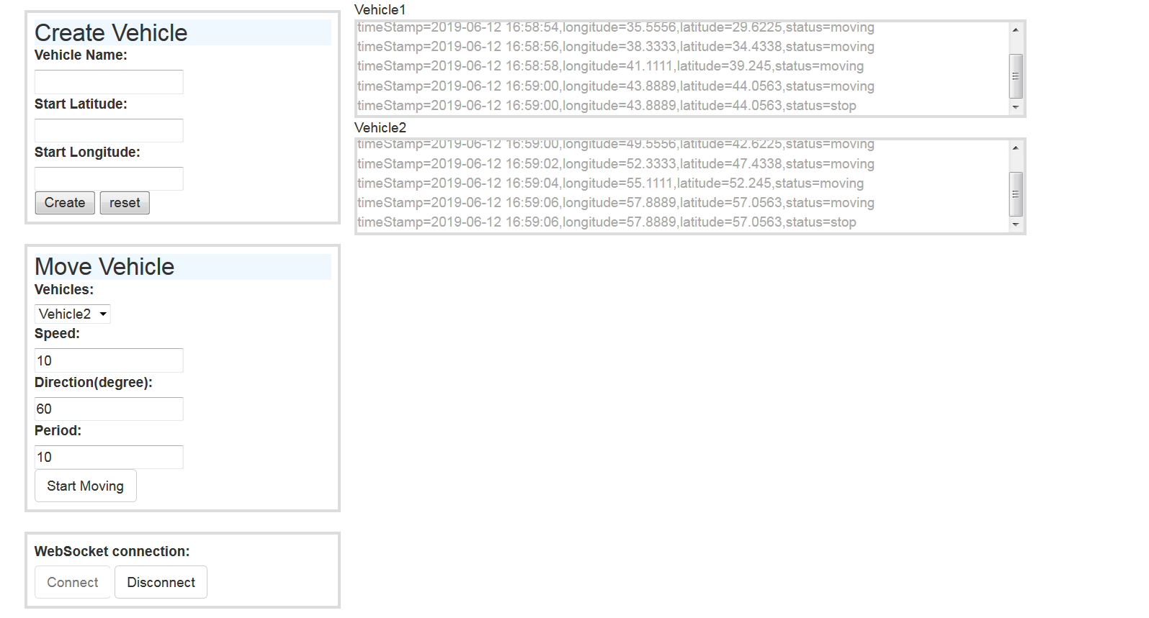

The movement attributes that the user should enter are explained below

Speed: speed of vehicle in KH unit.

Direction: The angle of vehicle direction to horizontal axis.

Period: duration of movement in seconds.