Sheela Ahmed

David Long

Intro to Imaging and Video Systems: Laboratory 5

15 April 2016

**Introduction**

The objective of this lab was to use high framerate photography to capture an object in free fall and calculate the acceleration due to gravity, g, of that object.

**Background/Theory**

Galileo is said to be the first scientist to believe that all bodies close to the Earth’s surface accelerate vertically when in free-fall. This acceleration is an aspect of the force of gravity. Gravity is a fundamental force in the universe that shows how two bodies of mass are attracted to one another [1]. Isaac Newton’s Law of Gravitation focuses on this attraction and states that the gravitational force between two objects with two different masses can be expressed as:

Fg = GmM/r2

Where G is the gravitational constant, 6.673 x 10-11Nm2/kg2, m and M are the two masses and r is the distance between them.

This equation can be related to Newton’s second law, which is the relationship between force, mass and gravity, and states that the force to move an object is equivalent to the objects mass multiplied by its acceleration (F = ma). By substituting in the force of gravity for F and the acceleration due to gravity for a, and then solving for acceleration, the equation comes to be:

g = Fg/m = GM/r2

(Where M is the mass of the object and r is the radius.)

Therefore, to calculate the acceleration due to gravity on Earth, the mass of the Earth and radius of the Earth would be plugged into the equation and give an answer of around 9.8 m/s2. This is the standard value for the acceleration due to gravity at sea level on Earth. But rather than using Newton’s laws to find the gravitational acceleration on Earth, g, this experiment implemented a high speed camera to calculate the time taken to travel a given distance and with a Kinematics equation to calculate the acceleration. Kinematics focuses on the movement of objects and encompasses distance, velocity, acceleration and time. It was introduced by Galileo as a method to analyze moving objects and predict outcomes of particular cases [2]. One of the primary kinematics equations involves distance, initial velocity, acceleration and time, and can be written as

x = x0 + vx0t + ½ at2.

For this experiment, the object – which was a water balloon – started from rest and therefore, its initial velocity was zero. So, the equation can be simplified to

x = ½ gt2,

where g represents the gravitational acceleration. This became the primary equation used for the calculations in this experiment since the distance had already been given and the time was measured, so the only variable in the equation was g.

The high-speed camera used for this experiment was the Sony NEXFS700. It was able to record up to a framerate of 960 frames per second in a 60Hz setting and contained a 14mm lens, allowing us to receive considerable results. The camera also required very little illumination, with a minimum of 1.2 lux at a shutter speed of 1/24sec, which made it easier to capture footage because the area wasn’t illuminated with much light, yet the videos created were neat and noise-free.

**Methods and Procedures**

The main objective of the procedure was to capture footage, using the high-speed camera, of water balloons dropping from various heights and measuring the time duration of the drop. With the time and distance, we would use a kinematics equation – like the one described in the introduction – to find the acceleration.

The water balloons and the Sony Fs700 camera were the two primary materials used in this experiment. Other materials included tape and a ladder. The tape was used first to label 4, 7, and 10 feet on the wall, where the top of the tape indicated the measured areas. While the camera recorded the water balloons dropping from the various heights, we made observations on the accuracy of the drop, including how precise the initial measurement was and if there was any initial force that appeared to be exerted on the balloon prior to the drop that could lead to a potential source of error in the calculations.

The Sony NEXFS700 camera contains Sony’s Exmor Super35 CMOS image sensor, which allows for little noise and higher sensitivity, making it the reason behind its fastest framerate at 960fps [3]. This sensor provides 4K resolution, with pixels totaling 11.6 million. This characteristic also means that much light isn’t necessary during shooting, so high-speed videos can be taken in low-light situations without any difficulty. The sensor size is 24.9 x 14mm, but after filming, the footage has a crop factor – a ratio of the dimensions of a camera’s imaging area in comparison to a reference format – of around 1.4 to 1.5, making the size 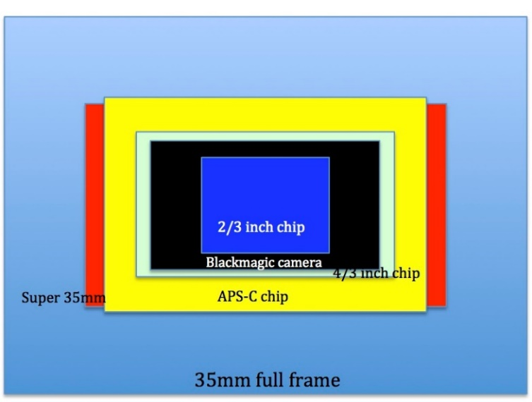approximately 23.5 x 12.6mm [4]. This image shows the sensor size in comparison to the full 35mm frame setting [5]. Since the sensor is the Super35, it falls into the “Super 35mm” area. In this case, it’s easy to see that the frame is much wider and crops off more from the top of the image than from the sides. That was essential to keep in mind because although we attempted to keep the entirety of the drop within the frame, there remains a possibility the crop factor could have caused “windowing” on the sensor, changed the field of view and capture a smaller portion of the image circle produced. That smaller portion could have blocked the ground or the top of the drop from view, creating more sources of error. Since the crop factor was taken into consideration whilst filming each of the videos, there wasn’t an enormous problem framing the drops, although in some videos, the ground is less visible than others.

**Results and Discussion**

At each of the heights, two videos were shot to ensure some more accuracy in the calculations. Since the camera was shooting at 960 frames per second, there was a drastic slowdown in time so the framerate needed to be converted to 24.97fps, which is the standard framerate for filming and had no slowdown. The time it took for the balloon to hit the ground from the given height in the video, at 960fps, was measured. Then, a proportion was created, setting that time at 960fps equal to another time at 24.97fps (Figure 1). For example, the first video shot was at 10 feet. The amount of time it took for the balloon to hit the ground from 10 feet was approximately 27 seconds. After solving the proportion to see how long it would take at 24.97fps, the answer came to be .702 seconds.

With the time and distance, the kinematics equation stated in the introduction was used to solve for the acceleration and received an answer of 11.09 m/s2. One important conversion was from feet to meters, because acceleration is measured in meters per second squared. After completing this same process for the remaining videos, my answers were as follows:

|  |  |
| --- | --- |
| 10 feet (take 1) | 11.09 m/ s2 |
| 10 feet (take 2) | 9.66 |
| 7 feet (take 1) | 10.09 |
| 7 feet (take 2) | 10.95 |
| 4 feet (take 1) | 12.47 |
| 4 feet (take 2) | 12.47 |

The total mean of all the values came out to be 11.12 m/ s2, which is not close to the standard value of the gravitational acceleration, 9.8. One main inference about this is since there seemed to be an extra force applied to the balloon as it fell, the acceleration was slightly faster than it should be. While watching the videos back, in the last trials at 4 feet, the balloon seemed to be moving slightly faster in the first few seconds, which explains why the acceleration is much larger than the second trial at the same height. Also, when the time was measured, there could have been a misinterpretation when watching the video to see when exactly the balloon hit the ground, which is a source of error. For the 10 feet trials, the crop factor probably came into play because the ground was a lot less visible so it was slightly more difficult to observe when the balloon hit the ground.

There were some other sources of error in this experiment, most of which had to do with the balloon before it was dropped. First, accurately holding the balloon at the correct height next to the tape was subject to change because it was measured using only the human visual system. Matching the balloon eye level could have some errors, especially since the person dropping the balloon depended on surrounding students to advise where to place the balloon before dropping. Since the camera was not level with the various heights, the balloon seemed to start below the top of the tape during the 10 feet trials, affecting both the distance and time observed while watching the videos back. Also, since the person was holding the balloon with their arm out, there could have been a possibility the person was moving their hand or arm slightly, giving the water balloon an extra applied force before falling. This came from an observation when conducting the 10-feet trials where the water balloon appeared to spin as it fell, so there must have been a force applied causing the balloon to spin and speed up more. Any extra force changes the calculations because the timing is much more different with the balloon has extra speed. This experiment dealt with an object that started from rest, so any initial force would skew the results perceived in the video and eventually lead to an inaccurate calculation of the acceleration.

For any future experiments, the main improvement would be higher accuracy with measurements and duration, as well as a level camera that eliminates the error of miscalculating the position of the balloon. These errors don’t seem too drastic on their own, but since they were all put together in this experiment, they all added up and produced an acceleration value that much exceeded the expected standard value.

**Conclusions**

For this lab experiment, we examined how high-speed cameras work and how they can be implemented in calculating the acceleration due to gravity. Although the experiment produced many errors, it helped create a better understanding of high-speed film and higher framerates and the connections made to classical physics. The average value of the gravitational acceleration came out to be 11.12 m/ s2, which, despite the fact that it’s larger, does match observations of external forces and other factors present as the water balloon was falling.

**References**

[1] “Acceleration Due to Gravity”. Atlantic Cape Community College: Dept. of Science and Mathematics. <http://www.atlantic.edu/program/academic/stratton/labreport_files/labreport.htm>

[2] “Kinematics”. Lock Haven University. <https://www.lhup.edu/~dsimanek/ideas/kinemat.htm>

[3] NEXFS700UK. Sony. <https://pro.sony.com/bbsc/ssr/product-NEXFS700UK/>

[4] Dr. Gary A. Klee. “Crop Factor”. Nature and Conservations Photography. San Jose State University. <http://www.sjsu.edu/people/gary.klee/docs/ENVS%20166%20-%20Crop%20Factor.pdf>

[5] “Lens Comparison and Crop Factors”. Daniel Haggett. <http://www.danielhaggett.com/blog/136-lens-comparison-and-crop-factors>

**Appendix**

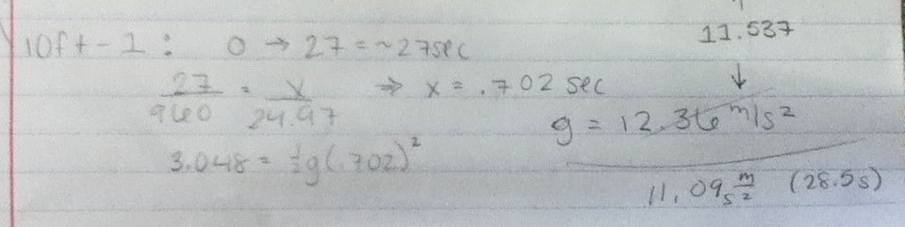

Figure 1: The work calculated for the first trial.