Tale of Ghanim Ben Ayyub, the Distraught, the Thrall O’ Love

Artifact

1. A chest
   1. Would be located near a tree (date tree); in a park/forest [add it as one of the locations]
   2. Hints
      1. In the story of Ghanim Ben Ayyub, he sets out to complete his father’s merchant journey to Baghdad. After a few incidences, the city gates are closed so Ghanim walks outside. He sees a few flashes of light and hides behind a tree. There, he sees a few men drop a chest near a date tree. [*date tree* would hint at the park/forest]
      2. In the story of Ghanim Ben Ayyub, Ghanim sees a few men drop the chest near a date tree, which is near a tomb away from the inner city.
   3. Clues for envelope
      1. Used in the Story of Ghanim Ben Ayyub where a group of men murdered a woman and threw her body in one of these.
      2. They then placed this near a date tree.
      3. It’s used to store numerous things including valuables and food.

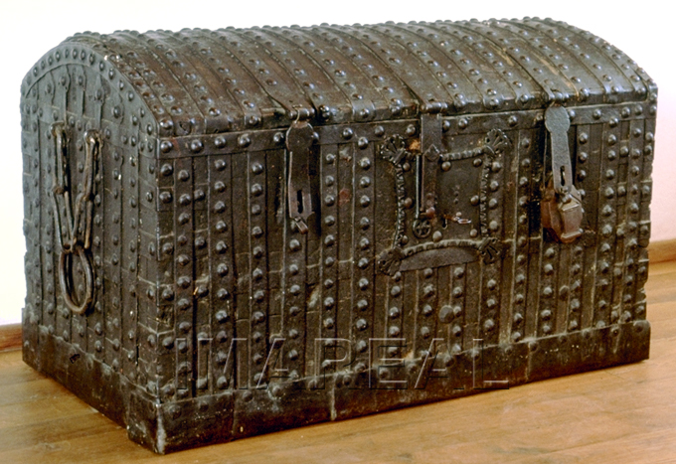

Tale of the Three Apples

Artifact

1. An apple, or apple tree
   1. Would be located near the forest, maybe the same location as the other artifact.
   2. Hints
      1. In the story of The Three Apples, a fisherman discovers a chest alongside a river, with a dead woman’s body inside. The woman’s husband is the murderer, and he claims he accused her of infidelity after journeying to a nearby city to attain a rare apple.
      2. The apples were extremely rare and were collected to cure the woman’s illness. They were from a nearby city known as Basra.
   3. Clues for envelope
      1. In a story in 1001 Nights, a husband murders his wife after accusing her of adultery. He set out on a journey to find a rare set of this fruit.
      2. 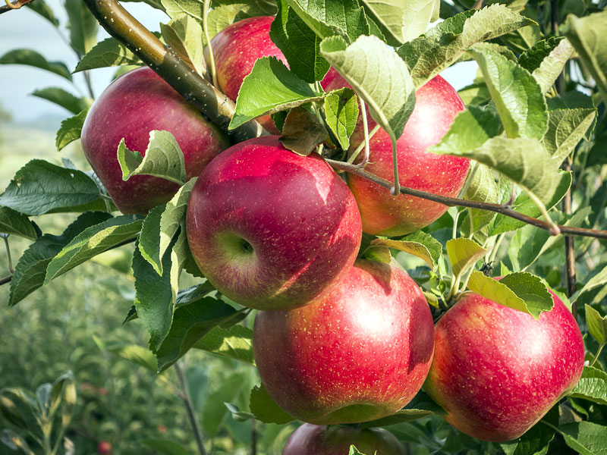They grow on trees and are very popular nowadays.