Sheela Ahmed

David Long

Intro to Imaging and Video Systems: Homework 1b

February 29, 2015

1. The visible light spectrum ranges from approximately 400nm to 700nm. On the shortest wavelength side, the colors are mainly blues and purples. This then goes to greens and yellows, which are around 500-600nm. This then leads to reds, which have the longest wavelengths for visible light. There are numerous colors that we observe and identify but aren’t seen in the visible light spectrum because they are composed of a mixture of colors that are present in visible light. Gray is one color that isn’t shown in the visible light spectrum but is a color that we can identify. Another color that is not in the visible light spectrum is pink because of its composition of different colors. Pink is a reflected color which means it only seems pink because of the way our eyes and brain perceive the reflected wavelengths [1]. For example, mixing red paint with white paint will give you pink paint. The same concept doesn’t necessarily apply to light because mixing red light with white light will produce a light with a slight red tint to it. This may appear slightly pink but the composition doesn’t necessarily depend on mixing red and white. White light is a combination of all light wavelengths within the visible light spectrum, so mixing it with red means mixing every color but making wavelengths corresponding with red to stand out and be reflected more than the rest. This leads to a shade of pink. The same applies to colors such as brown and cyan. There is a mixture of certain wavelengths that are reflected off of a surface that hit our eyes and make us perceive certain colors. Color perception has more to do with our optical system and brain, so we label certain reflected surfaces as a specific color because of the combination of visible wavelengths that reflect off the surface.
2. Using cotton as an example, the fabric generally has a yellow tint to begin with and when the fabric is worn more and more, the yellow color becomes more prominent. The reflectance percentage of cotton is higher for the larger wavelengths, which corresponds with reds and yellows and in turn makes those colors appear more than blues. Optical brighteners work by absorbing ultraviolet light from the outside into the fabric and then emitting it as blue light. The wavelength associated with blue light is longer than the wavelength associated with ultraviolet light [3]. This process of re-emitting longer wavelengths after absorbing shorter wavelengths is known as Stokes fluorescence. So the blue light is reflected along with the reds and yellows and in turn masks any yellow tint that is left on clothes after they’ve been worn for a while and makes the illusion that they are “whiter than white”.
3. Goniphotometry is a technique that measures the angular distribution of light and a goniophotometer is a device that is used to take those measurements [4]. When it comes to computer screens, LEDs don’t have homogenous light distribution so in order to get accurate color, the lights will be all over the place. By using a goniophotometer, you can find where all the lights are going. The spatial energy distribution is measured in terms of bidirectional surface-scattering distribution function, which abbreviates to brdf. The bdrf produces a ratio of reflected radiance from a surface to the irradiance incident upon that surface [5]. A better ratio, where the radiance measured off the surface is almost equal to the irradiance upon the surface, which leads to a more even distribution of light on a surface. This is important to modern computer graphics since more even distribution leads to more detail and better color which can easily transform the experience on the computer screen.
4. The equation for transmittance comes from Bouger-Beer’s Law for Liquid Transmission, which is: T = 10-E(λ)cl , where E is the molar absorptivity, λ is the wavelength, c is the absorber concentration and l is the path length. Since the transmission is the same at every wavelength, the wavelength can be ignored in the equation. The variable missing (besides transmittance) is the molar absorptivity (E), so to find that, .67 was set as the transmittance in the equation with a path length of .75mm and concentration of 3.5 moles/cm3. After converting the function to a logarithmic function, the value of E came out to be .015 m2/mol. After that, the value of E was plugged into the equation again, but this time, the path length was set to .75\*4 = 3mm, since the light is directed through four layers. After solving this equation, the transmittance found was 69.58%.
5. Using the equation for a single surface, P = (n2 – n1)/R, n1 would be the index of refraction for the first surface and n2 would be the index of refraction of the second surface. R was given for each of the surfaces. The refractive power would be:
   1. 48.3 Diopters
   2. -6.15 Diopters
   3. 6.17 Diopters
   4. -10.67 Diopters
6. Since the glass is likely in air, one of the indices of refraction would be that of air. The equation used for this problem was the “lensmaker’s equation”, which is: 1/f = (n-1) [(1/R1 – 1/R2) + ((n-1) d)/nR1R2], where f is the infinite image focal length, n is the index of refraction, d is the distance or thickness of the lens, and R1 and R2 are the radii of curvature. The index of refraction for the glass is approximately 1.52, the radius of curvature given was 45mm, the thickness of the lens was 15mm and the infinite image focal length was 50mm. When solved for the second radius of curvature, the answer came up to be 54.56mm. So the lens would have a back surface larger than the front surface as 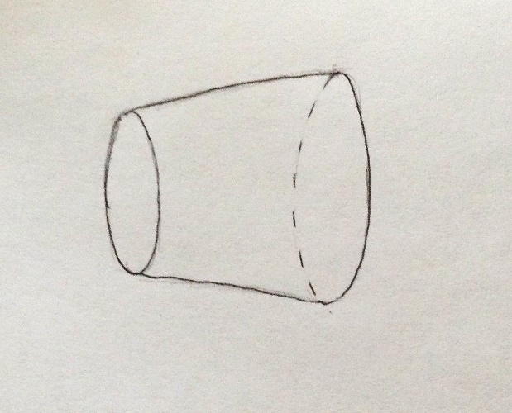shown:

Radius of curvature for back surface (54.56mm)

Radius of curvature for front surface (45mm)

Distance = 15mm

1. The thin lens equation doesn’t contain the thickness of the lens, which means it would result in the same number for every thickness given. The infinite image focal length should vary with differing thicknesses, so by using the lensmaker’s equation, the focal lengths come out to be:

5mm: 63.4mm 10mm: 72.8mm 15mm: 78.8 20mm: 85.8mm 25mm: 94.2mm

Comparing these to the 50mm focal length given in question 6, the percent error averages out to be 35.5%. This percent error shows the importance of an accurate focal length because different focal lengths produce different images. A camera with a short focal length will produce a wider image because rays of light that pass through the lens will converge at a point that is closer than a longer focal length. So if the focal length is inaccurate, a camera won’t capture the correct image and won’t be able to accurately focus on an image. In this case, the focal lengths determined by the lensmaker’s equation are much longer than the focal length produces by the thin lens equation (50mm), so the actual image that’s created would be narrower than if the focal length were 50mm.

1. If an object is in front of the infinite image focal length, then the image will be classified as virtual and the will appear somewhere on the same side of the lens as the object. This will make the image seem to be “behind” the object and therefore, the lens element won’t be able to move either away from or towards the camera body to accurately capture the image and have the object in focus.
2. Spherical aberration comes from the observation that spheres are not the best shape for imaging an object from a certain distance because rays that enter from the object’s side don’t converge at the same point on the image side. One solution for this is to use an aspheric lens in cameras, with a similar adjustment in the human eye which is the aspherical cornea. The aspherical shape is unique in that it has a radius of curvature that varies radially from the center of the lens, which prevents rays that enter from converging at different areas on the image side. The cornea, which is the front portion of the human eye is an aspherical shape so all light rays that enter are able to converge at the same point. Another solution is to restrict the aperture, which would limit the amount of rays that enter and therefore would limit the likeliness for entering rays to converge in different areas.

Chromatic aberration occurs when the dispersion of light results in having different focal points for different wavelengths. This means that all the different wavelengths that enter a lens will not be in focus at the same time. “Depth of field” is the idea used to solve this problem because it focuses on controlling the aperture to allow rays from different points on an object and of different wavelengths to enter a lens and converge at the same point on the image plane.

References

[1] National Aeronautics and Space Administration, Science Mission Directorate. (2010). Visible Light. Retrieved March 02, 2016, from Mission: Science. <http://missionscience.nasa.gov/ems/09_visiblelight.html#cite>

[2] Melissa. “The Color Pink”. *Feed Your Brain.* 14 November 2013. Web. <http://www.todayifoundout.com/index.php/2013/11/color-pink-doesnt-exist-can-see/>

[3] AVM Chemical Industries. “Chemistry of Optical Brightener and uses in

Textile Industries and its Mechanism”. <http://www.ptj.com.pk/Web-2010/07-10/PDF-july2010/Practical-Hints-AVM.pdf>

[4] Andersen, Marilyne. “Goniophotometry and assessment of bidirectional photometric properties of complex fenestration systems”. Massachusetts Institute f Technology. 2 May 2006. <http://www.sciencedirect.com/science/article/pii/S0378778806000570>

[5] Moidel, Chuck. “Bi-Directional Reflectance Distribution Functions”. Web. <http://web.cs.wpi.edu/~emmanuel/courses/cs563/write_ups/chuckm/chuckm_BRDFs_overview.html>