Sheela Ahmed

David Long

Intro to Imaging and Video Systems: Homework 3

March 18 2016

1. The three main components in color perception are the illuminant or light source, the object and the observer. The light source is important for color perception because it provides the light needed to actually see a color. Light sources like daylight, fluorescent light and halogen lamps all have different spectra, even though they appear to be “white light” to us. An object under a halogen lamp that has a relatively steady spectra will look different when under a fluorescent light which has an uneven spectra. The difference in energy present in a light source is important in determining how the object will be represented.

The object is the main component that ultimately determines the color that we perceive. Objects are colored typically by pigments or dyes into a polymer matrix so when a light source is shone upon it, the colorants act by absorbing certain wavelengths and reflecting others [1]. The reflected wavelengths then reach our eyes for interpretation and are what determine the color we perceive.

The observer is the third important component and deals with how the color is finally perceived. The lens in the human eye focuses the light that enters on the retina at the back of the eye, which contains two cells that detect light known as rods and cones. Cones are associated with color interpretation while rods aren’t since they only function in low-light situations. Also, there are three types of cones which are sensitive to longer, medium, and shorter wavelengths, respectively. The longer wavelengths associate with the color red, the medium wavelengths with green and the shorter wavelengths with blue. The combination of the magnitude of response from all three cones is sent to the brain to be analyzed to describe and determine the color.

The brain can cause many differences to color perception, which makes it the fourth component. Our eyes can gather as many visible wavelengths and send the responses to the brain, but the interpretation of those wavelengths into color is the reason why the brain is an important factor. The names we provide for certain colors depends on our cultural upbringing. We may associate different names to different colors depending on what we learned in our childhood. All of this plays into our brain’s ability to interpret information and connecting it to our own memory.

One color illusion that wasn’t shown in class but relates to the concept of shade is the image shown here. In this image, one wall is a very pale yellow color – almost a cream color – and the other wall is a darker yellow. It appears that the walls are facing outward for a period of time, but then it appears the walls are facing inward. If the walls were inward, the light would appear to be coming from the right side and shining on the left wall, but if the walls were outward, the light would appear to come from the left side to shine on the left wall. Once you look at the image long enough, you can move back and forth between the two situations because the brain notices that both of them are present. When the bottom half of the image is covered, the walls look like they are facing outward because the window panes are opened to the outside of the building rather than inside, and that makes the surrounding bricks and framework around the window appear to face outside as well. That’s a concept of vanishing point, where the lines that appear in image in perspective seem to converge to an endpoint, which emphasizes depth in the image. So the top and bottom parallel lines on the window pane, along with the lines of the bricks and framework of the window all appear to aim towards a point of convergence.

If the top half is covered, the walls appear to face inward because the window panes are now facing inside and, going along with the same concept, the surrounding lines seem to converge. Also, the man on the left side of the image is looking to his left, towards the other window. This further emphasizes the idea that the walls are facing inward and the windows are facing each other.

So when the entire image is put together, our brain first focuses on one aspect, whether it be the top or bottom of the image, to interpret the perspective and depth of the situation. Then, if we look at another area and see the alternative situation, our cognitive ability allows us to go back and forth between the two situations and interpret both as being true.

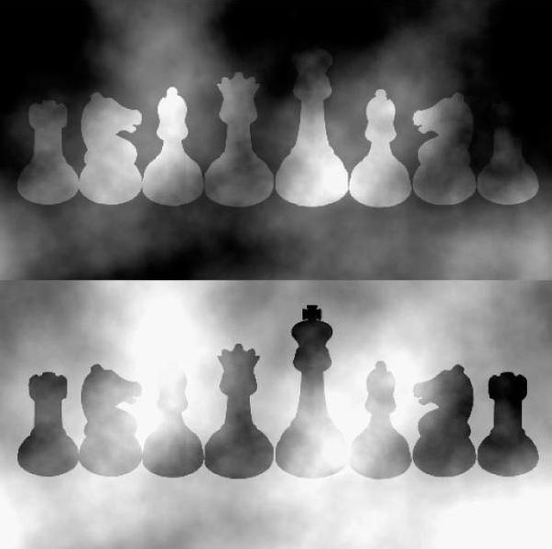Another image is the one displayed here, showing two sets of chess pieces that are set in front of a dark and light background. Both sets are the exact same size and color, but they appear completely different when put in front of the different backgrounds. Since the backgrounds change dramatically, our brain associates the chess pieces to be the opposite from the background. Therefore, we think the pieces in the top half are much lighter because they’re in front of a very dark background and the pieces in the bottom half are much darker. Rather than looking at the chess pieces alone, we take in the surroundings, so our brain isn’t able to differentiate between the individual colors accurately enough to perceive the chess pieces as being the same.

1. The foveal is a part of the retina which has approximately 1-2 degree opening that allows for total visual acuity. The foveal contains no rods but has the densest concentration of cones compared to the rest of the eye. Since cones are associated with color and the foveal is located near the back center of the eye, focus, acuity and color interpretation are very important aspects of the foveal. The dense concentration of cones allows for accurate color interpretation and since the foveal is a very small opening, it is where the center of focus in sight takes place. Since cones function best in bright-light situations, the ability to interpret color and focus properly becomes more difficult in darker environments because rods begin to take over and there are no rods present within the foveal.

Peripheral vision refers to the sight of objects and movement outside of the direct line of vision and relies on the work of rods instead of cones. Therefore, color isn’t distinguished very well in peripheral vision as compared to the direct line of vision. Although rods function best in low-light situations, peripheral vision is better in bright-light due to the ability to distinguish between certain objects and motions. Since peripheral vision is outside of the foveal, acuity is not a primary characteristic because the only range of focus is directly in front of the foveal and therefore, acuity decreases as the distance from the foveal increases.

1. The additive color system involves light emitted directly from a source before it hits an object. The primary colors involved are red, green, and blue, and the product of each of these mixed together is white. One main example of the additive color system is computer monitors and television screens. Each pixel on the screen is divided into red, green, and blue phosphor dots, and when different intensities are given, various colors are shown and an image appears on the screen. Since the dots are relatively small, our eye doesn’t distinguish between each of the colors and instead, we combine them all together to create an image.

When two of the colors from the additive color system are mixed together, they produce one of the primary colors for the subtractive color system. This system consist of cyan (blue and green), magenta (blue and red), and yellow (red and green). The subtractive color system works by subtracting, or absorbing certain wavelengths of color while reflecting other wavelengths back to us. It starts with an object that reflects light and uses colorants, such as dyes, ink or pigments, to subtract the white light that illuminates an object and reflect back other wavelengths of color [2]. Inkjet printers and other color printers use this method when producing images onto white pieces of paper. The cyan, magenta, and yellow ink colors subtract certain portions of the white light and reflect certain wavelengths back to the viewer, which are interpreted by us as specific colors.

1. 1. 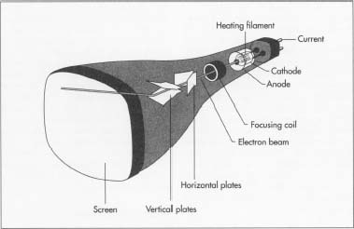A cathode ray tube is a device in which electron beams can be focused on a phosphorescent viewing screen and rapidly varied on position and intensity to produce a final image [3]. The first part of the cathode ray tube is the electron gun assembly, which consist of a heated cathode surrounded by a metal anode. This arrangement allows for a negative electric charge to reach the cathode and a positive electric charge to the anode, so electrons from the cathode flow through a small hole in the anode and create a beam of electrons. When the beam of electrons strikes the phosphor viewing surface, which is on the inside of the screen in the image shown, the surface emits visible light. The phosphor viewing surface is formed from a continuous layer of a single material in monochromatic CRTs, or is composed of individual dots of three different materials in color CRTs. One common material used in producing these surfaces is zinc sulfide, and various amounts of silver determine the color of the light emitted. For television screens and computer monitors, there are three phosphor viewing surfaces as well as three electron gun assemblies, each for the three color signals red, green, and blue. A 0.01% of silver activator emits the blue light and 0.001% emits green light. Red light is produced by adding silver or copper to the zinc sulfide that contains a higher percentage of cadmium sulfide [4]. The phosphors are deposited across a screen as tiny dots in an ordered fashion, and through a shadow mask, which is a perforated metal, different shades of color are shown to the viewer. These various tones and shades form an image on the screen of a television or computer that can be viewed and interpreted. A glass envelope is the flat face plate that holds the electron gun assemblies on one end, sealed into the glass neck, and has the phosphor viewing surfaces deposited on the inside.

Cathode ray tubes are able to produce a wide range of colors and have high – contrast images because of the individual phosphors deposited across the screen. Also, cathode ray tubes are able to process images at a quick pace so it is an excellent display method for fast moving images on television screens or for video games [5].

* 1. Liquid Crystal Display centers on liquid crystals which are made up of complicated molecules. The crystal can melt into a cloudy liquid when in higher temperatures, but eventually clears up with higher temperatures because the molecules become agitated. The liquid crystal region in an LCD is surrounded by a display glass, known as a substrate, which is coated with electrodes and contact pads to allow for an electric current to pass through. The display glass is primarily borosilicate glass since it has few ions which is important because ions can moved to the glass surface and alter the electric field pattern as well as the alignment of the molecules.

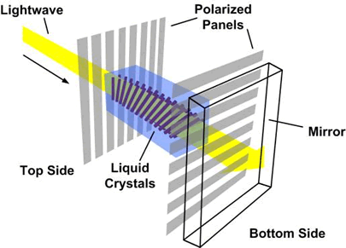The currents that pass through the crystals affect the arrangement of the molecules depending on the current’s voltage. It is used to switch between the cloudy and clear phases of segments of the liquid crystal by “untwisting” or rearranging the molecules. The segments of the liquid crystal can be in the shape of dots or pixels and arranged into rows and columns and each segment forms a part of a number or letter. For a dark spot to be shown on the reflecting screen, some segments are turned off to allow polarized light to pass through. Backlit LCDs contain fluorescent tubes above and behind the LCD along with a white diffusion panel so when the LCD redirects and scatters light, the distribution and display is even and uniform [6]. The brightness of a pixel depends on the voltage that passes through the segment of crystals. Anywhere there is light on an LCD screen is where there is a current flow through the pixel. LCD screens usually produce bright images because the intensity is almost always higher, so the screens are suitable for brightly lit rooms and environments.

Light – emitting diodes (LEDs) work by emitting light through electron excitation through diodes. The diodes, which are electrical valves allowing for electric current flow, are turned on to allow electrons to move from a region of high 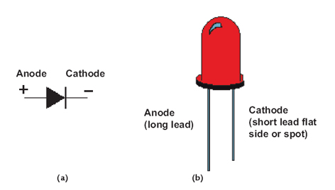electronic density to a region of low electron density. The electrons move from the cathode end to the anode end, as shown in the image. As they move, the energy released is in the form of light, so the more electrons move from high to low density, the brighter the light shown. LEDs are known for using a lot less power, which makes them an easy alternative for displaying images [7].Also, the diodes are relatively small, so LED screens on televisions are very small and thin, which is another advantage. The portability and size of LED screens makes them a popular method of display technologies used today.

* 1. Organic LEDs work in the same way as original LEDs, but instead use organic molecules to produce their electrons and holes. A simple OLED consists of the same layers and buildup of original LEDs. A voltage is attached across the anode and cathode regions to create the light. As the electricity begins to flow through, the cathode receives electrons from the power source from the anode. The electrons from the cathode combine with holes from the emit light from the energy created [8]. The process is the same, but OLEDs have a series of organic thin film set between the two anode and cathode regions. The flexibility and thin makeup of OLEDs make them a more efficient choice. Compared to LCDs, OLED displays have a better contrast and higher brightness simply due to the efficiency in the thin and flexible design of the structure [9]. Also, the flexibility can also allow OLED displays to be curved and embedded into windows and lamps, which can be an advantage for future display methods.
  2. Digital Mirror Devices (DMDs) consist of small mirrors that rotate and deflect in response to electrical signals, creating incident light. The structure is typically made up of a small mirror suspended over an air gap, which means the mirror is supported by various beams over an air gap [10]. For example, the torsion beam DMD is supported by two torsion hinges that are attached to opposite corners on the mirror and a voltage difference between the mirror and the electrodes located under – in the air gap – will cause the mirror to rotate about the axis of the hinges until it is stopped by electrodes that land on it. Light is projected when the mirror changes its position and deflects. An array of DMDs is sometimes used to modulate light and produce patterns or images when the elements are rotated. In HDTVs, a large range of DMD elements, or pixels, are ideal since there is a large host of pixels needed to produce a clear image [11]. A higher number of pixels will result in a higher concentration of DMDs, which can lead to higher resolution on the screen. On the other hand, torsion beam DMDs are prone to post scatter incident light due to balancing issues. Also, since the hinges are attached in the plane of the mirror, the area of the mirror decreases which, if this is repetitive throughout all DMDs on a screen, can lead to less overall image brightness. So DMDs are overall very efficient in terms of size and simplicity, but they can be less sturdy than other options for electronic color display.

Works Cited

[1] Mulholland, Bruce M. “Introduction to Color Theory”. Hoechst Technical Polymers. Web. <http://www.polymerplace.com/articles/INTRODUCTION%20TO%20COLOR%20THEORY.htm>

[2] “Understanding Color”. RGBWorld. Web. <https://www.rgbworld.com/color.html>

[3] “Cathode-Ray Tube”. How Products are Made. Volume 2. Web. <http://www.madehow.com/Volume-2/Cathode-Ray-Tube.html>

[4] Cathode Ray Tube – Patent. Jun 3, 1996. Web. <https://www.google.com/patents/US3448316>

[5] Torres, Matthew. “Pros and Cons: CRT Tube Television”. AboutTech. <http://tv.about.com/od/directviewtubetv/a/ProsConsTVtypes.htm>

[6] “Fundamentals of Liquid Crystal Displays – How They Work and What They Do”. Fujitsu Microelectronics America, Inc. 2006. Web. <http://www.fujitsu.com/downloads/MICRO/fma/pdf/LCD_Backgrounder.pdf>

[7] “Light-Emitting Diode (LED)”. How Products are Made. Volume 1. <http://www.madehow.com/Volume-1/Light-Emitting-Diode-LED.html>

[8] Woodford, Chris. “OLEDS (Organic LEDs and LEPs (light – emitting polymers))”. Explain That Stuff. November 4, 2015. <http://www.explainthatstuff.com/how-oleds-and-leps-work.html>

[9] Integrated Multicolor Organic LED Array – Patent. July 13, 1995. <https://www.google.com/patents/US5424560>

[10] Optimized Electronic Operation of Digital Micromirror Devices – Patent. Aug 22, 1995. <https://www.google.com/patents/US5444566>

[11] Multi-level Digital Micromirror Device – Patent. Dec 10, 1996. <https://www.google.com/patents/US5583688>