Sheela Ahmed

David Long

Intro to Imaging and Video Systems: Photography Lab

March 4 2015

The expectation before beginning this lab was that the depth of field between the nearest and farthest points of focus would increase as the intensity and aperture diameter changed. The aperture diameter, or f/#, decreased by 1-stop with each image by an increment of √2. This decrease led to narrower field of view, which is why the time was increased by increments of 2 to maintain the same exposure for the image. This inverse relation is known as the Reciprocity Law, and is where the exposure of an image remains balanced by an inverse relation between the shutter time and aperture diameter (f/#). The lab further emphasized this relationship because the exposure of each image taken was the same as the time increased and the aperture size decreased. There was no image in which the lighting was different – the only aspect that varied in each of the images was the focus.

As the images were taken, the area behind the telltale and the area in front were slowly beginning to appear sharper and in focus. At the same time, the person walking, who was Katie, was starting to appear blurry as she was moving. A longer exposure time meant Katie and the rest of the hallway were taken into account when creating the image, and since Katie was moving, the camera stopped focusing on her and instead on the rest of the hallway. Therefore, the area behind the telltale – including the lights and doorways – and the area in front were sharper, thus creating a wider depth of field.

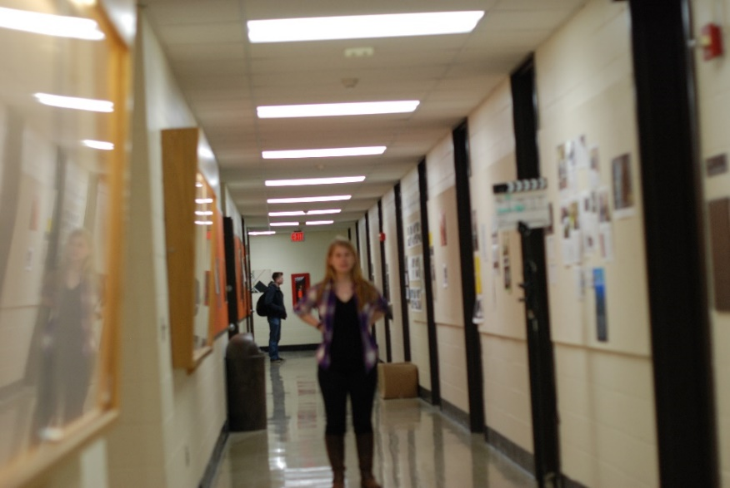A larger aperture also leads to a more shallow depth-of-field because there isn’t much focus beyond one single point, so there are more blur circles. In the first few images, this can be seen by looking around the edges – there is more blur than when the aperture is smaller. The rays of light that enter a camera with a wider aperture converge at wider angles, which leads to more blur around the edges. If the aperture is smaller, the rays that enter converge at smaller angles and therefore, a larger portion of the image is in focus. This also ties into the depth-of-field of an image because with a smaller aperture size, there is less blur and the depth-of-field is wider. The blur circles translate to a more shallow depth-of-field.

The far focus and near focus distances, approximated, as a function of f/#.

The changes in far focus and near focus distances were graphed by estimating the distance behind and in front of the telltale that were in focus. The distance from one door to the next was approximately 139.625 cm, so that’s where the far focus started. The near focus started a little before that because the telltale was located right in front of the door, so the distance from that to the camera was less. One observation made by creating the graph was that the far focus distance increased at a faster rate than the near focus. One reason for this is because the telltale was closer to the camera than to the end of the hallway, which means there was more distance to focus on further away than up close. By looking at the images and the progress in the focal distance, the camera focused on the area behind the telltale much faster than in front, and there was a larger distance covered as well. But Katie was appearing blurry, and it can be concluded that background was appearing in focus *because* Katie was moving. As stated earlier, a longer exposure time meant Katie wasn’t in focus since she was moving, and with a wider depth-of-field as the aperture decreased, she appeared more and more blurry as the rest of the hallway appeared more and more in focus. In the last image taken, Katie was running, and 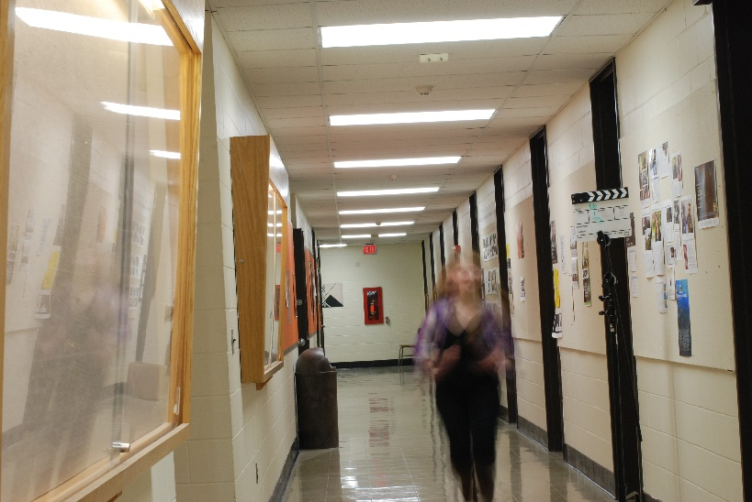her appearance seemed to fade a little it around the edges because, similarly, the camera chose to ignore her presence and instead focused on the rest of the hallway behind her. In the image we took, the entire hallway seems to be in focus, both behind and in front of the telltale, while Katie is extremely blurry.

To find the rotations per minute of the helicopter, we decided that the best way was to capture an image of its rotor moving a certain distance. Then, by using a protractor, we would measure the angle the rotor made in that fraction of a second and create a proportion comparing that angle to the total amount of degrees the rotor would spin in 60 seconds. So the proportion would look like: *[Angle in degrees]/duration (sec) = x/60sec.*

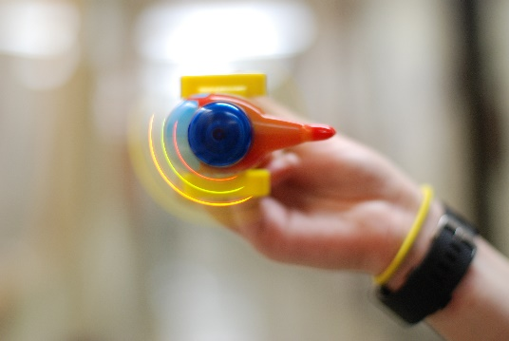 Since there are 360 degrees in one full rotation, the number would be divided by 360 to find the RPM. The best image we captured was with an exposure duration was 1/160sec and an f/# of 1.4. In 1/160th of a second, the rotor went approximately 135.6 degrees. So by creating a proportion and solving for *x*, the RPM of the helicopter ended up being 3,616.