Sheela Ahmed

Collette Caton

FYW: Writing Seminar

18 November 2015

In schools and college campuses all over the country and world, extracurricular activities have become common priorities in the lives of students. The immense amount of participation clearly shows the busy lives students have nowadays. While some researchers say the involvement can lead to an improvement in students’ overall social and communication skills, they fear it can impact their academic behaviors, such as decreasing their overall GPA. My research conducted for this paper revolved around the focus of communication skills and how students can improve their social lives by participating in extracurricular activities.

Over the last few decades, the involvement in extracurricular activities has changed dramatically, as well as the kinds of activities provided. Clubs and organizations are now related to almost any topic, from academics and education to sports and athletics to leisure activities. At the Rochester Institute of Technology, there are over 300 clubs and organizations available to students to join and participate in (Collegiate Link). In these activities, students have the opportunity to explore other interests and meet new people, as well as better their understanding for their majors and future careers. Researchers from numerous areas believe more participation leads to a better sense of social interaction and confidence among students. Jacquelynne Eccles writes in her paper, “Extracurricular Activities and Adolescent Development” that students end up preparing for their futures in a better way by participating in these activities because their careers, no matter what they may be, will involve some form of communication (Eccles). By becoming a part of clubs and organizations, students can gain friends, develop communication skills and understand how to solve problems and challenges they are faced with. A major setback, however, is that a large amount of participation can lead to major impacts on students’ grades and academic behaviors. Students can be so busy with clubs and events that they fall behind in their course work which can be detrimental to their overall GPA.

There are numerous factors that can impact student involvement in extracurricular activities, including life at home and general environment. Some studies have shown that the adults in an adolescent’s life can heavily influence their likeliness to join clubs, especially athletics. If parents or guardians encourage their children to be more involved, it can lead to a better sense of confidence and optimism. A specific study was conducted by Amy Feldman and Jennifer Matjasko, two writers for a research journal, in which it was concluded that athletics reduced females’ adherence to conformity and provided them with social and personal resources to help them through their school years. It also provided males with similar resources and helped them maintain a sense of commitment and discipline (Feldman). Another study related to parental influence was conducted by two professors over the course of 4 years. The conclusion was that a greater participation in extracurricular activities influenced by parents led to a decrease in sexual behavior and drug use, which in turn led to more positivity in students and made them more conscientious when making decisions. (Kao).

Another influence comes from the general environment in which the students are, including the schools and society in general. School – sponsored activities can expose students to different areas of interests and eventually guide them towards their future careers. A university in Michigan held a summer camp for high school students to explore engineering, with professors and engineers teaching students. The students were surveyed after the camp and most students said they would consider engineering as a possible career option when entering college (Rodriguez). This ties into the amount of academic clubs provided on college campuses to help students either explore new careers and majors or further better their knowledge of their current major.

My research was focused on this claim and finding out how different types of extracurricular activities had different impacts on student behaviors. I conducted a survey of only 9 questions that was distributed both online and in the classroom. Along with that, an interview was arranged with a professor, at the Rochester Institute of Technology, who was the head of a mathematics club, PiRIT at the university. I also observed three different clubs held on campus to analyze the general environment and make conclusions about the student behavior. The general hypothesis was that more involvement in extracurricular activities would lead to a sense of belonging in students as well as more optimism and better communication skills.

The primary research aside from the survey was conducted at the Rochester Institute of Technology which has limited my demographics to certain age groups and education levels, as well as area. However, after researching other studies conducted, the general claim and environment on college and high school campuses remains the same. Therefore, the results from my research can be compared to results from other studies to make conclusions about the impact of extracurricular activities on student behavior. Part of the survey’s recipients came from my YearOne class, a required course for freshman attending RIT. The remaining participants anonymously submitted the survey online and the results were analyzed in the form of charts and graphs. The results from both parts of the survey will be analyzed separately due to the drastic change in demographics, but they will be compared afterwards. A crucial part of my research was that it included both students and professors so that I can collect data from different aspects to completely understand the situation. The responses from students were personal and from first-hand experiences, while the responses from professors was more by observations and analysis.

The survey conducted online was constructed on the website “Survey Monkey” and consisted of 9 questions ranging from multiple choice to short answer. The first few questions were basic demographic questions, such as gender, age, and highest level of education. After that, the questions asked about participation in extracurricular activities and which ones satisfied them more and were more likely to have them recommend it to a colleague. The interview was arranged was with Dr. Matthew Coppenbarger, a professor of Mathematics at RIT and the head professor of PiRIT, a mathematics-based club which meets every Friday afternoon at 1:00 PM. Basic questions I asked Professor Coppenbarger included how he felt about extracurricular activities, what positive impact they have on students, what negative impact they have, and the difference between educational organizations and leisure organizations. For the observations, the three clubs I visited were the Anime Club, the Hand Lettering Club, and the Photographic Sciences Club. These three forms of extracurricular activities are clubs, which narrows my research due to a lack of other kinds of activities such as sports or campus events. However, the Photographic Sciences Club aims more towards educational whereas the remaining two fall under the leisure category. The observations seen at these three clubs were paired with an analysis to make conclusions about them. Of all of these forms of research, the general hypothesis was that students participating in extracurricular activities were more likely to be better communicators, be happier, and more likely to try to manage their time between the activities their course work.

As stated before, the results from the survey were separated into two parts to be analyzed. The results from the online portion were put into bar graphs showing the percentage of specific results given. Exactly half of the participants in the online portion were between the ages of 21 and 29, with 18-20 year old age group trailing right behind at 37.5%. Most of them either received a high school degree or a bachelor’s degree and a majority were male. The first question was “How happy are you with the choice of university-sponsored extracurricular activities?” Nearly 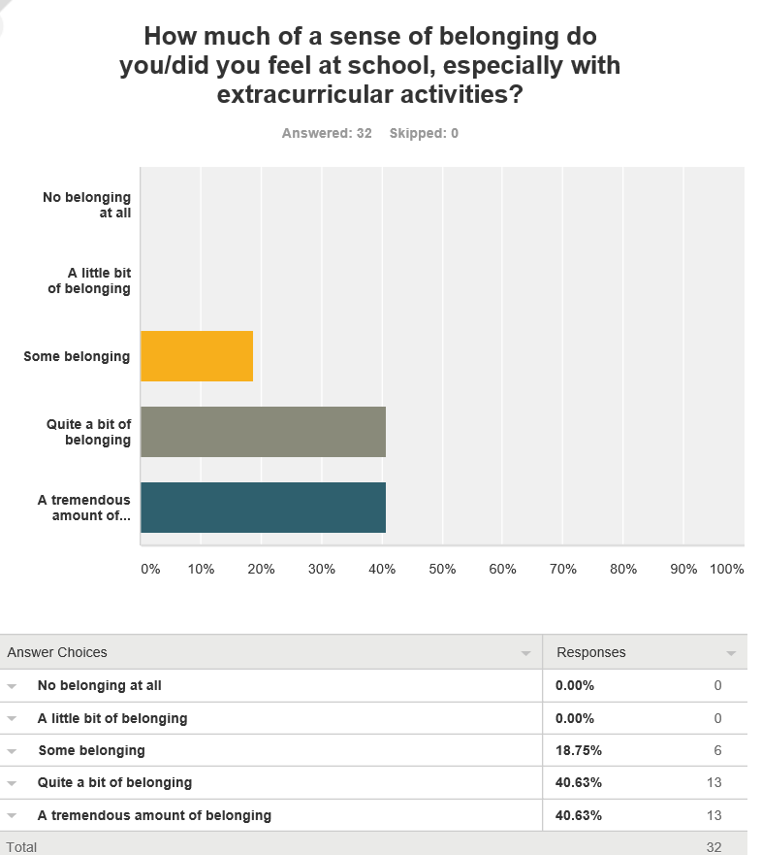sixty percent of participants said they were ‘very happy’, while only twenty-one percent said they were either ‘extremely happy’ or ‘moderately happy’. The question seen in Figure 1 is the significant question in this whole survey. Not one participant who took the survey said they didn’t feel a sense of belonging when participating in the activities. Most students said they felt as if they belonged to the club or organization. This shows that more participation does help students feel more involved and can help them be more confident and important in their schools. When asked why they couldn’t participate in an activity, almost every answer was a limited amount of time. So most students were unable to participate in their desired activities because of a lack of time. What the time spent was for was not asked, so it can be assumed that it was spent on either school related course work, other activities, or leisure activities. When asked the question of how often they participated in extracurricular activities, most students responded “moderately often” but there were no students who replied “not at all often”. So students did participate somewhat, whether it be sometimes or all the time. After looking at the rest of the data, I concluded that the reason why was due to time management with course work at schools and focusing on balancing both aspects. None of the participants in the survey seemed to be upset about the idea of activities; it was mostly lack of time and some interest in the certain activity. Comparing this question to Figure 1 above, even though most students didn’t participate all the time, they still felt that sense of belonging and importance. So involvement in extracurricular activities, although it isn’t all the time, does have some positive impact on students’ confidence and optimism levels, simply looking at the survey results.

Figure 1; Source: *Survey Monkey*

|  |  |
| --- | --- |
| *Table 1:* Observations | Thoughts |
| The main advisor drew some words on the board | This club involved a lot of communication and discussions which could improve social skills within students |
| Students were talking about the font of characters | The discussions force students to involve themselves more |
| One student talked about how their interest in calligraphy led to more fun in their lives | This club is a great way for students to have fun and involve themselves in something other than school work; keep themselves busy |
| Most students brought paper and pencils | The class draws in a specific audience: people interested in calligraphy and lettering |
| There’s a discussion about future projects | Being involved on the school campus can help students be more active and keep themselves occupied |

|  |  |
| --- | --- |
| *Table 2:*Observations | Thoughts |
| The club was in a computer lab | Involved some work with computers and cameras. Students probably have some general knowledge of using them. |
| The professor/advisor discusses future projects in the club | This club was more educational |
| A lot of hand-on activity with cameras and computers | The club is designed for students majoring in Photographic Sciences |
| Students were in groups working on different projects | While it is educational, it does show the importance of communication and teamwork |
| Music was playing in the background | The environment was still laid back and relaxing |

*Table 1:* Hand Lettering Club *Table 2:* Photographic Science Club

When analyzing the observations from the three clubs, the results from were somewhat expected. Since both the Anime Club and Hand Lettering Club were leisure activities, the observations for both of them were almost identical. The Photographic Sciences Club was more hands-on with projects and work rather than fun entertainment. All three of the clubs involved a lot of discussion between students and professors and essentially forced all the members to speak up at least once. During the Photographic Science meeting, students were split into groups to work on separate projects for campus events. This club was narrowed down to students majoring in Photographic Sciences, which is why there were many cameras and computers in the room. Students majoring in this field have the background knowledge of using the machines and this club was created for them to further increase their knowledge and experience. On the other hand, the Anime and Hand Lettering Club are available to all students but primarily to students interested in the activity. This explains the large amount of extracurricular activities available on campus. With so many new interests, there is a club or organization that fits all student lifestyles. Students have begun to create their own clubs to add to the collection, which further supports the statement that there are more things to do on campus than there were decades ago. If students wish to create a new club or organization targeting a different interest, the process is easy and they can attract students from all over campus.

The mathematics club at RIT, known as PiRIT, is run by Professor Matthew Coppenbarger and is held every Friday from 1-2:00 PM. This was a club created by students majoring in mathematics and was designed for other math majors to come in and enjoy their studies. I asked Dr. Coppenbarger what he enjoyed most about the club, to which he replied that it combines entertainment with education and allows students to explore their major while still having fun. PiRIT is organized by projects and discussions, where some weeks the members work on a project together and other weeks, they’ll discuss problems and solve puzzles. All of these tasks allow them to use their math skills towards something more entertaining, rather than simple worksheets and tests. He also stated that students can learn and improve communication skills by working on projects and discussing problems with each other. Dr. Coppennbarger said this is vital even in math-related fields because peer evaluation of problems and solutions can provide much more aid to a mathematician. Solving problems together rather than on your own becomes easier and allows for more minds to work together. I also asked Dr. Coppenbarger on his opinion of extracurricular activities and which kinds were “better” than others. He replied by saying he loves the idea of having something to do outside of the classroom and it’s very important for students to get involved, otherwise, their college experience “won’t be as fun.” He also said that educational clubs are helpful, but only if they can relate to a student’s desired major. Students can learn more about their majors and learn to apply them to situations more realistic and fun. Also, most educational clubs force students to make projects and work in groups, which helps a lot with communication and provides them with those skills to help them in the future.

Additionally, I had asked Dr. Coppenbarger on some advice he would give to students new to the university and looking for clubs to join. He simply stated to “have fun” and to not be afraid of trying new things. He said that he’s had a few students majoring in the sciences join PiRIT for the fun puzzles involved. He also said that if a student wants to improve social skills, extraurricualt activities are the best choice because they focus around the idea of discussing and communication. The statements by Dr. Coppenbarger match a lot with my general hypothesis as well as my research on the topic. Most other studies done have shown that participation in extracurricular activities helps students with communication skills and allows them to meet new people and explore new areas.

Christina Baker wrote her dissertation at the University of California on minority students and their involvement in extracurricular activities. She states that there are now more clubs created for minority group to help make them feel more involved, which ties back to the concept of students creating their own organizations on campus. As colleges allow students these rights to form their own clubs and feel a sense of belonging, students are more likely to join clubs and be happy as a part of it (Baker). For minority students, this is extremely important because diversity in colleges is now more prominent than ever before. Therefore, helping those students feel belonged and a part of the campus community can have a positive impact on their lives during the school year. More positivity can lead them to perform better in the classroom and can potentially improve their overall resumes after graduation. Going back to the survey conducted, every person said they felt at least some sense of belonging. So as students participate in activities on campus, they can communicate with other students and be involved in discussions, which can impact their social lives.

Students, especially in colleges, are becoming more and more involved in extracurricular activities on campus. Studies have been done to show that more participation can lead to better social skills amongst students and can help them feel a sense of importance and belonging. After conducting my own research on this topic, I conclude that students can improve their social skills and can impact their lives while participating in extracurricular activities.

Works Cited

Collegiate Link. RIT. *The Link @ R.I.T*. Rochester Institute of Technology. Web. 15 November 2015.

Eccles, Jacquelynne S. "Extracurricular Activities and Adolescent Development." Journal of Social Issues 59.4 (2003): 865. Academic Search Elite. Web. 26 Oct. 2015.

Feldman, Amy F., and Jennifer L. Matjasko. "The Role of School-Based Extracurricular Activities in Adolescent Development." Review of Educational Research. 2005. Web. 1 Nov. 2015.

[I’ll try to include at least two more sources in my paper]