- For several of your analyses in this lab, you will be creating plots of 2 or more spectra to be included on the same plot. We learned during the first week’s lab how we can use the COMMAND key along with click-dragging to select the multiple regions of numbers in your Excel sheet representing the x and y axis values. But there are a few other Excel plotting tricks you might find useful in creating plots for your report.
If you have found that your plot does not seem to be showing the correct x and y axis values even when you carefully selected the numbers with COMMAND-click-drag, you can always go back into the plot and adjust things. Do this by right clicking anywhere in your plot and selecting “Select Data” from the menu options. The following dialog box should appear. You can edit values for each series one at a time by highlighting the series you want to fix from the list on the left side of the screen.

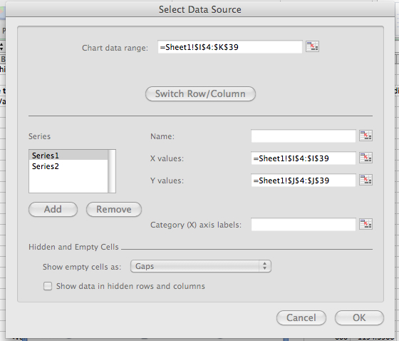

Here you have options to type in a name for each data series (it will show up in the plot’s legend) and change the array of numbers used for the x and y axis values (click the icon to the right of the entry window for each to be taken to your worksheet where you can click-drag the numbers you want to use)
- In a second issue, you may have noticed your Planck blackbody calculator uses an x-axis domain from 400-700nm by 5nm jumps while the spectroradiometer used to measure the real sources gave a different range. Getting both data series on the same plot as required in some of your data analyses thus requires some specific Excel editing, given the 2 different x-axis domains.
Start by building a normal “Scatter” plot with only one of the data series. Next, return to your Excel data and COMMAND-click-drag the second data to be plotted, including both its x-axis and y-axis values. Next, use your favorite “Copy” command (either COMMAND-C or through the “Edit” menu). Next, click into the area of your plot to highlight it and then use the “Edit” menu in Excel to select “Paste Special.” The following dialog should appear. You need to be sure to check the appropriate boxes in this dialog before saying OK. For example, you will want to paste a “New Series” where the data is in “Columns” and the “X-axis is in the first column.” After doing this, you will find you have 2 plots that will each have their own x-axis values. Keep in mind, this only works if your plot type is “Scatter.” Other plot types do not allow different x-axis values for the different series in the plot.

