DBMS
LAB Assignment-3
- Create table EMPLOYEE with the following details.
FIELD NAME | TYPE
EMPLOYEE_ID | NUMBER(6)
LAST_NAME | VARCHAR2(25)
JOB_ID | VARCHAR2(10)
SALARY | NUMBER(8,2)
COMM_PCT | NUMBER (4,2)
MGR_ID | NUMBER (6)
DEPARTMENT_ID | NUMBER (4)

QUERY: CREATE TABLE EMPLOYEE (EMPLOYEE_ID INT(6),LAST_NAME VARCHAR(25),JOB_ID VARCHAR(10),SALARY DECIMAL(8,2),COMM_PCT DECIMAL (4,2),MGR_ID INT(6),DEPARTMENT_ID INT(4));

- Insert the following data into EMPLOYEE table.
EMPLOYEE_ID | LAST_NAME | JOB_ID | SALARY | COMM_PCT | MGR_ID | DEPARTMENT_ID
198 | Connell | SH_CLERK | 2600 | 2.5 | 124 | 50
199 | Grant | SH_CLERK | 2600 | 2.2 | 124 | 50
200 | Whalen | AD_ASST | 4400 | 1.3 | 101 | 10
201 | Hartstein | IT_PROG | 6000 | null | 100 | 20
202 | Fay | AC_MGR | 6500 | null | 210 | 20
203 | Mavris | AD_VP | 7500 | null | 101 | 40
204 | Baer | AD_PRES | 3500 | 1.5 | 101 | 90
205 | Higgins | AC_MGR | 2300 | null | 101 | 60
206 | Gitz | IT_PROG | 5000 | null | 103 | 60
100 | King | AD_ASST | 8956 | 0.3 | 108 | 100
101 | Kochar | SH_CLERK | 3400 | 1.3 | 118 | 30

QUERY: INSERT INTO EMPLOYEE VALUES
-> (198, 'Connell', 'SH_CLERK', 2600, 2.5, 124, 50),
-> (199, 'Grant', 'SH_CLERK', 2600, 2.2, 124, 50),
-> (200, 'Whalen', 'AD_ASST', 4400, 1.3, 101, 10),
-> (201, 'Hartstein', 'IT_PROG', 6000, NULL, 100, 20),
-> (202, 'Fay', 'AC_MGR', 6500, NULL, 210, 20),
-> (203, 'Mavris', 'AD_VP', 7500, NULL, 101, 40),
-> (204, 'Baer', 'AD_PRES', 3500, 1.5, 101, 90),
-> (205, 'Higgins', 'AC_MGR', 2300, NULL, 101, 60),
-> (206, 'Gitz', 'IT_PROG', 5000, NULL, 103, 60),
-> (100, 'King', 'AD_ASST', 8956, 0.3, 108, 100),
-> (101, 'Kochar', 'SH_CLERK', 3400, 1.3, 118, 30);

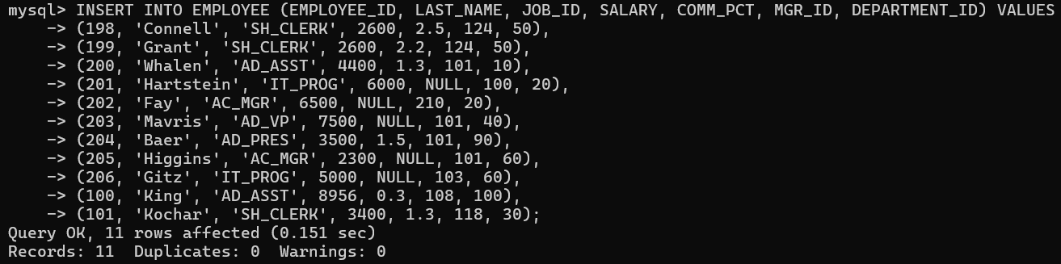

- Display last_name, job_id, employee_id for each employee with employee_id appearing first.
QUERY: SELECT last_name, job_id, employee_id FROM EMPLOYEE;

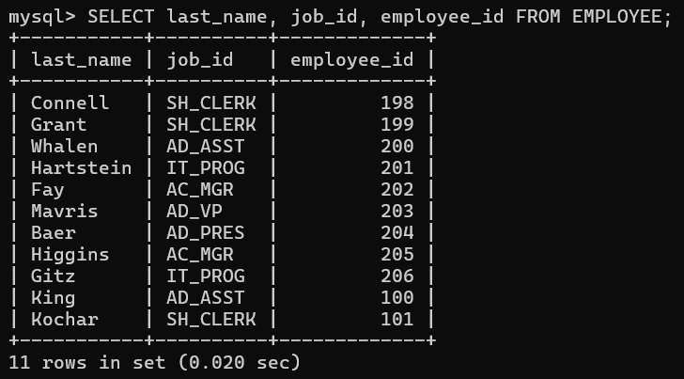

- Display the details of all employees of department 60.
QUERY: SELECT * FROM EMPLOYEE WHERE DEPARTMENT_ID =60;

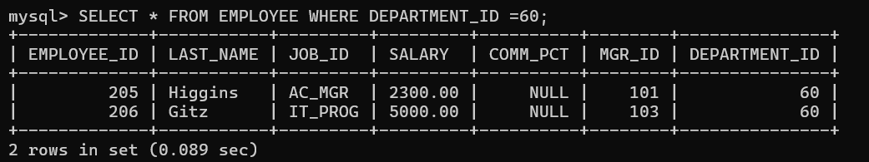

- Display the employee details of the employee whose last_name is King.
QUERY: SELECT * FROM EMPLOYEE WHERE LAST_NAME = 'King';

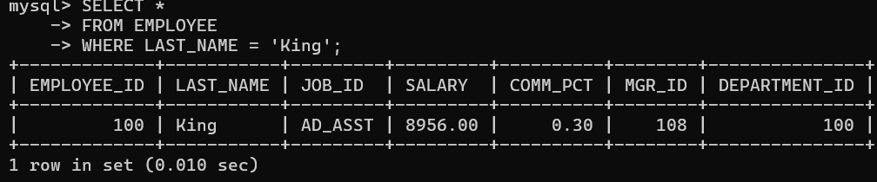

- Display unique job_id from EMPLOYEE table. Give alias name to the column as JOB_TITLE.
QUERY: SELECT DISTINCT JOB_ID AS JOB_TITLE FROM EMPLOYEE;

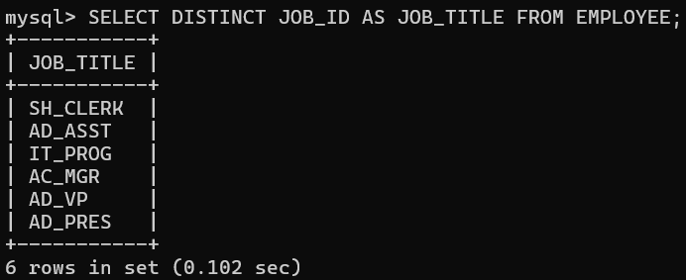

- Display last_name, salary and salary increase of Rs300. Give the new column name as ‘Increased Salary’.
QUERY: SELECT LAST_NAME, SALARY (SALARY + 300) AS Increased_Salary FROM EMPLOYEE;

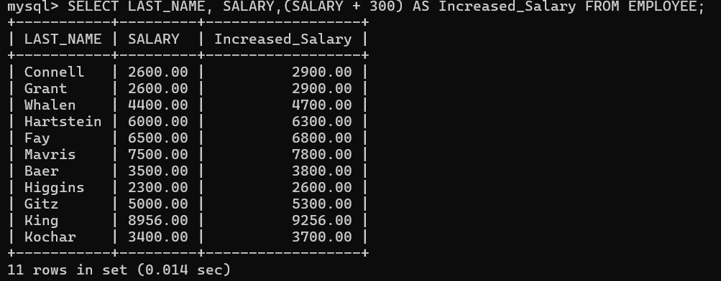

- Display last_name, salary and annual compensation of all employees, plus a onetime bonus of Rs 100. Give an alias name to the column displaying annual compensation.
QUERY: SELECT LAST_NAME, SALARY, ((SALARY*COMM_PCT)*12)+100) AS ANNUAL_COMPENSATION FROM EMPLOYEE;

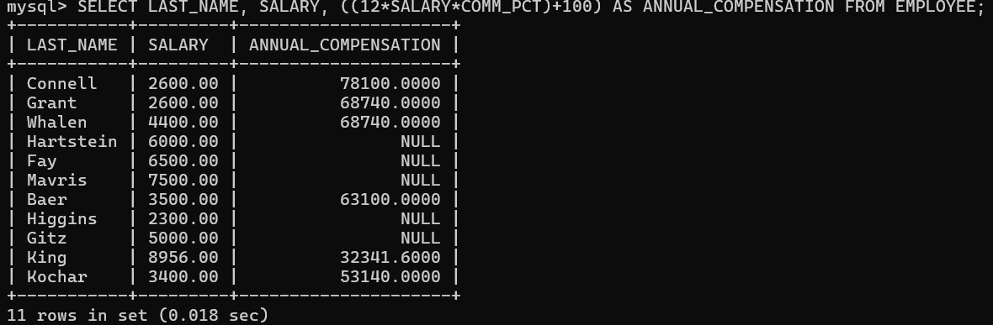

- Display the details of those employees who get commission.
QUERY: SELECT * FROM EMPLOYEE WHERE COMM_PCT IS NOT NULL;

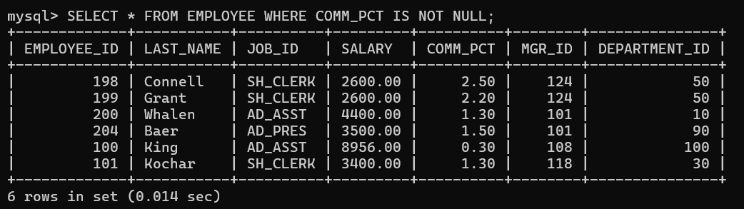

- Display the details of those employees who do not get commission.
QUERY: SELECT * FROM EMPLOYEE WHERE COMM_PCT IS NULL;

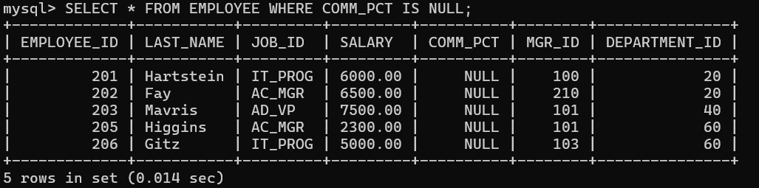

- Display the Employee_id, Department_id and Salary all employees whose salary is greater than 5000.
QUERY: SELECT EMPLOYEE_ID, DEPARTMENT_ID, SALARY FROM EMPLOYEE WHERE SALARY>5000;

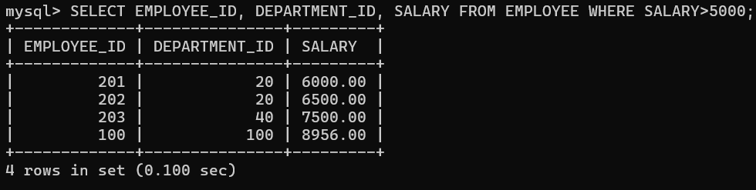

- Display the Last_Name and Salary of all employees whose salary is between 4000 and 7000.
QUERY: SELECT LAST_NAME, SALARY FROM EMPLOYEE WHERE SALARY BETWEEN 4000 AND 7000;

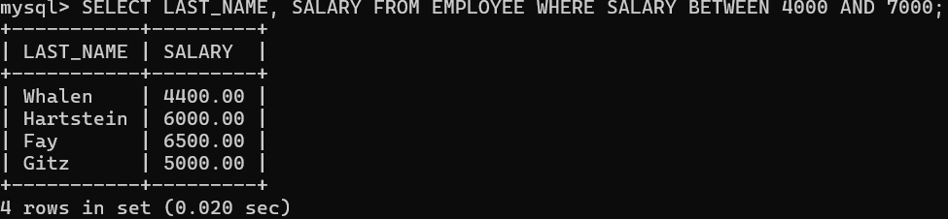

- Display the details of all employees whose salary is either 6000 or 6500 or 7000.
QUERY: SELECT * FROM EMPLOYEE WHERE SALARY IN(6000,6500,7000);

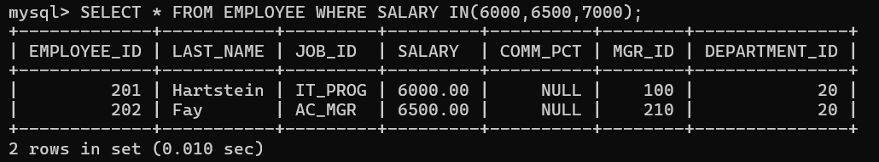

- Display the details of all those employees who work either in department 10 or 20 or 30 or 50.
QUERY: SELECT * FROM EMPLOYEE WHERE DEPARTMENT_ID IN(10,20,30,50);

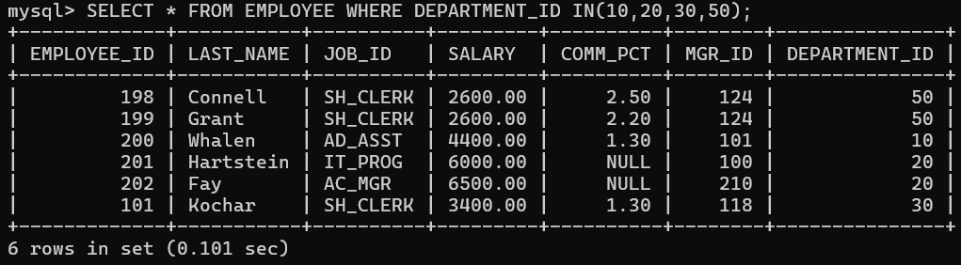

- Display the details of all employees whose salary is not equal to 5000.
QUERY: SELECT * FROM EMPLOYEE WHERE SALARY!= 5000;

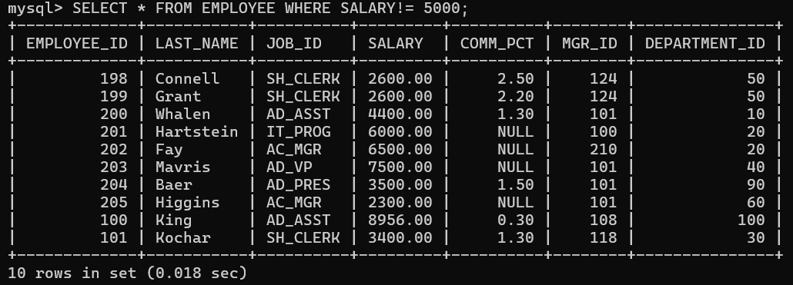

- Display the details of all the CLERKS working in the organization.
QUERY: SELECT * FROM EMPLOYEE WHERE JOB_ID LIKE ‘%CLERK’;

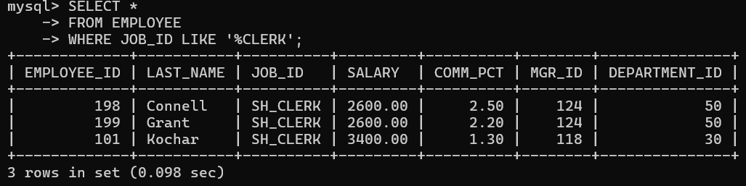

- Update the job_id’s of the employees who earn more than 5000 to Grade_A. Display the table EMPLOYEE after updating.
QUERY: UPDATE EMPLOYEE TABLE SET JOB_ID = ‘Grade_A’ WHERE SALARY>5000;

SELECT * FROM EMPLOYEE;

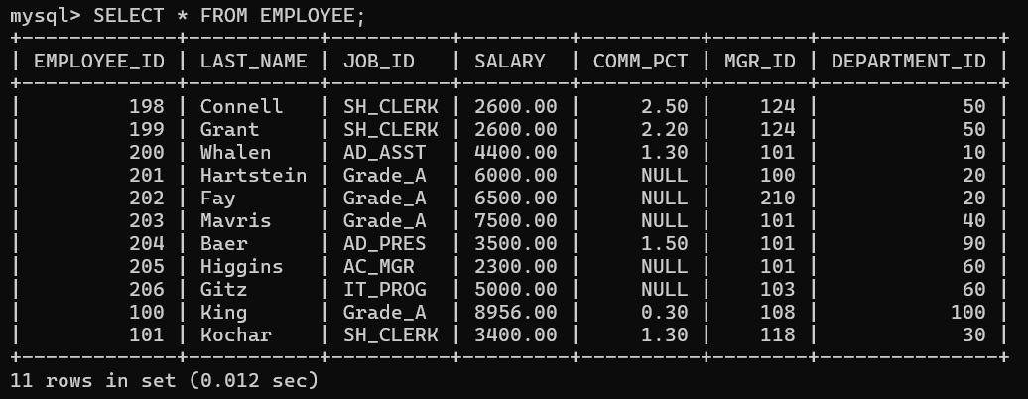

- Display the details of all those employees who are either CLERK or PROGRAMMER or ASSISTANT.
QUERY: SELECT * FROM EMPLOYEE WHERE LAST_NAME LIKE ‘%CLERK’ OR ‘%PROG’ OR ‘ASST’;

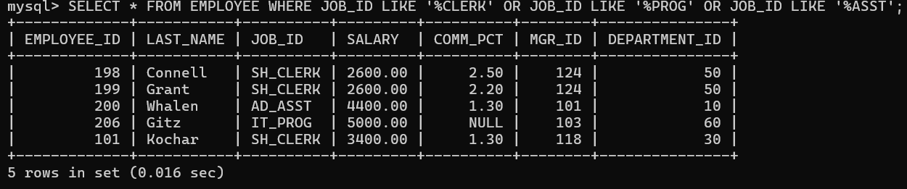

- Display those employees from the EMPLOYEE table whose designation is CLERK and salary is less than 3000.
QUERY: SELECT * FROM EMPLOYEE WHERE JOB_ID LIKE ‘%CLERK’ AND SALARY<3000;

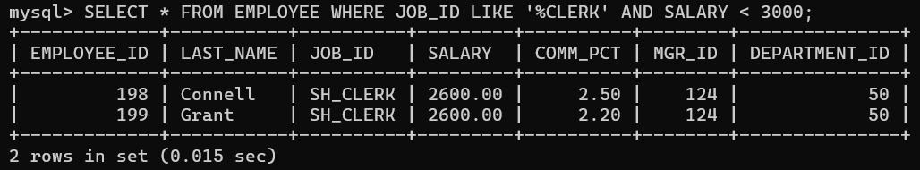

- Display those employees Last_Name, Mgr_id from the EMPLOYEE table whose salary is above 3000 and work under Manager 101.
QUERY: SELECT LAST_NAME, MGR_ID FROM EMPLOYEE WHERE SALARY>3000 AND MGR_ID = 101;

