LAB Assignment-5

- Create the following tables:
(Giving names to all the constraints are mandatory)
a) Table Name: Client_Master

Column Name | Data Type | Size | Constraints
Client_no | Varchar2 | 5 | Primary Key, Should start with C
Name | Varchar2 | 20 | Not Null, Unique Key
Address1 | Varchar2 | 30
State | Varchar2 | 30
City | Varchar2 | 15 | Should be within Delhi, Mumbai and Chennai

Data for Client_Master table:
Client_no | Name | Address1 | State | City
C01 | Ivaan | Church Rd | Maharashtra | Mumbai
C02 | Vandana | St.Mary Rd | Tamil Nadu | Chennai
C03 | Pramada | Mall Rd | Maharashtra | Mumbai
C04 | Basu | Church Rd | Maharashtra | Mumbai
C05 | Ravi | Chandni | null | Delhi
C06 | Rukmini | Mall Rd | Maharashtra | Mumbai

b) Table Name: Sales_Order
Column Name | Data Type | Size | Constraints
S_order_no | Varchar2 | 10 | Primary Key, Should start with O
S_order_date | Date
Client_no | Varchar2 | 5 | Foreign Key references client_no of Client_Master table
Salesman_no | Varchar2 | 10 | Should start with S
Product_no | Varchar2 | 10 | Foreign Key references Product_no of Product_Master table

Data for Sales_Order table:
S_order_no | S_order_date | Client_no | Salesman_no | Product_no
O19001 | 12-jan-96 | C01 | S01 | P01
O19002 | 25- jan-96 | C02 | S02 | P02
O19003 | 18-feb-96 | C03 | S03 | P03
O19004 | 03-apr-96 | C01 | S01 | P04
O19005 | 20-may-96 | C04 | S02 | P05
O19006 | 24-may-96 | C05 | S04 | P06

c) Table Name: Products_Master
Column Name | Data Type | Size | Constraints
Product_no | Varchar2 | 10 | Primary key, should start with P
Description | Varchar2 | 20 | Not Null, Unique Key
Qty_on_hand | Number | 8 | Should be greater than 10.
Sell_price | Number | 8,2 | Not Null
Cost_price | Number | 8,2 | Not Null

Data for table Products_Master:-
Product_no | Description | Qty_on_hand | Sell_price | Cost_price
P01 | 1.44 Floppies | 100 | 525 | 500
P02 | Monitors | 25 | 12000 | 11280
P03 | Mouse | 20 | 1050 | 1000
P04 | 1.22 floppies | 100 | 525 | 500
P05 | Keyboards | 15 | 3150 | 3050
P06 | Cd drive | 14 | 5250 | 5100

QUERY: CREATE TABLE Client_Master (Client_no VARCHAR(5) PRIMARY KEY CHECK(Client_no LIKE 'C%'), Name VARCHAR(20) UNIQUE NOT NULL, Address1 VARCHAR(30), State VARCHAR(30), City VARCHAR(15) CHECK(City IN ('Delhi','Mumbai','Chennai')));

CREATE TABLE Products_Master (Product_no VARCHAR(10) PRIMARY KEY, Description VARCHAR(20) UNIQUE NOT NULL, Qty_on_hand INT CHECK (Qty_on_hand > 10), Sell_price DECIMAL(8,2) NOT NULL, Cost_price DECIMAL(8,2) NOT NULL, CHECK (Product_no LIKE 'P%'));

CREATE TABLE Sales_Order (S_order_no VARCHAR(10) PRIMARY KEY CHECK (S_order_no LIKE 'O%'), S_order_date DATE, Client_no VARCHAR(5), Salesman_no VARCHAR(10) CHECK (Salesman_no LIKE 'S%'), Product_no VARCHAR(10), FOREIGN KEY (Client_no) REFERENCES Client_Master(Client_no), FOREIGN KEY (Product_no) REFERENCES Products_Master(Product_no));

- Add a Not Null constraint on the address1 field of Client_Master table and display the structure of the table.
QUERY:
ALTER TABLE Client_Master MODIFY Address1 VARCHAR(30) NOT NULL;

DESC Client_Master;

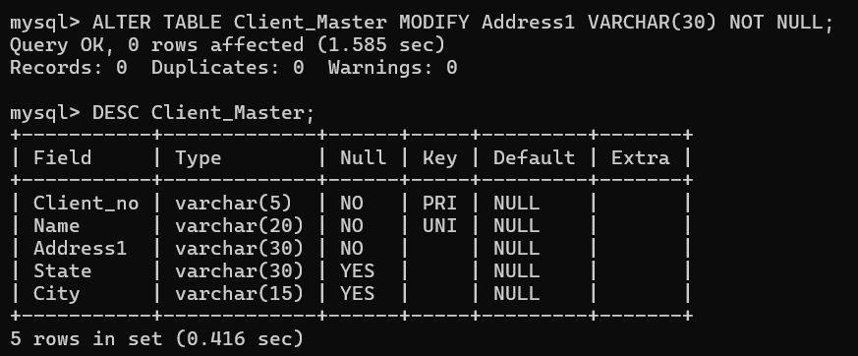

- Calculate the profit (Sell_price-Cost_price) from the Products_Master table. Name the column as ‘Profit’.
QUERY: SELECT Product_no, Description, Sell_price - Cost_price AS Profit
FROM Products_Master;

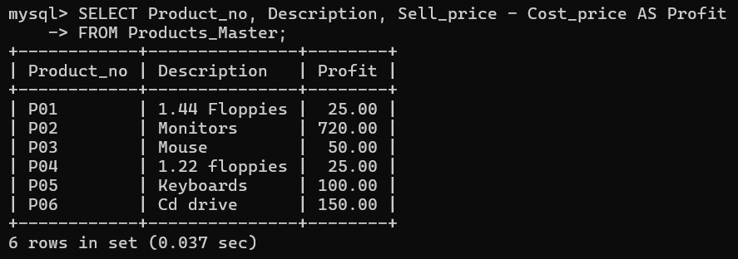

- Calculate and display the total cost price (Qty_on_hand * Cost_price) of the stock present in hand. Name the column accordingly.
QUERY: SELECT Product_no, Description, Qty_on_hand * Cost_price AS Total_Cost
FROM Products_Master;
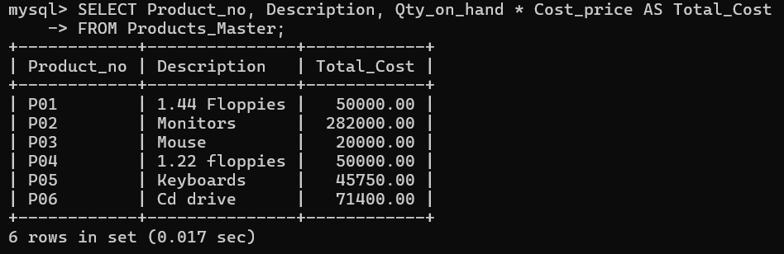

- Display the client details of all the clients whose name starts with I.
QUERY: SELECT *
FROM Client_Master
WHERE Name LIKE 'I%';

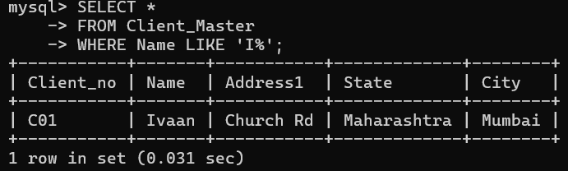

- Display the client details of all the clients whose name start with R and ends with i.
QUERY: SELECT *
FROM Client_Master
WHERE name LIKE 'R%i';

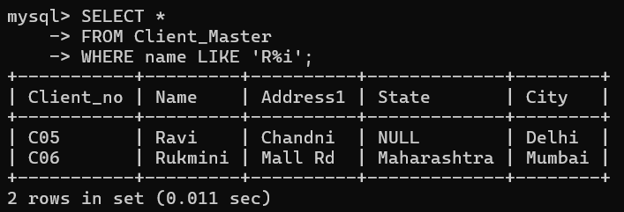

- Display the client details of all the clients whose name contains a in the third and fifth position.
QUERY: SELECT *
FROM Client_Master
WHERE name LIKE '__a_a%';

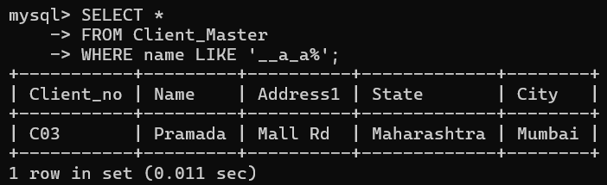

- Display the client details of all the clients whose name contains aa.
QUERY: SELECT *
FROM Client_Master
WHERE name LIKE '%aa%';

- Display the client details of all the clients whose name contains exactly four characters.
QUERY: SELECT *
FROM Client_Master
WHERE LENGTH(name) = 4;

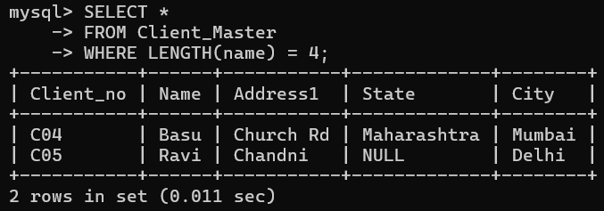
- Display the client details of those clients who have not mentioned state in his/her address.
QUERY: SELECT *
FROM Client_Master
WHERE State IS NULL OR State = '';

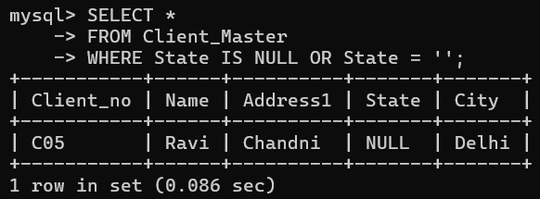

- Display the order details placed after January, 1996.
QUERY: SELECT *
FROM Sales_Order
WHERE s_order_date > '1996-01-01';

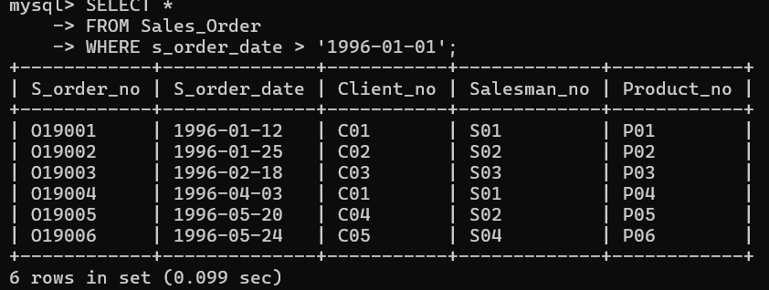

- Change the s_order_date of client_no ‘C01’ to 24/07/96, Product_no to ‘P06’, Salesman_no to ‘S04’.
QUERY: UPDATE Sales_Order
SET s_order_date ='1996-07-24',
Product_no = 'P06',
Salesman_no = 'S04'
WHERE Client_no = 'C01';

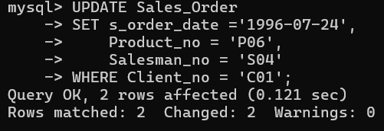

- Change the city of client_no ‘C05’ to ‘Kolkata’.
QUERY: DELETE FROM Client_Master
WHERE Client_no = 'C02';

- Change the field size of Client_no to 15 in all the tables where the field Client_no is present.
QUERY: ALTER TABLE Client_Master
MODIFY Client_no VARCHAR(15);

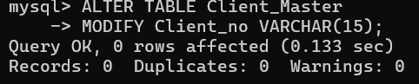

ALTER TABLE Sales_Order
MODIFY Client_no VARCHAR(15);

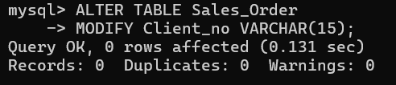

- Remove the record for Client_no C02 from Client_Master table.
QUERY: DELETE FROM Client_Master
WHERE Client_no = 'C02';

- Remove those records from Product_Master table for which sell price is between 1000 and 10,000.
QUERY: DELETE FROM Products_Master
WHERE Sell_price BETWEEN 1000 AND 10000;

- Create a table of your own with a composite primary key.
QUERY: CREATE TABLE Enrollment (
Student_id VARCHAR(10),
Course_id VARCHAR(10),
Enrollment_date DATE,
PRIMARY KEY (Student_id, Course_id)
);

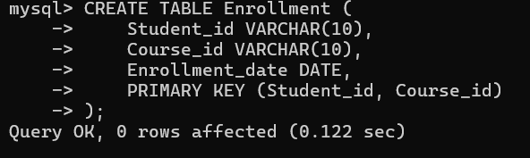

- Create another table of your own wish, where the composite primary key of problem 24 will act as a foreign key here.
QUERY: CREATE TABLE Grades (
Student_id VARCHAR(10),
Course_id VARCHAR(10),
Grade VARCHAR(2),
FOREIGN KEY (Student_id, Course_id) REFERENCES Enrollment(Student_id, Course_id)
);

