1) Dataset Preparation

1.1)Loading the dataset:

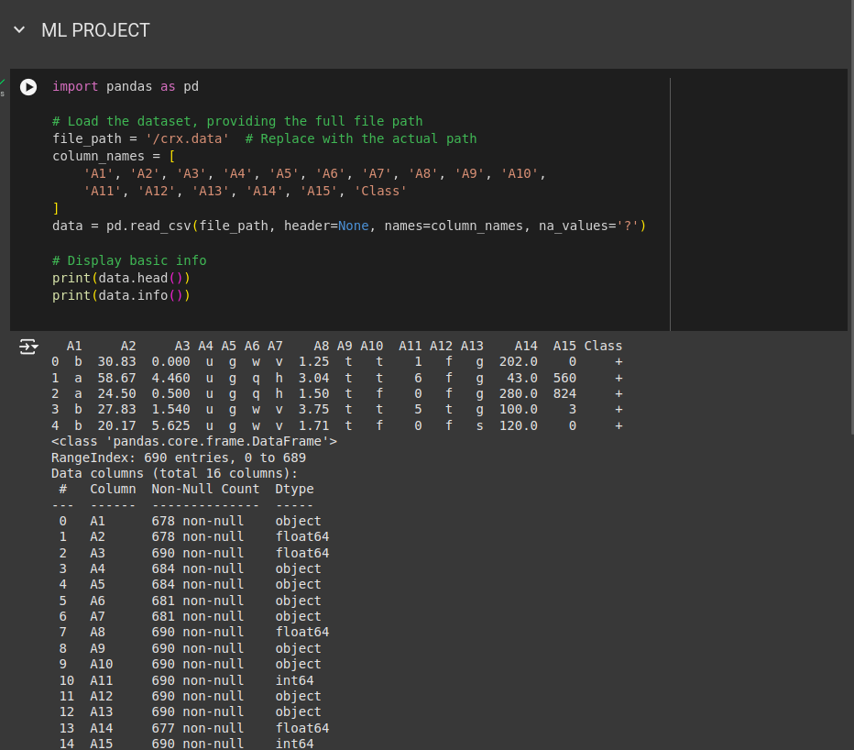

1.2) Handling Missing Values:

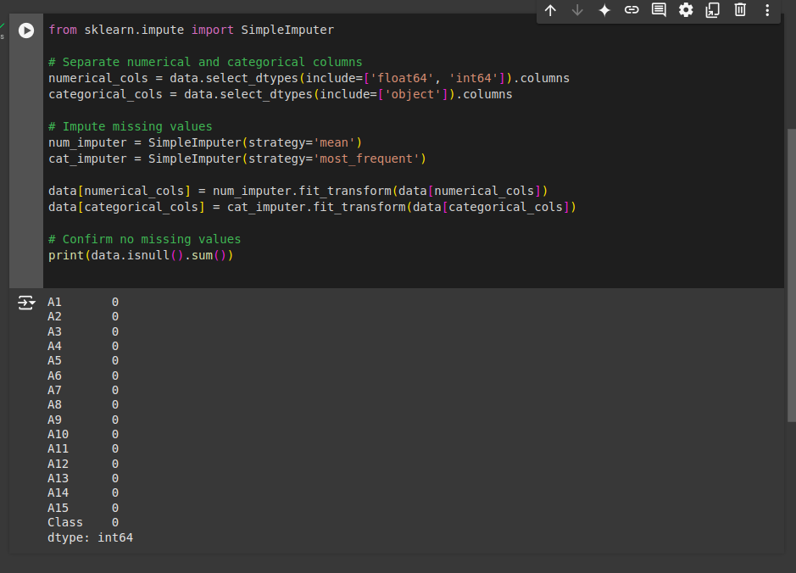

2) EDA :
2.1) Understand Data Distribution

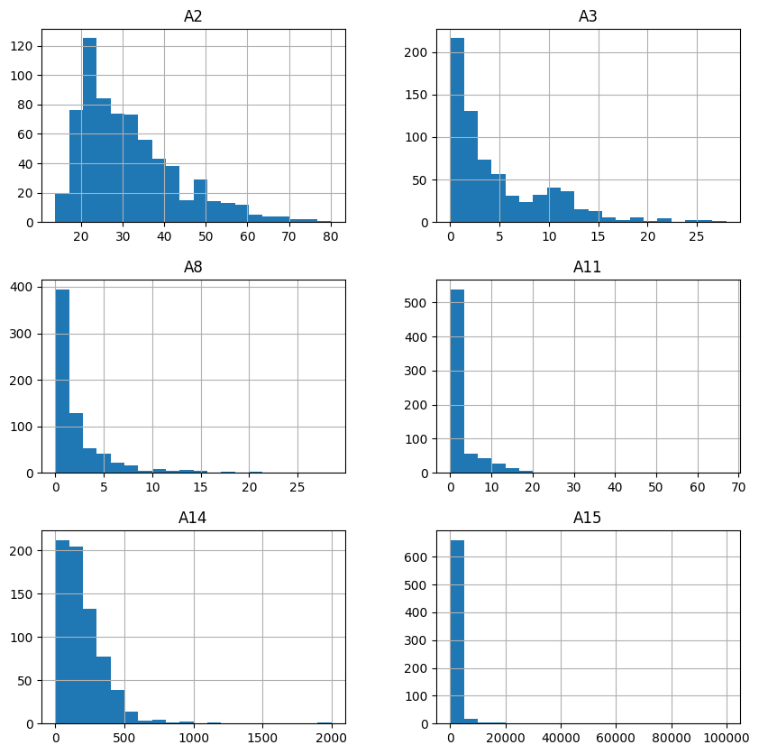

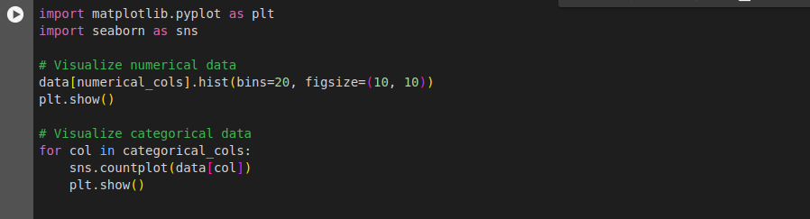
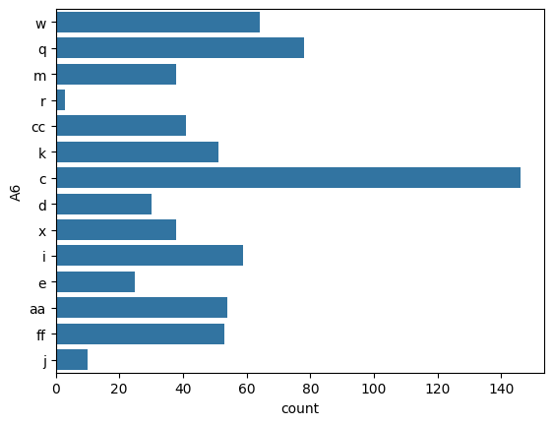

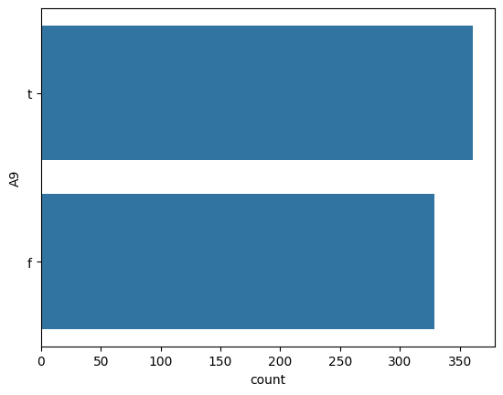

2.2) Class balance
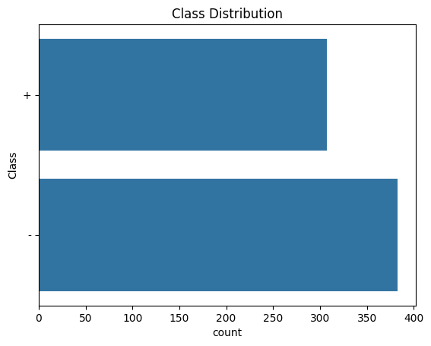

2.3) Correlation Analysis

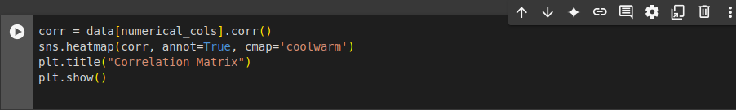
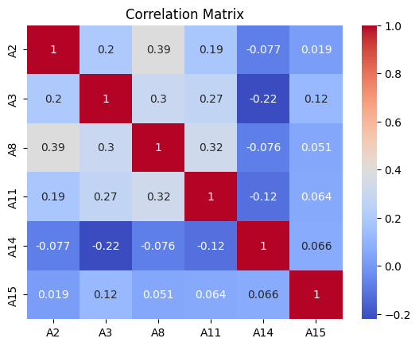

2.4) Outlier Detection

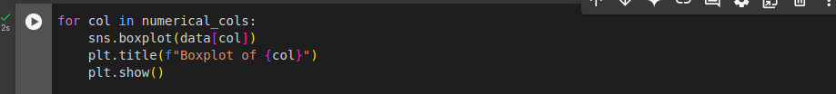

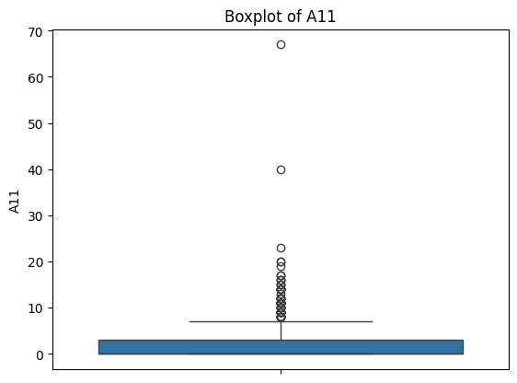

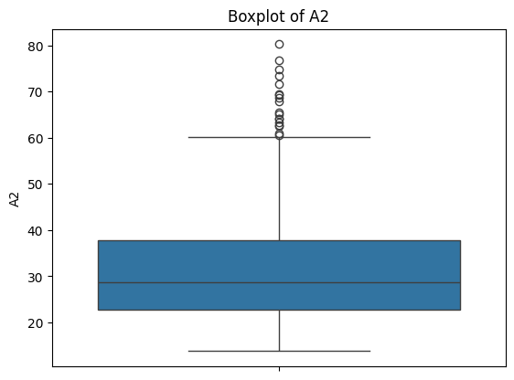

3) Train-test Split
3.1) Encode Categorical Data
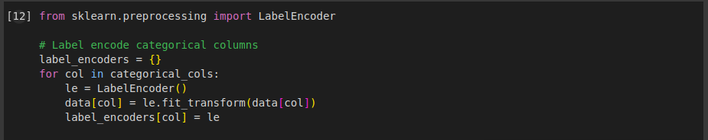
3.2) Split Data

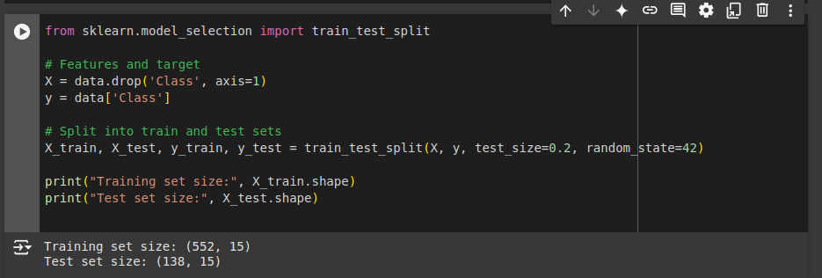
4) Applying ML Algorithms:
4.1) Logistic Regression
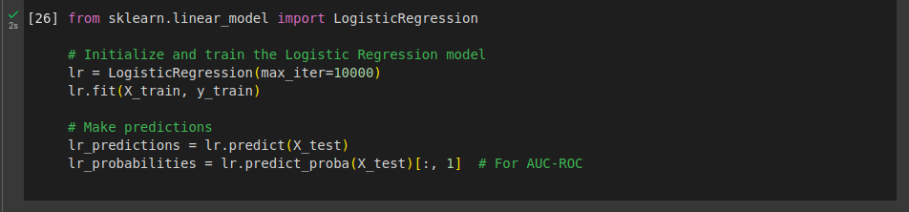
4.2)Decision Tree
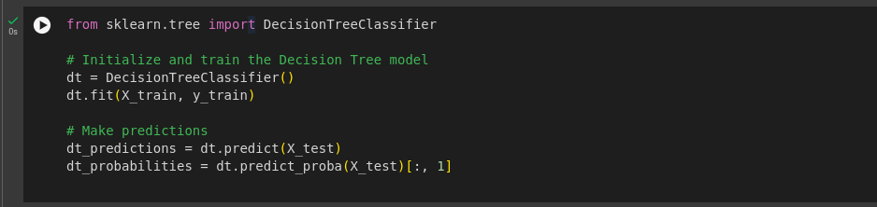
4.3) Random Forest

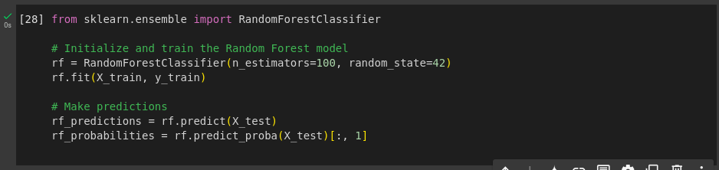

4.4) Gradient Boosting
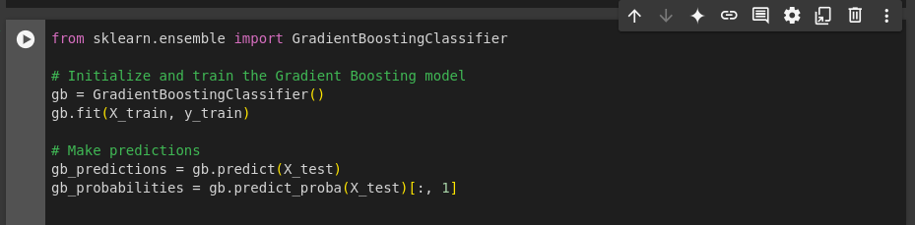
5) Evaluation Metrics
5.1) Evaluating Models
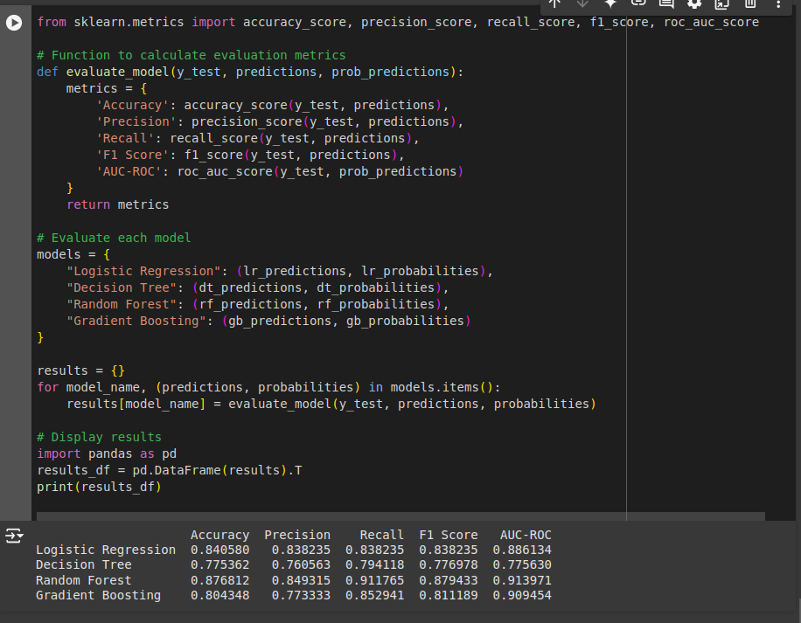
5.2) Plotting ROC Curves
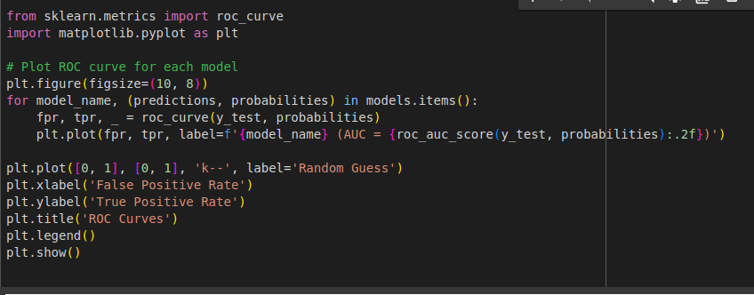
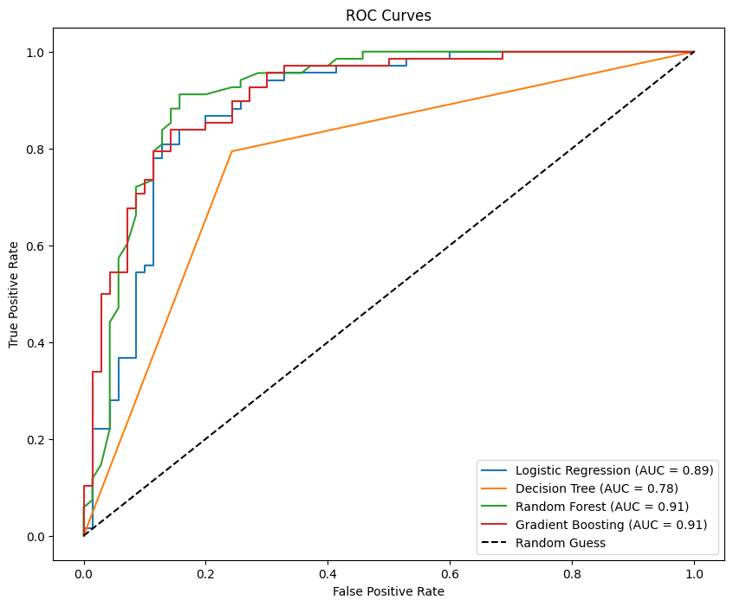

6) Comparing Results

6.1) Logistic Regression:
- Strengths: Decent performance with an AUC-ROC of 0.89 and a balanced F1 Score of 0.838.

- Weakness: Slightly lower precision compared to Random Forest.

6.2) Decision Tree:
- Strengths: Interpretable model with reasonable metrics.

- Weakness: Lowest AUC-ROC (0.78) and F1 Score (0.777) among the models, indicating weaker overall performance.

6.3) Random Forest:
- Strengths:
  - Best performance in most metrics, with the highest Accuracy (0.876), Precision (0.849), F1 Score (0.879), and AUC-ROC (0.91).
  - Excellent balance between recall and precision.

- Weakness: Slightly longer training and prediction times due to its ensemble nature.
6.4) Gradient Boosting:
- Strengths:
  - Competitive performance with Random Forest in Recall (0.811) and AUC-ROC (0.91).
  - Slightly more robust on imbalanced datasets due to boosting methodology.

- Weakness: Lower F1 Score (0.853) compared to Random Forest, making it slightly less favorable overall.

Selection Criteria:
- Overall Best Model: Random Forest is the most suitable model for this task due to its consistently high metrics, including accuracy, precision, recall, F1 Score, AUC-ROC.

- Alternative Model: Gradient Boosting can be considered if the goal is to explore more robust ensemble techniques or prioritize slightly better recall.

Conclusion :

- Random Forest can be used as the primary model for loan default prediction.

- We can perform hyperparameter tuning for Random Forest to further improve performance.

