Water Tank Monitoring System

Team Members
- SHAIK REHAAN ASHRAF (AM.EN.U4CSE22153)
- ROHIT VARMA DATLA (AM.EN.U4CSE22119)
- DARSHAN KUMAR (AM.EN.U4CSE22114)
- SAHODEV (AM.EN.U4CSE22172)
- ATHULYA (AM.EN.U4CSE22169)

Abstract
The "Water Tank Monitoring System" offers a practical solution to address water scarcity by mitigating wastage caused by overflow. This system employs Arduino Uno microcontroller-based automation to monitor water levels in real-time, using ultrasonic sensors. It controls the motor operation, ensuring optimal water usage and energy efficiency. The system can also alert users through visual (LCD), auditory (buzzer), and optional remote notifications via a smartphone app, enhancing convenience and safety.

Objective
- Monitor water levels in a tank using an ultrasonic sensor.
- Automate the water pump motor based on water level detection.
- Provide alerts when the tank is full (buzzer activation).
- Display the current water level on an LCD.

Components Used
Component | Description
Arduino UNO | Microcontroller for processing data
Ultrasonic Sensor | Measures distance to water surface
Relay Module | Controls water pump motor
Buzzer | Provides alert sound when tank is full
LCD (16x2) Display | Displays water level and motor status
Water Pump Motor | Represents the tank motor
Block Diagram
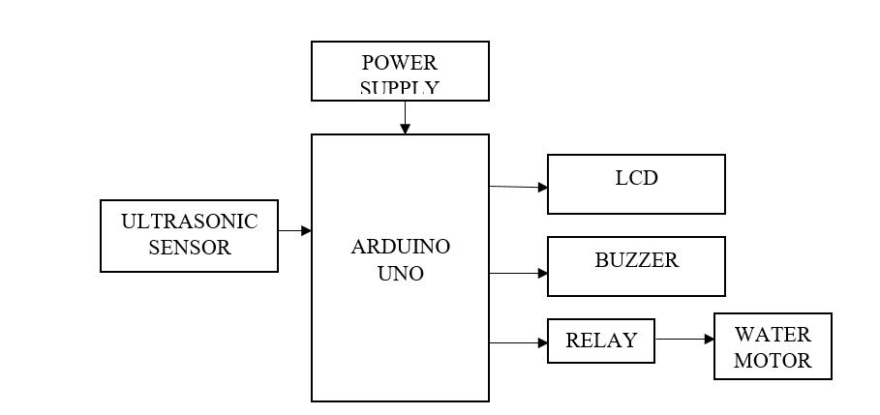

Working
- Ultrasonic Sensor:
  - Sends an ultrasonic wave via the trigger pin.
  - Calculates the distance based on the reflected wave using the echo pin.
- Water Level Detection:
  - Distance is calculated using: Pulse Duration×0.034/2
- Motor Control:
  - If the water level is low: The motor turns ON.
  - If the water level is medium: The motor remains OFF.
  - If the water level is full: The motor turns OFF, and the buzzer sounds.
- LCD Display:
  - Displays water level (distance in cm) and motor status.
- Buzzer:
  - Alerts when the tank is full.

Programming Code

#include <LiquidCrystal.h>
const int rs = A0, en = A1, d4 = A2, d5 = A3, d6 = A4, d7 = A5;
LiquidCrystal lcd(rs, en, d4, d5, d6, d7);

const int wat_motor = 8;
const int buzzer = 9;
const int trigPin = 10;
const int echoPin = 11;
float duration;
float distanceCm;

void setup() {
lcd.begin(16, 2);
Serial.begin(9600);
pinMode(echoPin, INPUT);
pinMode(trigPin, OUTPUT);
pinMode(wat_motor, OUTPUT);
pinMode(buzzer, OUTPUT);
digitalWrite(wat_motor, HIGH); // Motor off initially
}

void loop() {
digitalWrite(trigPin, LOW);
delayMicroseconds(2);
digitalWrite(trigPin, HIGH);
delayMicroseconds(10);
digitalWrite(trigPin, LOW);
duration = pulseIn(echoPin, HIGH);
distanceCm = duration * 0.034 / 2;

if (distanceCm <= 4) { // Full
digitalWrite(wat_motor, HIGH); // Motor OFF
digitalWrite(buzzer, HIGH);
lcd.setCursor(0, 0);
lcd.print("Water: Full");
lcd.setCursor(0, 1);
lcd.print("Motor: OFF");
delay(1000);
digitalWrite(buzzer, LOW);
} else if (distanceCm > 28) { // Low
digitalWrite(wat_motor, LOW); // Motor ON
lcd.setCursor(0, 0);
lcd.print("Water: Empty");
lcd.setCursor(0, 1);
lcd.print("Motor: ON ");
} else { // Medium
digitalWrite(wat_motor, HIGH); // Motor OFF
lcd.setCursor(0, 0);
lcd.print("Water: Medium");
lcd.setCursor(0, 1);
lcd.print("Motor: OFF ");
}
delay(500);
lcd.clear();
}

Results and Screenshots
- Water Level: Full
  - Buzzer ON
  - Motor OFF
  - Screenshot: LCD shows "Water: Full" and "Motor: OFF".

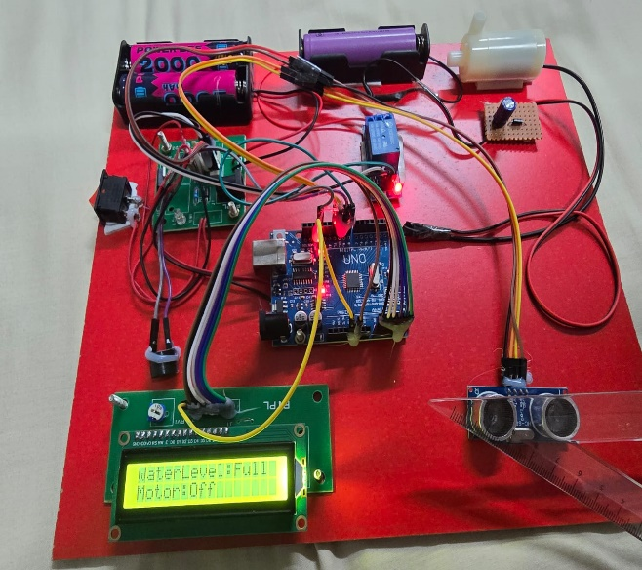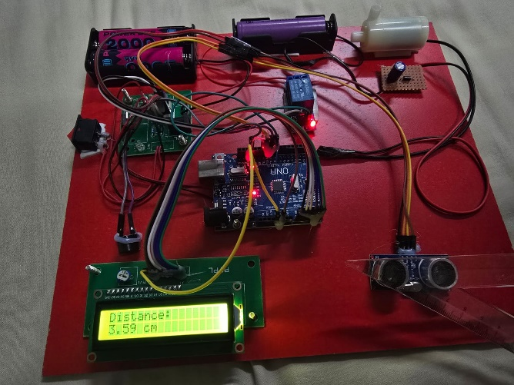

- Water Level: Medium
  - Motor remains OFF
  - Screenshot: LCD shows "Water: Medium" and "Motor: OFF".
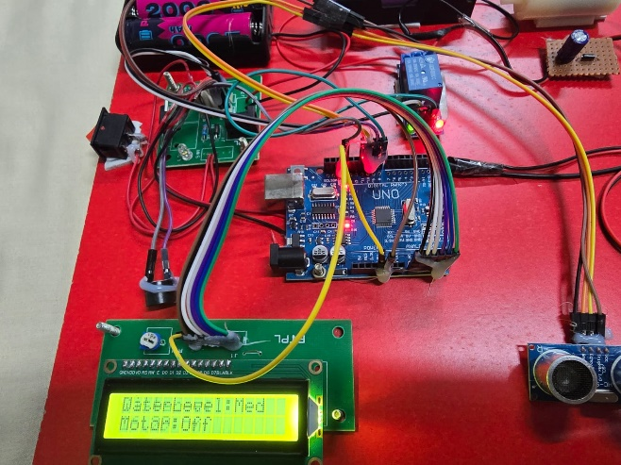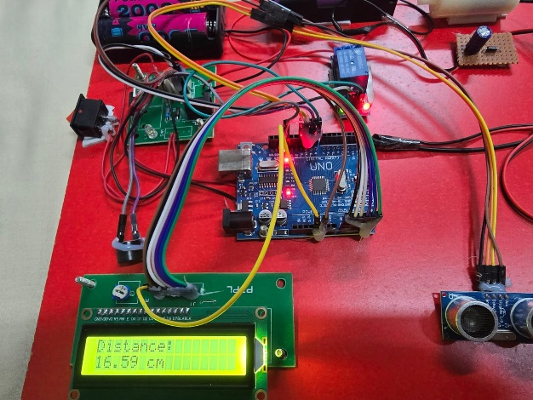
- Water Level: Low/Empty
  - Motor ON to fill the tank
  - Screenshot: LCD shows "Water: Empty" and "Motor: ON".
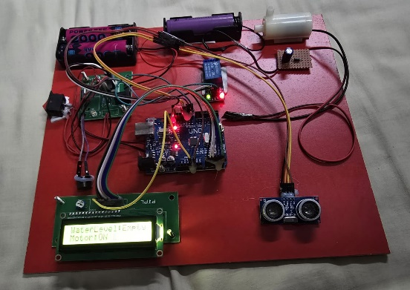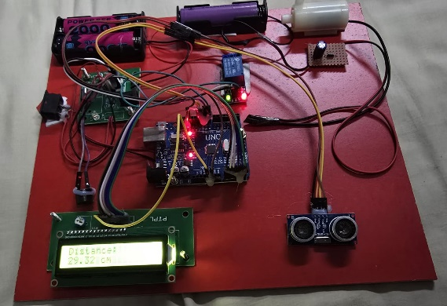

Conclusion
- The water tank monitoring system efficiently monitors water levels and controls the motor automatically.
- It prevents overflow, conserves energy, and provides a reliable water level indication.
- This system is simple, cost-effective, and ideal for home and industrial use.

