SUMMARY OF REPRODUCTIVE PARAMETERS OF SPECTACLED EIDER (SOMATERIA FISCHERI) NESTS AT KIGIGAK ISLAND, 2022–2026
August 2026
Memorandum
To: Daniel Rizzolo, Wildlife Biologist, Endangered Species Recovery Program
From: Sarah Hoepfner, Research Technician, Endangered Species Recovery Program

Background
The U.S. Fish and Wildlife Service has monitored Spectacled Eider (Somateria fischeri) nests at Kigigak Island in most years since 1992. One objective of this project is to monitor Spectacled Eider productivity. Previous work done by Friendly et al. (2025) provided nest survival estimates for the years 1994–2015, 2019, and 2021. However, nest survival estimates have not been updated since 2021.

Objective
I estimated nest survival of Spectacled Eiders at Kigigak Island 1994–2026 following Friendly et al. (2025) and summarized reproductive output in terms of clutch size and successfully hatched eggs as indicated by egg membranes for the years 2022–2026.

Methods

Data preparation
I used the nesting data from Spectacled Eiders at Kigigak Island in the Access data base file named “db_kig_nesting_waterfowl_2019-2025_compiled_20250724.accdb” that was shared via Microsoft OneDrive July 2026 (D. Rizzolo, personal communication) and appended with “db_kig_nesting_waterfowl_2026.accdb”. All data wrangling was done in R using this data base file. Once that file was in the correct format for nest survival analyses, I combined it with the input file Friendly et al. (2025) used and is stored in the ScienceBase catalog (https://www.sciencebase.gov/catalog/item/67e1cab8d34ee7f14221668a) as the file name “INP_20220921.csv”.
Data wrangling involved condensing the original nest fate categories to a binary fail/hatch variable, changing calendar dates to Julian dates, determining nest initiation dates based on estimated and observed hatch dates, determining AgeDay1 values for the nest age explanatory variable, and removing nests that did not contribute to monitoring days (i.e., nests visited only once).
I created nest survival R code based on code from Friendly et al. (2025) as stored in the ScienceBase catalog (https://www.sciencebase.gov/catalog/item/67e1cab8d34ee7f14221668a). The code I modified was in the file “fit_ns_models.R” within the folder “Nest Survival Analysis” and I saved the modified code as “fit_ns_models_1994-2026_ssa_revision.R”. This file also includes code to summarize clutch size and hatched egg membrane counts by year.
To determine nest initiation dates to use in the nest survival analysis, I subtracted 24 days (the mean duration of the incubation period) from nest hatch dates. For nests at which hatch was observed as either hatching eggs (i.e., starred or star-pipped eggs) or hatched eggs (wet or dry ducklings in the nest bowl), the date of the first pipped egg was used as the hatch date. Egg pipping was assumed to occur one day after egg starring, one day before wet ducklings in the nest, and two days before dry ducklings in the nest. For nests that failed prior to hatching and had no known hatch date, I based hatch date on egg floatation and egg candling embryo age estimates made during the last visit to the nest. I removed nests that had inviable eggs or abandoned eggs. I centered initiation dates by subtracting the mean initiation date for each year from individual nest initiation dates in that year. Initiation date, as defined here does not include the egg laying period, and thus represents the start of nest incubation.
As input data, daily nest survival models in Program MARK (Laake 2013) require the variables FirstFound (i.e., the date a nest was discovered), Last Present (i.e., the date the nest was last checked while it was active), and LastChecked (i.e., the date the nest was last checked; equivalent to LastPresent for successfully hatched nests). All dates were standardized to the first day of the study period across years, Julian date 137. As a result, the minimum first FirstFound became day 1 in the input data set. The variable AgeDay1, used to estimate the nest age effect, was also standardized to the first day of the study as the age of the nest on the first day of the study period (i.e., 133 – initiation date). The final data file for the nest survival analysis was saved as “inp_ns_models_1994-2026_ssa_revision.csv”.

Nest survival
I fit daily nest survival models in the nest survival module of Program MARK (version 11.1; Dinsmore et al. 2002) using the Program R (version 4.6.1; R Core Team 2026) and package RMark (version 3.1.0; Laake 2013). Daily nest survival models are generalized linear models that assume a binomial distribution and use a logit link. I estimated nest survival on the entire dataset 1994–2026 to best evaluate the years 2022–2025.
The number of daily occasions estimated by the model was determined by the duration of the study, which was 61 days. I used the model year + init + nestage that accounts for consistent sources of variation in nest survival estimates.
I calculated cumulative nest survival probabilities for each year as the product of daily nest survival over the 24-day incubation period using the “prod” function in RMark with nest initiation set to the mean Julian date for each year. I used the delta method (“deltamethod.special” function in RMark) to calculate standard errors, and calculated 95% confidence intervals as the estimate ± 2 × SE.

Clutch size
I based clutch size for each nest on its maximum observed clutch size across all visits to the nest 2022–2025. I removed nests with clutch sizes that were likely incomplete as indicated by nest visit records with egg floatation and egg candling data indicating incubation had not yet started. Because clutch size was not monitored continuously through egg laying and incubation, these data cannot consistently detect partial clutch loss. For this reason, clutch size estimated from these data may be biased low. For each year of data, I calculated mean, median, and modal clutch size.

Egg membranes
Egg membranes are indicative of successfully hatched eggs. In the field, observers counted all egg membranes in the nest bowl at a subset of nests visited after hatch. Egg membrane counts from 2022–2025 are estimates of the maximum number of egg membranes present in a nest bowl, but can be imprecise due to torn and incomplete membranes. I summarize egg membrane counts as the mean, median, and modal membrane count for each year of data.

Results
Between the years 1994–2026, a total of 3,038 nests were used to estimate nest survival (232 nests from the years 2022–2026). The earliest date for monitoring is the Julian date 134 and latest monitoring was Julian date 195.

Nest survival
Model results support a strong negative association between nest daily survival rate (DSR) and both nest initiation and nest age (Figure 1).

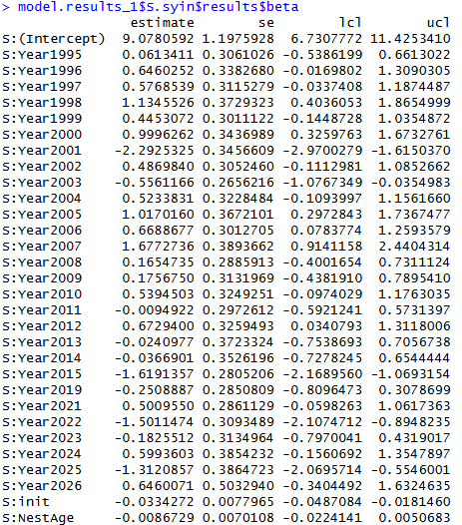

Figure 1. Parameter estimates from the model year + init + nestage estimating daily nest survival of Spectacled Eiders nesting at Kigigak Island 1994–2026.

Cumulative nest survival probabilities 2022–2026 ranged from 0.15 (95% CI: 0.04 to 0.26) to 0.81 (95% CI: 0.65 to 0.96; Table 1; Figure 2).
Table 1. Cumulative nest survival estimates with lower and upper confidence limits of Spectacled Eiders nesting at Kigigak Island, 2022–2026, using the annual values of nest initiation and the effects of nestage.
Year | Estimate | LCL | UCL
2022 | 0.148 | 0.037 | 0.260
2023 | 0.595 | 0.465 | 0.725
2024 | 0.750 | 0.622 | 0.878
2025 | 0.245 | 0.040 | 0.450
2026 | 0.806 | 0.653 | 0.958

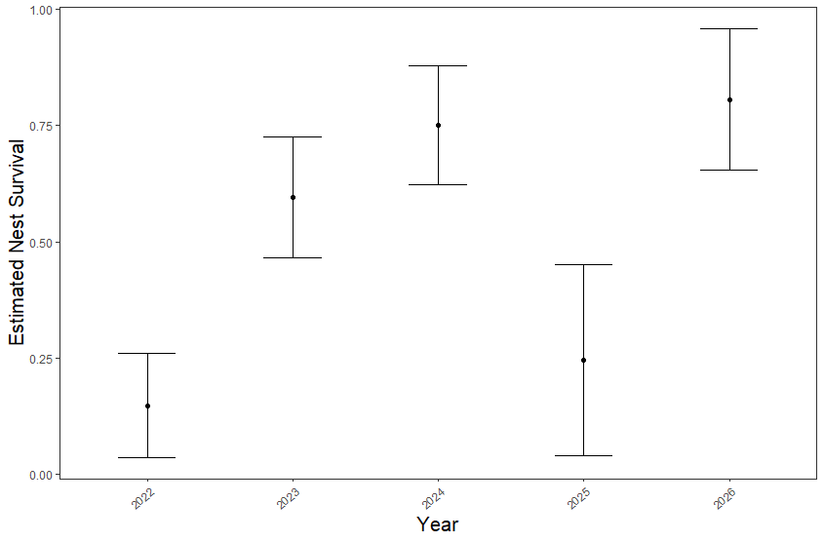
Figure 2. Estimated nest survival probabilities with 95% confidence intervals of Spectacled Eiders nesting at Kigigak Island, 2022–2026, using the annual values of nest initiation and the effects of nestage.

Clutch size
Between the years 2022–2026 the mean maximum observed clutch size was 4.9 eggs per nest. This value is similar to results reported in Friendly et al. (2025) who found an average of 5.01 eggs per nest 2022–2026. Mean annual clutch size ranged from 4.67 in 2025 and the largest was to 5.20 in 2026 (Table 2; Figure 3).
Table 2. Summary of Spectacled Eider clutch sizes at Kigigak Island, 2022–2025.
Year | Nest numbers | Mean | Median | Mode
2022 | 30 | 4.83 | 4.5 | 4
2023 | 79 | 5.10 | 5 | 5
2024 | 57 | 5.00 | 5 | 5
2025 | 21 | 4.67 | 5 | 5
2026 | 30 | 5.20 | 5 | 5
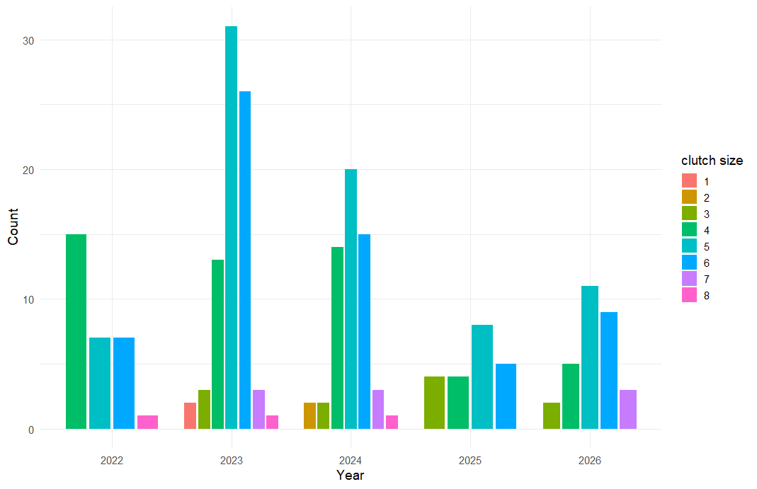
Figure 3. Clutch size distribution of Spectacled Eider nests at Kigigak Island, 2019–2026.

Hatched Eggs
Between 2022–2026 egg membranes were counted in 88 nests. The overall mean number of membranes was 3.836 membranes per nest and ranged from 2.71 in 2025 to 4.07 in 2023 (Table 3; Figure 4).
Table 3. Summary of egg membranes in hatched Spectacled Eider nests 2022–2026.
Year | n | Mean | Median | Mode
2022 | 4 | 3.00 | 3.5 | 4
2023 | 44 | 4.07 | 4 | 4
2024 | 33 | 3.73 | 4 | 4
2025 | 7 | 2.71 | 2 | 2
2026 | 22 | 4.05 | 4 | 5

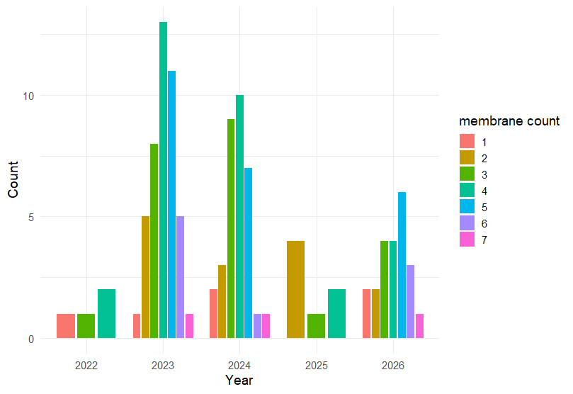
Figure 4. Counts of egg membranes in hatched Spectacled Eider nests at Kigigak Island, 2019–2026.

References
Dinsmore, S. J., White, G. C., & Knopf, F. L. (2002). Advanced techniques for modeling avian nest survival. Ecology, 83(12), 3476-3488.
Friendly, R. J., M. S. Lindberg, and D. J. Rizzolo (2025). Carry-over effects of winter conditions on nesting Somateria fischeri (Spectacled Eider), a sea ice-associated sea duck. Ornithology 142:ukaf008.
Laake J (2013). “RMark: An R Interface for Analysis of Capture-Recapture Data with MARK.” AFSC Processed Rep. 2013-01, Alaska Fish. Sci. Cent., NOAA, Natl. Mar. Fish. Serv.
R Core Team (2026). R: A Language and Environment for Statistical Computing. R Foundation for Statistical Computing, Vienna, Austria. https://www.R-project.org/

