Summary of reproductive parameters of Spectacled Eider (Somateria fischeri) nests at Kigigak Island from 2019-2025
August 2026
To: Daniel Rizzolo, Wildlife Biologist, Endangered Species Program
From: Sarah Hoepfner, Research Technician, Endangered Species Program
Background.
Nest monitoring of Spectacled Eiders (Somateria fischeri) at Kigigak Island has been occurring from 1994–2016 and 2019–2026. One of the main focuses of the project is thorough nest searching and monitoring of nests to determine nest fate. Previous work done by Friendly et al. (2025) found that nest survival varied by year and increased with increasing sea ice cover from the previous winter over the years 1994–2015, 2019, and 2021. However, no update has been made to this dataset since 2021.
Objective.
The objective of this work was to estimate nest survival of Spectacled Eiders at Kigigak Island 2019–2025 following Program R code and methods from Friendly et al. (2025), as well as simple summaries of reproductive output of eggs and successful hatches. I used the nesting data from Spectacled Eiders at Kigigak Island in the Access data base file named “db_kig_nesting_waterfowl_2019-2025_compiled_20250724.accdb” that was shared via Microsoft OneDrive July 2026 (D. Rizzolo, personal communication). All data wrangling was done in R using this data base file. Here, I share the methods and results of estimating Spectacled Eider nest survival from 2019-2025 in relation to year, nest age, and nest initiation date, as well as a summary of clutch size and number of hatched eggs.

Methods.
1) Data prep
Data wrangling involved removing unnecessary columns, changing column names, condensing the original nest fate categories to fail/hatch, changing calendar dates to Julian dates, determining initiation dates (based on estimated hatch dates), determining AgeDay1 values for the nest age explanatory variable, and removing nests that did not contribute to monitoring days (i.e., nests visited only once).
The nest survival R code is based on Friendly et al. (2025) as stored within the ScienceBase catalog (https://www.sciencebase.gov/catalog/item/67e1cab8d34ee7f14221668a). The code I modified is the file “fit_ns_models.R” within the folder “Nest Survival Analysis”. I ignored code related to Utqiaġvik and references to “site” since Kigigak Island was the only site in this data set. The file that I modified for data wrangling and running the models was “fit_ns_models_2026_Sarah.R”. At the end of the R script is also the code used to generate summary stats of clutch size and number of membranes found.
To determine nest initiation date, I subtracted 24 days (the mean duration of the incubation period) from the hatch date, which was calculated with two different methods. First, the hatch date of nests with known (i.e., observed) hatch dates was used to fill in the new column named Hatch_Date. Then, for nests that failed prior to hatching and had no known hatch date, the column was filled using the hatch date estimated based on the float and candle embryo age estimates made during the last visit to the nest. I manually reviewed and filtered nest records by dates that seemed unlikely (late in July) and corrected these erroneous dates. These outliers were nests that had late last visit dates, e.g., from nests that had inviable eggs or abandoned eggs or were data entry errors. Initiation dates were then centered around the initiation mean for each year (i.e., nest initiation date minus annual average initiation date). As a note, initiation dates for this work did not consider clutch size and back calculating to the date the first egg was laid, thus the initiation date value used in this analysis is more representative of the start of nest incubation.
All dates were standardized to the first day of the study. The Julian dates for the variables FirstFound, LastPresent, and LastChecked were scaled to the first Julian date of the study period across years, day 137. As a result, the minimum first FirstFound (Julian day 137) became day 1 in the input data set. AgeDay1 was also standardized to the first day of the study as the age of the nest on the first day of the study period (i.e., 137 – initiation date). The final data file for the nest survival analysis was labeled “INP_2026_Sarah.csv”.
For calculating clutch size, some years of data collection left the column “n_eggsTotal” blank. These nests required going through the database and reviewing the visits and comments to determine the max number of eggs seen at the nest and adding this to the column. The final database for clutch size and membranes was “db_kig_nesting_waterfowl_2019-2025_compiled_20250724.accdb”.
2) Nest survival.
The nest survival analysis is based on general RMark models for nest survival and code Friendly et al. (2025) used for his similar analyses for this site 1994-2019. I used R version 4.6.1 and MARK version 11.1. The model type “Nest” in RMark is a generalized linear models that assumes a binomial distribution and default use of logit link.
Between the years 2019-2025 there were 465 nests that were included in the nest survival analysis. The earliest date for monitoring is Julian date 137 and oldest monitoring was Julian date 195. All Julian dates had 136 days subtracted from them to be standardized to the start of the study period. The number of occasions fed into the model was the duration of the study which was 195-136 = 59. The models that I ran included combinations of the variables year, initiation date, and nest age as represented by AgeDay1. The five models ran include: null, year, year+init, year+nestage, and year+init+nestage.
I calculated cumulative nest survival probabilities for each year by taking the product of daily nest survival over the 24-day incubation period for each year using the “prod” function in R. I set nest initiation to the mean Julian date for each year. I used delta method (“deltamethod.special” function in R) to calculate standard error.
3) Clutch size
To determine clutch size, I needed to find the largest number of eggs seen on a visit and determine that the nest was not in lay. Each nest may have had many visits with different numbers of eggs recorded. I grouped nest visits by nest ID and kept only the visit with the largest egg count recorded. This left 477 nests for the years 2019-2025. To avoid counting nests that may not have had the complete number of eggs, I filtered out nests that were likely in lay. Since most nests have 4-6 eggs, I filtered out nests that had three or less eggs and the float age was “sink flat” suggesting it had not been incubated yet. This removed 44 nests and still left several nests that were found with 1-3 eggs but were being incubated and developing. It is likely that nests with less than the usual clutch number of eggs were partially depredated or may have been a second smaller clutch. It is also likely that nests with greater than four eggs may have experienced partial depredation. The clutch sizes reported here represent the minimum values.
4) Membranes
In the field a nest is determined successful if at least one egg hatches, this is usually indicated by the presence of egg membranes left in the nest bowl. All empty nests are thoroughly searched for membranes and the number of membranes is recorded. Similarly to determining clutch size of nests, I filtered nests from the database that had membranes found in the nest and used 234 nests for future steps. This does not necessarily include all nests that hatched based on other evidence (i.e., ducklings seen in bowl and nest not revisited again). The membrane counts reported here represent the minimum values of the minimum number of nests that hatched.

Results.
Nest survival results
Four top models had DeltaAICc values < 2.0, indicating support from the data. These ranked as: (1) year + init + nestage (yin), (2) year + nest (yn), (3) year, and (4) year + init (Table 1). These results were similar to results from Friendly et al. (2025).

Table 1. Model results for estimating daily nest survival of Spectacled Eiders breeding at Kigigak Island 2019-2025.
Model | N parameters | AICc | DeltaAICc | weight | deviance
year + init + nestage | 8 | 800.66 | 0.00 | 0.37 | 784.64
year + nest | 7 | 801.17 | 0.50 | 0.29 | 787.15
year | 6 | 802.06 | 1.40 | 0.19 | 790.05
year +init | 7 | 802.45 | 1.79 | 0.15 | 788.43
null | 1 | 841.13 | 40.64 | <0.05 | 839.13
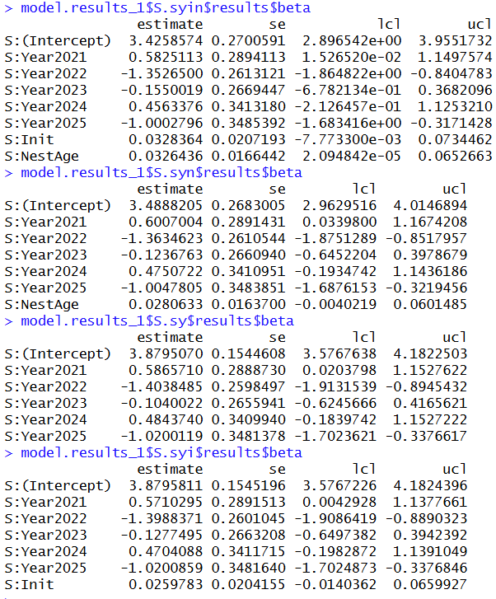

Figure 1. Beta results from the top four models (year + init + nestage, year + nestage, year, and year + init) estimating daily nest survival of Spectacled Eiders nesting at Kigigak Island 2019-2025.
Model results support a positive association between nest daily survival rate (DSR) and nest age, and a smaller positive association between DSR and nest initiation date (Figure 1). The 95% confidence interval for nest age was bound away from zero in the top model (yin) but not in the second (yn), and the parameter estimate was positive in both models, indicating nest DSR increased with increasing nest age. The parameter estimate for initiation date was positive, and most values included in the 95% confidence interval around the estimate were positive, but the interval included zero, precluding strong interference. However, because initiation date was in the top model and supported in the larger data set analyzed by Friendly et al. (2025), I chose to estimate cumulative nest survival for each year of data using the top model that included both nest age and initiation date.
Cumulative nest survival probabilities 2019-2025 ranged from 0.14 (95% CI: 0.0 to 0.25) to 0.74 (95% CI: 0.64 to 0.85; Table 2; Figure 2). Values from this analysis and those from Friendly et al. (2025) can be compared for the year 2019. My 2019 cumulative nest survival estimate is lower (0.59; 95% CI: 0.50, 0.69) than the published value and likely do not overlap, or barely overlap (rough estimate visually determined from graph: 0.73; CI: 0.69, 0.78; Friendly et al. 2025).
Table 2. Cumulative nest survival estimates with lower and upper confidence intervals of Spectacled Eiders nesting at Kigigak Island 2019-2025.
Year | Estimate | LCI | UCI
2019 | 0.593 | 0.498 | 0.689
2021 | 0.744 | 0.638 | 0.850
2022 | 0.138 | 0.030 | 0.246
2023 | 0.546 | 0.404 | 0.689
2024 | 0.716 | 0.573 | 0.859
2025 | 0.255 | 0.047 | 0.462

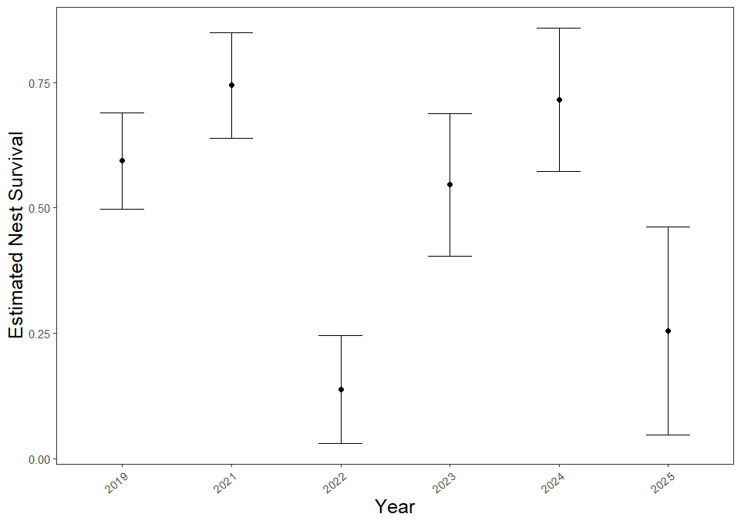
Figure 2. Estimated nest survival probabilities with 95% confidence intervals of Spectacled Eiders nesting at Kigigak Island 2019-2025.

Clutch size results
Between the years 2019-2025 the average complete clutch size was 4.92 eggs per nest. This is similar to results reported in Friendly et al. (2025) who found an average of 4.8 eggs per nest 1994-2019. The smallest average clutch size was in 2025 and the largest was in 2023 (Table 3; Figure 3).
Table 3. Spectacled Eider clutch sizes at Kigigak Island 2019-2025.
Year | Nest numbers | Mean | Median | Mode
2019 | 150 | 4.75 | 5 | 5
2021 | 96 | 5.05 | 5 | 5
2022 | 30 | 4.83 | 4.5 | 4
2023 | 79 | 5.10 | 5 | 5
2024 | 57 | 5.00 | 5 | 5
2025 | 21 | 4.67 | 5 | 5
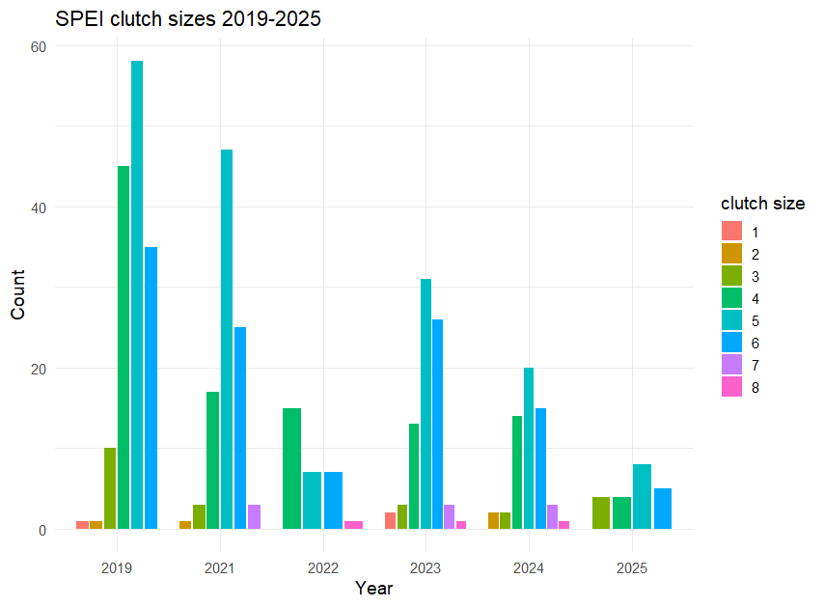

Figure 3. Clutch sizes of Spectacled Eider nests at Kigigak Island 2019-2025.

Membrane results
Between 2019-2025 there were 234 nests that were found to have membranes in the nest bowl. The overall average number of membranes found was 3.80 membranes per successful nest (Table 4; Figure 4).
Table 4. Number of membranes found in Spectacled Eider nests 2019-2025.
Year | Nest numbers | Mean | Median | Mode
2019 | 87 | 3.60 | 4 | 4
2021 | 59 | 4.14 | 4 | 5
2022 | 4 | 3.00 | 3.5 | 4
2023 | 44 | 4.07 | 4 | 4
2024 | 33 | 3.73 | 4 | 4
2025 | 7 | 2.71 | 2 | 2

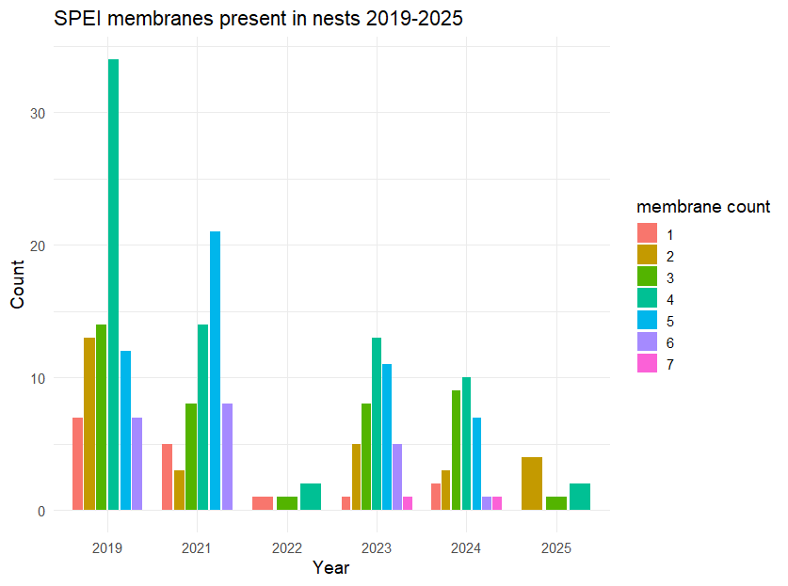
Figure 4. Number of membranes found in Spectacled Eider nests at Kigigak Island 2019-2025.

