lsblk

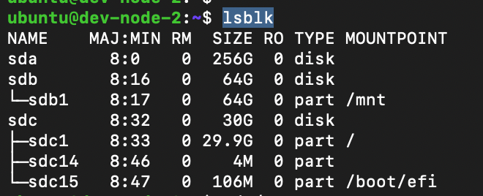

Here is a disk with no partition

i.e. sda

So now creating partition out of this

sudo fdisk /dev/sda

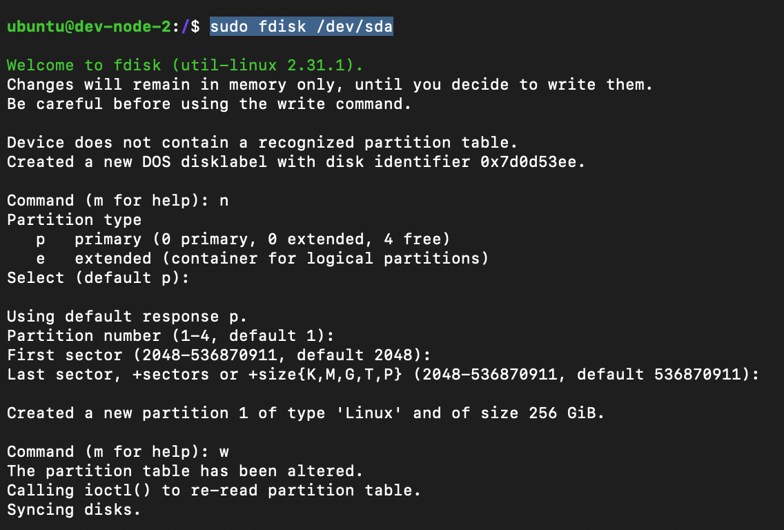

n - for new partition

lsblk -f

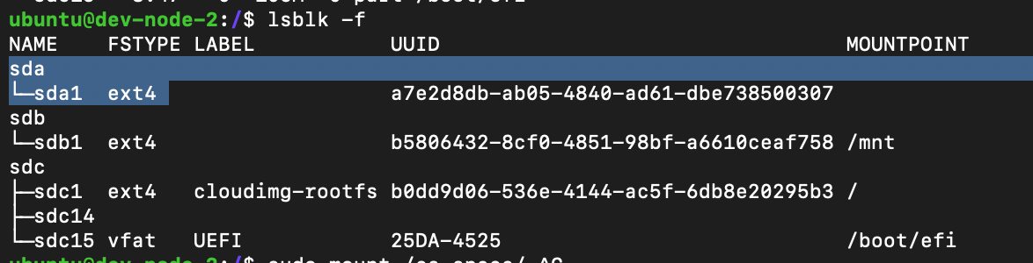

After creating partition format it through ext4 file-system

sudo mkfs.ext4 /dev/sda1

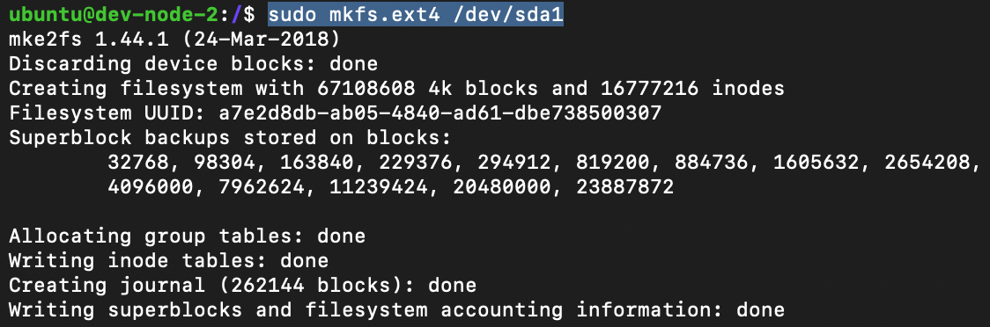

lsblk -f

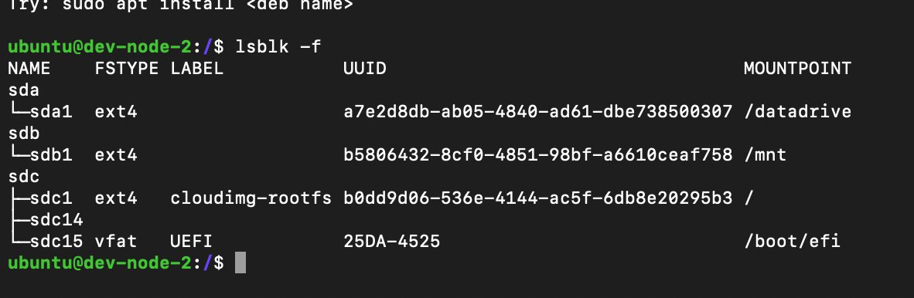

Now create a new directory and mount it to this disk

sudo mkdir dir-name

sudo chown $USER:$USER dir-name

chmod 775 dir-name

sudo mount /dev/sda1 dir-name