- How is the shopping distribution according to gender?
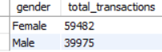
Female customers performed more transactions (59,482) compared to male customers (39,975)

- Which gender did we sell more products to?
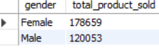
We sold more products to female customer totalling 1,78,659 units sold.

- Which gender generated more revenue?
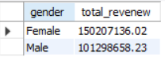
Female customers generated higher revenue, contributing
15,02,07,136.02 to total sales.
- Distribution of purchase categories relative to other columns?
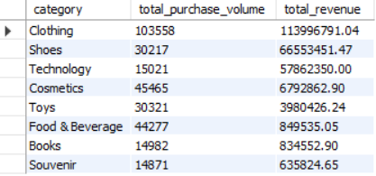
Clothing generated the heighest volume and revenue.

- How is the shopping distribution according to age?
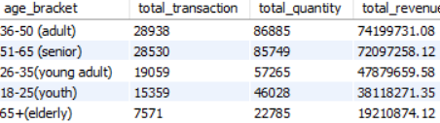
Customer in 36-50 (Adults) and 51-65 (senior) age group recorded the heighest number of transactions, with 28,938 and 28,530 transaction respectively.
- Which age cat did we sell more products to?
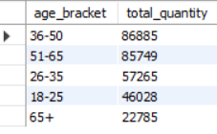

We sold the highest number of products to the 36-50 age group,
With a total quantity of 86,885.

- Which age cat generated more revenue?
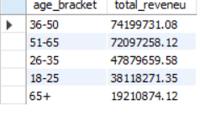
The 36-50 age group generated the highest revenue, contributing
7,41,99,731.08 to the total sales.

- Distribution of purchase categories relative to other columns?
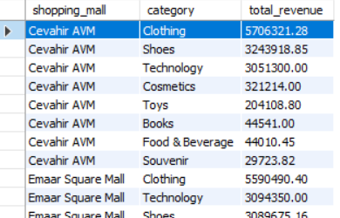
Across shopping malls, the clothing category consistently generates
The highest revenue (for example - 57,06,321.28 in Cevahir AVM
And 55,90,490,40 in Emaar square mall).

- Does the payment method have a relation with other columns?
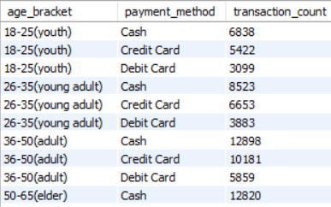
Yes, for the 18-25(Youth) age group, Cash is the most preferred
Payment method with 6,838 transactions, followed by Credit card with
5,422 transactions.

- How is the distribution of the payment method?
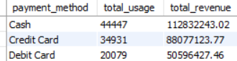
Cash is the most frequently used payment method with 44,447 transactions, generating the highest revenue 11,28,32,243.02, followed
By credit card (34,931 usage) and debit card (20,079 usage).

- Visualize the data using Tableau /PowerBI and derive insights and give your inputs/suggestions to the company.

