- How is the shopping distribution according to gender?
Query: - select gender, count(*) AS total_shopping from project_customer_segmentation.customer group by gender;

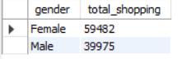
- Which gender did we sell more products to?
Ans – Female
- Which gender generated more revenue?
Query: - select gender, sum(price)as total_revenue from project_customer_segmentation.customer group by gender;

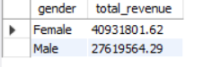
Female generated more revenue.
- Distribution of purchase categories relative to other columns?
Query:- select category, count(*) as total_count from project_customer_segmentation.customer group by category;
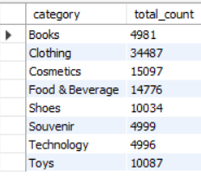
- How is the shopping distribution according to age?
Query:- select age, count(*) as total_count from project_customer_segmentation.customer group by age;
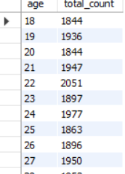
- Which age cat did we sell more products to?
Query:- select age, count(*) as total_count from project_customer_segmentation.customer group by age order by total_count desc;
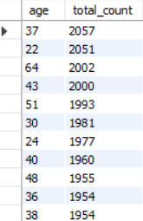
- Which age cat generated more revenue?
Query:- select age, sum(price) as total_revenue from project_customer_segmentation.customer group by age order by total_revenue desc;
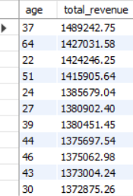
- Distribution of purchase categories relative to other columns?
Query:- select category, count(*) as total_count from project_customer_segmentation.customer group by category;
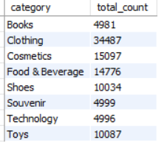
- Does the payment method have a relation with other columns?
Query:- select category, payment_method, count(*) as total_count from project_customer_segmentation.customer group by category,payment_method order by
category, total_count desc;
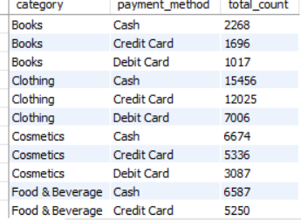

- How is the distribution of the payment method?
Query:- select payment_method, count(*) as total_count from project_customer_segmentation.customer group by payment_method order by total_count desc;
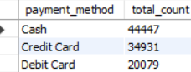

- Visualize the data using Tableau /PowerBI and derive insights and give your inputs/suggestions to the company.
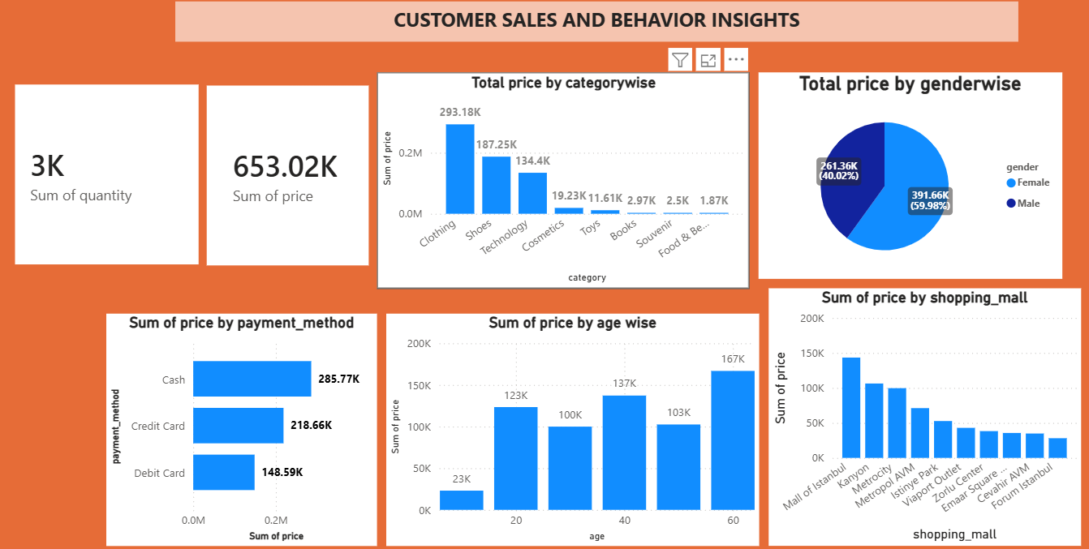

Key insights & suggestions:-

Top Categories:- clothing and shoes drive higher sales.
Suggestion:- Increase stock of these categorys and Runs promotion for top items.
Payment Methods :- customer mostly prefer cash, credit card and debit card.
Suggestion:- Offer cashbacks and smooth checkout for these popular options.
Customer Demography:- Specific age groups and locations bring more footfall.
Suggestion:- Target marketing campaigns towards these core segments.

