

SOEN 341

Software Process and Practices

Department of Computer Science and Software Engineering (CSE)

CarrerConnect

Sprint 1 Submission

Group Members:

Sara Noori (40224277)
Sahra Ali (40328476)
Hiba Tydrini (40348854)
Aya Lakhoitri (40330319)
Amine Ait Yakoub (40315369)
Melissa Luk (40089387)

Due Date: September 28th, 2026

Copy of README File

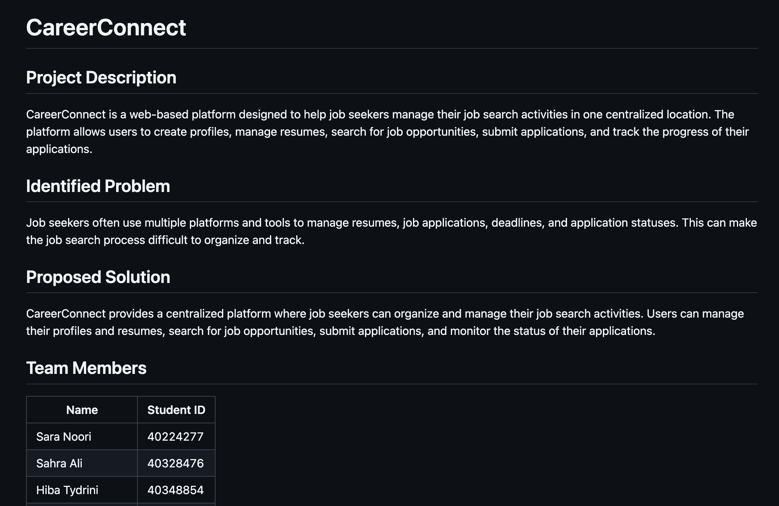

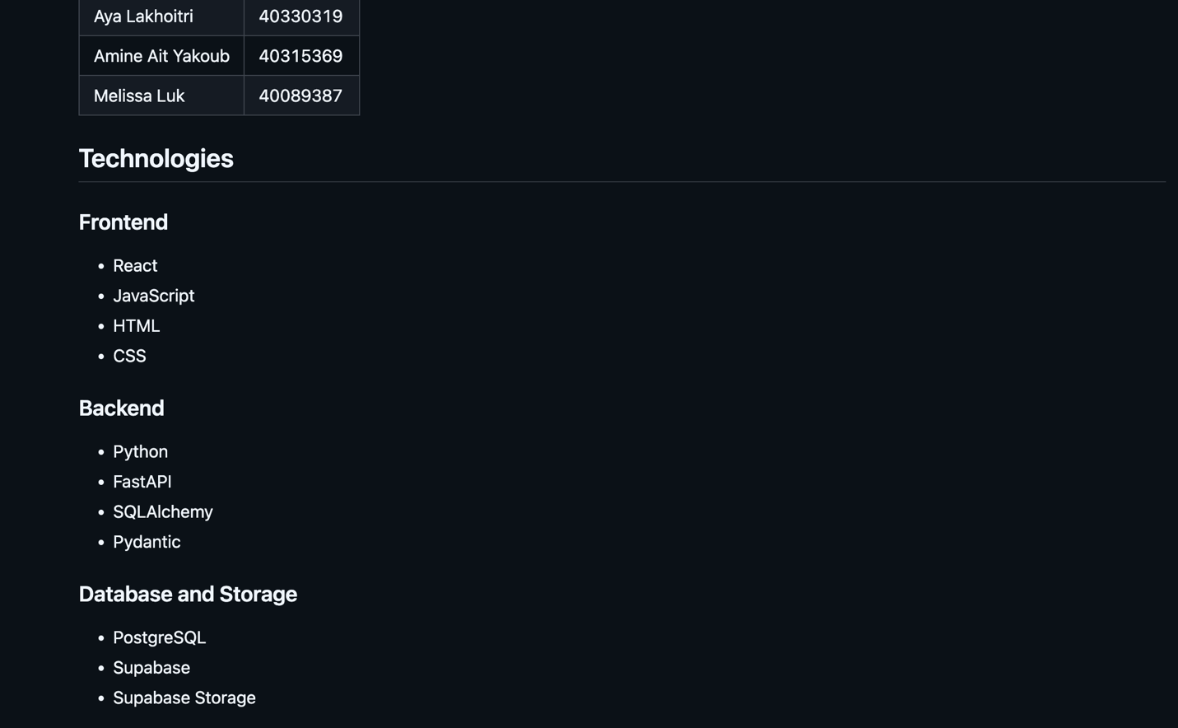

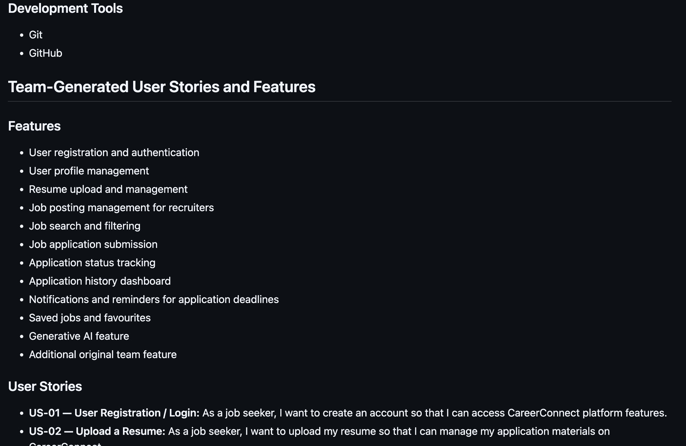

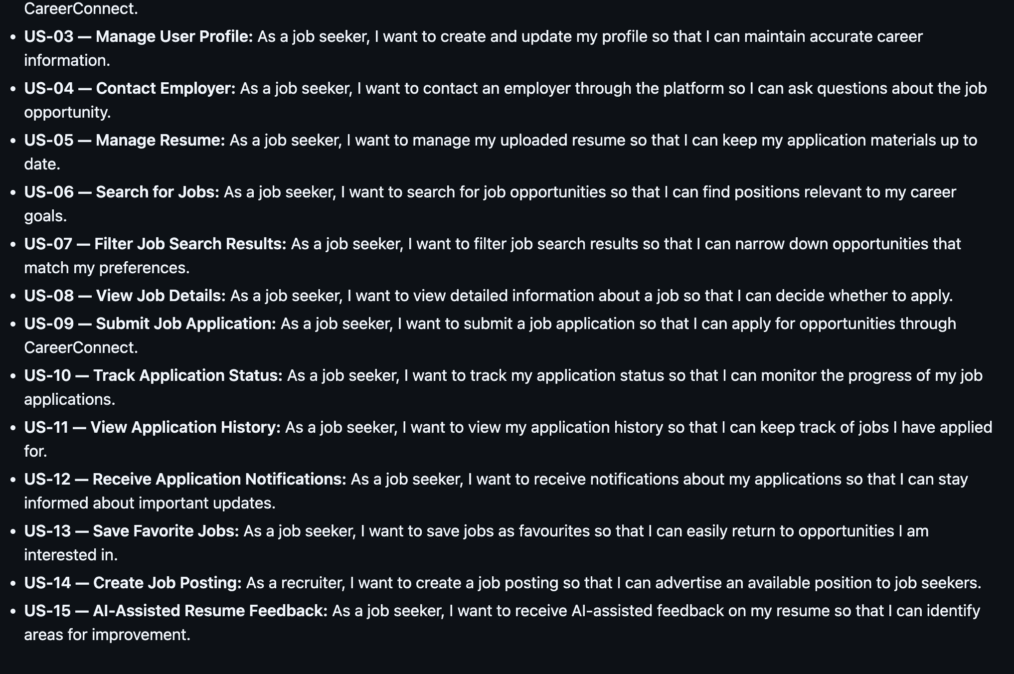

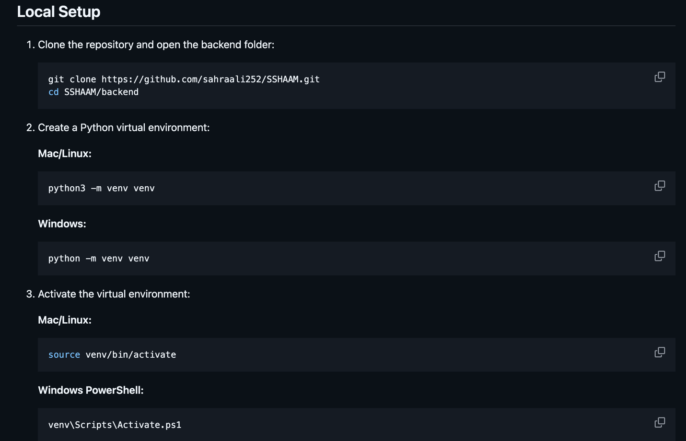

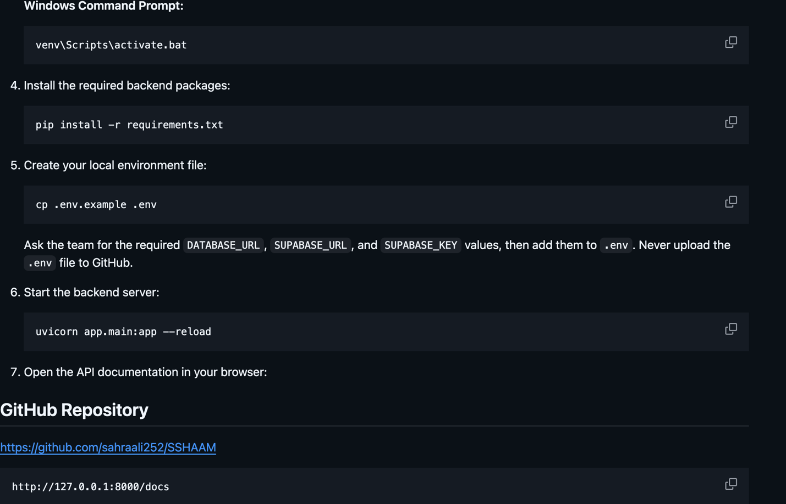

GitHub Repository Link: https://github.com/sahraali252/SSHAAM

