
Q1. Perform Following Filter Operation on Superstore Dataset
- Display Top 5 Customers based on Sales.
- Show products having sales greater than ₹50,000 (Condition Filter).
- Display customers whose names start with "A". Wildcard Filter
- Find Top 10 Products in the Technology Category.

Steps : a) Display Top 5 Customers based on Sales.

- Open Tableau → connect to the Superstore dataset.
- Go to a new Worksheet.
- Left pane → Data tab → Data pane: Dimensions (blue fields) are in the upper part, Measures (green fields) in the lower part; the Rows and Columns shelves are the two bars above the canvas, and the Filters shelf is the box above the Marks card → locate these before dragging.
- Drag Customer Name → Rows.
- Drag Sales → Columns.
- Click the Customer Name drop-down on Rows.
- Select Filter.
- Go to the Top tab.
Select:
- By field
- Top: 5
- Sum of Sales
- Click OK.
- Sort the chart descending using the sort icon.
- Check → canvas → only 5 customers are listed, with the highest Sales bar at the top.

Output :

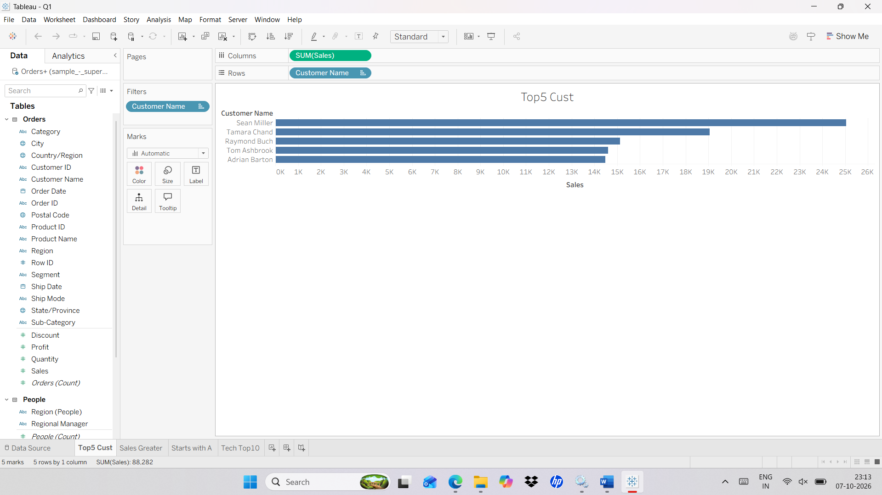

Steps : b) Show products having sales greater than ₹50,000 (Condition Filter).
- Create a new worksheet.
- Left pane → Data pane → Dimensions → Product Name and Measures → Sales; the Filters shelf is the box above the Marks card on the left → locate these before dragging.
- Drag Product Name - Rows.
- Drag Sales - Columns.
- Drag Product name again - Filters.
- In the filter window Select condition filter
- Select by field
- Set the condition to: SUM(Sales) > 50000
- Filter window → third tab is Condition → By field option → first drop-down: Sales, second drop-down: Sum, operator: > (greater than), value box: 50000 → the condition reads SUM(Sales) > 50000.
- Click OK.
Output:
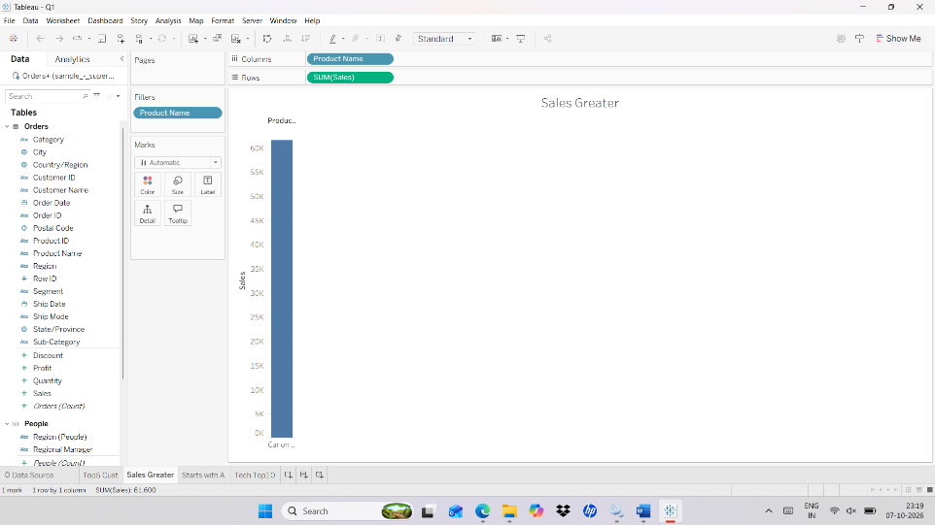

Steps : c) Display customers whose names start with "A". Wildcard Filter

- Create a new worksheet.
- Left pane → Data pane → Dimensions → Customer Name; the Filters shelf is the box above the Marks card → locate these before dragging.
- Drag Customer Name - Rows.
- Drag Customer Name - Filters.
- In the Filter window, select the Wildcard tab.
- Select Matches pattern.
- Wildcard tab → the Match value is typed in the box; choose Starts with (other options: Contains, Ends with, Exactly matches) so only names beginning with A remain.
- Enter: A
- Click OK
Output :

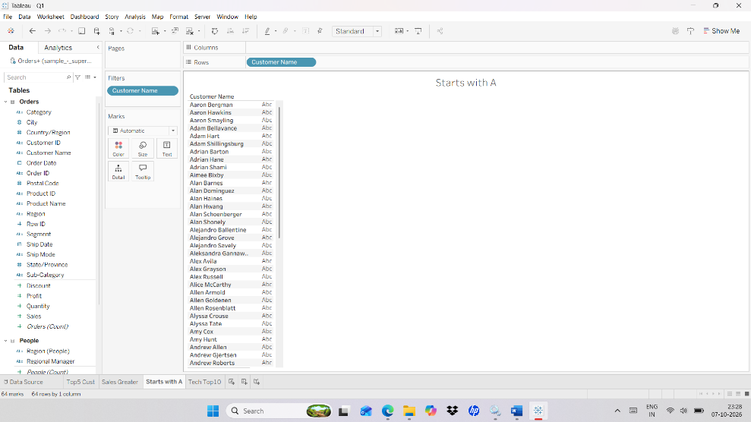

Steps : d) Find Top 10 Products in the Technology Category.

- Create a new worksheet.
- Drag Product Name - Rows.
- Drag Sales - Columns.
- Left pane → Data pane → Dimensions → Category is used for the next filter; the Filters shelf is above the Marks card → locate it before dragging.
- Drag Category - Filters.
- In the filter window select only: Technology
- Click Category in filter pane and select “Add to Context”
- Filters shelf → right-click the Category pill → Add to Context → the pill turns grey and moves to the top of the Filters shelf.
- Click OK.
- Drag Product name – Filters
- In the filter window select Top tab
- By field
- Top: 10
- Sum of Sales
- Click OK

Output :
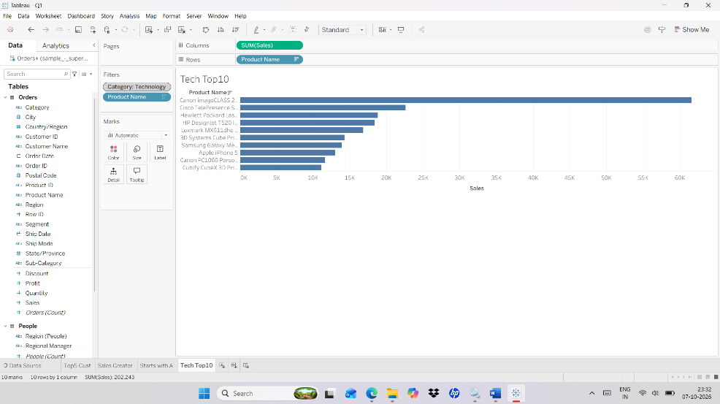

Q2. Perform Following Sorting Operation on Superstore Dataset.
- Arrange Sub-Categories from highest sales to lowest sales.
- Sort States based on Profit.
- Sort Sales in Descending Order based on product.
- Arrange customer names in ascending alphabetical order.
Steps : a) Arrange Sub-Categories from highest sales to lowest sales.

- Left pane → Data pane → Dimensions → Sub-Category and Measures → Sales; Rows and Columns shelves are the two bars above the canvas → locate these before dragging.
- Drag Sub-Category to Rows.
- Drag Sales to Column.
- Right-click Sub-Category on the Rows.
- Rows shelf → click the small drop-down arrow on the Sub-Category pill → Sort… is in the menu → the Sort window opens with Sort order and Sort by sections.
- Select Sort.
- Under Sort By, select Field.
- Set:
- Order: Descending
- Field: Sales
- Aggregation: Sum
- Click OK.

Output :

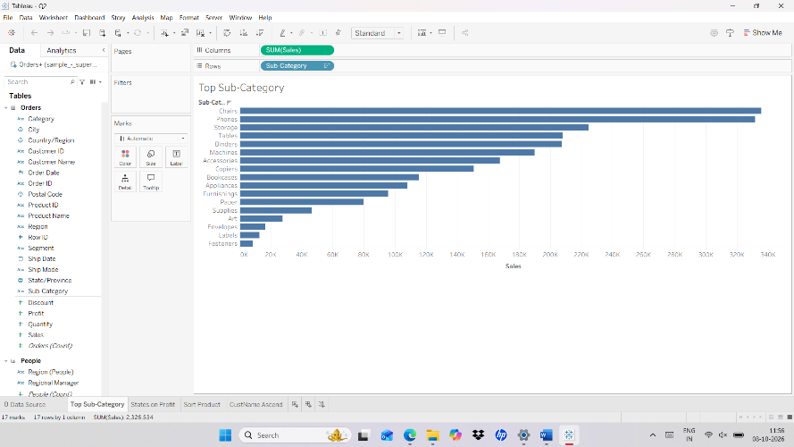

Steps : b) Sort States based on Profit.
- Create a new Worksheet.
- Left pane → Data pane → Dimensions → State and Measures → Profit; Rows and Columns shelves are above the canvas.
- Drag State → Rows.
- Drag Profit → Columns.
- State → Sort → Sort By → Field → Descending → SUM(Profit)
- Click OK.
Output :
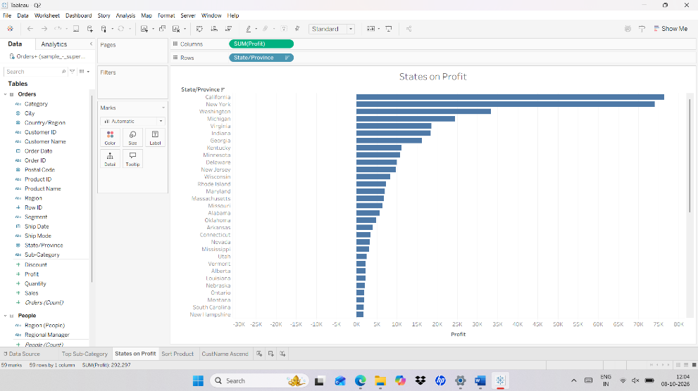

Steps : c) Sort Sales in Descending Order based on product.

- Create a new Worksheet.
- Left pane → Data pane → Dimensions → Product Name and Measures → Sales.
- Drag Product Name → Rows.
- Drag Sales → Columns.
- Right-click Product Name.
- Select Sort.
- Choose:
- Sort By: Field
- Order: Descending
- Field: Sales
- Aggregation: Sum
- Click OK.

Output :

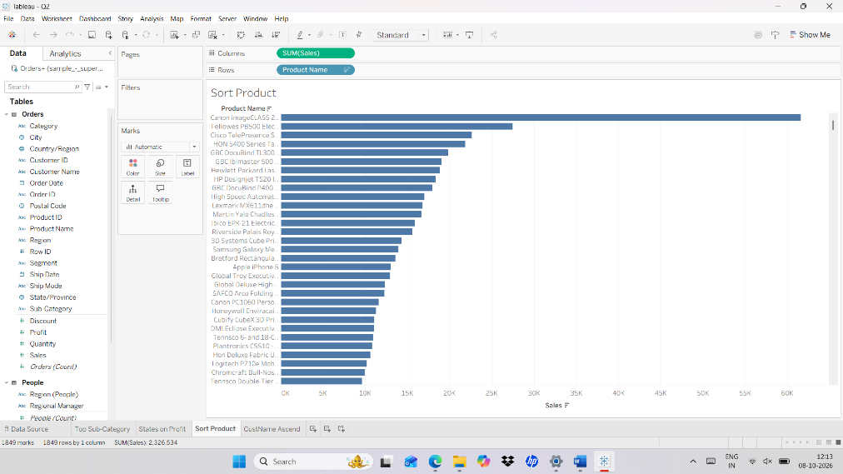

Steps : d) Arrange customer names in ascending alphabetical order

- a new Worksheet.
- Drag Customer Name → Rows.
- Right-click Customer Name on the Rows shelf.
- Rows shelf → Customer Name pill → drop-down arrow → Sort… → the Sort window opens; Alphabetic and Ascending options are inside it.
- Select Sort.
- Under Sort By, select:
- Alphabetic
- Under Order, select:
- Ascending (A-Z)
- Click OK.

Output :

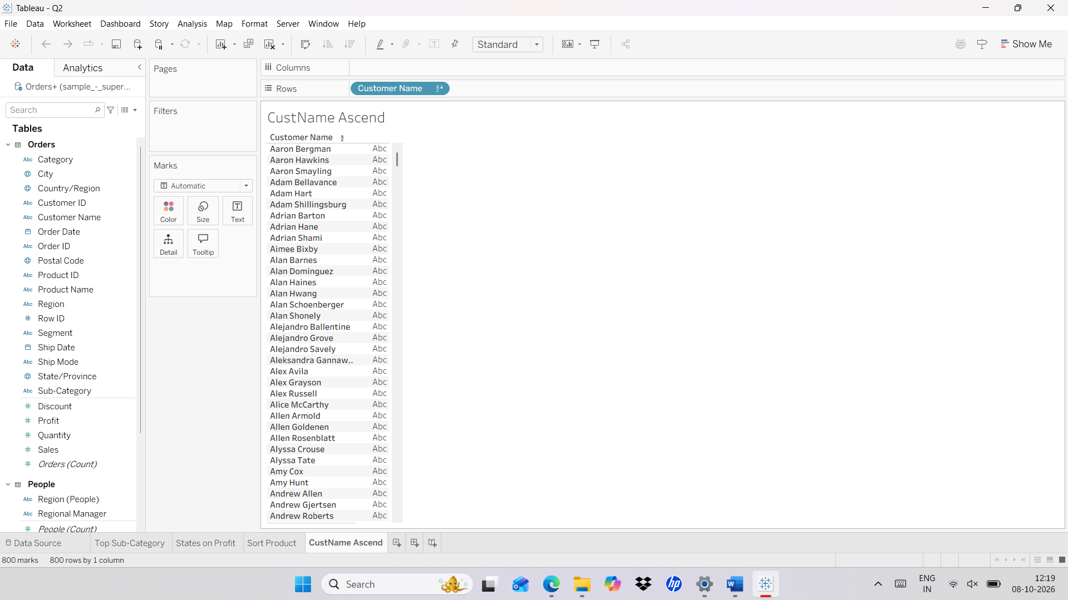

Q3. A) Use FMCG_sales_dirty.csv data source.
- Find missing values in the Sales field and replace them with an appropriate value.
- The Product field contains inconsistent capitalization and unnecessary spaces. Clean the product names.
Steps : a) Find missing values in the Sales field and replace them with an appropriate value.
- Start page (left pane) → Connect → To a File → Text file → browse to FMCG_sales_dirty.csv → click Open → Data Source page shows the columns Product, Category, Sales and Quantity.
- Go to a new Worksheet.
- Left pane → Data pane → Measures (green) → Sales; the Analysis menu is in the Menu bar at the top → locate these before creating calculated fields.
- Create Calculation Field – AVG([sales]) – Drag to the sheet.
- Menu bar (top of the window) → Analysis → Create Calculated Field… → the Calculated Field window opens with a Name box (top) and a Formula box (below). Name: Avg Sales. Formula: AVG([Sales]). Click OK → Avg Sales appears under Measures; drag it to Text on the Marks card (left of the canvas) to see the average value.
- Now create another Calculation Field - IF ISNULL([Sales]) THEN 14877 ELSE [Sales] END
- Menu bar (top of the window) → Analysis → Create Calculated Field… → the Calculated Field window opens with a Name box (top) and a Formula box (below). Name: Sales Clean. Formula: IF ISNULL([Sales]) THEN 14877 ELSE [Sales] END (14877 = the average found in the previous step). Click OK → Sales Clean appears under Measures.
- Better formula without a typed-in number → same Calculated Field window → Name: Sales Clean. Formula: IFNULL([Sales], {FIXED : AVG([Sales])}) → click OK.
- Data pane → Measures → drag Sales Clean next to Sales on the sheet → blank Sales values now show the replacement value.

Output :
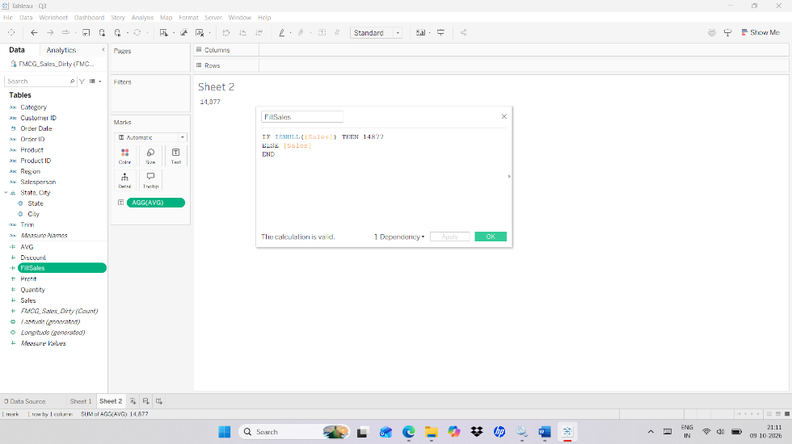

Steps : b) The Product field contains inconsistent capitalization and unnecessary spaces. Clean the product names.
- Go to a new Worksheet.
- Left pane → Data pane → Dimensions → Product is the field to clean; Analysis menu is in the Menu bar.
- Create Calculation Field – TRIM([sales])
- Menu bar (top of the window) → Analysis → Create Calculated Field… → the Calculated Field window opens with a Name box (top) and a Formula box (below). Name: Product Clean. Formula: TRIM([Product]) → click OK → Product Clean appears under Dimensions (use the Product field here, not Sales, because TRIM works only on text).
- To also fix capital letters → same window → Name: Product Proper. Formula: UPPER(LEFT(TRIM([Product]),1)) + LOWER(MID(TRIM([Product]),2)) → click OK.
- Data pane → Dimensions → drag Product Clean to Rows → duplicate names such as " cola" and "Cola" merge into one.

Output :
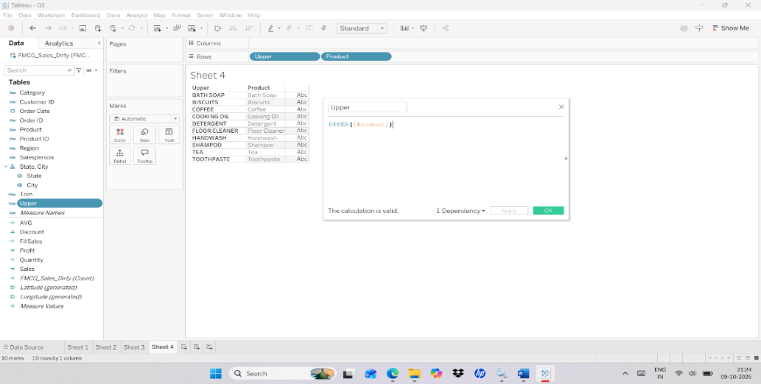

Q4. ) Use FMCG_sales_dirty.csv data source.
    - Identify inconsistent category names such as Beverage, beverage, BEVERAGES, etc., and create a standardized category field.
b) Find negative values record from quantity and sales convert to positive values with ABS().

Steps : a) Identify inconsistent category names such as Beverage, beverage, BEVERAGES, etc., and create a standardized category field.

- Go to a new Worksheet.
- Left pane → Data pane → Dimensions → Category; Analysis menu is in the Menu bar at the top.
- Create Calculation Field – UPPER(TRIM([Category]))
- Menu bar (top of the window) → Analysis → Create Calculated Field… → the Calculated Field window opens with a Name box (top) and a Formula box (below). Name: Category Clean. Formula: UPPER(TRIM([Category])) → click OK → Category Clean appears under Dimensions.
- If BEVERAGE and BEVERAGES still appear separately → Create Calculated Field → Name: Category Standard. Formula: IF STARTSWITH(UPPER(TRIM([Category])),"BEVERAGE") THEN "BEVERAGE" ELSE UPPER(TRIM([Category])) END → click OK.
- Data pane → Dimensions → drag Category Clean (or Category Standard) to Rows → one consistent label per category.

Output :
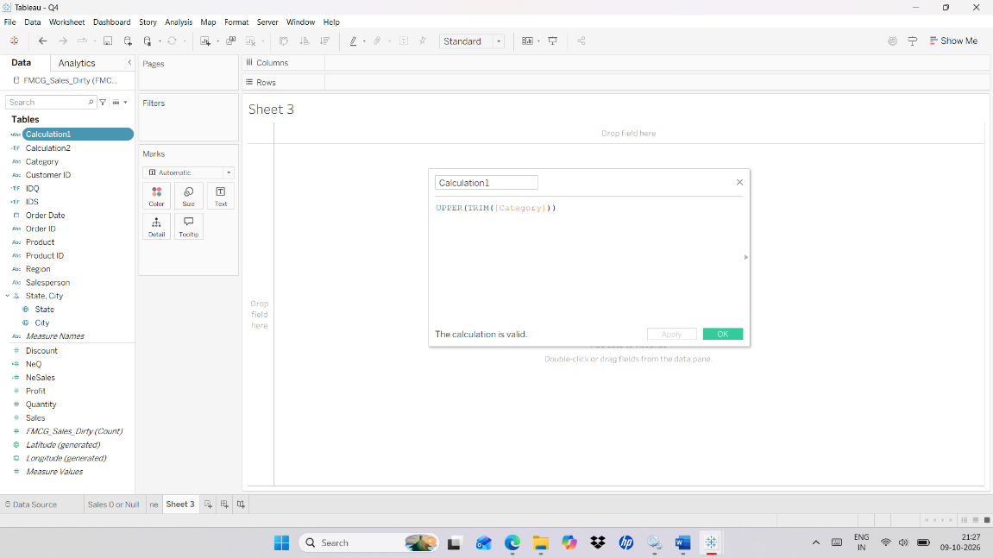

Steps : b) Find negative values record from quantity and sales convert to positive values with ABS().

- Go to a new Worksheet.
- Left pane → Data pane → Measures → Sales and Quantity; Analysis menu is in the Menu bar.
- Create Calculation Field – ABS([Sales]) and ABS([Quantity])
- Menu bar (top of the window) → Analysis → Create Calculated Field… → the Calculated Field window opens with a Name box (top) and a Formula box (below). Name: Negative Flag. Formula: IF [Sales] < 0 OR [Quantity] < 0 THEN "Negative" ELSE "OK" END → click OK → drag Negative Flag to Rows to find the negative records.
- Same window → Name: Sales Abs. Formula: ABS([Sales]) → click OK.
- Same window → Name: Quantity Abs. Formula: ABS([Quantity]) → click OK.
- Data pane → Measures → drag Sales Abs and Quantity Abs to Text on the Marks card → negative values now show as positive.

Output :

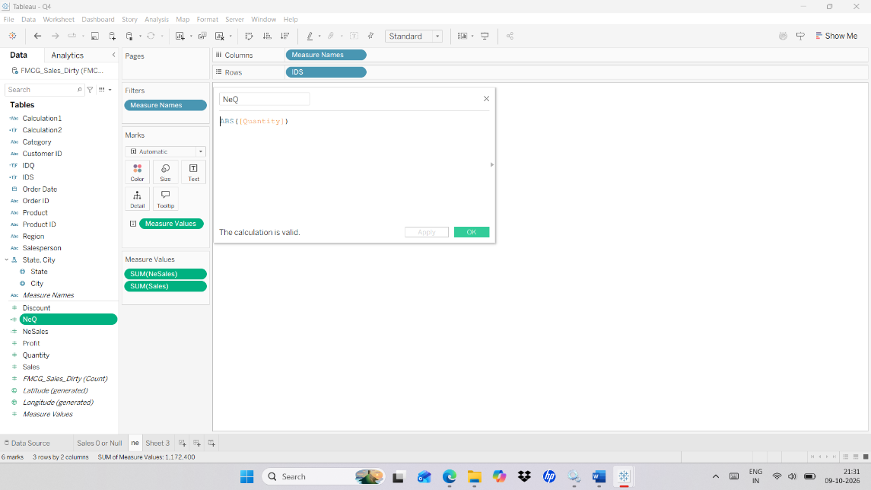

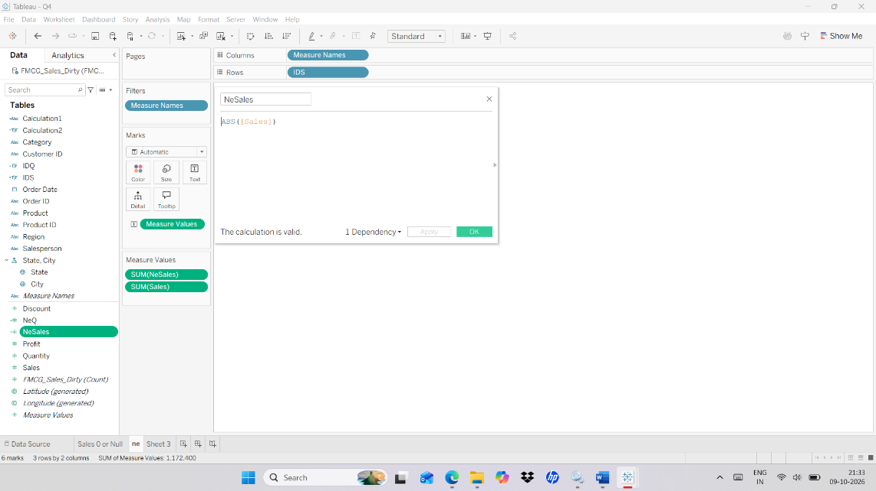

Q5. Join the Orders and Returns tables and identify which orders were returned.
Steps :
- Create New Worksheet
- Bottom left of the window → two tabs: Data Source and Sheet 1 → the Data Source tab opens the page where tables are joined.
- In data source join Orders and Return table.
- Data Source page → left pane lists tables (Orders, Returns) → drag Orders to the canvas (top area) → double-click Orders to open the join area → drag Returns next to it.
- Join icon (two overlapping circles) between the tables → click it → select Inner join → under Join clauses choose Order ID = Order ID → the data grid at the bottom shows the Returned column.
- Bottom left → click Sheet 1 → worksheet opens; Data pane → Dimensions now lists fields from both Orders and Returns.
- Drag Order ID and Order Date to rows
- Drag Returned to Text.
Output :
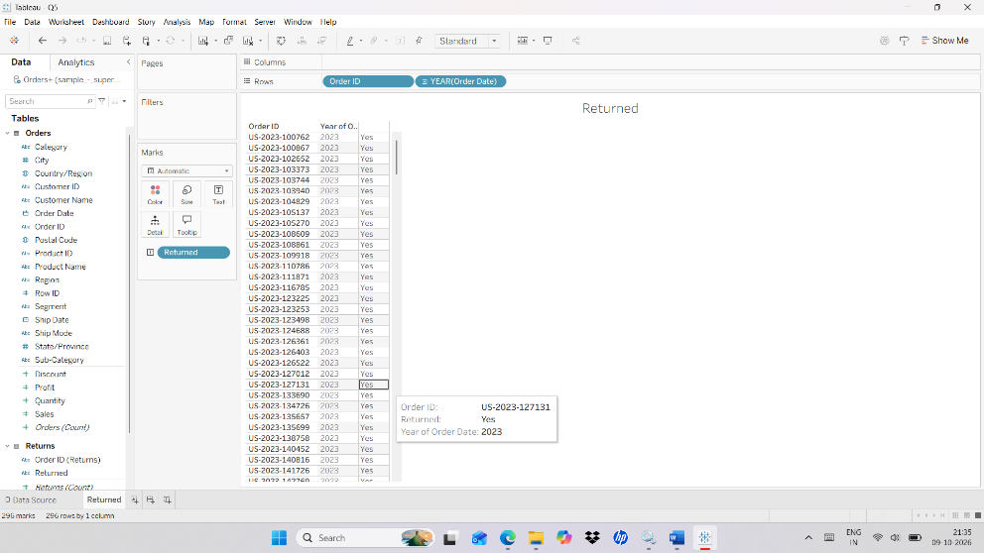
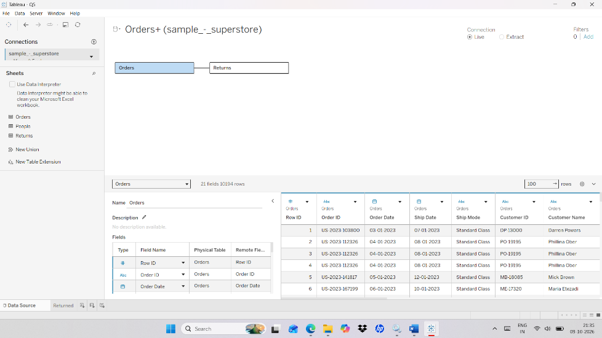

Q6. Combine Two Regional Sales Tables Using Union.

Steps :

- Connect to the Bookshop Dataset.
- Start page (left pane) → Connect → select the Bookshop file type (for example Microsoft Excel or Text file) → open the Bookshop file → Data Source page shows its tables.
- In Data Source Click – New Union
- Data Source page → left pane → New Union is listed under the tables → drag it to the canvas → in the Union window click the Specified (manual) tab.
- Drag two sales table.
- Union window → drag the first regional sales table into the drop area, then drag the second one below it → both names are listed.
- Click ok
- Bottom left → Sheet 1 → Data pane → Dimensions → the Table Name field shows which table each row came from.

Output :
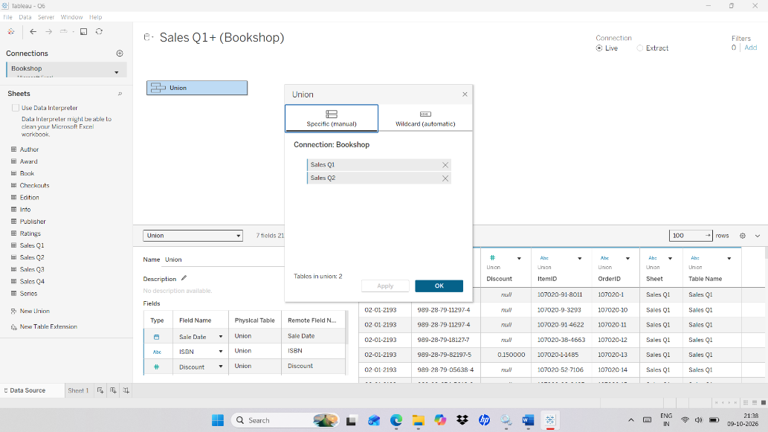

Q7. Display the data Handling Joins, on orders and return.

Steps :

- Connect to Superstore dataset.
- Start page → Connect → Saved Data Sources (or Microsoft Excel) → Sample - Superstore → Data Source page opens; tables are listed in the left pane.
- Drag Order table.
- Double click Order table - Drag Return table.
- Select the required Join Operation.
- Join icon (two overlapping circles) between Orders and Returns → click it → choose Inner, Left, Right or Full Outer (the four Venn diagrams) → data grid at the bottom updates.
- Join clauses → set Order ID = Order ID → Inner keeps matching rows only, Left keeps all Orders, Right keeps all Returns, Full Outer keeps everything.
- Bottom left → Sheet 1 → Data pane → Dimensions → drag Order ID to Rows and Returned to Text to compare the result.

Output :
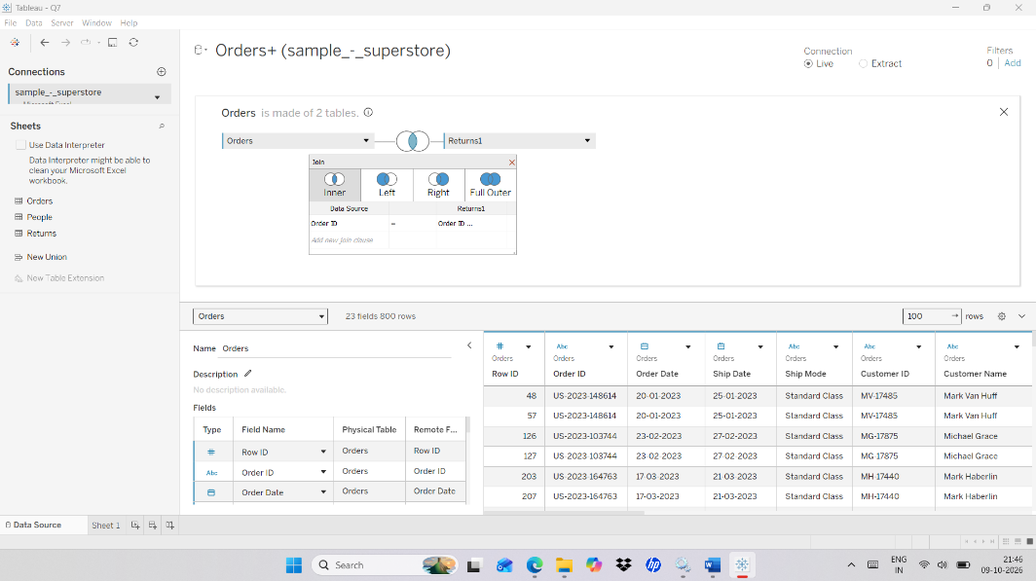

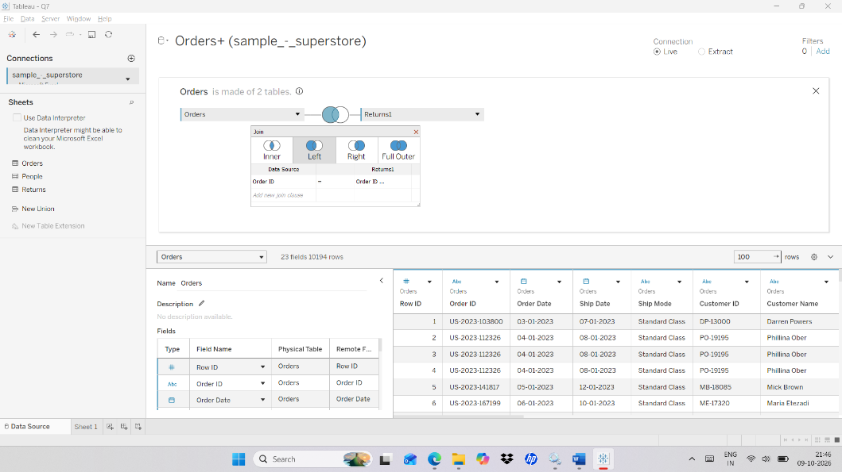

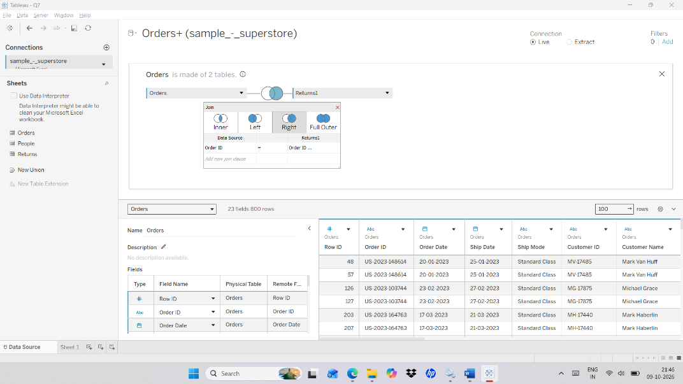

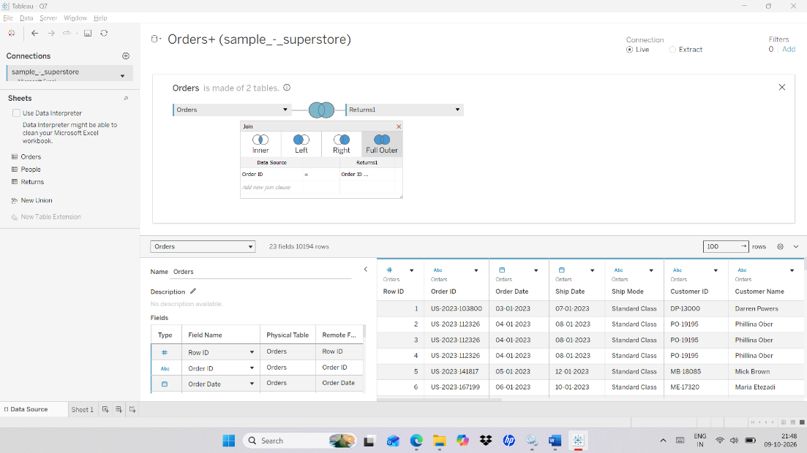

Q8. Find the first order date for every customer using an LOD expression.
Steps :

- Connect to Superstore dataset.
- Menu bar (top) → Analysis menu is used to create the calculation; Data pane → Dimensions → Customer ID, Customer Name and Order Date are used in it.
- Create Calculated Field - { FIXED [Customer ID] : MIN([Order Date]) }
- Menu bar (top of the window) → Analysis → Create Calculated Field… → the Calculated Field window opens with a Name box (top) and a Formula box (below). Name: First Order Date. Formula: { FIXED [Customer ID] : MIN([Order Date]) } → click OK → First Order Date appears in the Data pane.
- Drag Calculated field to text.
- Data pane → drag First Order Date to Text on the Marks card (left of the canvas); then Data pane → Dimensions → drag Customer Name to Rows → each customer shows one first-order date.
- Drag Customer name to rows.

Output :

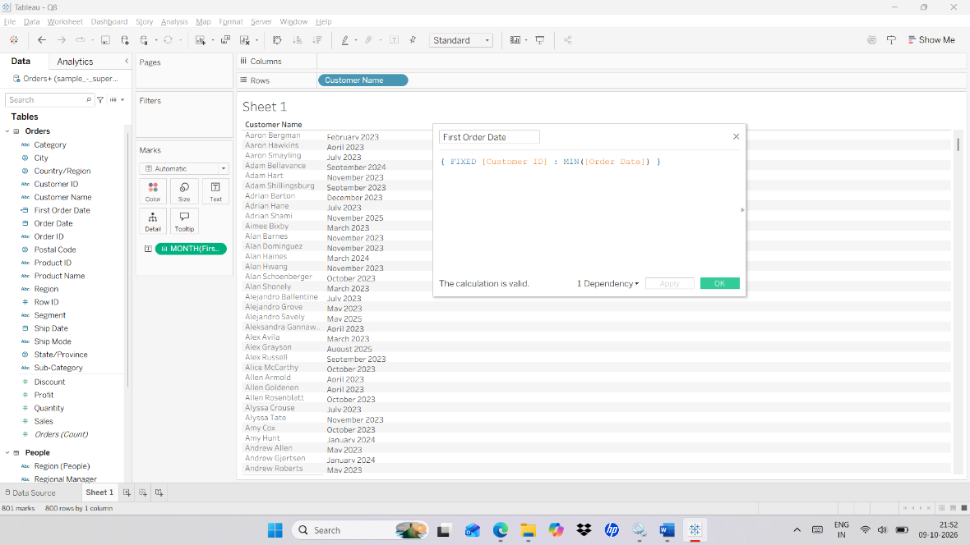

Q9. Calculate the average order value for each Region using LOD.

Steps :

- Connect to Superstore dataset.
- Menu bar (top) → Analysis menu creates the calculation; Data pane → Dimensions → Region and Order ID, Measures → Sales.
- Create Calculated Field.
- Select Create Calculated Field - SUM([Profit]) / SUM([Sales])
- Click ok
- Drag Calculated Field to text in marks card.
- Menu bar (top of the window) → Analysis → Create Calculated Field… → the Calculated Field window opens with a Name box (top) and a Formula box (below). Name: Order Sales. Formula: { FIXED [Order ID] : SUM([Sales]) } → click OK → this gives one sales total per order.
- Data pane → Dimensions → drag Region to Rows; Data pane → drag Order Sales to Text on the Marks card → right-click the Order Sales pill → Measure → Average → average order value shows for each Region.
- Optional profit ratio (what the formula above in this lab calculates): Name: Profit Ratio. Formula: SUM([Profit]) / SUM([Sales]).

Output :
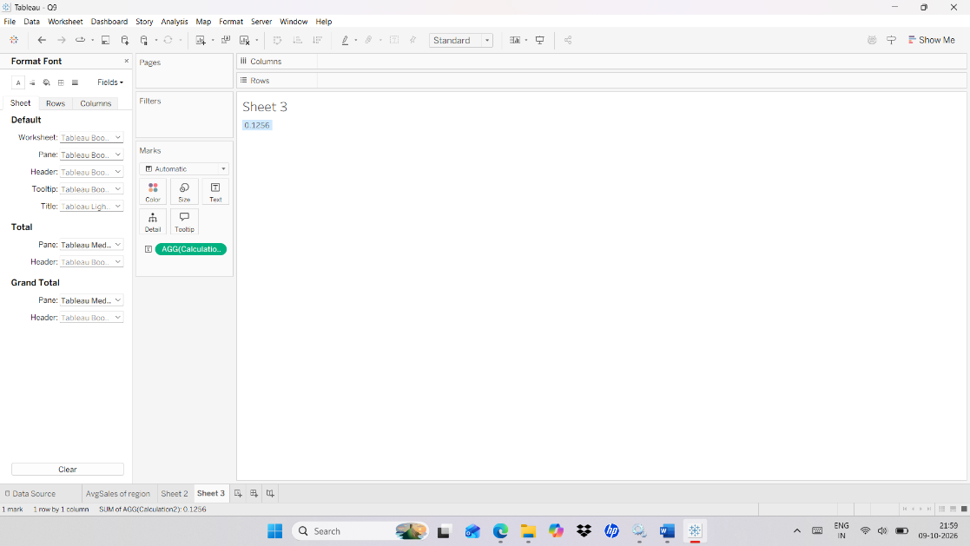

Q10. Create a Heat Map, Motion chart for Order date, and Product Forecast for sales with Trend Line.

Steps : Heat map

- Open a new worksheet and connect to Superstore.
- Show Me is at the top right of the window (button next to the toolbar); the Marks card is on the left of the canvas, under the Filters shelf; Data pane → Dimensions → Category and Order Date, Measures → Sales.
- Drag Category - Text
- Drag Order Date(Month) -Text
- Data pane → Order Date → right-click and drag it to the sheet → choose MONTH(Order Date) from the menu that appears; for the year use the Order Date drop-down on the pill → select Year.
- Drag Order Date(Yeat) - Text
- Drag Sales - Color.
- Drag Sales - Size.
- In Show me click Heat Map.
- Marks card → mark type drop-down (shows Automatic) → select Square → coloured squares appear.

Output :

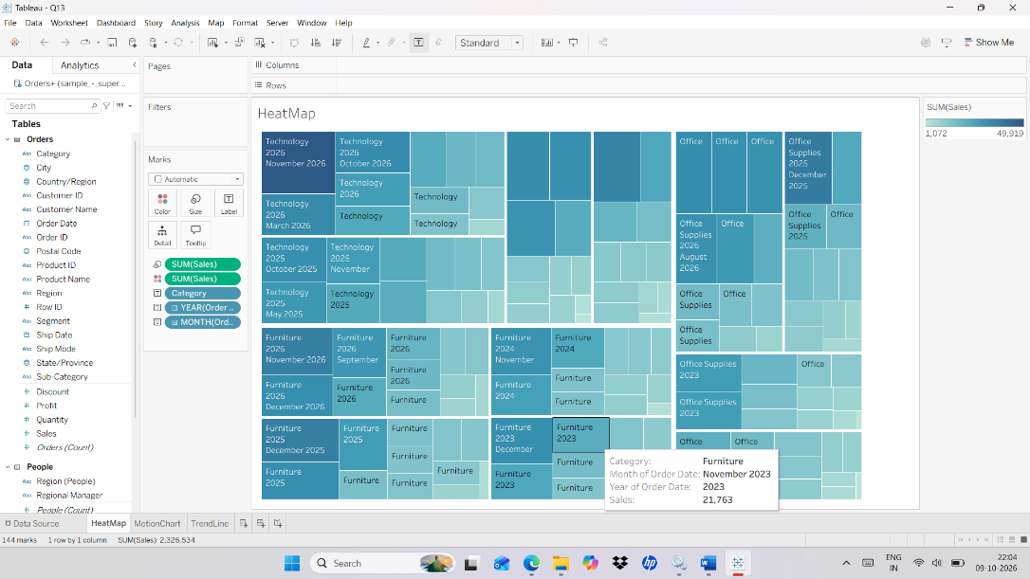

Steps : Motion Chart

- Open a new worksheet and rename it Motion Chart.
- Pages shelf is at the top left of the sheet, above the Filters shelf; the Rows and Columns shelves are above the canvas.
- Drag Order Date(Month) → Pages and color
- Data pane → Order Date → right-click and drag to Pages → choose MONTH(Order Date) → Pages card shows a slider and a Play button at the right of the window.
- Drag Sales - Rows.
- Drag Category - rows
- Open the Pages card and click the Play button.
- Pages card (right side of the window) → click the Play button → the view animates month by month; use the speed control to slow it down.

Output :
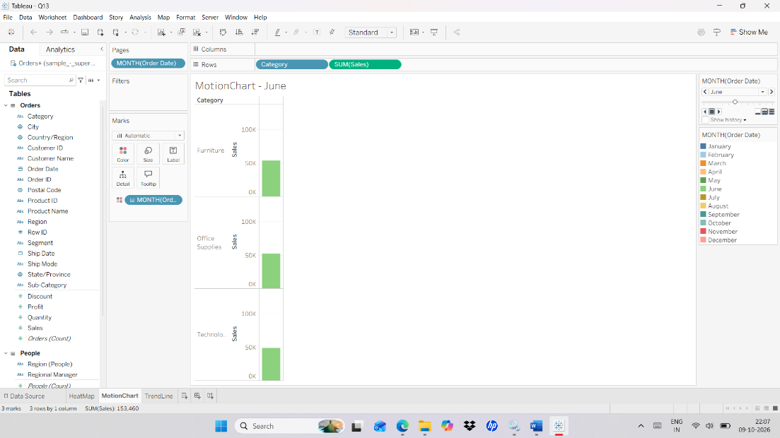

Steps : Trend Line with forecast.

- Connect to Superstore dataset.
- Drag Sales – rows.
- Drag Order Date – Column
- Left pane → the Analytics tab is next to the Data tab at the top; the Order Date pill drop-down arrow is on the Columns shelf.
- Select Month and Continuous for Order Date.
- Columns shelf → click the drop-down arrow on the Order Date pill → choose Month in the second group of the list (the green continuous one) → the pill turns green.
- Go to Analytics and select TrendLine and Forecast.
- Left pane → Analytics tab → Model section → drag Trend Line onto the view → drop it on Linear; then drag Forecast onto the view → a shaded forecast area appears to the right of the line.

Output :
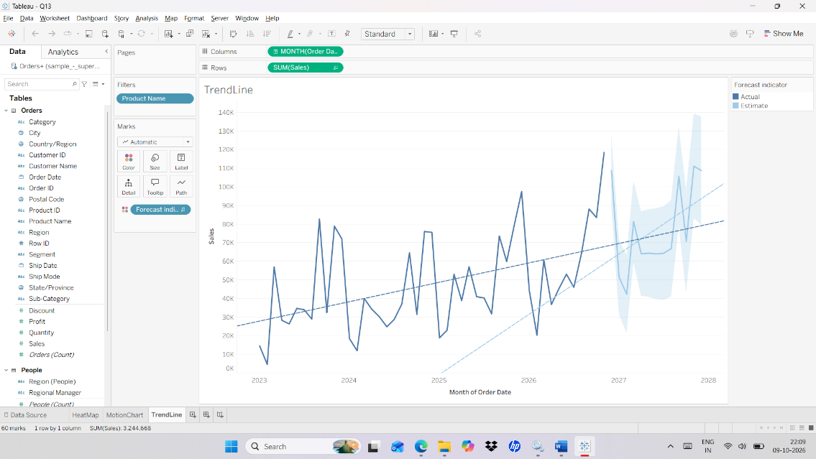

Q11. Create a Dashbaord as follows__
- Create KPI ‘s for Total_sales,Total_profit,Total_Discount.
- Report on Subcategory of product, region Wise Sales.
- Top 5 Customers in each region.
- Category wise sales and profit.
Steps : a) Create KPI ‘s for Total_sales,Total_profit,Total_Discount.

- Bottom of the window → click the New Worksheet icon (first small icon right of the sheet tabs) or Menu bar → Worksheet → New Worksheet → a blank sheet opens.
- Right-click the sheet tab at the bottom → Rename → type Total_Sales for the first KPI sheet (use Total_Profit and Total_Discount for the next two sheets).
- Drag Sales to the sheet.
- Drag Profit to the sheet.
- Drag Discount to the sheet.
- Menu bar (top of the window) → Analysis → Create Calculated Field… → the Calculated Field window opens with a Name box (top) and a Formula box (below). Name: Total_Sales. Formula: SUM([Sales]) → OK. Repeat for Name: Total_Profit. Formula: SUM([Profit]) and Name: Total_Discount. Formula: SUM([Discount]).
- Data pane → Measures → drag each Total field to Text on the Marks card on its own sheet → each sheet shows one large number; increase the font size from Marks card → Text → … button.

Output :
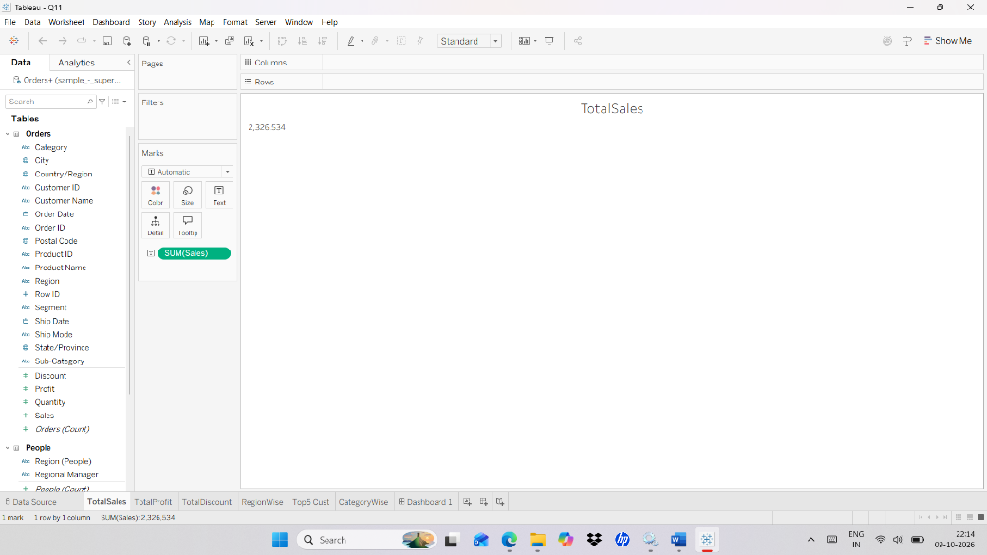

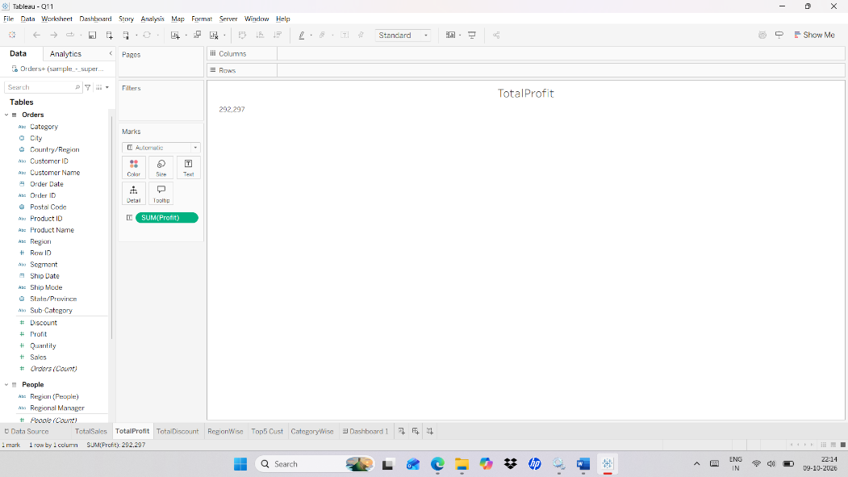

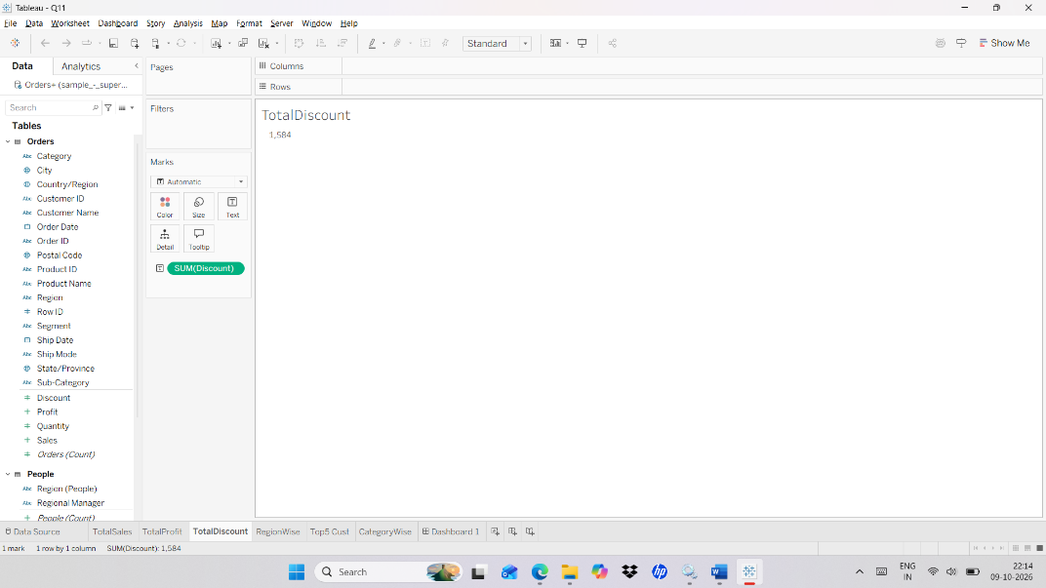

Steps : b) Report on Subcategory of product, region Wise Sales.

- Connect to Superstore dataset.
- Left pane → Data pane → Dimensions → Sub-Category and Region, Measures → Sales; Text and Color buttons are in the Marks card on the left of the canvas.
- Drag sub-category to rows.
- Drag Region to columns.
- Drag sales to number and color in marks card.

Output :
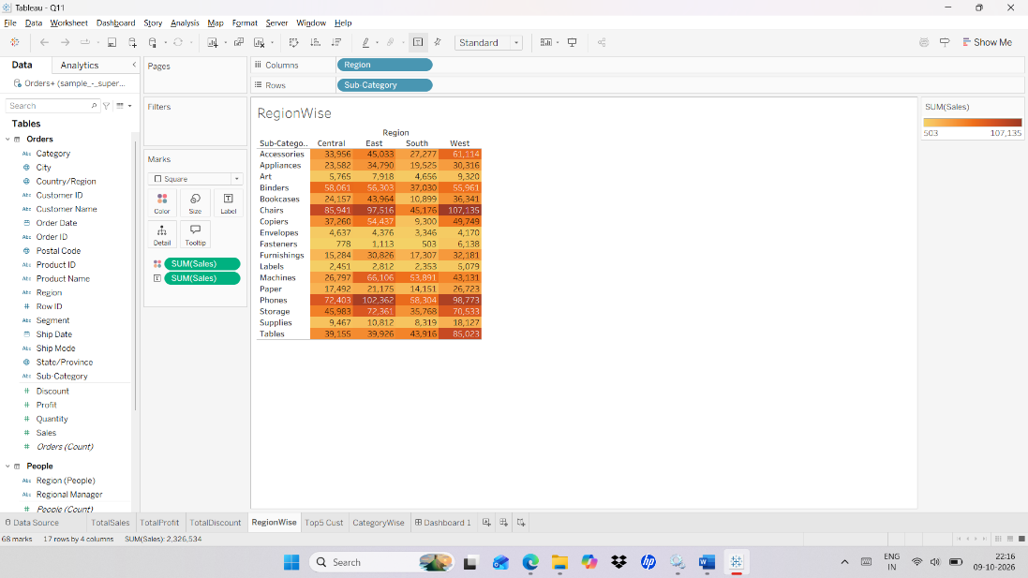

Steps : c) Top 5 Customers in each region.

- Connect to Superstore dataset.
- Left pane → Data pane → Dimensions → Region and Customer Name, Measures → Sales; Analysis menu is in the Menu bar.
- Create Calculated field - RANK(SUM([Sales]), 'desc')
- Menu bar (top of the window) → Analysis → Create Calculated Field… → the Calculated Field window opens with a Name box (top) and a Formula box (below). Name: Rank. Formula: RANK(SUM([Sales]), 'desc') → click OK → Rank appears under Measures as a green pill (table calculation).
- Drag Sales to columns.
- Drag Region to rows.
- Drag Customer name to rows.
- Drag calculated field to filter and edit table calculation.
- Select specific dimension – customer name.
- Click ok.
- Filters shelf → the Filter [Rank] window appears after dragging Rank to Filters → choose Range of values → set At most to 5 → click OK.
- Rows or Columns shelf → right-click the Rank pill → Compute Using → Customer Name → only the top 5 customers remain in each Region.

Output :

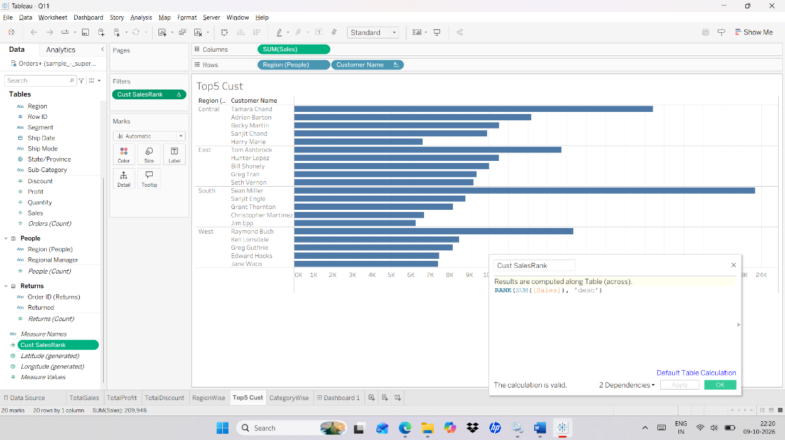

Steps : d) Category wise sales and profit.
- Connect to Superstore dataset.
- Left pane → Data pane → Measures → Sales and Profit, Dimensions → Region and Category.
- Drag Sales and Profit to rows
- Drag Region to rows.
- Drag Category to columns.

Output :
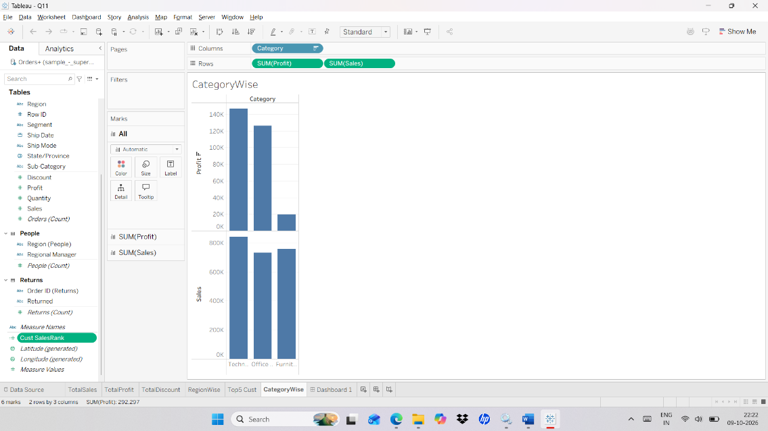

Steps : Dashboard

- Bottom of the window → click the New Dashboard icon (second small icon right of the sheet tabs) or Menu bar → Dashboard → New Dashboard → a blank dashboard opens.
- Dashboard window → left pane → Size section (bottom of the left pane) → choose Automatic; the Sheets list is at the top of the left pane; the Tiled and Floating buttons are under Objects at the bottom-left.
- Select Automatic for size.
- Select floating.
- Drag Sheets to the Dashboard.
- Dashboard window → Sheets list (top of left pane) → drag each sheet onto the dashboard canvas → release when a shaded drop area appears; resize so no sheets overlap.

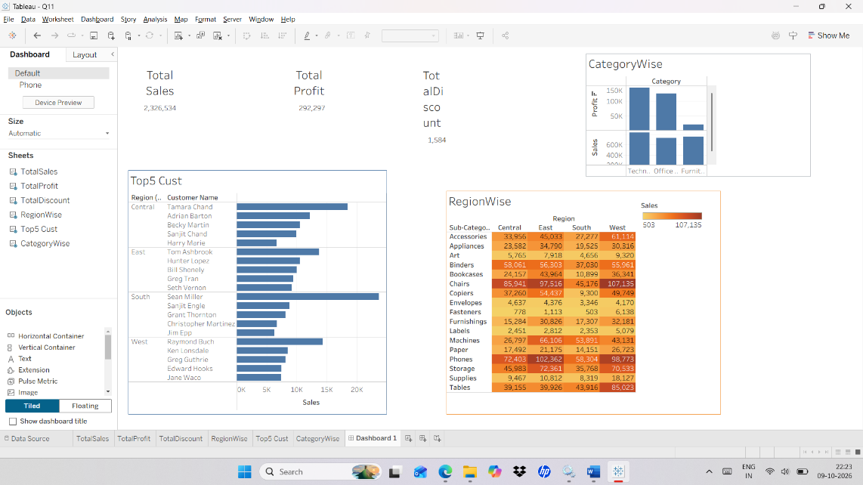

Q12. Create a dashboard Showing result such as follows-
Create an inventory monitoring dashboard as follows___
- Total Books
- Total Checkouts
- Checkout by Award
- Checkout by Book
Steps : Total books, Total checkout
- Left pane → Data pane → Tables: Award, Book and Checkouts → Measures section is at the bottom of the Data pane.
- Menu bar (top of the window) → Analysis → Create Calculated Field… → the Calculated Field window opens with a Name box (top) and a Formula box (below). Name: TotalBooks. Formula: COUNTD([Book ID]) → click OK.
- Same Calculated Field window → Name: TotalCheckouts. Formula: SUM([Number of Checkouts]) → click OK.
- Bottom of the window → click the New Worksheet icon (first small icon right of the sheet tabs) or Menu bar → Worksheet → New Worksheet → a blank sheet opens. Data pane → Measures → drag TotalBooks to Text on the Marks card; on a second sheet drag TotalCheckouts to Text.
- Drag Sales to the Sheet.
- Drag Checkouts to the Sheet.
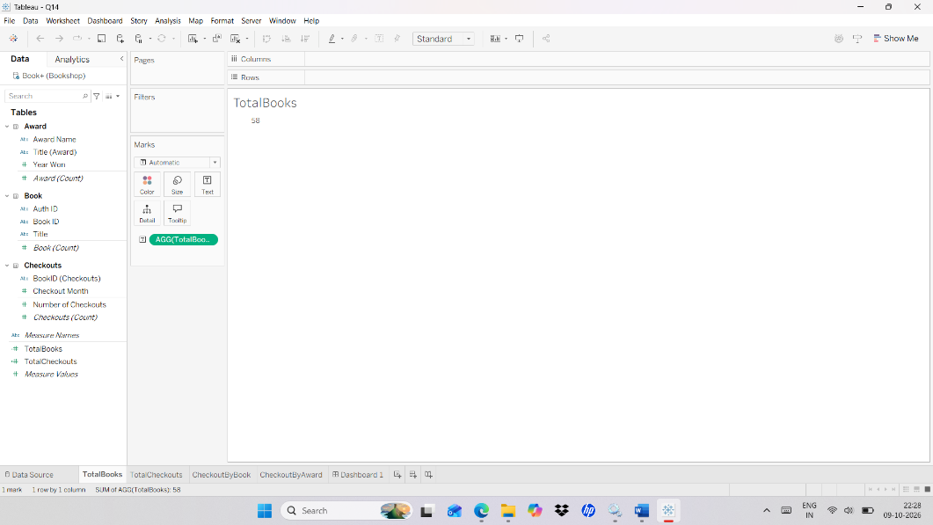
Output :

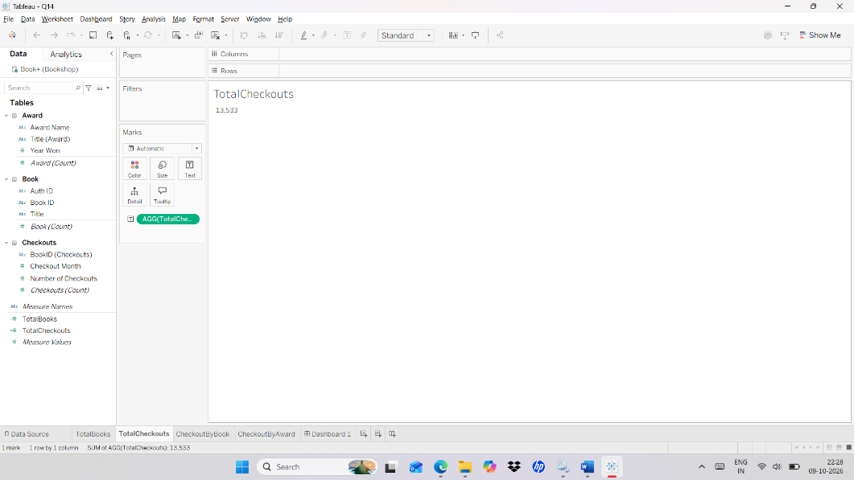

Steps : Checkout by Book

- Left pane → Data pane → Checkouts table → Number of Checkouts (measure) and Book table → Title and Book ID (dimensions); the Columns shelf is the bar above the canvas.
- Drag Checkouts to column.
- Drag Book title and Book ID to rows.

Output :
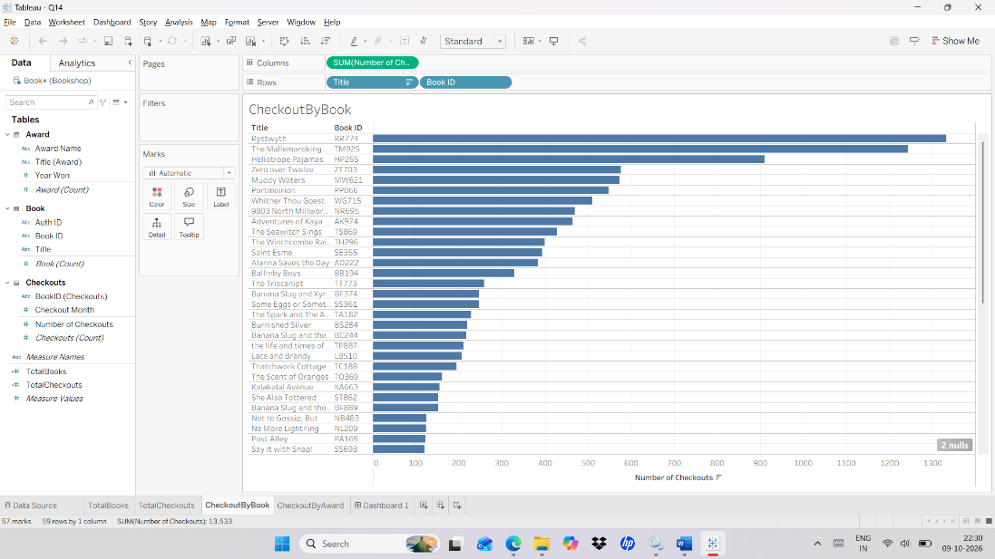

Steps : Checkout by Award

- Left pane → Data pane → Checkouts table → Number of Checkouts and Award table → Award Name and Title (Award) (dimensions).
- Drag Checkouts to column.
- Drag Award name and Award title to rows.

Output :
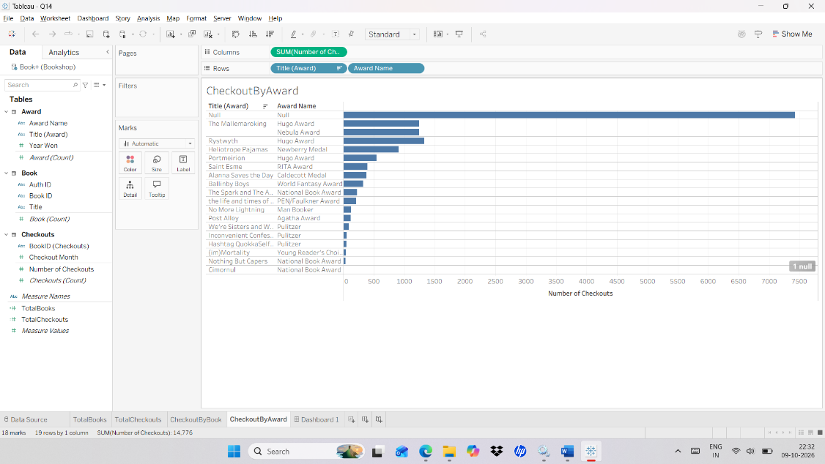

Steps : Dashboard

- Bottom of the window → click the New Dashboard icon (second small icon right of the sheet tabs) or Menu bar → Dashboard → New Dashboard → a blank dashboard opens.
- Dashboard window → left pane → Size section (bottom of the left pane) → choose Automatic; the Sheets list is at the top of the left pane; the Tiled and Floating buttons are under Objects at the bottom-left.
- Select Automatic for size.
- Select floating.
- Drag Sheets to the Dashboard.

Output :
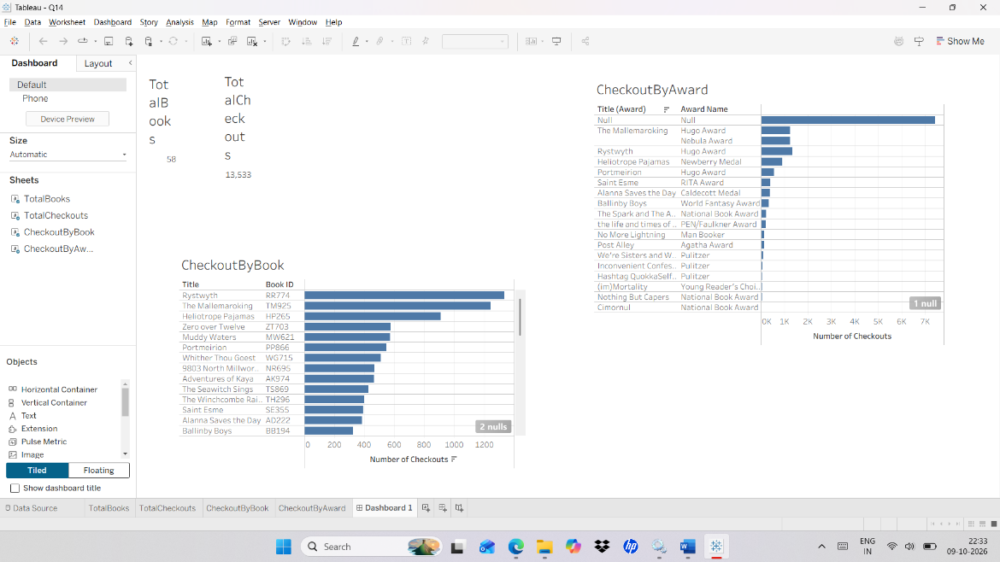

Q13. Create a Story using Superstore data source.

Steps :

- Bottom of the window → New Worksheet icon (first icon right of the sheet tabs) → create each sheet; Rows and Columns shelves are above the canvas; Data pane → Dimensions → Region and Sub-Category, Measures → Sales, Profit and Quantity.
- Create 3 worksheets.
- 1st worksheet Drag region and sales to column and sub-category to rows.
- 2nd worksheet Drag profit to column and sub-category and sales to rows.
- 3rd woksheet Drag sub-category and region to column and quantity to rows.
- Create a new story and drag all three sheets one by one.
- Bottom of the window → click the New Story icon (third icon right of the sheet tabs) or Menu bar → Story → New Story → a story canvas opens.
- Story window → left pane → Sheets list → drag the first sheet to the centre; then click New Blank Point (left pane) and drag the second sheet; repeat for the third sheet.
- Story canvas → click Add a caption above each point → type a short title for each story point.

Output :
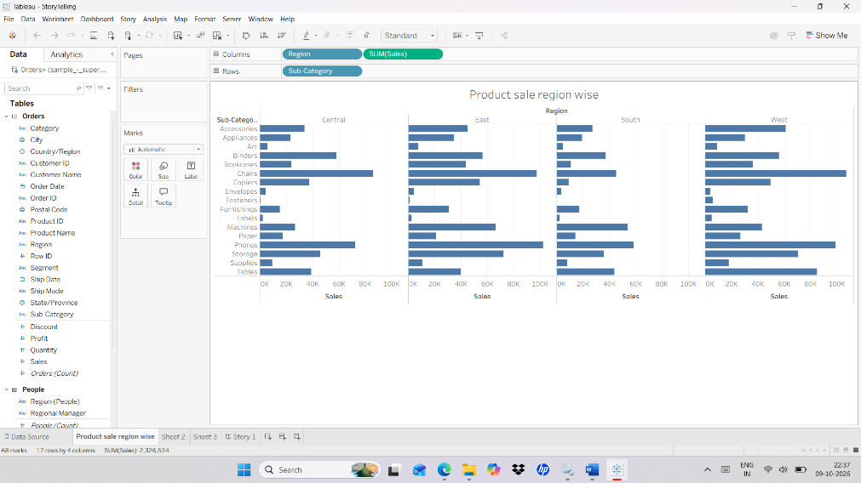

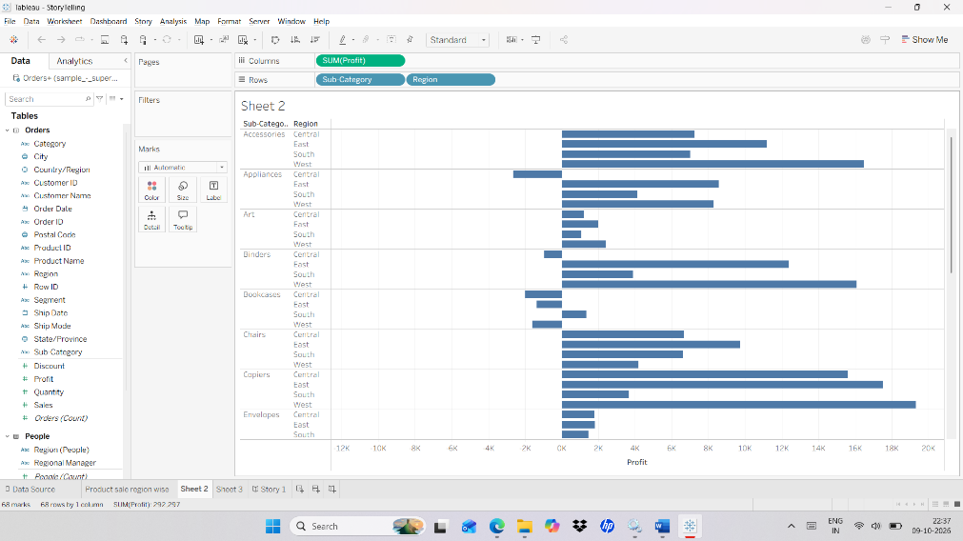

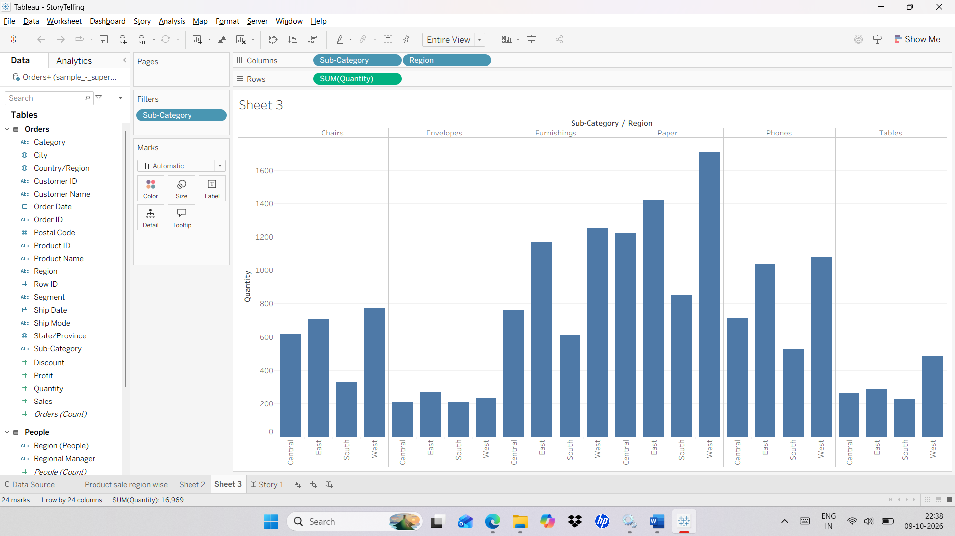

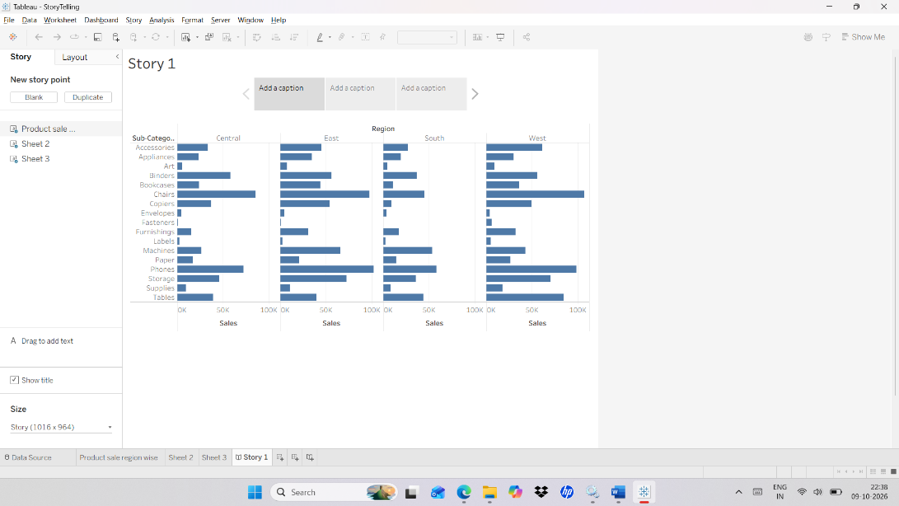

Q14. Implementation of Geographical Analysis.

Steps :

- Create new worksheet and connect to Superstore.
- Left pane → Data pane → Dimensions → State; Measures list ends with the generated Longitude and Latitude fields; Show Me is at the top right of the window.
- Drag State to filters and in filter pane select all.
- Drag State to color.
- Drag longitude to column and latitude to rows.
- In show me select Geographical map.
- Marks card → mark type drop-down → Map → check the view shows coloured states; if Unknown locations appears at the bottom right of the map, click it → Edit Locations.

Output :
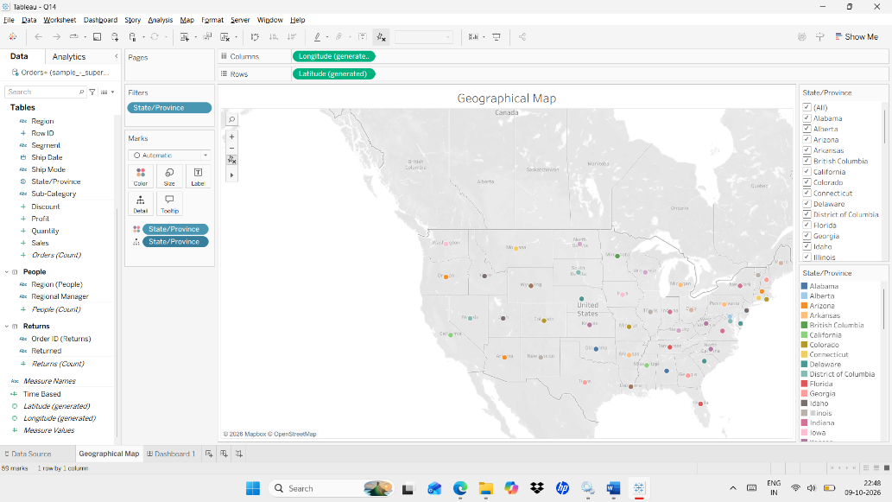

Steps : Dashboard

- Bottom of the window → click the New Dashboard icon (second small icon right of the sheet tabs) or Menu bar → Dashboard → New Dashboard → a blank dashboard opens.
- Dashboard window → left pane → Size section (bottom of the left pane) → choose Automatic; the Sheets list is at the top of the left pane; the Tiled and Floating buttons are under Objects at the bottom-left.
- Select Automatic for size.
- Select floating.
- Drag Sheets to the Dashboard.

Output :
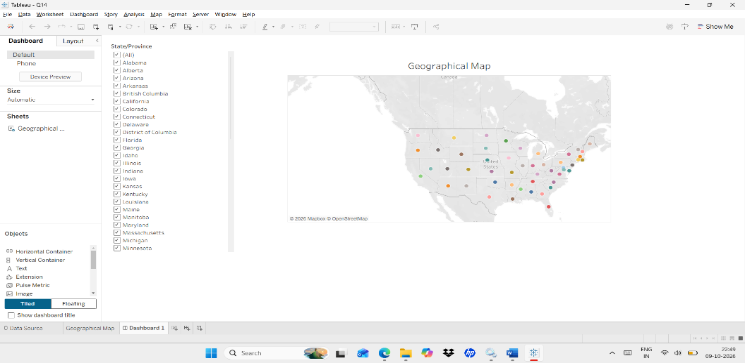

Q15. Create an interactive dashboard using superstore dataset show product trend line and forecast.
Steps : Trend Line with forecast.

- Connect to Superstore dataset.
- Left pane → Data tab → Data pane → Dimensions → Region, Category, Segment, Order Date; Measures → Sales; Analytics tab is next to the Data tab.
- Drag Sales – rows.
- Drag Order Date – Column
- Select Month and Continuous for Order Date.
- Go to Analytics and select TrendLine and Forecast
- Left pane → Analytics tab → Model section → drag Trend Line onto the view, then drag Forecast onto the view.
- Drag Region, Category and Segment to filters.
- Filters shelf → right-click each filter pill (Region, Category, Segment) → Show Filter → filter cards appear on the right side of the view.

Output :
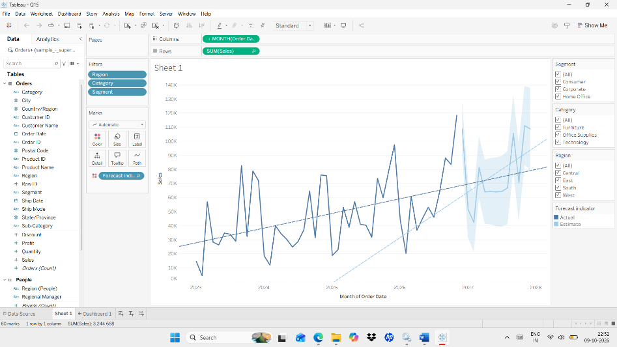

Steps : Dashboard

- Bottom of the window → click the New Dashboard icon (second small icon right of the sheet tabs) or Menu bar → Dashboard → New Dashboard → a blank dashboard opens.
- Dashboard window → left pane → Size section (bottom of the left pane) → choose Automatic; the Sheets list is at the top of the left pane; the Tiled and Floating buttons are under Objects at the bottom-left.
- Select Automatic for size.
- Select floating.
- Drag Sheets to the Dashboard.
- Dashboard window → click the sheet → filter drop-down arrow → Apply to Worksheets → All Using This Data Source → the filters control every sheet.

Output :
