 Chat Bot for Customer Service

Inspiration?

Humans designed computers to make our life easier and let the computer handle all the repetitive and boring tasks. That boring task includes answering the same question to thousands of customers. The solution to this dilemma will be a Chatbot that will answer customers' questions before any human interaction takes place. As Elon Musk said, “Proposed tasks for the Tesla Bot are ones that are dangerous, repetitive and **boring**”. That is the motivation for this project; why not delegate the tedious task of answering queries to bots?

The top three possible benefits of chatbots as reported by consumers in a ChatBot Survey: Service is available 24 hours a day, seven days a week, and simple queries are answered instantaneously. Chatbot applications improve customer experience by streamlining interactions between individuals and services. At the same time, they provide businesses with the new potential to boost customer engagement and operational efficiency by lowering the traditional cost of customer support. A chatbot solution should be able to accomplish both of these functions successfully in order to be successful. Human assistance is critical in this situation: Human intervention is critical in configuring, training, and optimizing the chatbot system, regardless of approach or platform.

Layout of our Project ?

1. Creating a JSON file(dataset) with questions and responses.
2. Using NLP techniques to remove stop words.
3. Creating training data(will use the feed-forward neural network).
4. Pytorch model and training.
5. Load the model and implement.

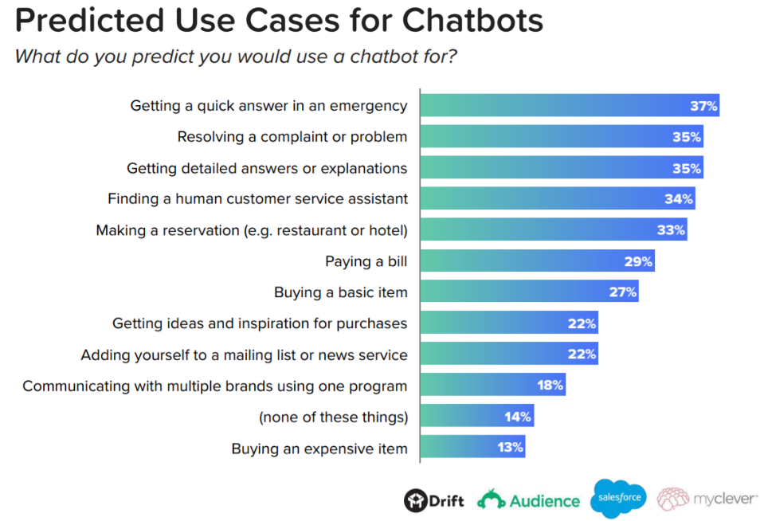

According to Drift's Case Study, the number of firms using Chatbots to improve customer support is steadily expanding.