(2) Quantum Sensing
(Quantum sensors, such as atomic clocks and magnetometers, often require complex setups and intricate data analysis.)
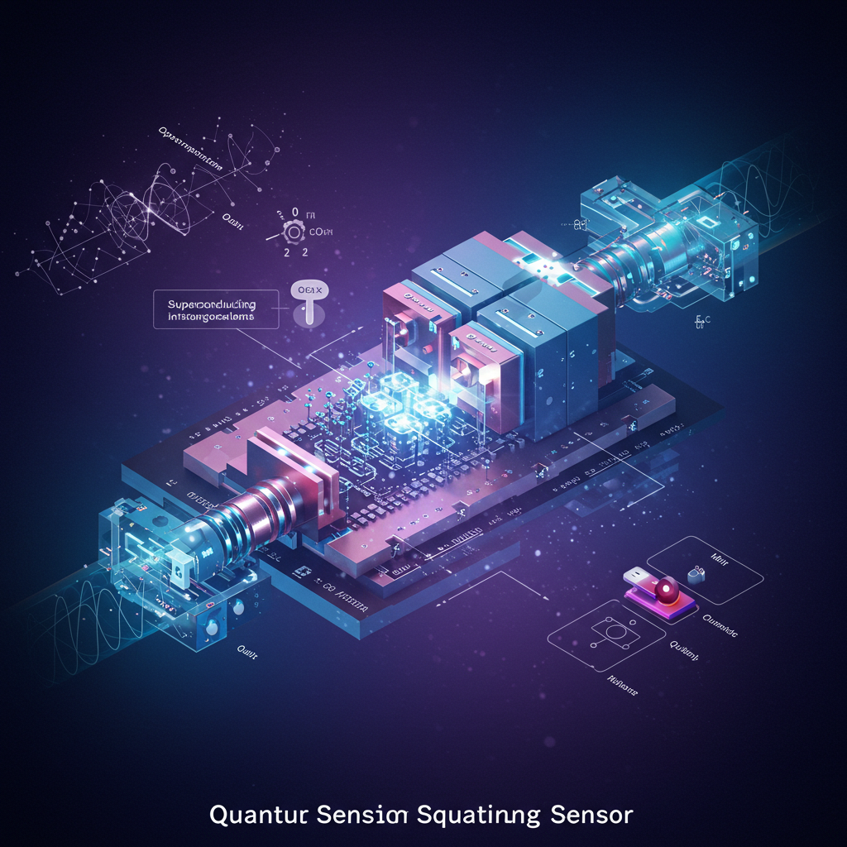
(i) Topic : Ultra-Sensitive Quantum Sensors Enhance Security and Remote Sensing
Description:Quantum Sensors Boost Security & Remote Sensing
Researchers at the University of Sussex have developed Secure Quantum Remote Sensing (SQRS), combining quantum communication and sensing for higher precision and security.
Quantum Sensing

Key Breakthroughs
🔹 Unhackable Data Transmission – Quantum encryption prevents interception.
🔹 Higher Sensitivity – Detects weaker signals with superior accuracy.
🔹 Real-World Validation – Successfully tested in proof-of-concept trials.

Potential Applications
🚀 Next-Gen Radars – Improved air traffic control, defense, and weather forecasting.
📡 Telecommunications – More precise GPS & 5G/6G networks via atomic clocks.
🩺 Medical Monitoring – Early detection of heart disease & neurological disorders.
☀️ Space Weather Forecasting – Protects satellites & power grids from solar storms.

What’s Next?
🔬 Researchers are working on scaling SQRS for commercial & governmental use, with potential impact on secure networks, military systems, and healthcare.
This innovation merges quantum sensing with secure communication, paving the way for high-precision, unhackable remote sensing across industries.
Post Reference:
https://www.linkedin.com/posts/keith-king-03a172128_ultra-sensitive-quantum-sensors-enhance-security-activity-7293463917119344641-tDCe?utm_source=share&utm_medium=member_desktop&rcm=ACoAADkOj4EBvBlS1YkItRX9TFjIAyE23wo8F80
(ii) Topic : Quantum Sensors Enable a Revolutionary New Type of Microscopy
Description:Breakthrough in Imaging: Nuclear Spin Microscopy Developed at TUM
🔬 Revolutionizing Magnetic Imaging
Researchers at the Technical University of Munich (TUM) have unveiled nuclear spin microscopy, an advanced imaging technique using quantum sensors to visualize magnetic signals at an unprecedented microscopic scale. Published in Nature Communications, this breakthrough enhances nuclear magnetic resonance (NMR) imaging with ultra-high resolution, surpassing conventional MRI technology.
🛠 How It Works
💎 Quantum Sensors: Convert magnetic resonance signals into optical signals, captured by a camera.
📡 Diamond Quantum Chips: Detect nuclear spin interactions with extreme precision.
📏 Unprecedented Resolution: Capable of imaging at ten-millionths of a meter, enabling visualization of cellular structures.
🌍 Implications for Science & Medicine
🧬 Biomedical Imaging: Enables detailed study of cellular processes, diseases, and molecular interactions.
🧪 Materials Science: Provides insights into nanostructures and quantum computing materials.
⚙️ Nanoscale Engineering: Facilitates precise manipulation and analysis of materials at the atomic level.
This quantum-powered imaging technique marks a significant leap in diagnostics, potentially unlocking new frontiers in medicine, nanotechnology, and quantum research. 🚀
Post Reference:
https://www.linkedin.com/posts/keith-king-03a172128_quantum-sensors-enable-a-revolutionary-new-activity-7300505337122430978-IPai?utm_source=share&utm_medium=member_desktop&rcm=ACoAADkOj4EBvBlS1YkItRX9TFjIAyE23wo8F80
(iii) Topic :
Description:
Post Reference:

(iv) Topic :
Description:
Post Reference:
(v) Topic :
Description:
Post Reference:

