**Hands – On Lab**

**Workshop 2**

*Note: It is mandatory for all students to draw the diagram in drawing tools as well as in a A4 paper describing the flow of each diagram in a paragraph.*

# Activity Diagram

1. Using an activity diagram, describe the process of student enrollment in an

University

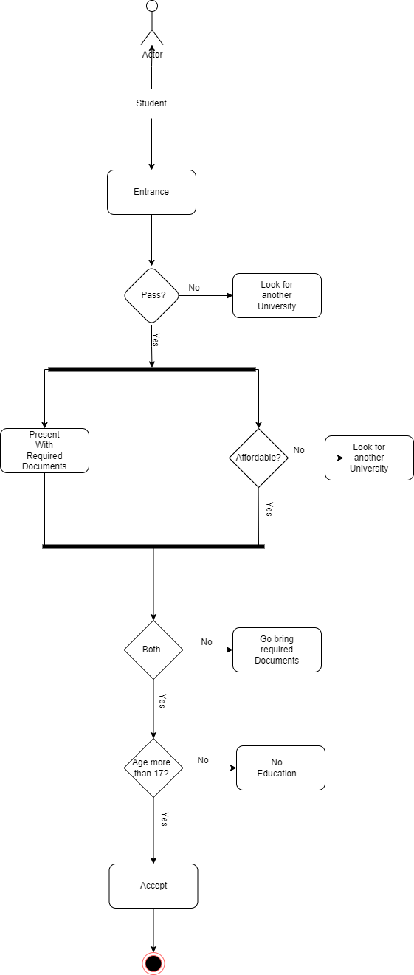

After the student enters, they check to see if they passed or not. If they don't pass, they look for another university; if they do then the university checks the necessary documents to see if they are present. If not, they add them to the wait list and if the university is not affordable then the student looks for another one. If the necessary documents are missing, they are not admitted to the university and are instead added to the wait list. If they meet both requirements and are approved, they can continue their study in a university if they are over the age of 17, but if not, they are not allowed to.

1. Consider the scenario of Order Processing. Once the order is received, the activities split into two parallel sets of activities. One side fills and sends the order while the other side handles the billing. On the Fill Order side, the method of delivery is decided conditionally. Depending on the condition either the

Overnight Delivery activity or the Regular Delivery activity is performed. Finally, the parallel activities combine to close the order. With activity diagram, describes the processing of ordering

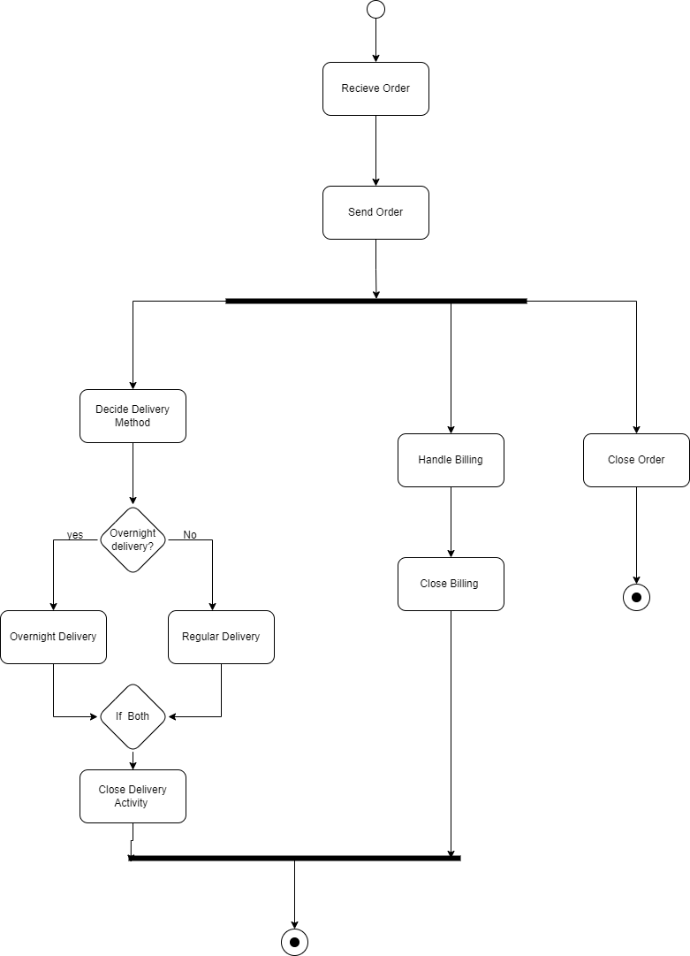

The business first receives the customer's order and sends it, which then encounters a fork in activities that it must pass through in order to send. First, it determines whether the order is closed or not; if it is, the system is immediately terminated. Additionally, it takes care of the billing if the order is not closed, checks to see if the customer selected overnight delivery or not, closes the delivery activity after selection, closes the billing activity, and then ends the system and fulfills the order.

1. Show the flow of word processing application software with the help of activity diagram

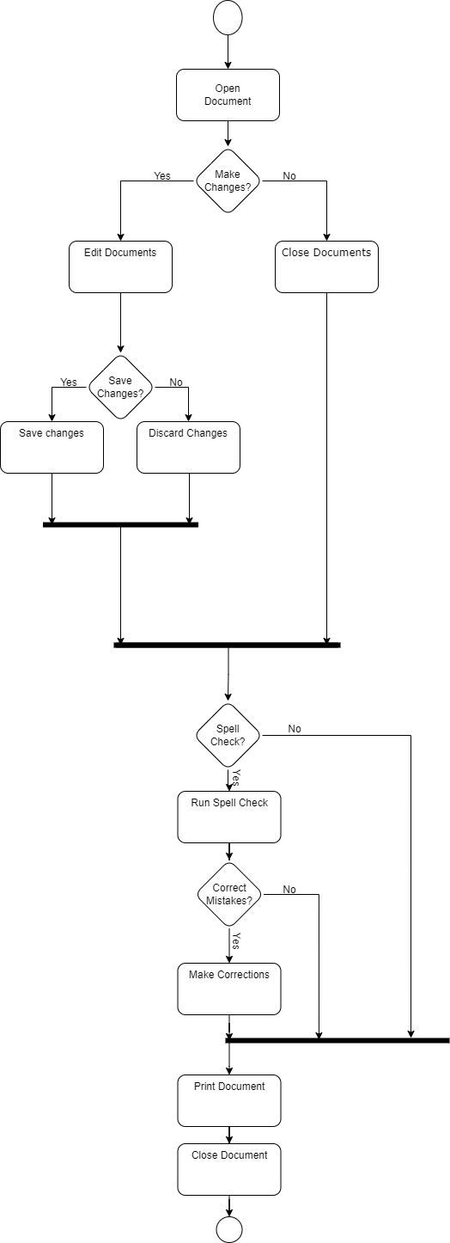

This software checks to determine if the user wants to make any changes to the document. First, it opens the document and asks the user if they want to make changes or not. If they choose not to, they are then led to the fork where the document terminates, and some checks are optional. If they decide to amend the document, they are given the option to save their modifications or not after making their changes, if they choose to save them then the changes are stored and if not, then the document is trashed. After all of these adjustments, they are brought to the fork to have their spelling checked. Their spellings are then checked, and if any errors are discovered, the user is given the opportunity to make the necessary edits before the document is printed and delivered.

# Sequence Diagram

1. Consider a Library Management System. Using sequence diagram, show the interaction of objects in the system to perform the function ‘Create new library user account’

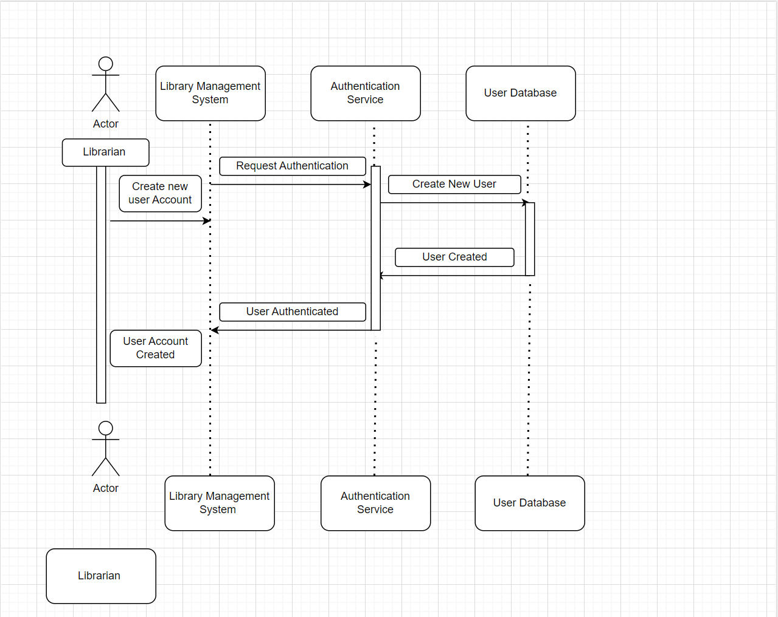

The above sequence diagrams demonstrate how the library's objects interact with one another. When a new user account is created by a librarian in the library management system, the request is repeated to the authentication service, which determines whether the request has been authenticated or not. If it has, the program continues; if it has not, it terminates.

1. In which sequence does the Online Exam System flow? Describes using sequence diagram

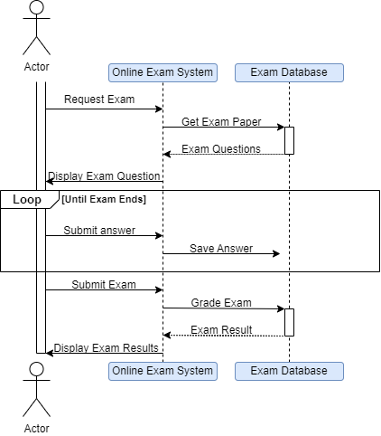

The student plays the role of the actor in this scenario. The student requests the exam from the online exam system, which then requests the exam questions from the exam database and retrieves them before displaying them for the student to answer. Following that, a cycle of activity takes place in which the student submits the response they believe to be accurate, and the online test system continuously records it in the exam database for all the questions and edits the student makes. When the allotted time has passed or the student has finished the exam, they submit it to the online exam system, which scores it, enters the results in a database, and displays them.

1. Represent the School Management System with sequence diagram

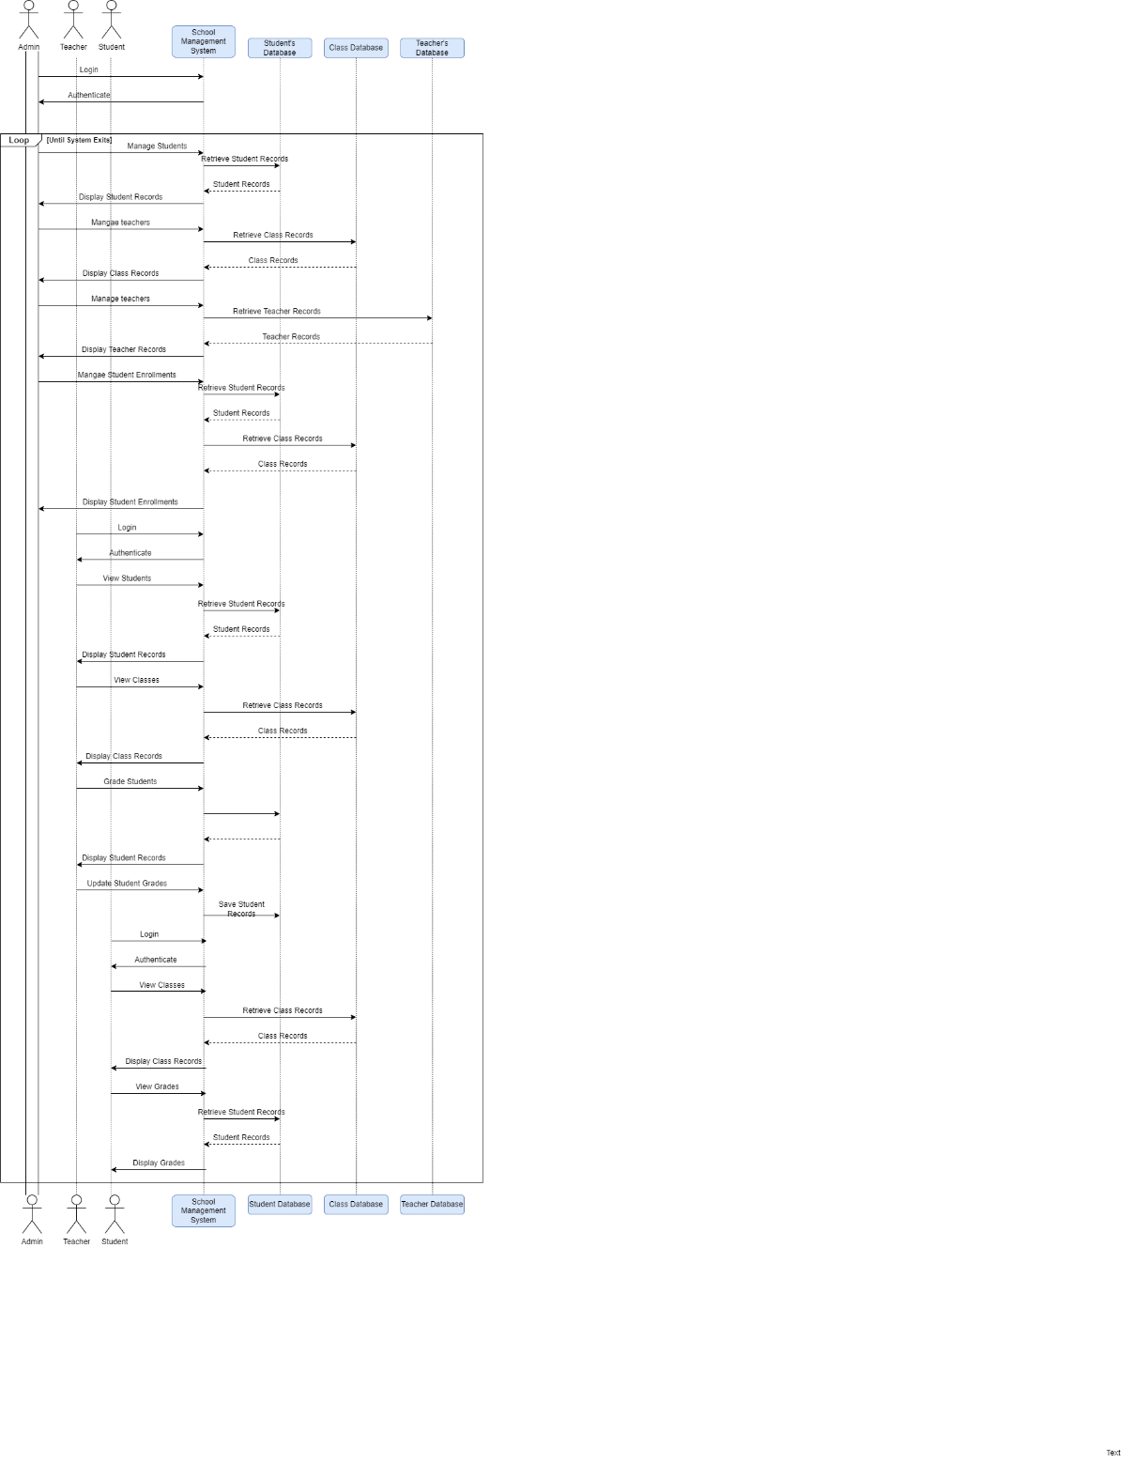

The system takes the login information from the admin, students, and teachers and checks it in the database for checking and if it matches allows for the data retrieval which is restricted. The above diagram is of the college account system, the authentication, and the login for admin to the login of the students more records for the students, fewer for the teachers, and unrestricted access for the administrators allows the administrators to access all of the university's, teachers', and students' records, while teachers can access their own records, class records, and student records, and students can access their own records, personal records, and timetables.

# Deployment Diagram

1. Show the necessary nodes, artifacts, associations and components required for

Hospital Management System

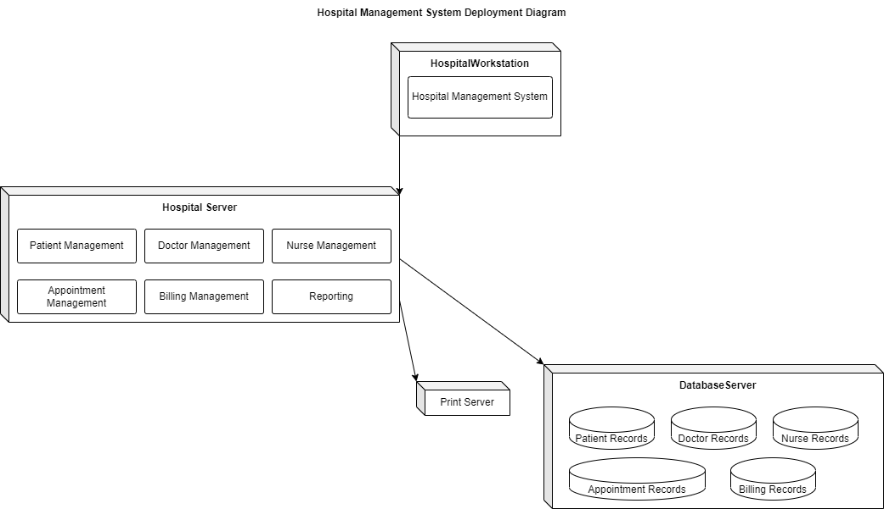

The hospital management system's deployment diagram up top shows how its nodes are connected. In the diagram above, all the data are connected to the hospital system, and all of the management is located underneath the hospital server. All the management can be accessed through the server, and the data are stored on the database server, where they can all be accessed by the hospital workstation and printed. This is how the fundamental node and connection required to set up the hospital network successfully works.

1. Draw a deployment diagram for Hotel Management System

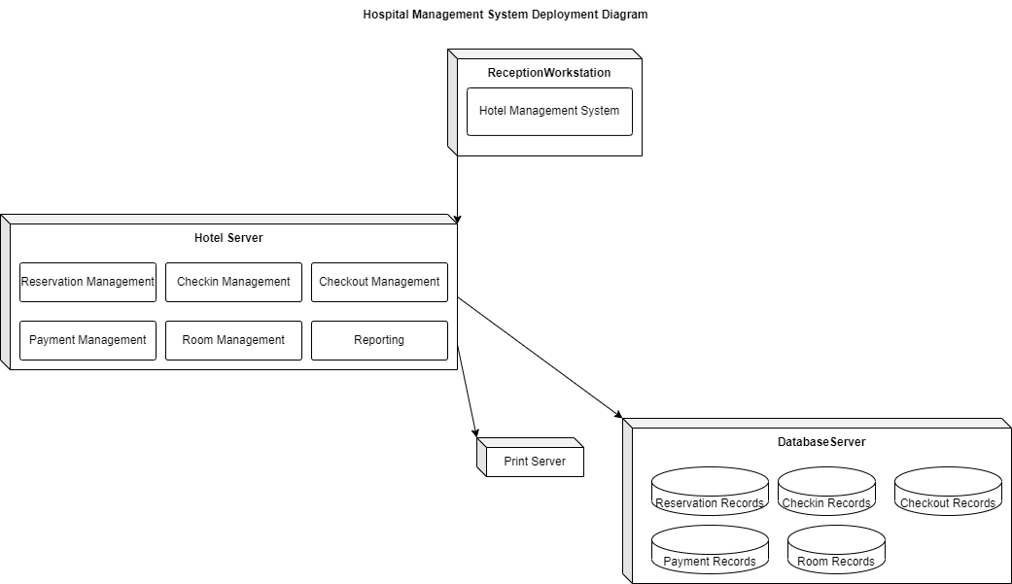

Hari can be said about the hotel system in that the server also has complete access to the management system and can call them, as well as the database of records from the reservation and the check-in and check-out records to the room and the things in them. The reception workstation can access the entire system to see where and when the people clocked in from their employees to their customers and all the management unit and have ability to print them.