Low Level Document (LLD)

Website Scraper

Version number: 1.0

Last date of revision: 11 May 2022

Sunny Sahsi

**DECLARATION**

We declare that this written submission represents us ideas is our own words and where others' ideas or words have been included, we have adequately cited and referenced the original sources.

We also declare that we have adhered to all principles of academic honesty

and integrity and have not misrepresented or fabricated or falsified any idea/data/fact/source in my submission.

We understand that any violation of the above will be cause for disciplinary action by the Institute and can also evoke penal action from the sources which have thus not been properly cited or from whom proper permission has not been taken when

needed.

**Revision History**

|  |  |  |  |  |  |
| --- | --- | --- | --- | --- | --- |
| **Version** | **Date** | **Author** | **Reviewer** | **Approver** | **Comments** |
| 1.0 | 11-05-2022 | Sunny Sahsi |  |  |  |
|  |  |  |  |  |  |
|  |  |  |  |  |  |
|  |  |  |  |  |  |
|  |  |  |  |  |  |

Table of Contents

1. Introduction ………………………………………………………………………………….6

1.1 Scope of the document…………………………………………………………………6

1.2 Intended Audience………………………………………………………………………6

1.3 System Overview………………………………………………………………………..7

1. Project Briefing……………………………………………………………………………….
2. Problem Statement…………………………………………………………………………..
3. Problem Solution……………………………………………………………………………..
4. Objective of Project…………………………………………………………………………..
5. Scope of Project………………………………………………………………………………
6. Block Diagram…………………………………………………………………………………
7. Requirements Gathering…………………………………………………………………….
8. Analysis……………………………………………………………………………………….
9. Final Screenshot of Project Output…………………………………………………………
10. **Introduction:**

**1.1 Scope of the Document**

* This section will cover details regarding scope of the document
* Low level design document will be at component level i.e., for website portal there will be one LLD

**1.2 Intended Audience**

* This section will cover categories of audiences who will be referring/reviewing this document

**1.3 System Overview**

* This section will capture overview of system application i.e for what system is being developed
* Who are the stake holders of system?
* What are other external Systems through which this will be interacting

1. **Project Briefing:** A Web Scraper is a program that quite accurately scrapes or gathers data from websites. Let’s take an imaginary example, where we might build a web scraper that would go to Twitter, and gather the content of tweets. At the micro-level, web scraping is simply the act of gathering data from the internet, in any form. However, at the large-scale level, web scraping allows you to collect data in large volumes by using bots. The bots, called crawlers or spiders, go through the source code of a given web page and tag data according to some present parameters. After this, the data extractor accumulates the attached data and extracts it into a spreadsheet file. Social media reputation monitoring: Examining your social media channels is one of the best ways to keep an eye on your company’s reputation. With web scraping tools, you can easily filter through the mass of data that is being created on social media to find the comments connected to your business and address them.
2. **Problem Statement:** To create the scraping-based tool to scrape the data from website then specific code for specific websites.
3. **Problem Solution:** Develop the application to scrape the data then first of all scrap the json text and then categories the data.
4. **Objective of the Project:** Objective of this project is to scrape the useful data.
5. **Scope of Project:** Scrape data from Twitter in two way first we use Username and second we user Twitter Advance Search Query Features to scrape the Data.
6. **Block Diagram:**

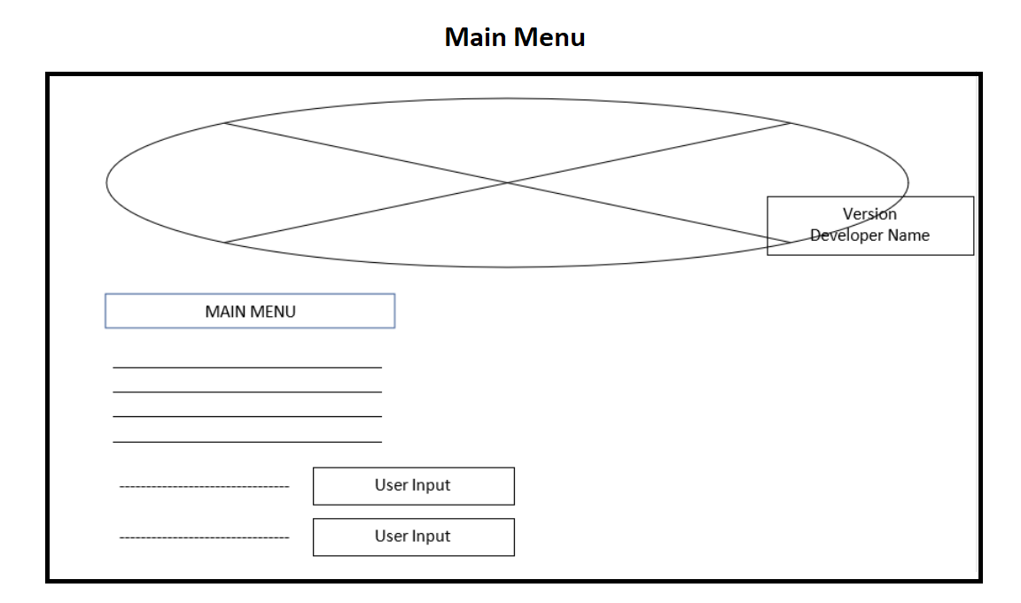

1. **Requirements Gathering:**

* Any Operating System
* Visual studio and PyCharm
* Python 3.10+
* Some Python Module

1. **Analysis:** A Web Scraper is a program that quite accurately scrapes or gathers data from websites. Let’s take an imaginary example, where we might build a web scraper that would go to Twitter, and gather the content of tweets. At the micro-level, web scraping is simply the act of gathering data from the internet, in any form. However, at the large-scale level, web scraping allows you to collect data in large volumes by using bots. The bots, called crawlers or spiders, go through the source code of a given web page and tag data according to some present parameters. After this, the data extractor accumulates the attached data and extracts it into a spreadsheet file. Social media reputation monitoring: Examining your social media channels is one of the best ways to keep an eye on your company’s reputation. With web scraping tools, you can easily filter through the mass of data that is being created on social media to find the comments connected to your business and address them.
2. **Final Screenshot of Project Output**

