Digital Credit Access and Financing Constraints Amongst Firms: Evidence from India and Peer Economies
Aryan Srivastava (IIT2024501), Aditya Agrawal (IEC2024116), Jaydeep Ghosh (IEC2024031)
Entrepreneurial Finance
Abstract: Small firms are often denied credit because lenders cannot observe their quality. Digital finance is widely argued to ease this constraint, but evidence on India is mostly descriptive. We build a country-level panel of 215 World Bank Enterprise Survey observations (142 economies, 2013–2024), define credit constraint as the share of firms that are fully or partially credit constrained, and ask whether digital-access indicators help explain it beyond traditional financial depth. A ridge baseline on income, private credit, lending spread and macro controls reaches a country-held-out R² of 0.505 (MAE 10.2 pp). Adding digital features and using gradient boosting raises R² to 0.522 and lowers MAE to 10.0 pp, a modest gain; income per capita remains the dominant predictor. India (2022) has 34.5% of firms constrained (10.5% fully), against a sample median of 26.7%. The digital model predicts 31.8% for India out of sample and 27.3% if India’s digital indicators reached the sample top quartile. Results are associational, not causal.
I. INTRODUCTION
Access to external finance is a binding constraint on firm growth, especially for small and medium enterprises (SMEs) that lack hard collateral, audited accounts and long credit histories [1], [2]. The IFC estimates the global MSME credit gap at close to $5 trillion [3]; for India, estimates put the gap near $500 billion [4]. Digital credit, meaning lending screened with transaction, mobile and platform data, is a leading response, and a growing literature links digital finance to eased financing constraints and to more innovation, green innovation and resilience [5]–[8].
Most of that evidence relies on constructed indices of constraint (KZ, WW) and on Chinese listed firms, and a term-paper-level review cannot test it. This paper moves from review to measurement for India. Our questions are: (RQ1) how constrained are Indian firms relative to peer economies; (RQ2) do digital-access indicators explain credit constraint beyond traditional financial depth; and (RQ3) what does a simple machine-learning model imply for India’s position and its digital headroom?
II. RELATED WORK
Information asymmetry between lenders and opaque firms produces rationing [1]. Kuntchev et al. [9] argue that perception-based answers about “access to finance” are unreliable and instead classify firms from actual loan outcomes into not needing credit, unconstrained, partially constrained and fully constrained. We use the aggregate shares of the latter two categories published in the World Bank Enterprise Surveys, which follow this logic. Kaplan and Zingales [10] and Whited and Wu [11] show why index-based proxies are imperfect, a limitation that outcome-based measures avoid.
On digital finance, studies on Chinese data find that digital inclusive finance lowers SME constraints, particularly for non-state and technology firms [5], [12], and that relief feeds into innovation and asset-allocation discipline [6]–[8]. Bank–FinTech coopetition [13], bank digitalization [14] and digitized firm records [2] are further channels. Causal designs remain scarce; we therefore frame our contribution as predictive benchmarking, not identification.
III. DATA
All data are open and obtained through the World Bank’s public WDI API (script fetch_data.py). The outcome is the percentage of firms that are fully plus partially credit constrained (Enterprise Surveys). Predictors fall in two groups. Traditional: log GDP per capita, private credit to GDP, lending-deposit spread, inflation and GDP growth. Digital: internet users (% of population), mobile subscriptions, broadband subscriptions, secure internet servers per million people (log), and account ownership at a financial institution or mobile money provider (Global Findex; the latest wave is carried forward within country because Findex is triennial). Missing predictors are median-imputed.
The analysis sample has 215 country-year observations from 142 economies (2013–2024); mean shares are 13.8% fully and 16.0% partially constrained. Internet use correlates with constraint at r = −0.59 (n = 208) and account ownership at r = −0.57 (n = 200) (Fig. 2). India contributes one outcome observation (2022).
IV. METHODOLOGY
A. Baseline
Following the outcome-based tradition of [9], the baseline explains constraint with traditional financial-depth variables only, fitted by ridge regression with a cross-validated penalty.
B. Improvements
We (i) add the five digital-access indicators and (ii) replace the linear model with Random Forest (300 trees, minimum leaf 3) and Gradient Boosting (150 shallow trees, learning rate 0.05). To avoid leakage across repeated observations of one economy, we use 5-fold GroupKFold by country, so every score is out-of-country. We report R² and mean absolute error (MAE, percentage points). Importance is measured by permutation importance. For India, models are refit without India and used to predict its constraint, and a counterfactual lifts India’s digital indicators to the sample 75th percentile.
V. RESULTS
A. India in context
In 2022, 34.5% of Indian firms are credit constrained (10.5% fully, 24.0% partially), above the sample median of 26.7%; 36% of survey observations are more constrained than India. Fig. 1 compares India with 13 emerging peers. Over 2014–2022 India’s share of firms using banks to finance investment rose from 30.3% to 56.1%, internet use from 13.5% to 55.9%, and account ownership from 53.1% (2014) to 77.5% (2021), while private credit to GDP fell from 51.9% to 38.2%.
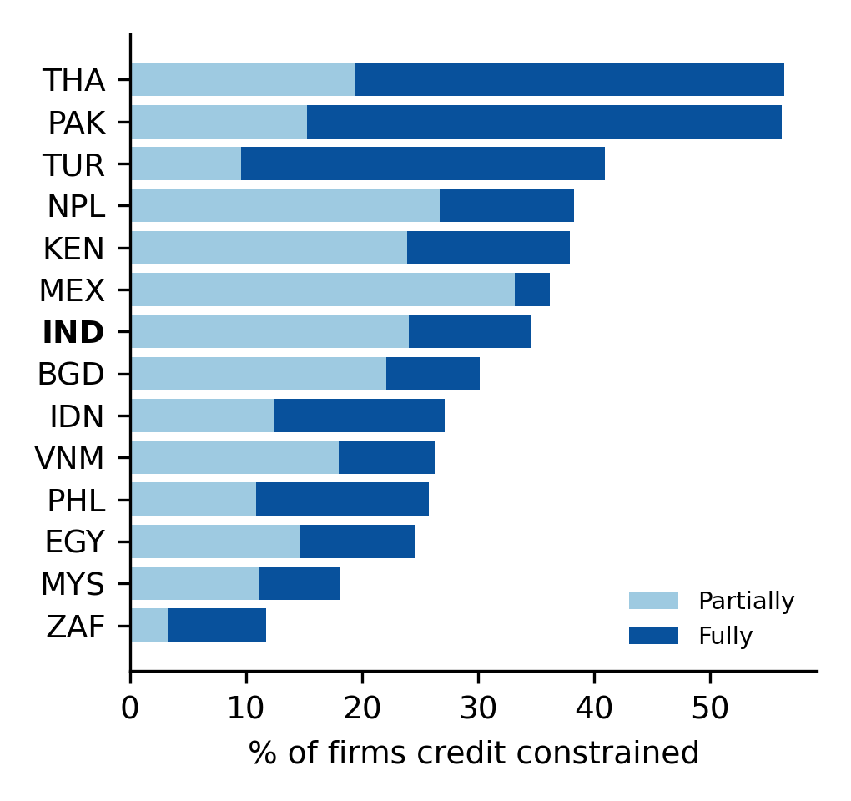
Fig. 1. Share of credit-constrained firms, India and selected peers (latest survey).
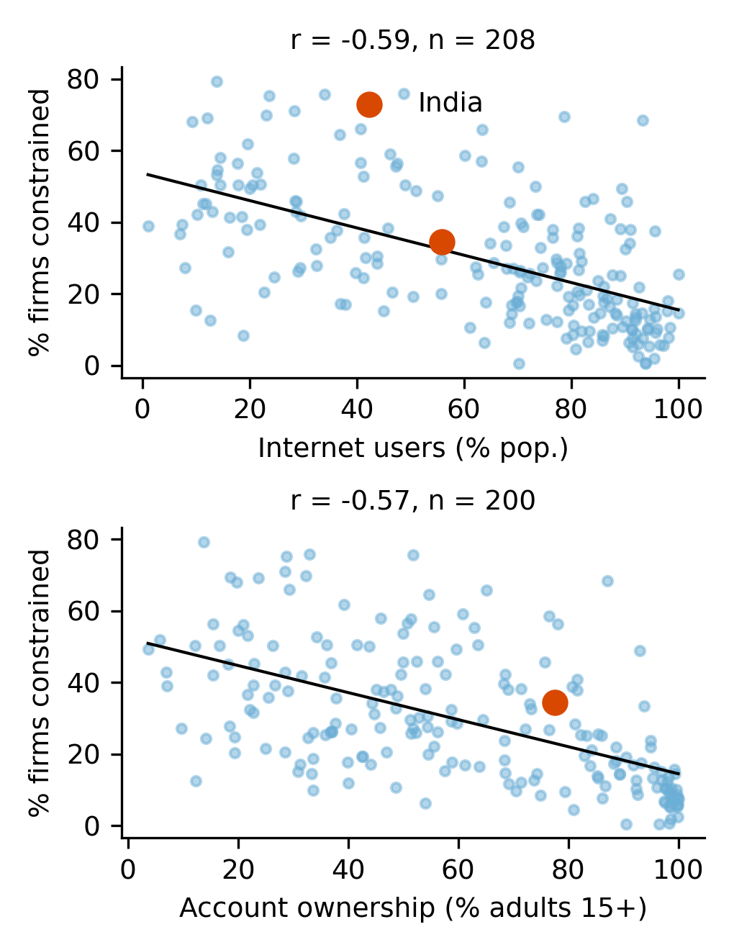
Fig. 2. Constraint vs digital access; India highlighted.
B. Do digital indicators help?
Model | R² | MAE (pp)
Baseline: ridge (financial depth) | 0.505 | 10.16
+ Digital: ridge | 0.506 | 10.30
+ Digital: random forest | 0.520 | 9.88
+ Digital: gradient boosting | 0.522 | 9.99

TABLE I. Country-held-out cross-validation (5 folds).
Adding digital features to the linear model changes almost nothing (R² 0.505 to 0.506), but tree ensembles lift R² to 0.52 and cut MAE by up to 0.3 pp (Fig. 3). The improvement is small; we do not claim digital access is a strong independent driver once income is accounted for, since digital reach and GDP per capita are highly collinear.
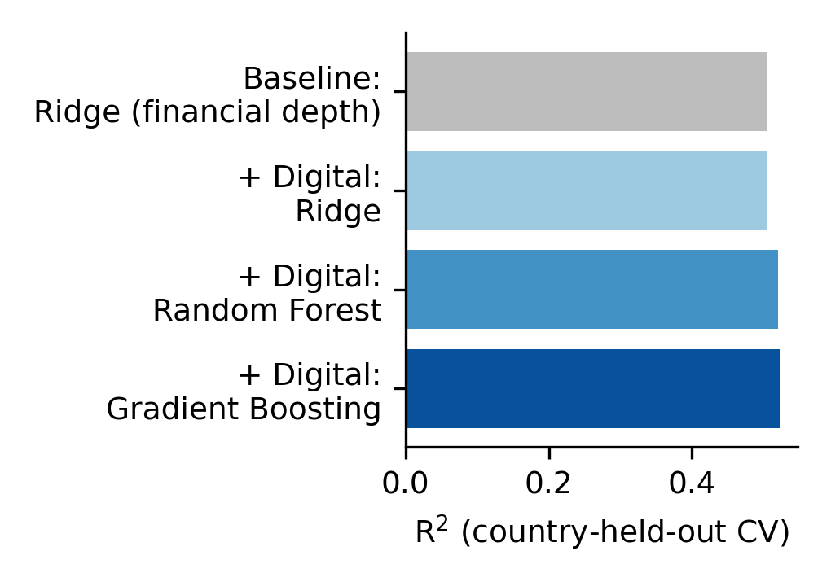
Fig. 3. Out-of-country R² by model.
C. Drivers
In the gradient-boosting model, log GDP per capita dominates (permutation importance 0.34), followed by private credit to GDP (0.18). Digital variables jointly matter: secure servers (0.11), broadband (0.09), mobile subscriptions (0.06), account ownership (0.05) and internet use (0.05) (Fig. 4).
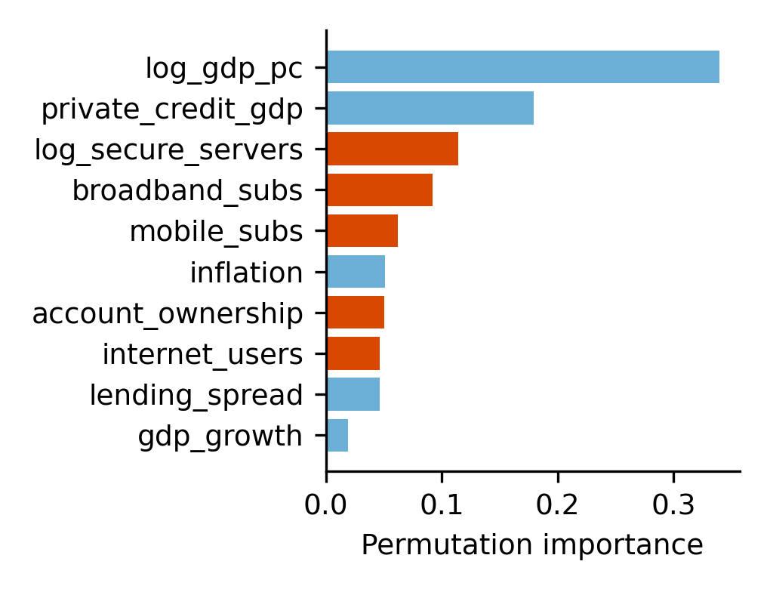
Fig. 4. Permutation importance (digital features in orange).
D. India prediction and counterfactual
With India excluded from training, the baseline predicts 38.8% constrained against an actual 34.5%; the digital gradient-boosting model predicts 31.8%. Lifting India’s digital indicators to the sample top quartile lowers the prediction to 27.3% (−4.5 pp). The estimate is an associational benchmark and inherits the collinearity noted above.
VI. DISCUSSION
Policy: India’s model-implied position is better than the traditional baseline suggests, consistent with digital public infrastructure doing some of the work that collateral and credit depth do elsewhere, while falling private-credit depth indicates room for bank–FinTech data-sharing [13]. Managers: digitizing accounts and payments improves lender visibility [2]. Lenders: alternative-data underwriting should avoid excluding firms with thin digital footprints.
VII. LIMITATIONS AND FUTURE WORK
(1) Country-level aggregates (n = 215) support only ecological, associational conclusions. (2) India has one outcome observation; no time series is possible. (3) Digital indicators are population-level, not firm-level digital credit usage. (4) Findex values are carried forward. Future work should use the firm-level India Enterprise Survey microdata and state-level UPI and credit data, and quasi-experimental variation such as staggered digital-lending regulation.
VIII. CONCLUSION
Using open data, we measured credit constraint directly and found that 34.5% of Indian firms are constrained. Digital-access indicators add modest out-of-country predictive power over traditional financial depth (R² 0.505 to 0.522), and a digital counterfactual suggests several points of headroom for India. The evidence is associational; firm-level and causal work remains the priority.
REFERENCES
[1] Z. Lu, J. Wu, H. Li, and D. K. Nguyen, “Local bank, digital financial inclusion and SME financing constraints: Empirical evidence from China,” Emerg. Markets Finance Trade, vol. 58, no. 6, pp. 1712–1725, 2022.
[2] AIM Rizalino Navarro Policy Center for Competitiveness, “Firm characteristics and credit constraints across SMEs in the Philippines,” Asian Inst. Manage., 2019.
[3] GPFI/IFC, “2024 GPFI MSME Finance Report,” 2024.
[4] ETV Bharat, “Thinning of credit supply to MSMEs,” 2024.
[5] X. Wang and X. Chen, “An empirical study on financing constraints of digital inclusive finance development on small and medium-sized technology-based enterprise,” Kybernetes, vol. 52, no. 2, pp. 585–600, 2022.
[6] L. Yao and X. Yang, “Can digital finance boost SME innovation by easing financing constraints? Evidence from Chinese GEM-listed companies,” PLOS ONE, vol. 17, no. 3, e0264647, 2022.
[7] L. Han and Z. Zhang, “Impact of digital finance on enterprise green innovation,” PLOS ONE, vol. 18, e0295809, 2023.
[8] Y. Feng, M. Meng, and G. Li, “Impact of digital finance on the asset allocation of SMEs in China: Mediating role of financing constraints,” J. Innov. Knowl., vol. 8, no. 3, 100405, 2023.
[9] O. Kuntchev, R. Ramalho, J. Rodríguez-Meza, and J. S. Yang, “What have we learned from the Enterprise Surveys regarding access to credit by SMEs?,” World Bank Policy Res. Work. Paper 6670, 2013.
[10] S. N. Kaplan and L. Zingales, “Investment-cash flow sensitivities are not valid measures of financing constraints,” Quart. J. Econ., vol. 115, no. 2, pp. 707–712, 2000.
[11] T. M. Whited and G. Wu, “Financial constraints risk,” Rev. Financial Stud., vol. 19, no. 2, pp. 531–559, 2006.
[12] C. Yang, Z. Fang, X. Song, and Y. Liang, “The influence of digital finance based on the intermediary effect of investor confidence on organizations’ financing constraints,” Front. Psychol., vol. 13, 2022.
[13] B. Larsson et al., “Digital disruption diversified—FinTechs and the emergence of a coopetitive market ecosystem,” Socio-Econ. Rev., vol. 22, pp. 655–675, 2023.
[14] UCL Discovery, “Bank financial innovation and SME lending,” working paper, n.d.
[15] World Bank, “World Development Indicators, Enterprise Surveys and Global Findex,” api.worldbank.org, accessed Oct. 2026.

