Python_sahithi_Siddamsetty_SD_936.docx

2.
code:
#!/usr/bin/python
n=input(“enter number:”)
def func(n):
if (n>=0):
func(n-1)
print n
func(10)
output:
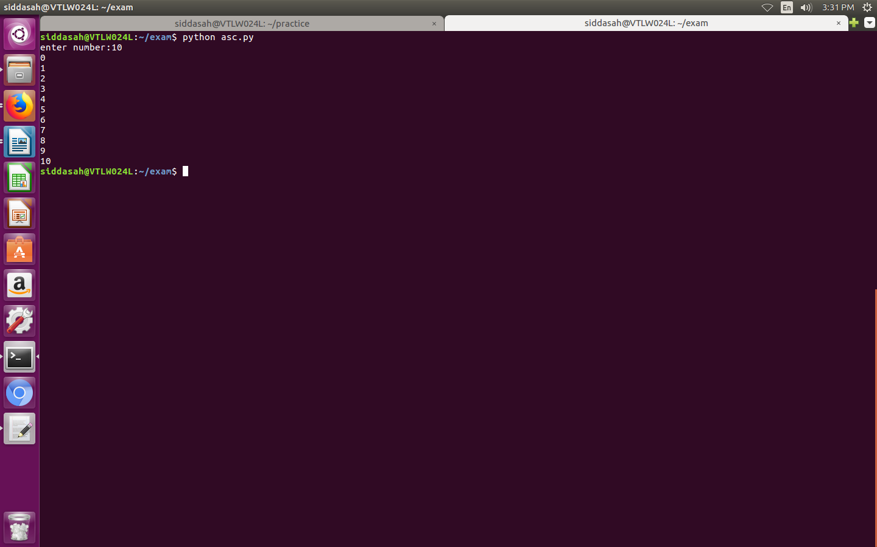
descending order

code:
#!usr/bin/python
n=input("enter number:")
def fun(n):
if(n>=0):
print n
fun(n-1)
fun(n)
output:
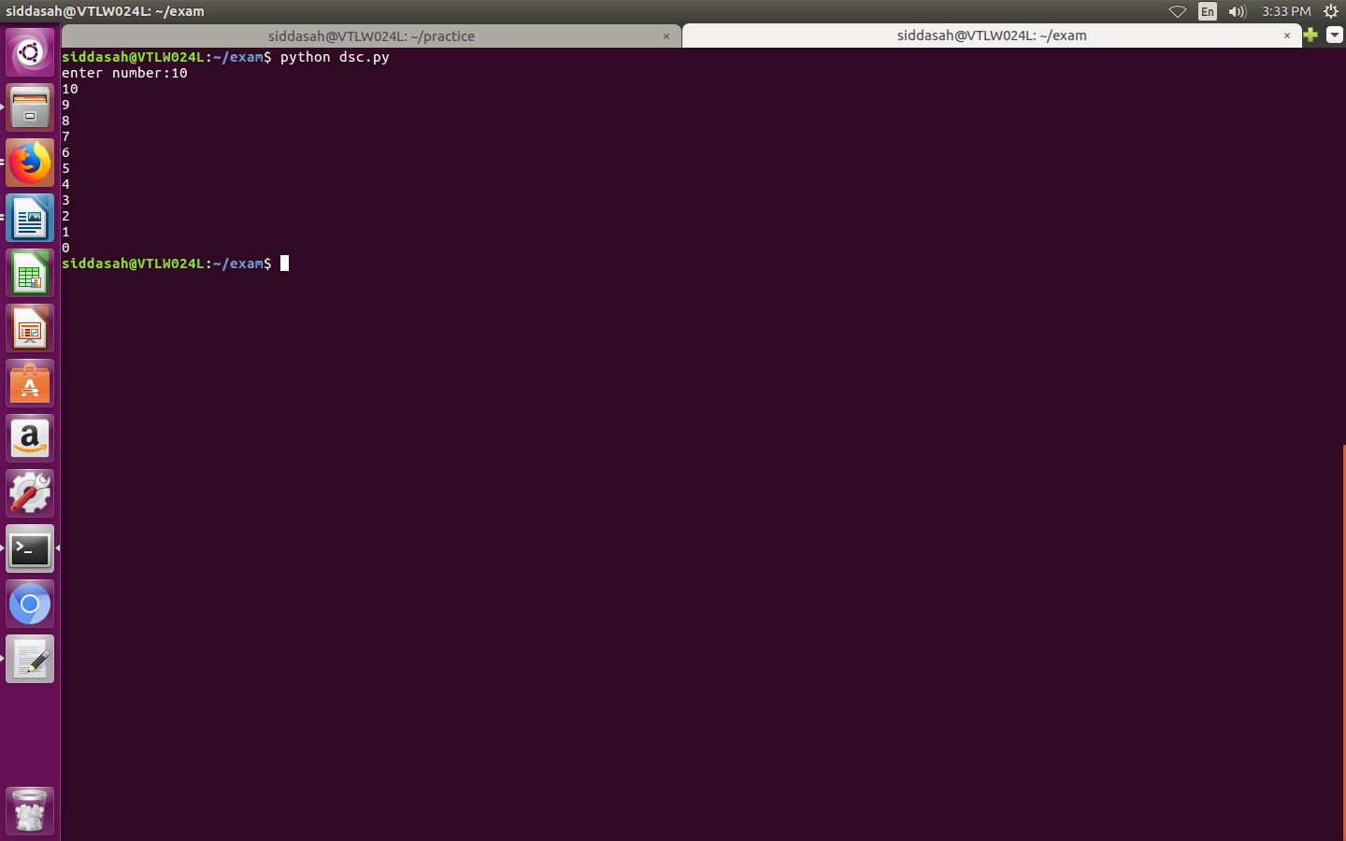
3.
code:
#!/usr/bin/python
nums = list(input("Enter :"))
for i in range(len(nums)):
if nums[i]<0:
n=nums.pop(i)
nums.append(n)
print nums
output:
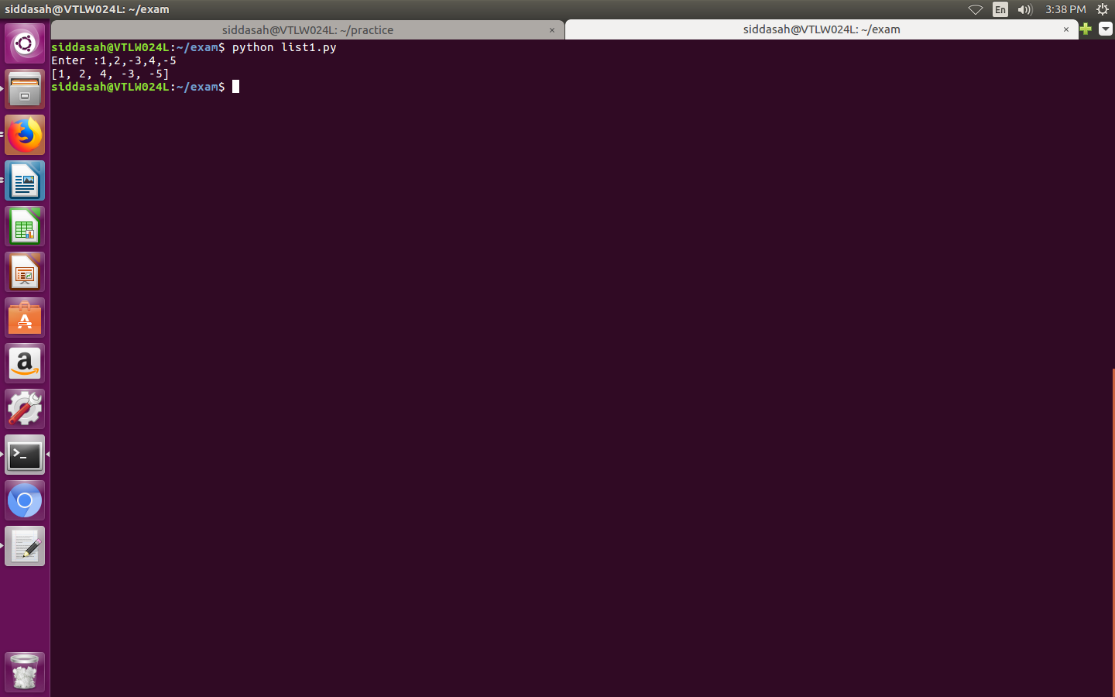
5.

code:
class gen(object):
def __init__(self,num,end):
self.start = 1
self.end = end
self.num = num
def next(self):
for i in range(self.start,self.end):
if i % self.num == 0:
yield i
else:
continue

if __name__ == '__main__':
End_range = input("Enter range: ")
num = input("Enter divisible number: ")
ob = gen(num,End_range)
print ob.next()
x = iter(ob.next())
while True:
try:
print "ob.next() = "+str(x.next())
except StopIteration:
break

output:
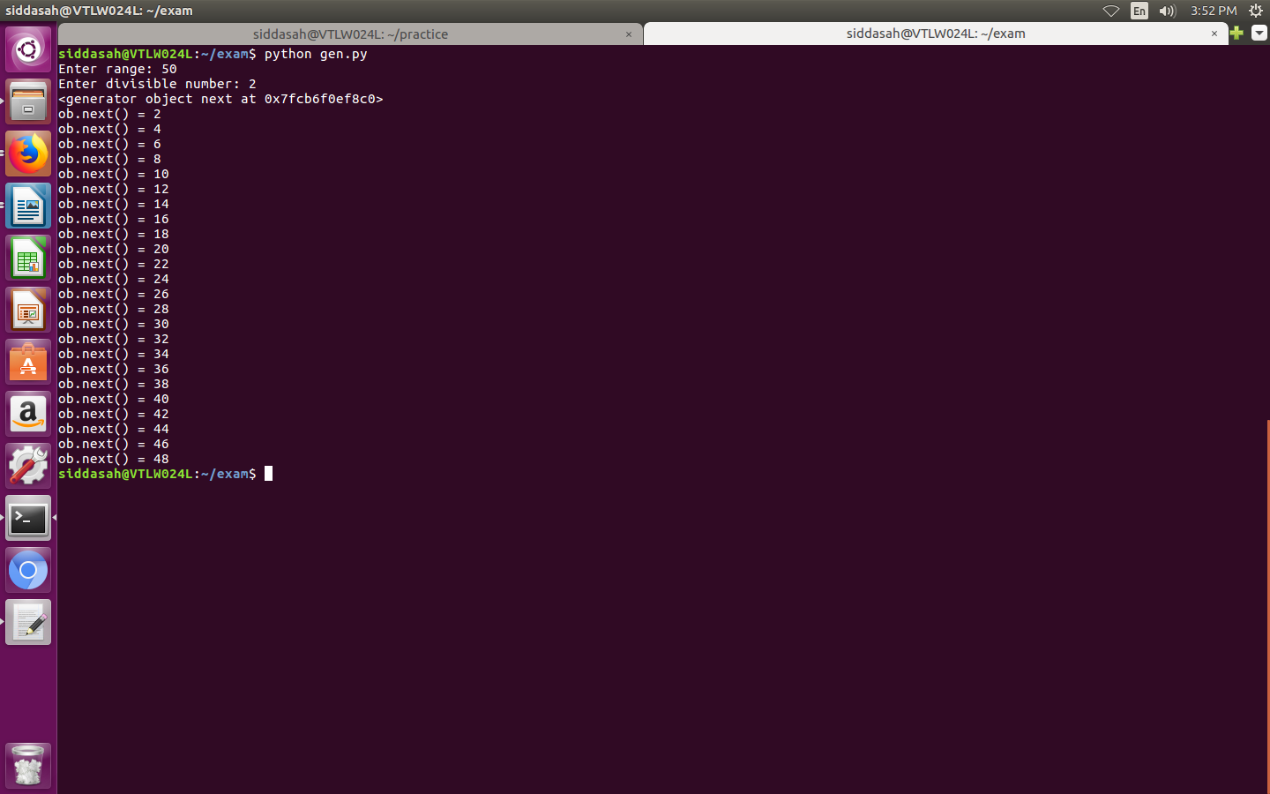
4.
code:

#!/usr/bin/python
def prime_num(inp):
for val in range(2,(inp/2)+1):
if (inp%val==0):
print "%d is not a prime number"%inp
break
else:
print "%d is prime number"%inp

inp=input("Enter the input number :")
prime_num(inp)
def prime_list(inp1=1,inp2=100):
l=[]
for val in range(inp1,inp2):
if(val>1):
for val1 in range(2,(val/2)+1):
if (val%val1==0):
break
else:
l.append(val)
return l
print prime_list()

output:

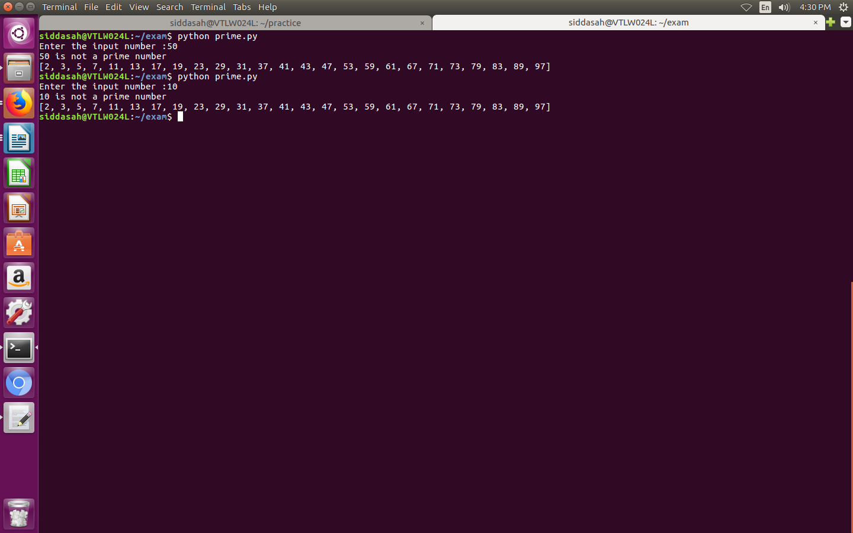

6.
code:

#!/usr/bin/python
list1=list(input("enter elements:"))
list2=list(input("enter elements:"))
c=0
for i in list2:
if i in list1:
c+=1
if c==len(list2):
print "list2 is subset of list1"
else:
print "list2 is not a subset of list1"

output:
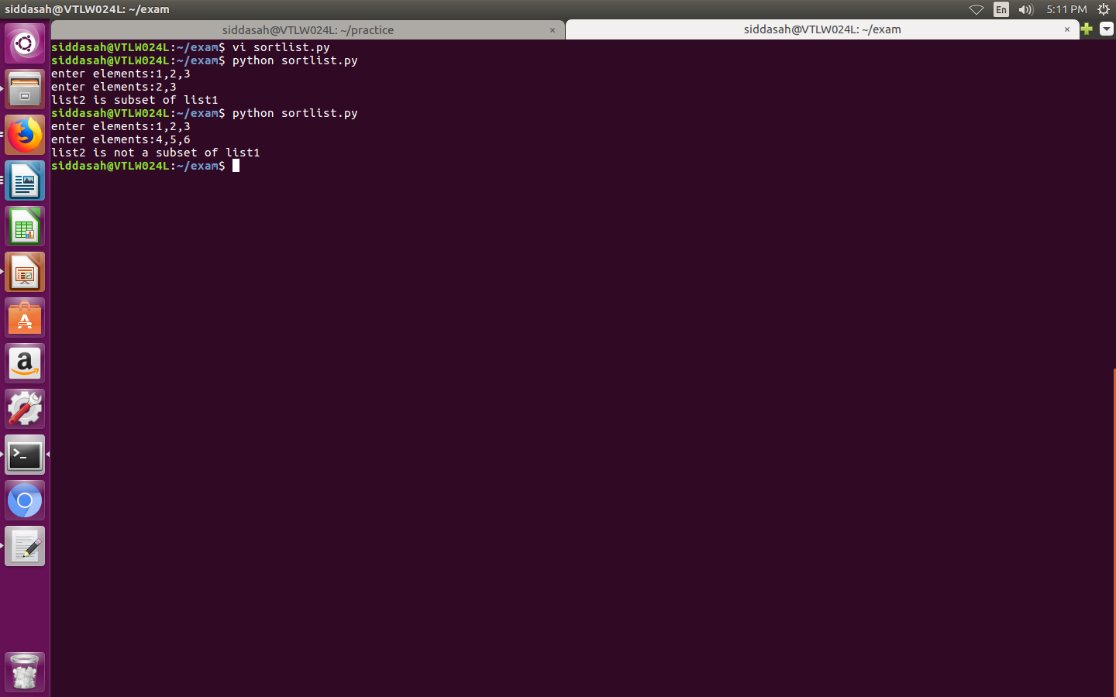

Linux:

6.
Memory layout of a process:

A typical representation of c program consists of following sections.They are:
1.Text segment
2.Initialised Data segment
3.Uninitialised Data segment
4.stack
5.Heap

Text segment:
A text segment is als known as code segment,it is usually placed below the heap or stack.Text segment is a read-only segment,to prevent a program from accidentially modifying instructions

Initialised Data segment:
It contains the global variables and static variables whichn are initialised by the programmer,it is not a read-only segment

Uninitialised Data segment:
Uninitialised Data segment starts at the end of data segment and it also contains all global variables and static variables

stack:
The stack area contains the program structure,LIFO structure i.e., last in first out.stack where automatic variables are stored along with the information that is saved from each function

Heap:
Heap is the segment where dyanamic memory allocation takes place.Here execution of malloc,realloc and calloc functions takes place.

1.
Booting process of SOC

There are four steps in that,they are:

xloader

uboot

rootfile system

linux kernel
These are the four steps in booting process

