Aptitude_Sahithi_Siddamsetty_SD_936.docx

General Aptitude:
1.
Project:
Installed ELK and Visualised LTP data through Kibana,Integrated logtsash data to jenkins using logstash plugin and visualised these LTP logs through Jenkins

Integrated git with Jenkins and performed automatic entry of testcases through VTAT tool using Gitpython and build the LTP log data in jenkins,LTP log data taken from remote server,by generating a pub key and had an access to git remote server

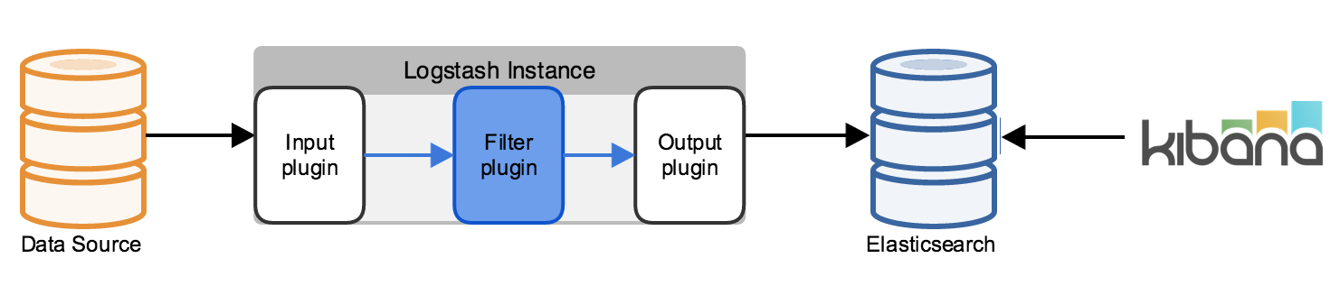

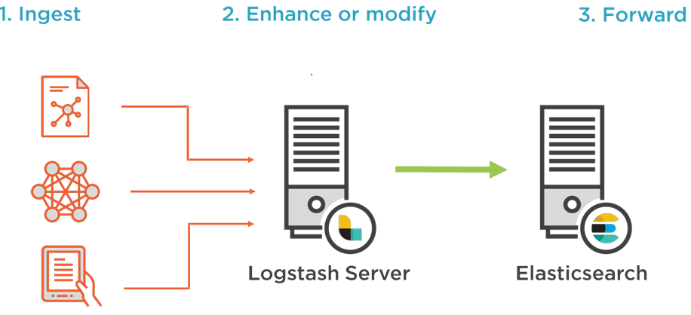
2.Architectural Diagram:
2. Architecture Diagram

The above diagram gives a brief picture for us,In this way we send data from file beat to logsatash and from logstash it goes to elastic search and from elastic search we can visualise data through kibana,The kibana Visualisation pictures are shown below

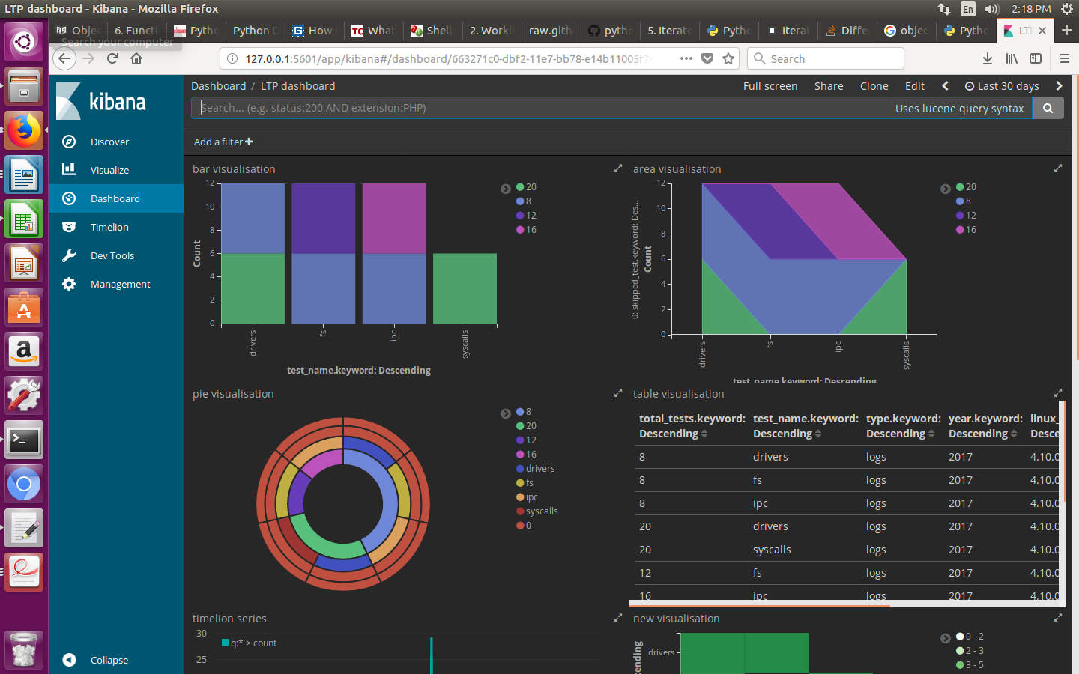

3.

We can implement or extend our project,we are in the same scenario to extend the project.
We can implement more and more dashboards using kibana and we can visualise different types of data through kibana,These are the things which we can do in our project

4.
I Want to grow up my career and want to implement new methodologies for my company,
and trying to achieve that and trying to give my best to the company and trying to achieve the challenges given by manager

