- Get the registry image: Run the docker pull command as follows to pull the registry image from the Docker Hub Registry.

$ sudo docker pull registry:latest

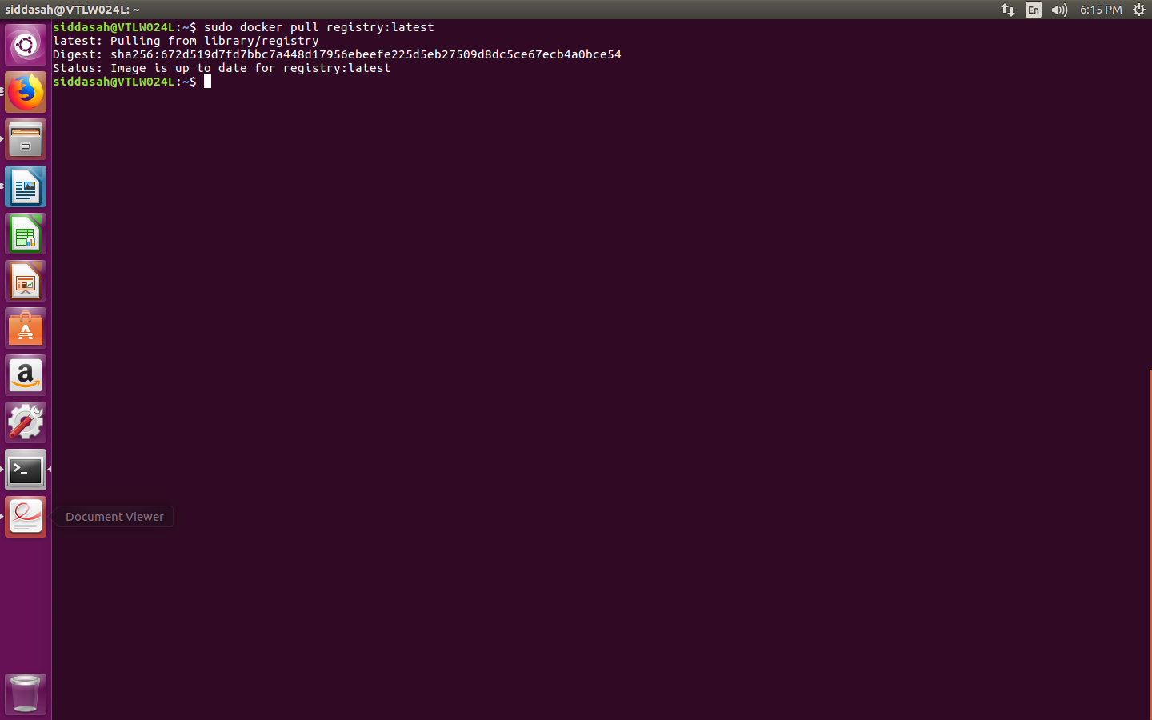

- Run the registry image: To try out the Docker registry, run the image in the foreground so you can watch messages produced as the container image is running. This command starts the latest registry image, exposes TCP port 5000 on the system so clients outside the container can use it, and runs it as a foreground process in the first terminal:

$ sudo docker run -p 5000:5000 registry:latest
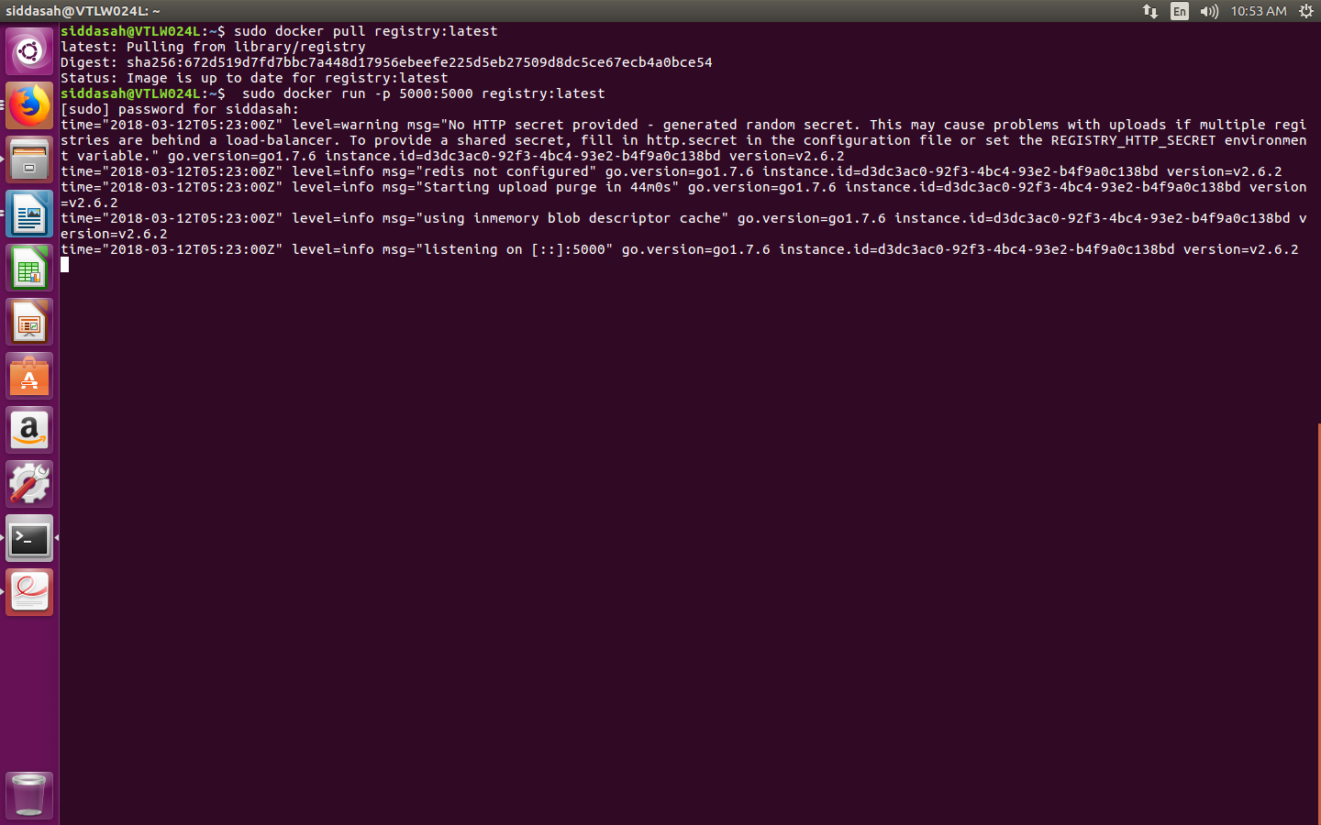

- Get an image: To test that you can push and pull images, open a second Terminal window. A common image used to test Docker is the hello-world image available from the Docker Hub Registry. Run that image as follows (which pulls that image to the local system and runs it):
$ sudo docker run --name myhello hello-world

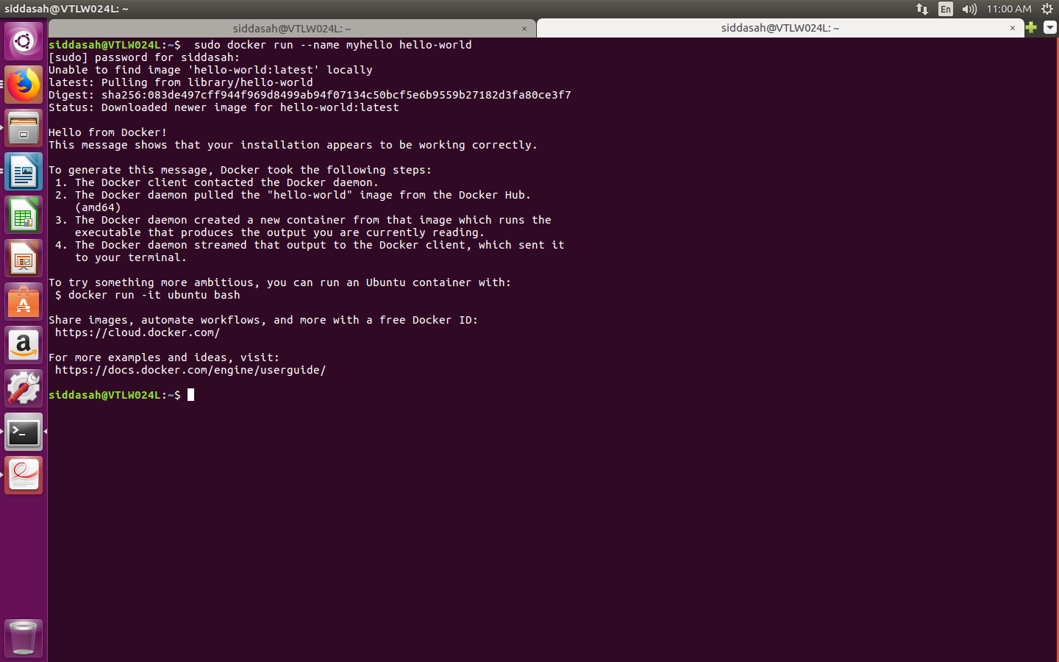

4. Tag the image: Use docker tag to give the image a name that you
can use to push it to the Docker registry on the local system:

$ sudo docker tag hello-world localhost:5000/hello-me:latest

5. Push the image: To push the hello-world to the local Docker
registry, type the following:

$ sudo docker push localhost:5000/hello-me:latest
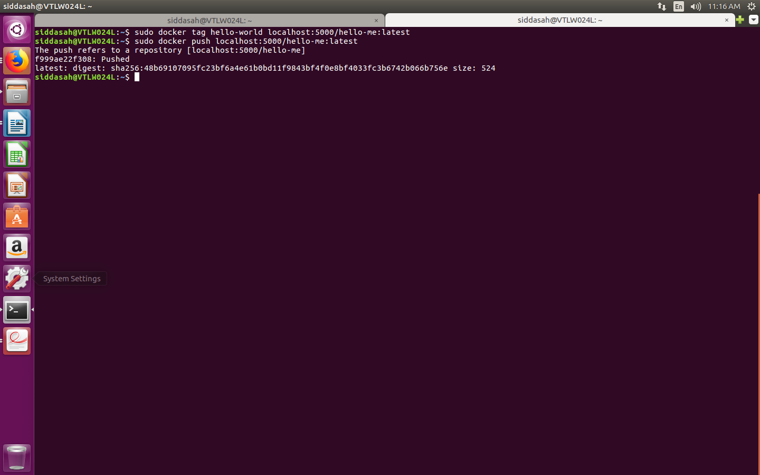

6. Check the Docker registry log messages: If the image was
pushed to the registry successfully, in the first Terminal you should
see messages showing PUT commands succeeding. For example:

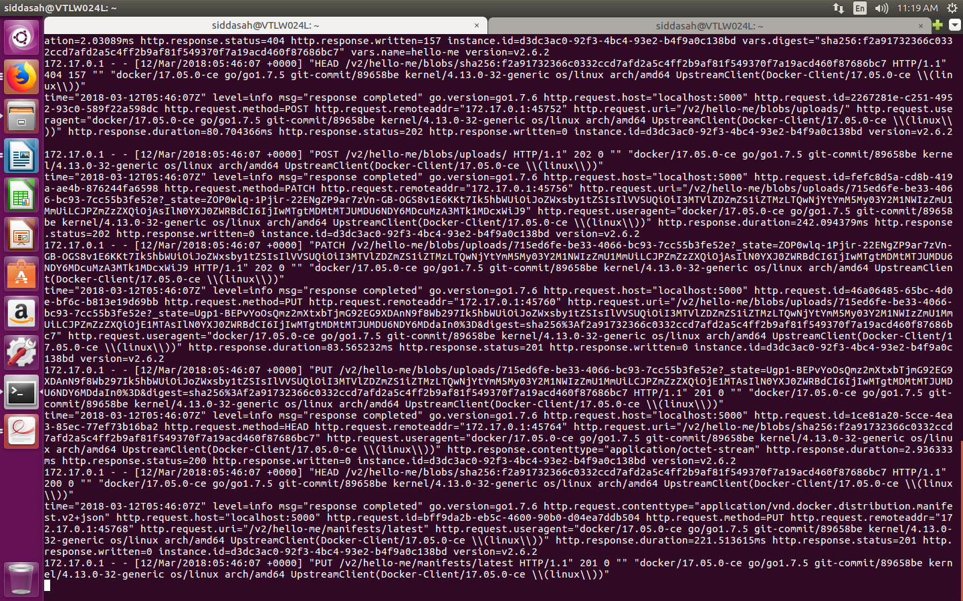

7.Pull the image: To make sure you can retrieve the image from the registry, in the second Terminal remove the image from your system, and then try to retrieve it from your local registry:
$ sudo docker rm myhello

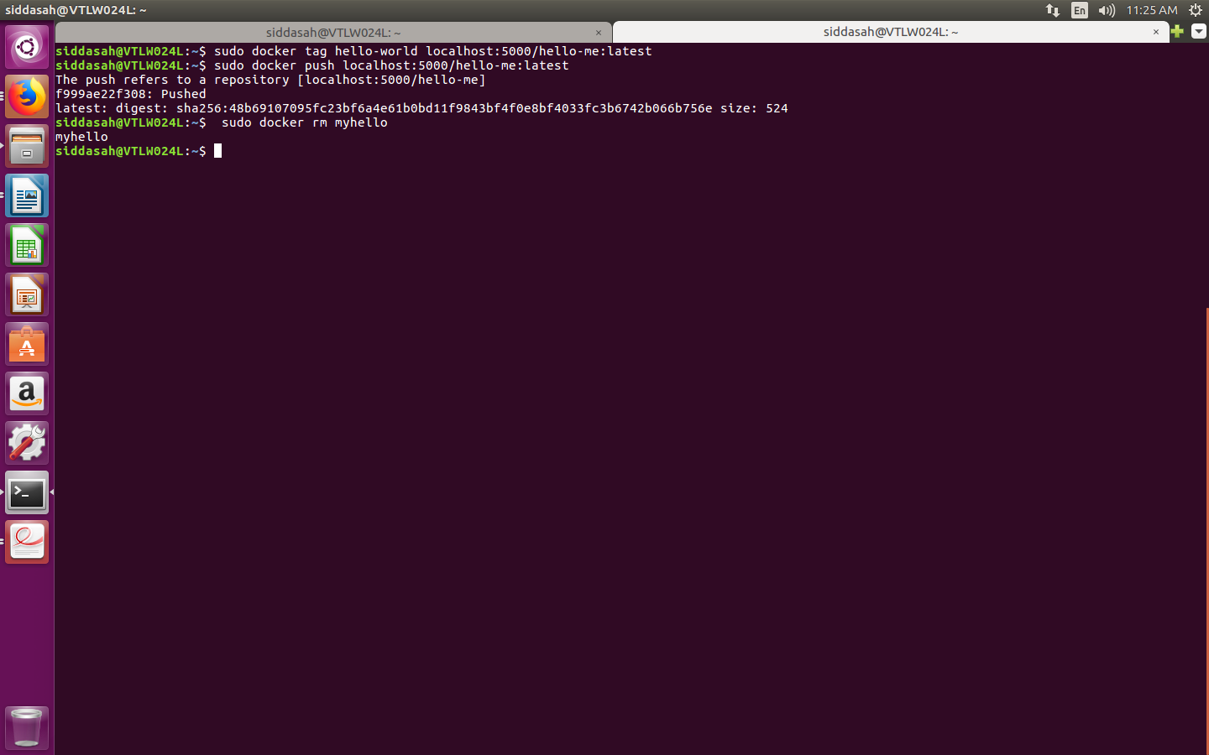

$ sudo docker rmi hello-world localhost:5000/hello-me:latest

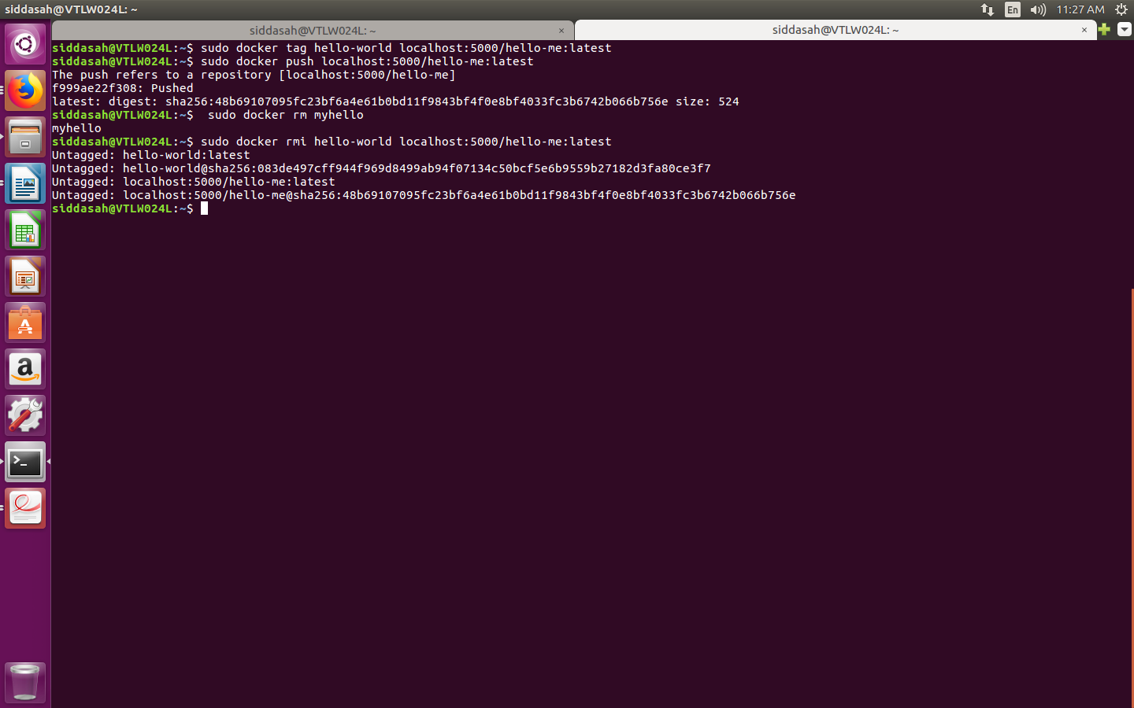
$ sudo docker pull localhost:5000/hello-me:latest

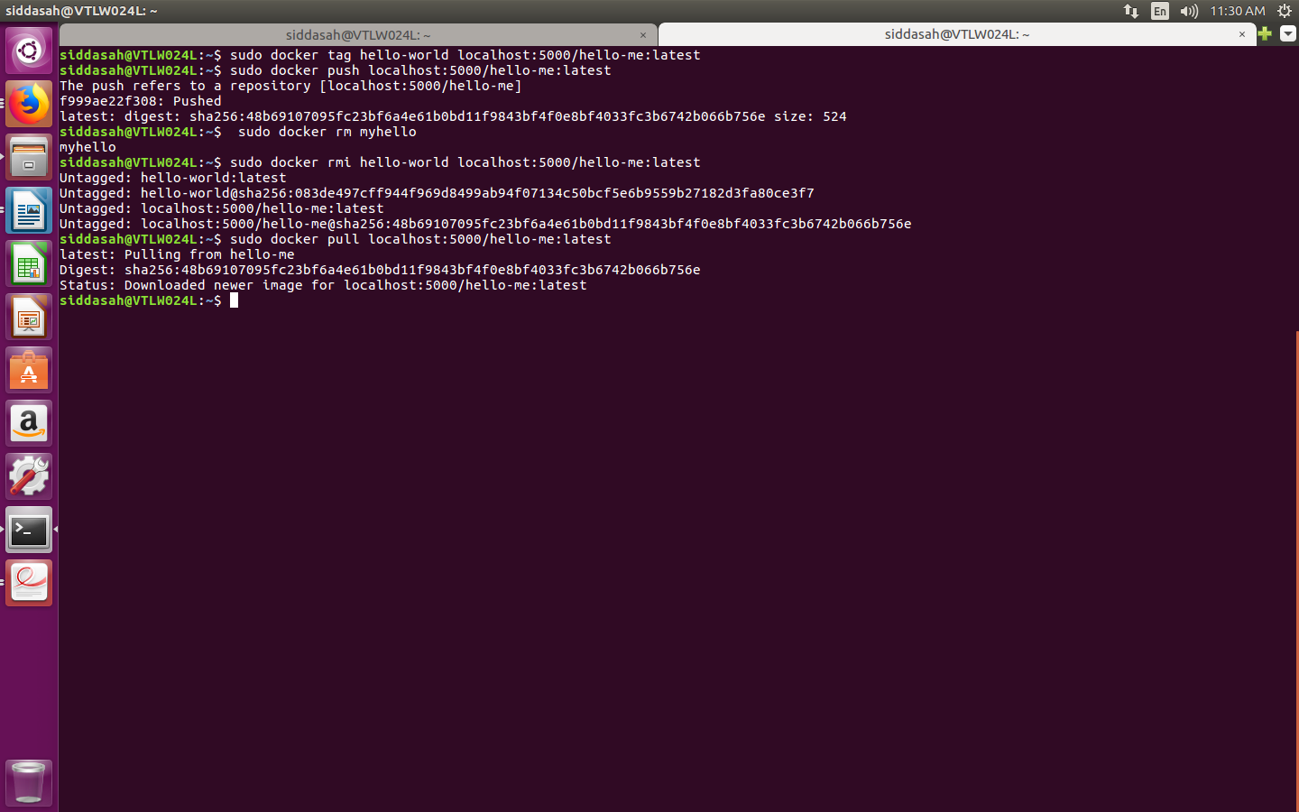

$ docker ps

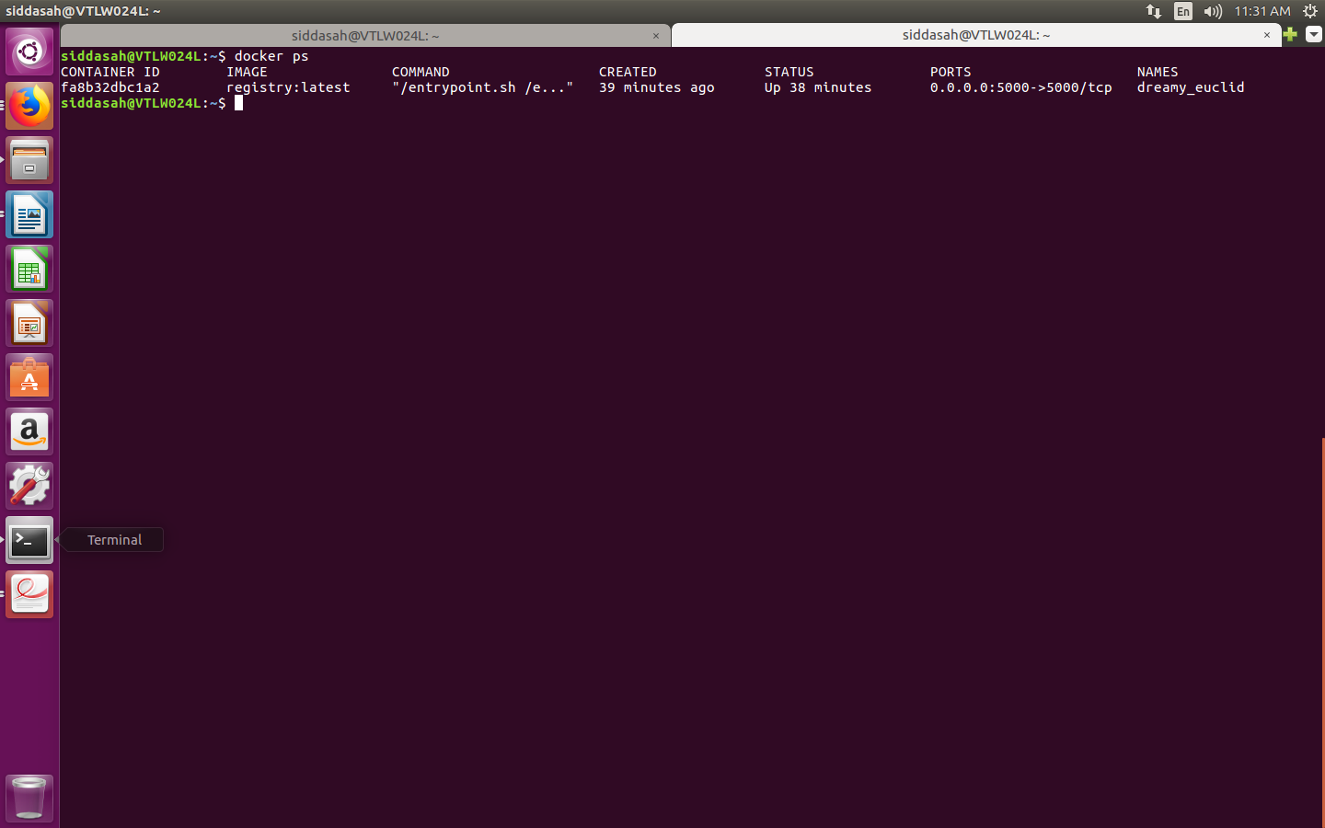
8.Run the docker registry again: Instead of running the registry image in the foreground, holding the Terminal open, you can have it run more permanently in the background (-d). To do that, close the running registry container and start a new image as follows:

$ sudo docker run -d -p 5000:5000 registry:latest
The Docker registry is running in the background now, ready to use.Open a terminal and type http://localhost:5000/v2/,u would see our registry is running.

