Sahithi_VT-936
1.
#!/usr/bin/python
pos=input("enter which position number u want:")
num=2
count=0
while count!=pos:
for val in range(2,num):
if num%val==0:
num+=1
break
else:
num+=1
count+=1
print("prime number is position {} is {}." .format(pos,num-1))

output:

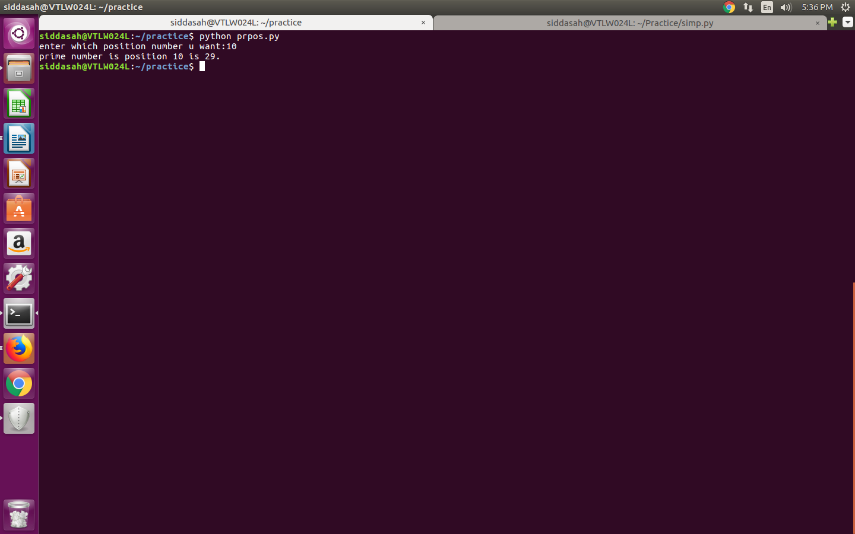
4.

#!/usr/bin/python
def fn(s):
order=[]
counts={}
for x in s:
if x in counts:
counts[x]+=1
else:
counts[x]=1
order.append(x)
for x in order:
if counts[x]==1:
return x
return -1
print fn('hello')

output:
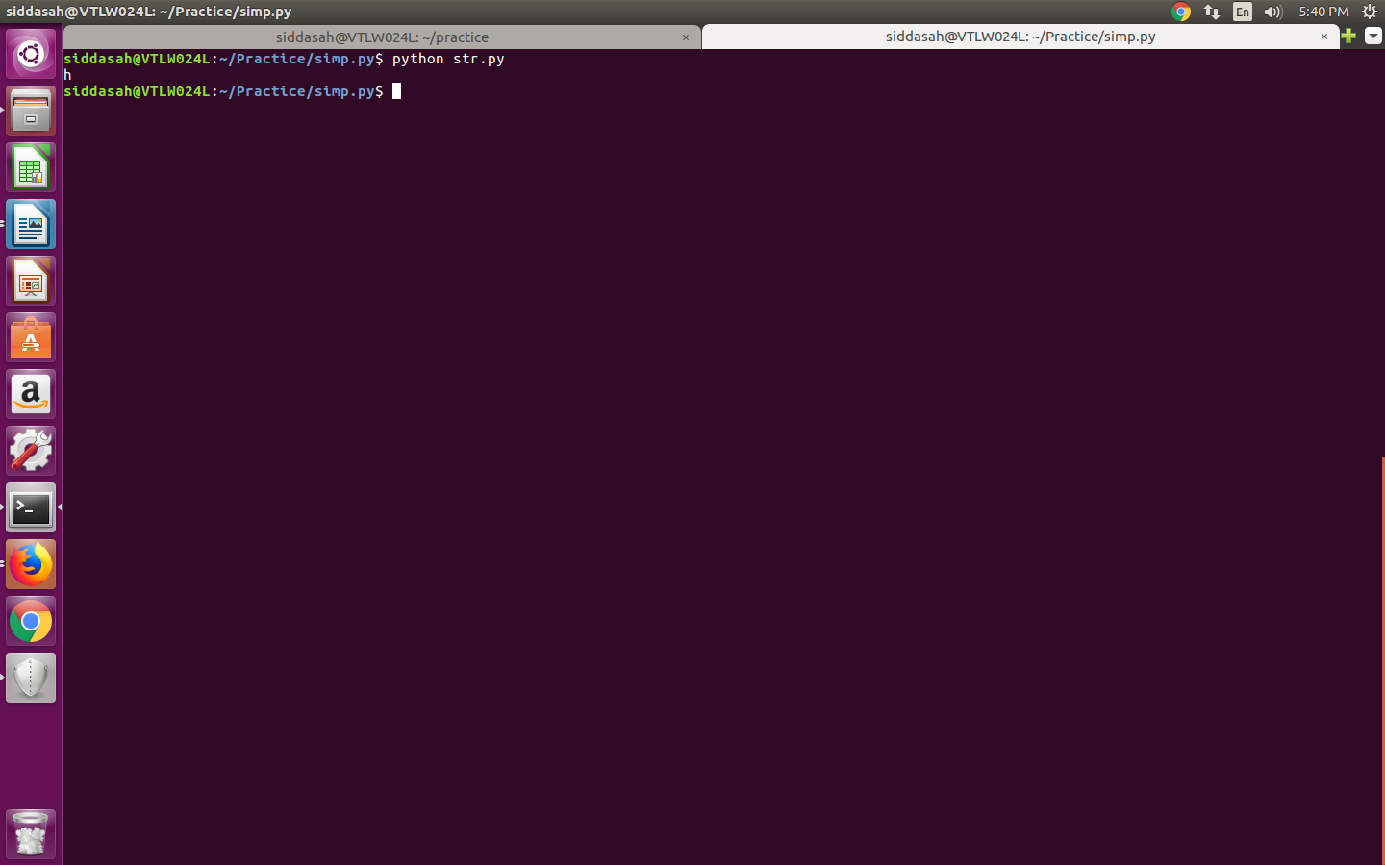
3.

#!/usr/bin/python

var1 = int(input("Enter a number to find out num is both a prime and a fibonacci number: "))

a = 1
b = 1
lst = []

for val in range(2, var1):
if var1 % val == 0:
print("Number {} is not Fibonacci-Prime".format(var1))
break
else:
while a <= var1:
lst.append(a)
a, b = b, a + b

if var1 in lst:
print("Number {} is Fibonacci-Prime".format(var1))
output:

