# Perforce client

A **Perforce client** workspace is a set of files on a user's machine that mirror a subset of the files in the depot. More precisely, it is a named mapping of depot files to workspace files. Use the p4 **client** command to create or edit a **client** workspace specification.

# Perforce applications

You use Perforce applications to communicate with the versioning service. Perforce applications enable you to check files in and out, manage conflicts, create development branches, track bugs and change requests, and more. Perforce applications include:

* **P4**, the Perforce Command-Line Client, for all platforms
* **P4V**, the Perforce Visual Client, for Mac OS X, UNIX, Linux, and Windows
* **P4Web**, the Perforce Web Client, a browser-based interface to Perforce

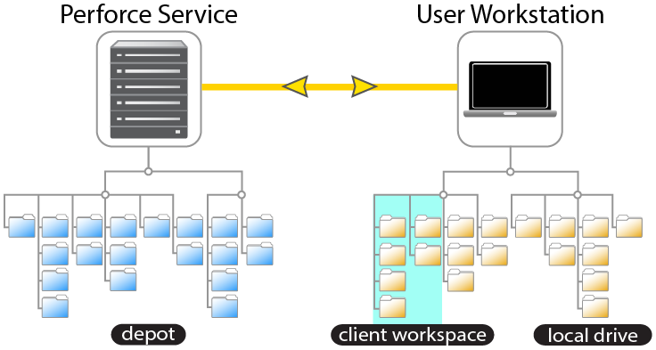

# Mapping files in the depot to your workspace

* Workspace defines a mapping of files between server and the client. This is nothing but which files you want to download.
* Workspace definition are stored on the perforce server, not on the developer’s machine.
* Workspace can be updated, modified after it is created.

To control where the depot files appear under your workspace root, you must map the files and directories on the shared versioning service to corresponding areas of your local hard drive. These mappings constitute your *workspace view*.

Workspace views:

* Determine which files in the depot can appear in a workspace.
* Map files in the depot to files in the workspace.

Client workspace views consist of one or more lines, or mappings. Each line in your workspace view has two sides: a depot side that designates a subset of files within the depot and a client side that controls where the files specified on the depot side are located under your workspace root.

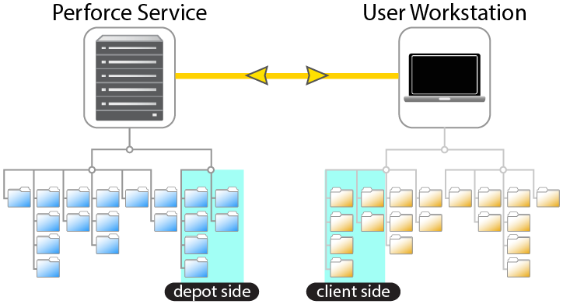

Creating a workspace doesn't transfer any files from the depot to your computer. The workspace and its view merely define the mapping that controls the relationship between the depot and your workspace when files are transferred.

# Getting files from the DEPO

The perforce manages the depot, which is nothing but a shared repository, that holds the all the versions of every files.

Your workspace is nothing but the subset of depot’s files, this is mapped to depots files.

p4 client command to create or edit a client workspace specification.

For new workspaces, the client name defaults to the **P4CLIENT** environment variable if set, or to the current host name.

The command [**p4 workspace**](https://www.perforce.com/manuals/v17.1/cmdref/Content/CmdRef/p4_workspace.html) is an alias for **p4 client**.

P4 client **-d *clientname***

Example:

$ P4 client –d haramoha:shared_component

|  |  |
| --- | --- |
| **Perforce** | **Description** |
| client/workspace | read-only files, all meta info is in server depot |
| depot | central repository |
| Change list | changes to a set of files, depot-global |
| base version | the version a file is based on |
| head | the latest change in a branch, new changes must be based on this |
| branch | location in depot dedicated to one project |
| **Working on files** | changes are pending in WD until commit |
| p4 edit | open a file for edit |
| p4 add | add files |
| p4 delete | remove files |
| p4 diff | show diff for files opened for edit |
| $P4DIFF | external (graphical) diff program |
| p4 opened | show scheduled changes |
| p4 integ; p4 delete | move file keeping history |
| p4 integ | copy file keeping history |
| p4 revert | drop all changes, revert to base version |
| p4 sync | update p4 client to other repo version |
| **Looking in repository** | changes nothing |
| p4 print | show repository file |
| p4 annotate | show modification info for each line in a file |
| p4 changes | show history of (branch of) repo |
| p4 filelog | show history of file |
| p4 tag | add a tag for a changeset |
| p4 have | show info for client files |
| p4 have | show info for client files |
| p4 have | show info for client files |
| p4 files | show info for repo files |
| p4 branches | list branch specifications - that is officially related branches |
| p4 describe | show changelist with its changes |
| **Working with repository** | all changes are pending until submit |
| p4 client | create a new branch+client from scratch |
| p4 client; p4 sync | create a new workspace for existing repo |
| p4 client; p4 integ | create a new branch+client based on other |
| p4 integ; p4 resolve | get changes from other p4 branch |
| p4 integ | integrate changes from other branch |
| p4 integ | integrate changes to other branch |
| (diff; merge) | can't move changes to other repos - must be done manually |
| p4 sync; p4 resolve | rebase scheduled changes to other repo version |
| p4 sync | get new changes from central repository |
| p4 sync; p4 resolve | get changes from central repo and merge them with local changes |
| p4 submit | add pending changes to the chain of changesets in branch |
| p4 submit | submit a change to the central repository |
| p4 triggers | run commands (send email) when certain events happen |
| p4 protect | control user's access |