Exp-3

NAME-AKASH KUMAR SAHU

ID-2019KUEC2026

AIM:- To generate and demodulate the amplitude shift key (ASK) signal using matlab.

## THEORY:-

**Amplitude Shift Keying**ASKASK is a type of Amplitude Modulation which represents the binary data in the form of variations in the amplitude of a signal.

Any modulated signal has a high frequency carrier. The binary signal when ASK modulated, gives a **zero** value for **Low** input while it gives the **carrier output** for **High** input.

The following figure represents ASK modulated waveform along with its input.

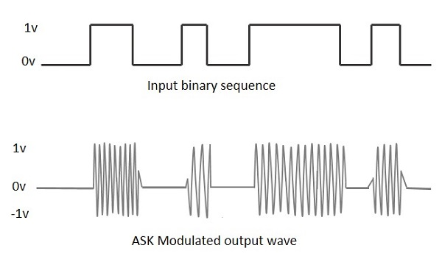

To find the process of obtaining this ASK modulated wave, let us learn about the working of the ASK modulator

## Matlab code:-

%GENERATE CARRIER SIGNAL

Tb=1; fc=10;

t=0:Tb/100:1;

c=sqrt(2/Tb)*sin(2*pi*fc*t);

%generate message signal

N=8;

m=rand(1,N);

t1=0;t2=Tb

for i=1:N

t=[t1:.01:t2]

if m(i)>0.5

m(i)=1;

m_s=ones(1,length(t));

else

m(i)=0;

m_s=zeros(1,length(t));

end

message(i,:)=m_s;

%product of carrier and message

ask_sig(i,:)=c.*m_s;

t1=t1+(Tb+.01);

t2=t2+(Tb+.01);

%plot the message and ASK signal

subplot(5,1,2);axis([0 N -2 2]);plot(t,message(i,:),'r');

title('message signal');xlabel('t--->');ylabel('m(t)');grid on

hold on

subplot(5,1,4);plot(t,ask_sig(i,:));

title('ASK signal');xlabel('t--->');ylabel('s(t)');grid on

hold on

end

hold off

%Plot the carrier signal and input binary data

subplot(5,1,3);plot(t,c);

title('carrier signal');xlabel('t--->');ylabel('c(t)');grid on

subplot(5,1,1);stem(m);

title('binary data bits');xlabel('n--->');ylabel('b(n)');grid on

Demodulation code:

t1=0;t2=Tb

for i=1:N

t=[t1:Tb/100:t2]

%correlator

x=sum(c.*ask_sig(i,:));

%decision device

if x>0

demod(i)=1;

else

demod(i)=0;

end

t1=t1+(Tb+.01);

t2=t2+(Tb+.01);

end

%plot demodulated binary data bits

subplot(5,1,5);stem(demod);

title('ASK demodulated signal'); xlabel('n--->');ylabel('b(n)');grid on

**Output:-**

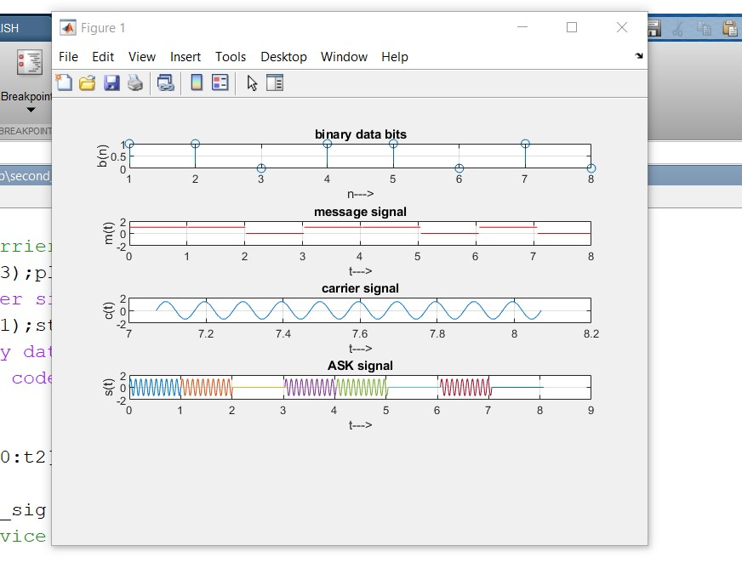

Conclusion-. Result image Amplitude shift key (ASK) signal was generated and demodulated successfully using matlab.