Objectives-

Below tasks should be automated through Jenkins by creating a pipeline:

1. Install and configure puppet agent on the slave node (Job 1)

2. Push an Ansible configuration on test server to install docker (Job 2)

3. Pull the PHP website, and the Dockerfile from the git repo and build and deploy your PHP docker container. After. (Job 3)

4. If Job 3 fails, delete the running container on Test Server

GIT Repo used for deomnstration-- <https://github.com/sahubibh/AppleBite>





A jenkins slave node created which will act as a test server (with label test)

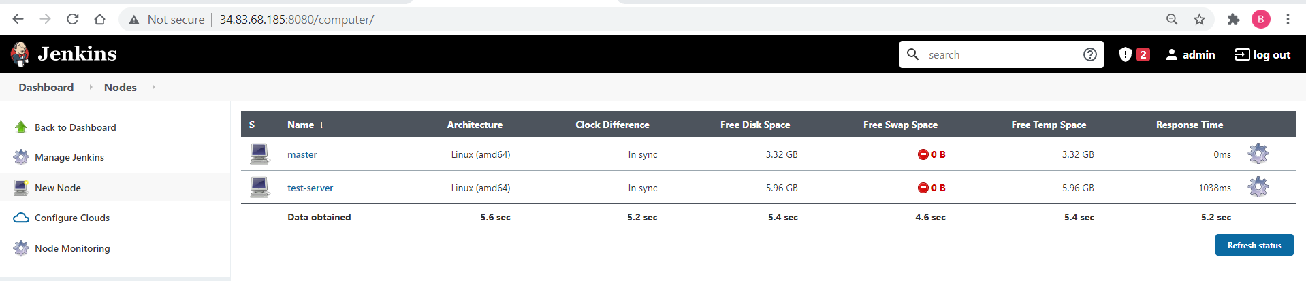

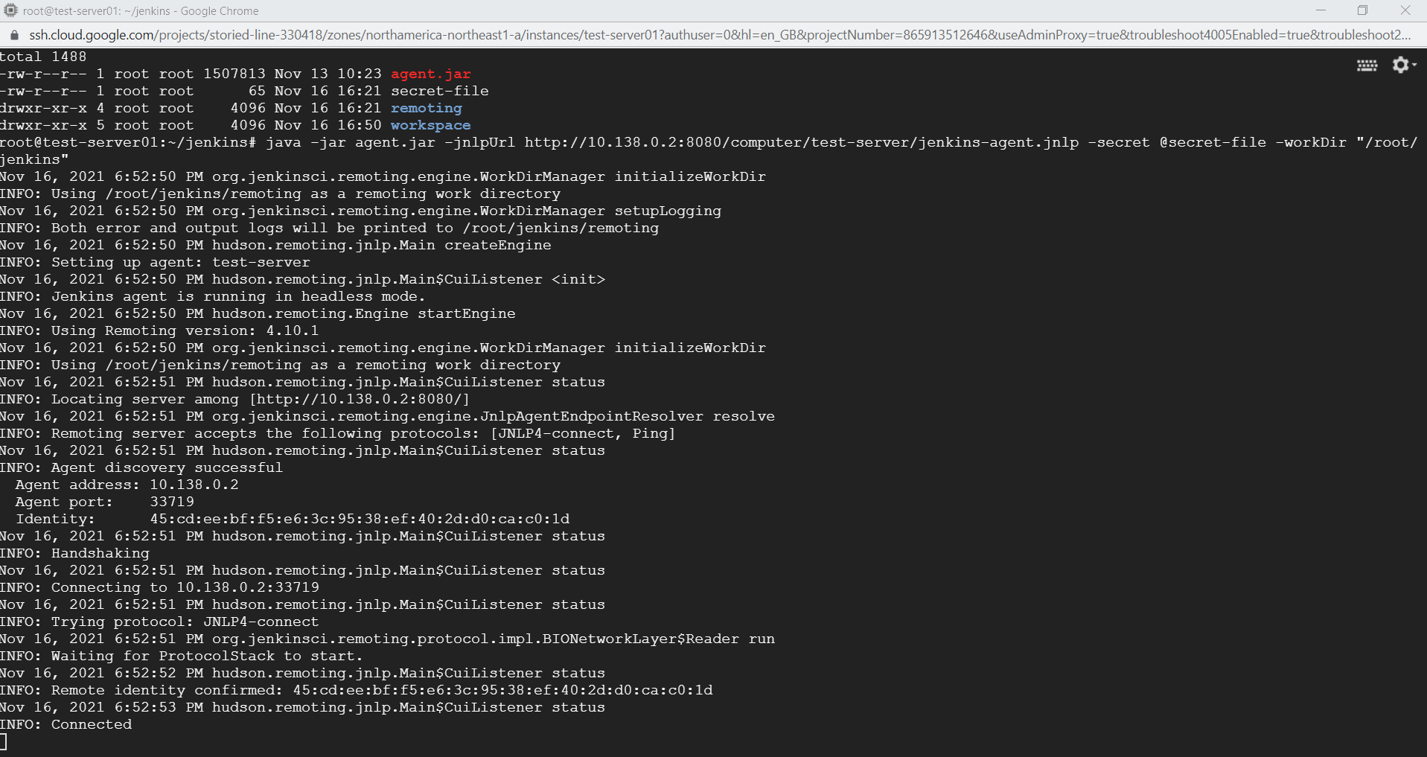

Installing puppet agent on test server-

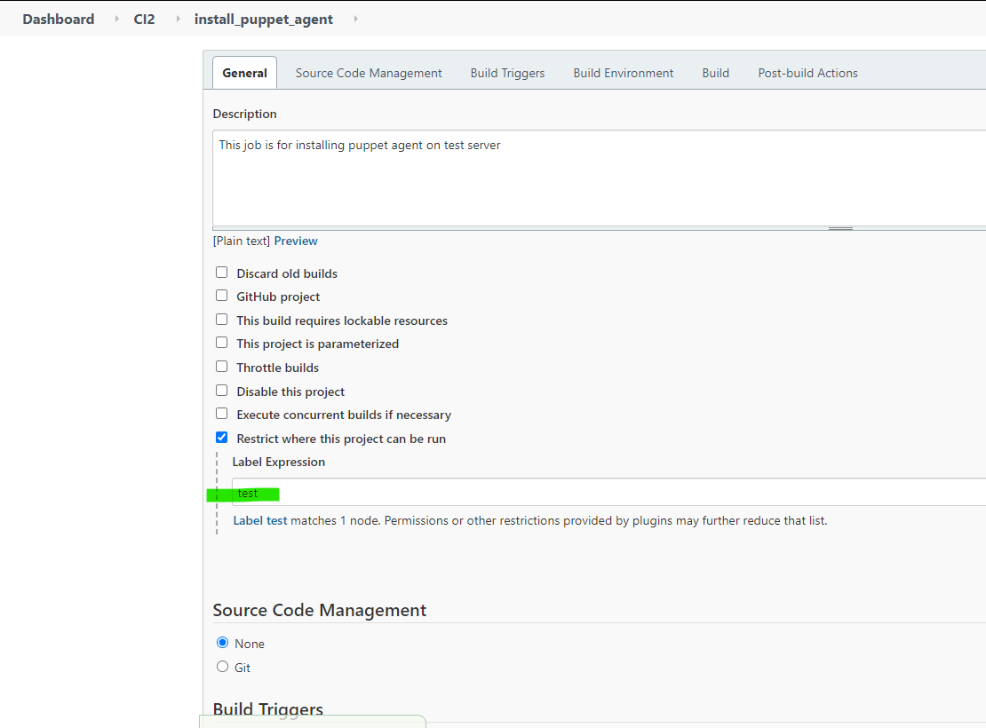

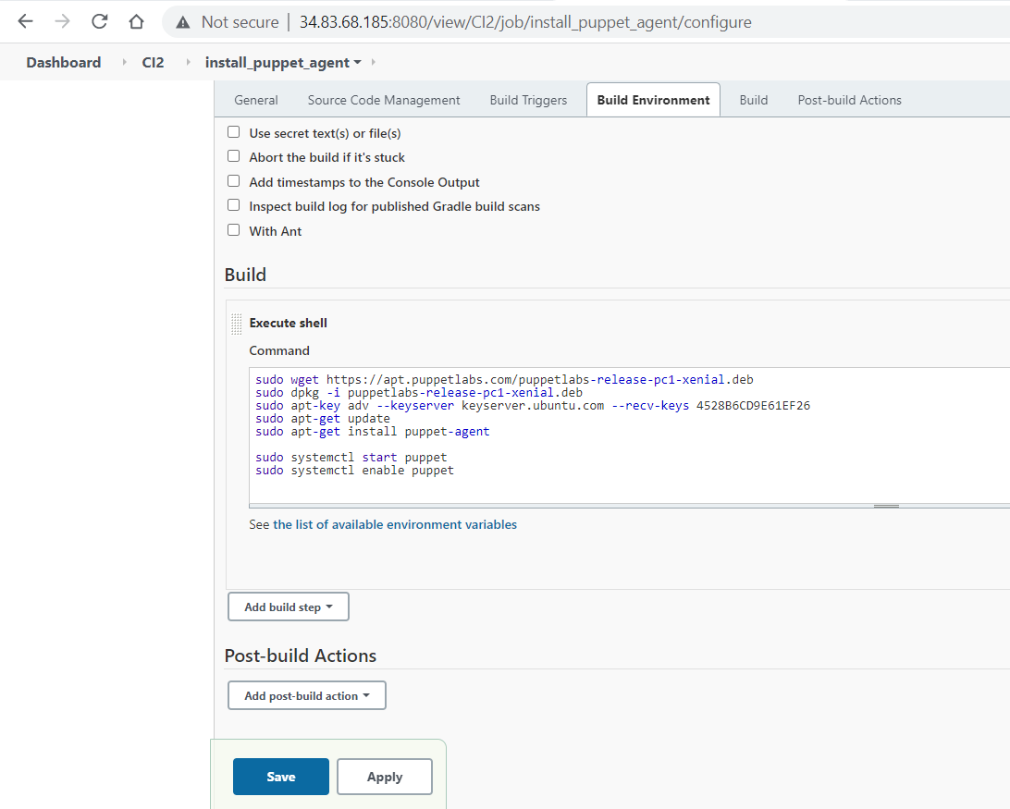

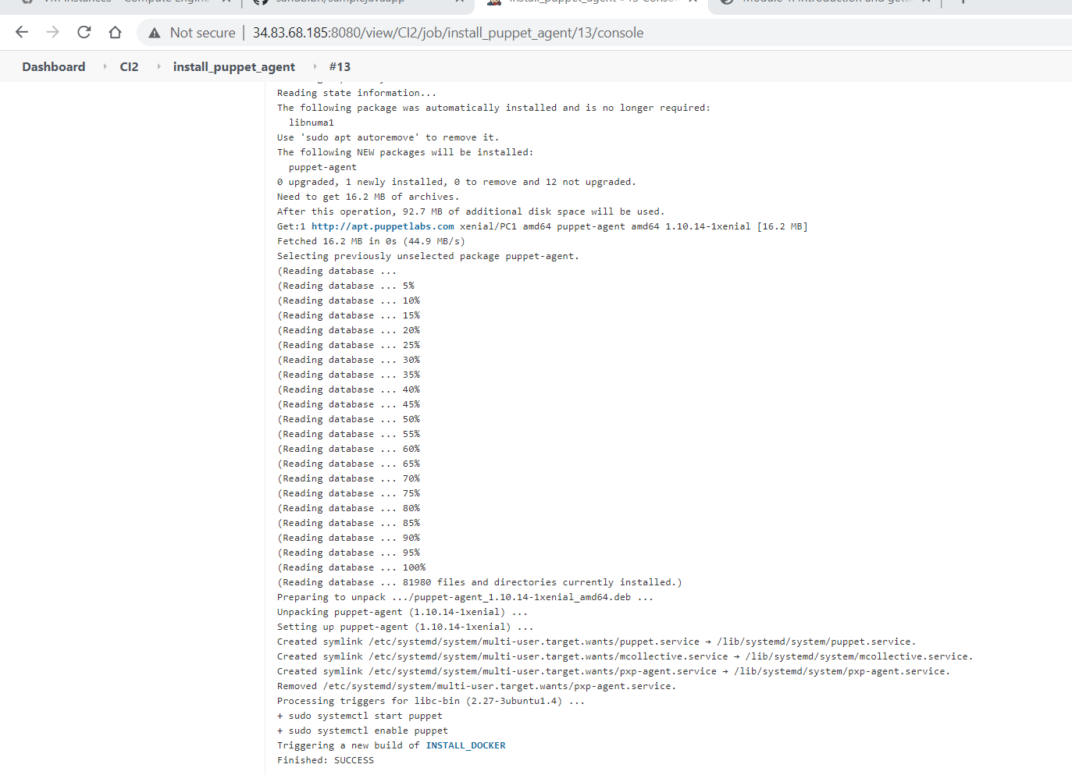

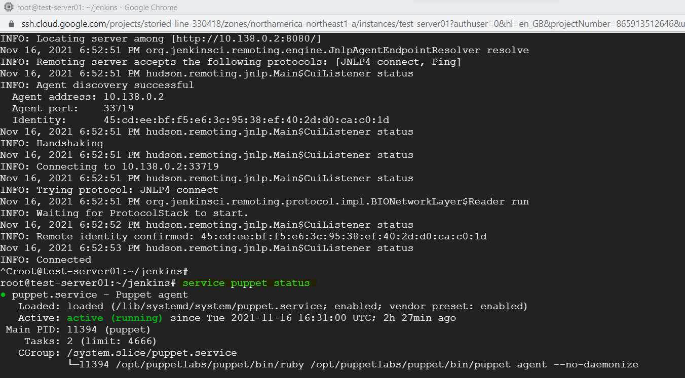

Installing docker using Ansible on test server-

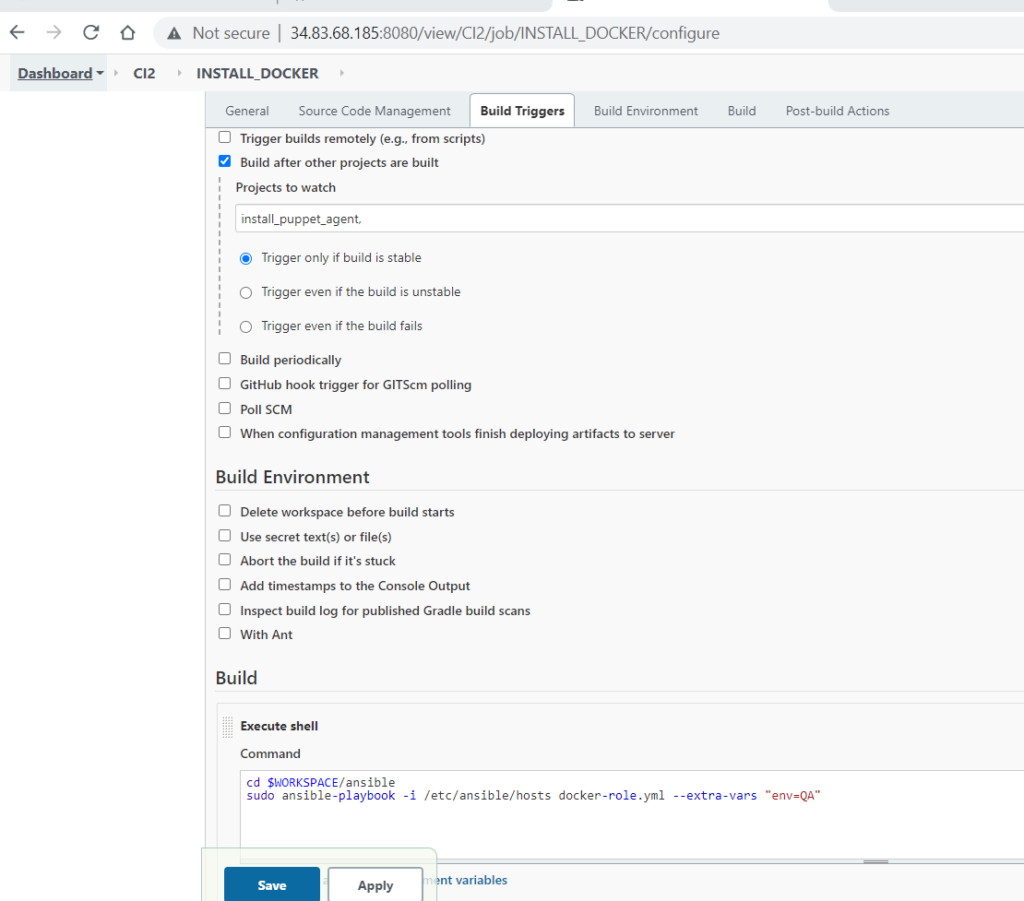

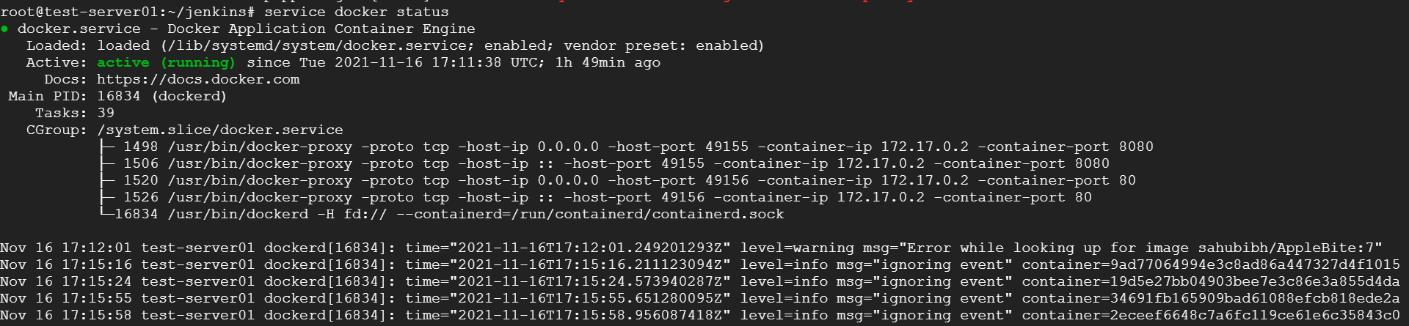

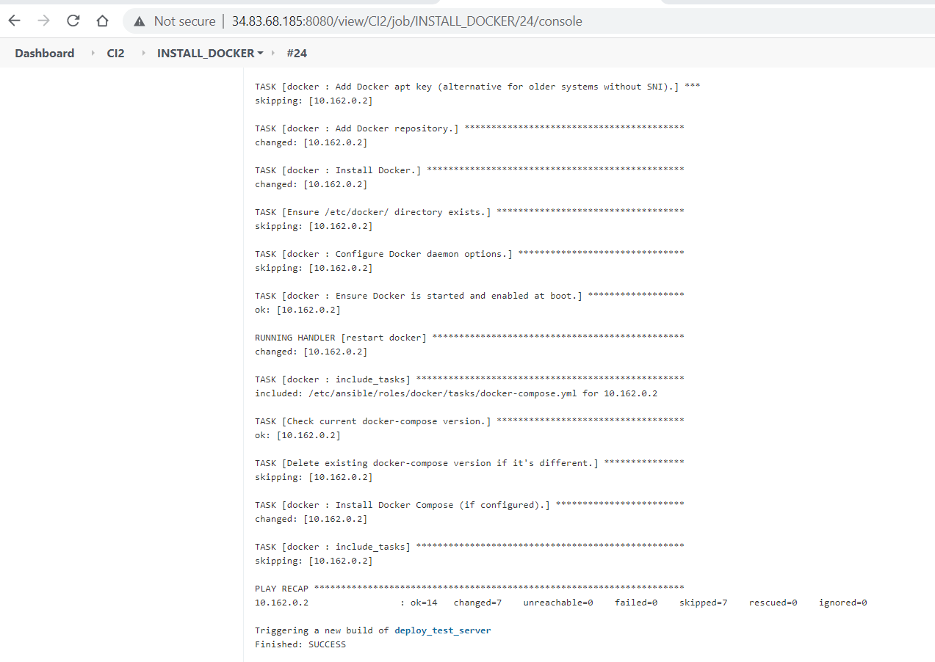

Deploying the code on test server-

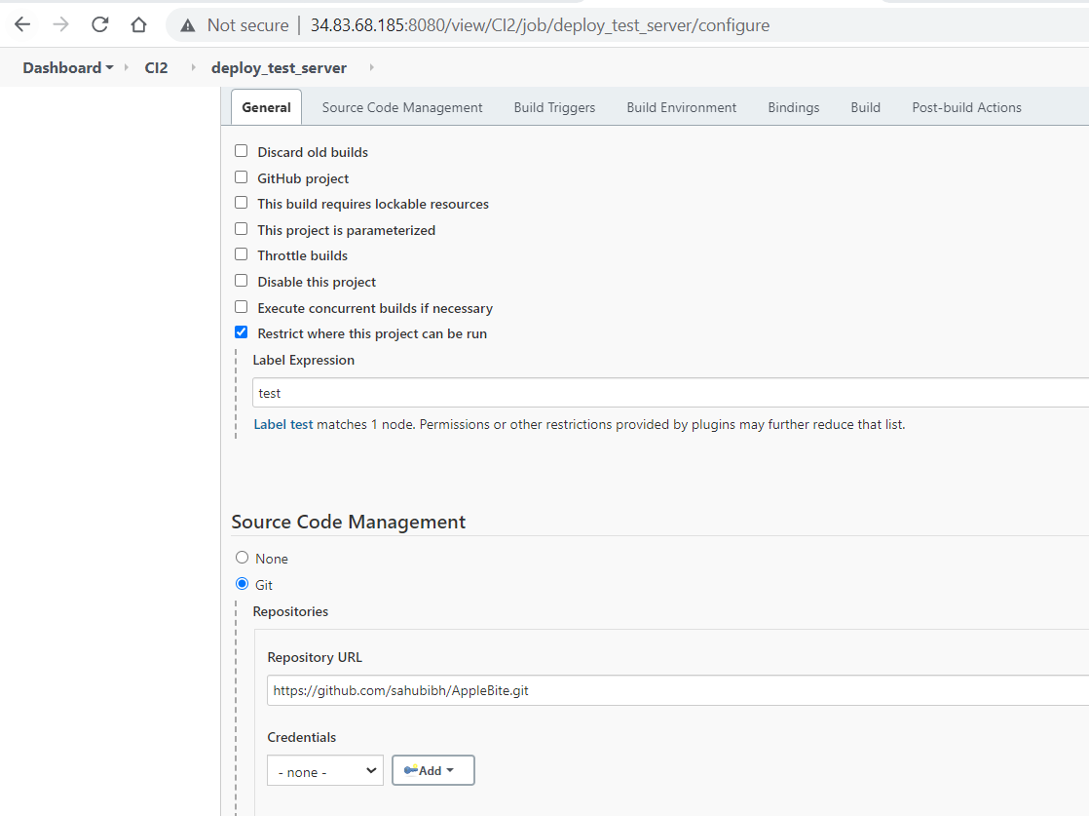

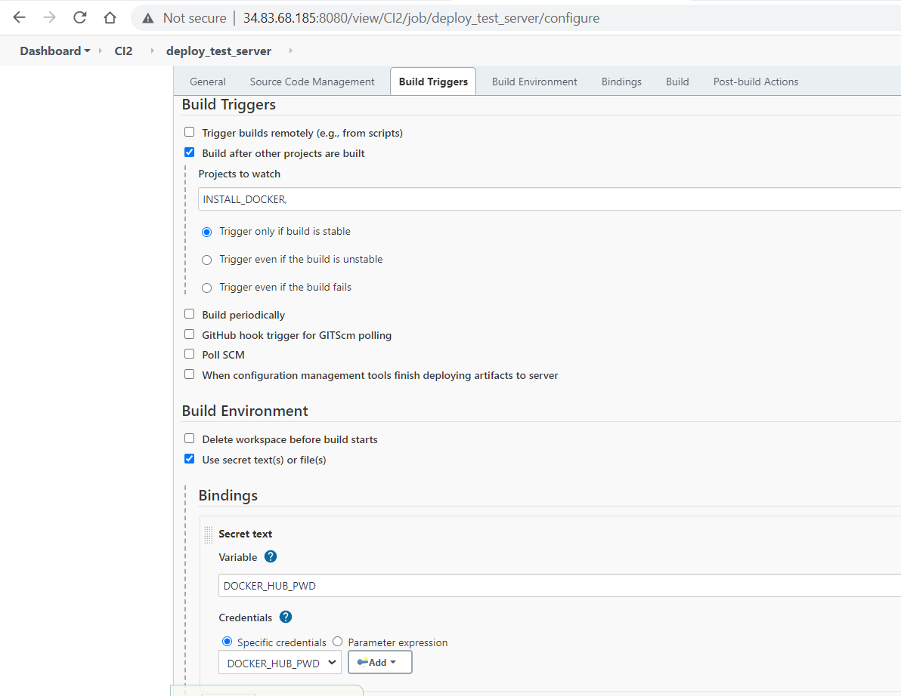

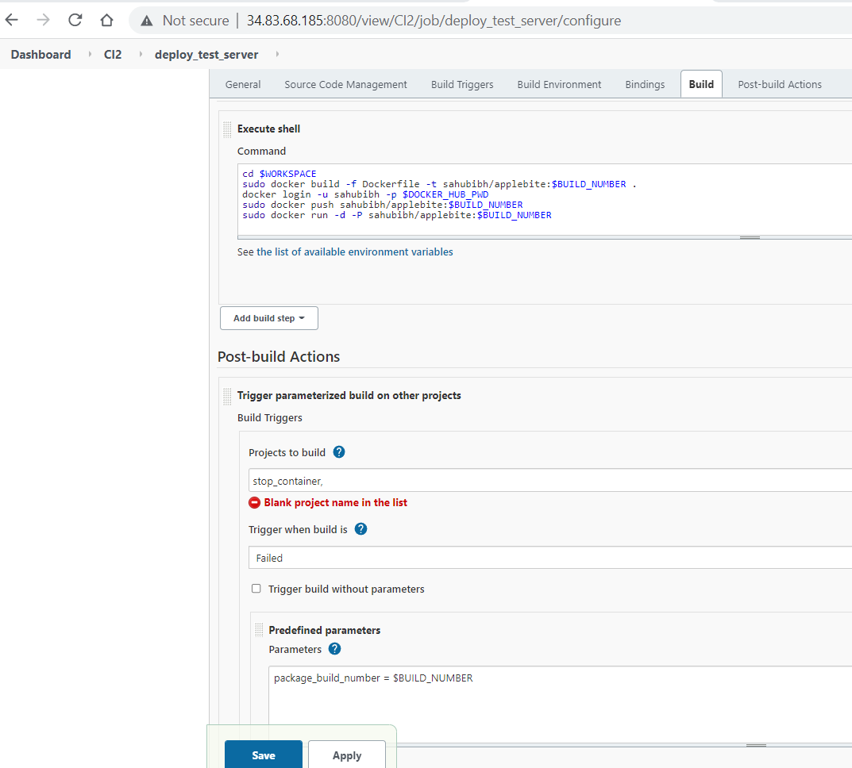

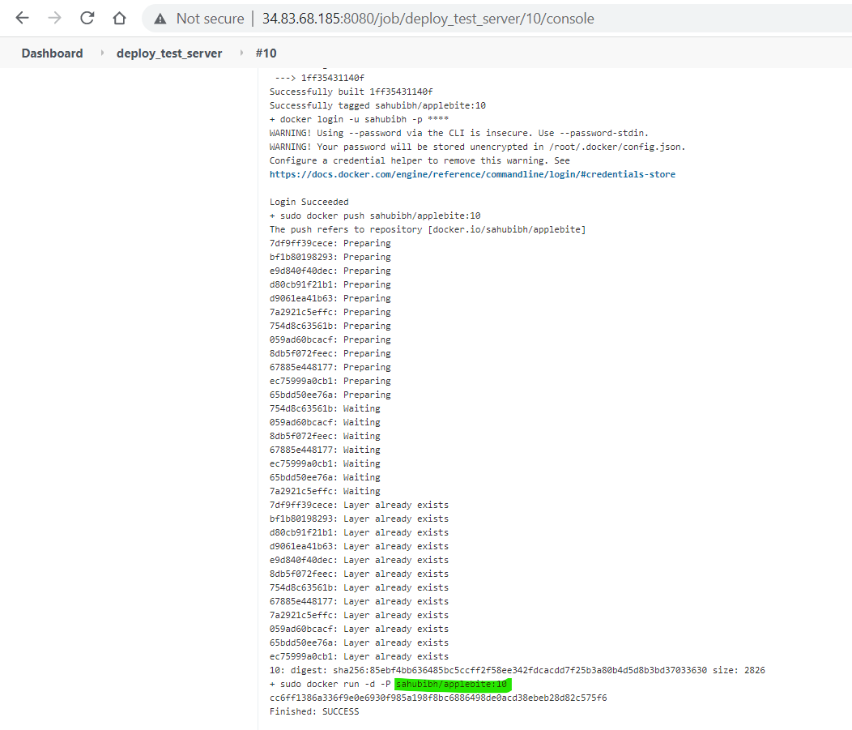

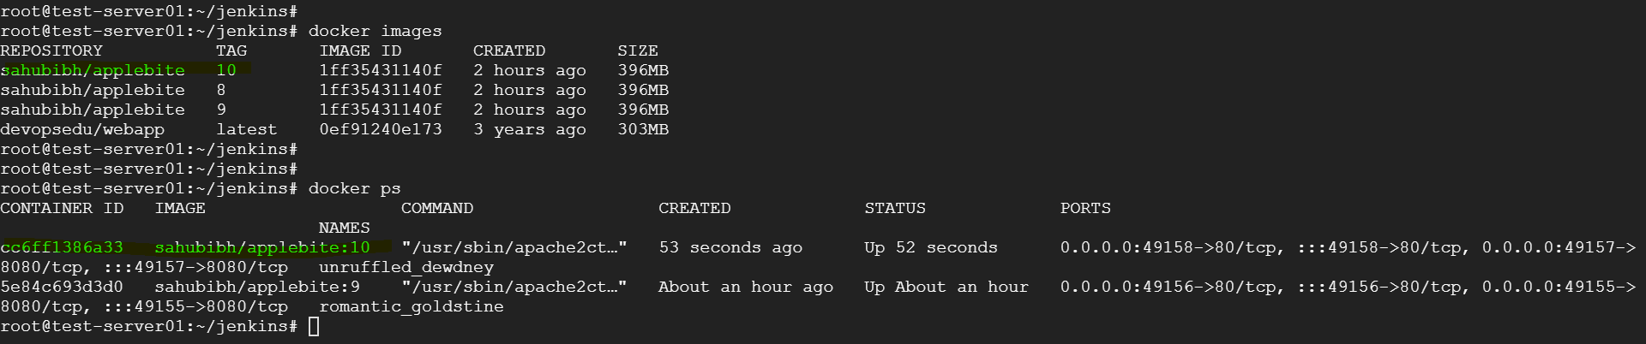

Build Pipeline View-

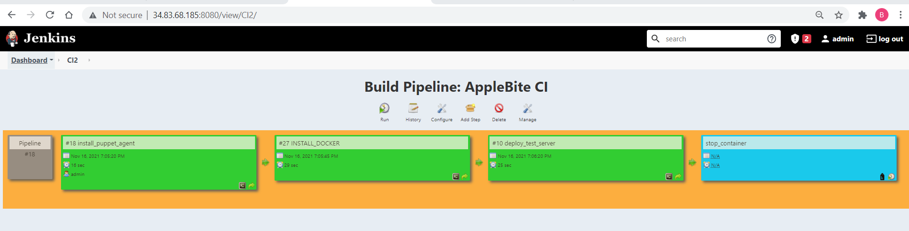

Please note stop_container job will only run when job 3 i.e., deploy_test_server fails.

