**Objectives-**

* The team of developers working on new features will merge their code to a GitHub repo.
* As soon as the code reaches GitHub, using a CI (Continuous Integration) pipeline, setup in Jenkins, automated builds will be triggered.
* The automated builds will frequently deploy new features to the production website.
* Every build will prepare a Dockerfile and push docker images to docker-hub.
* Every docker image will be deployed (Continuous Deployment) to a Kubernetes-cluster.



**Jenkins-master** is my Build server- (this is the server where source code is pulled, compiled, unit testing performed and packaged. Upon successful completion then docker image is created and then the image is deployed to QA and prod Kubernetes clusters subsequently.

Prod k8s cluster -

Test k8s Cluster -



Ansible Hosts file-

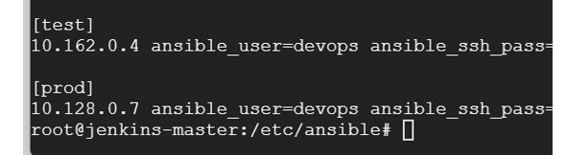

**Build Pipeline View-**

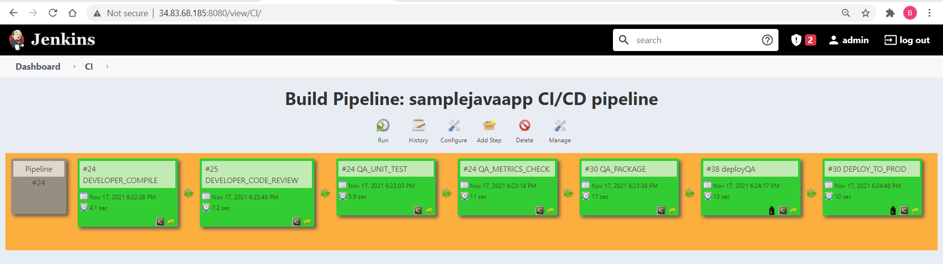

GIT Repo used for demonstration- <https://github.com/sahubibh/samplejavaapp.git>

(Please note the repo provided in the assignment having Gradle build which we did not cover during this Devops course,

hence, I have used this repo which has maven build)

Code commit in GitHub pushed the changes to Jenkins-

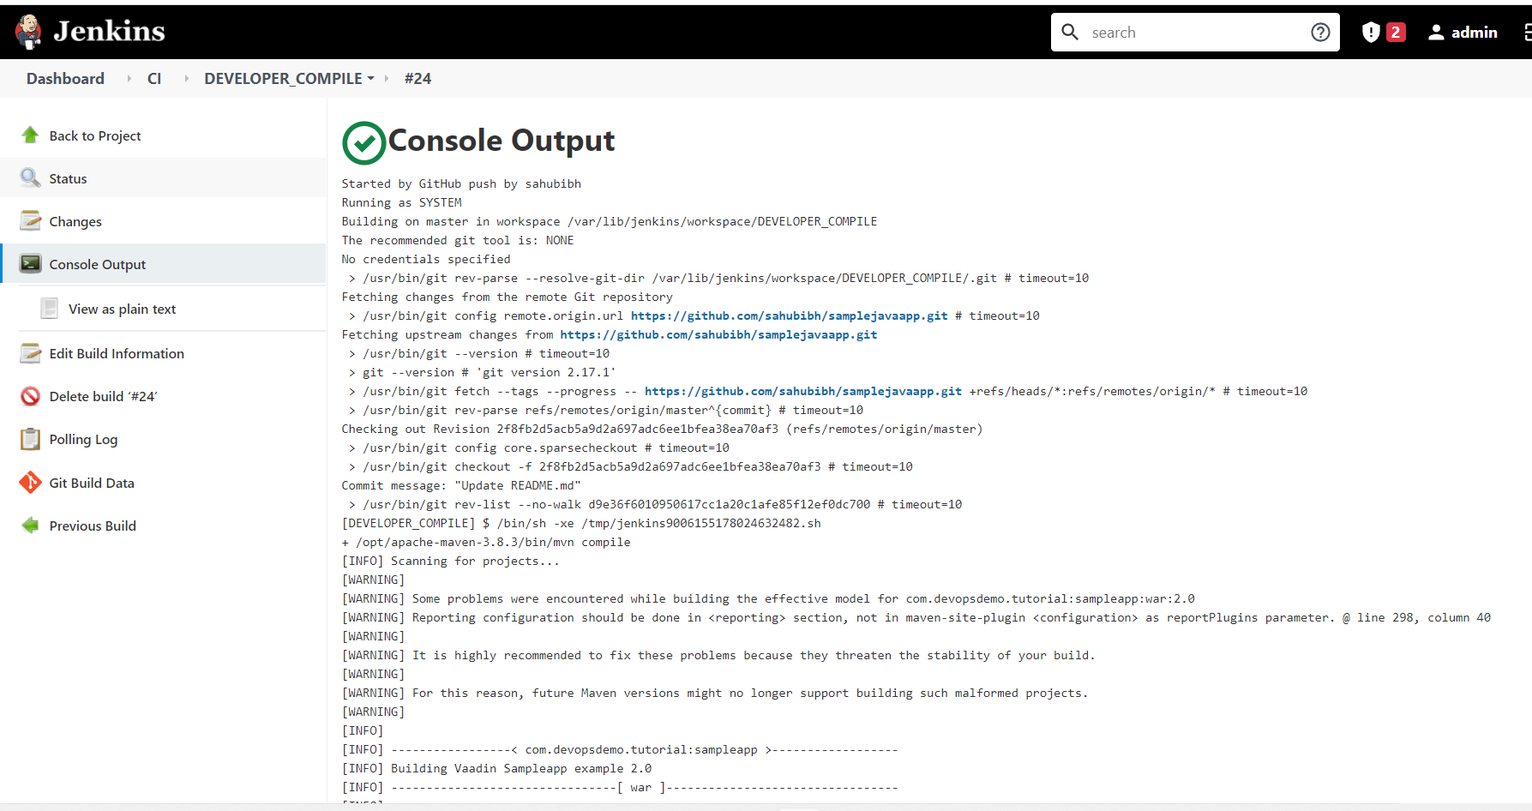

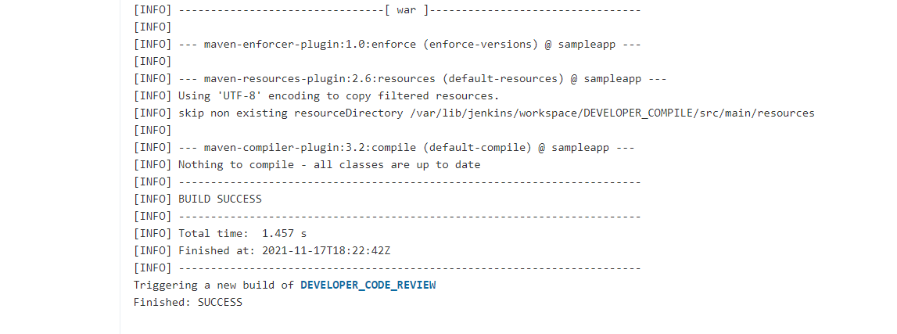

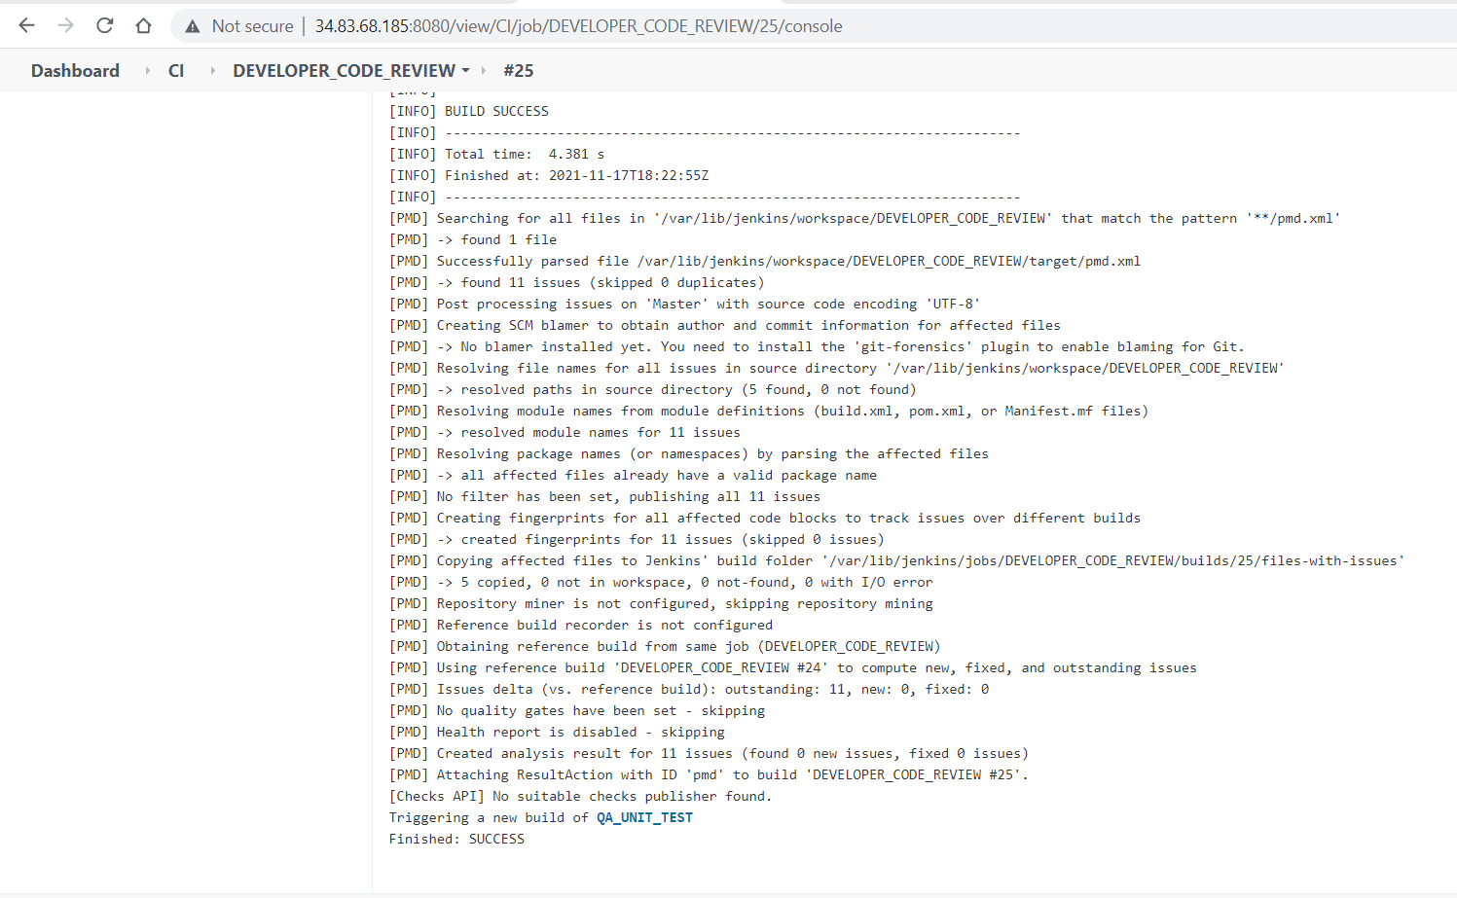

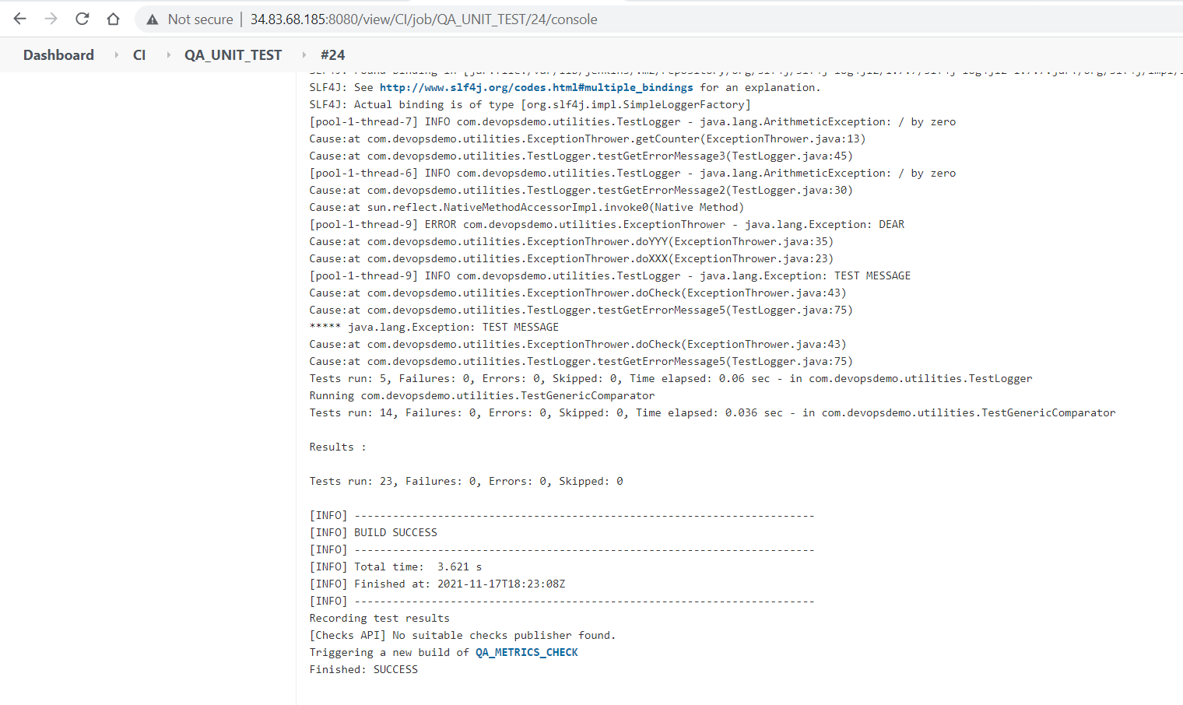

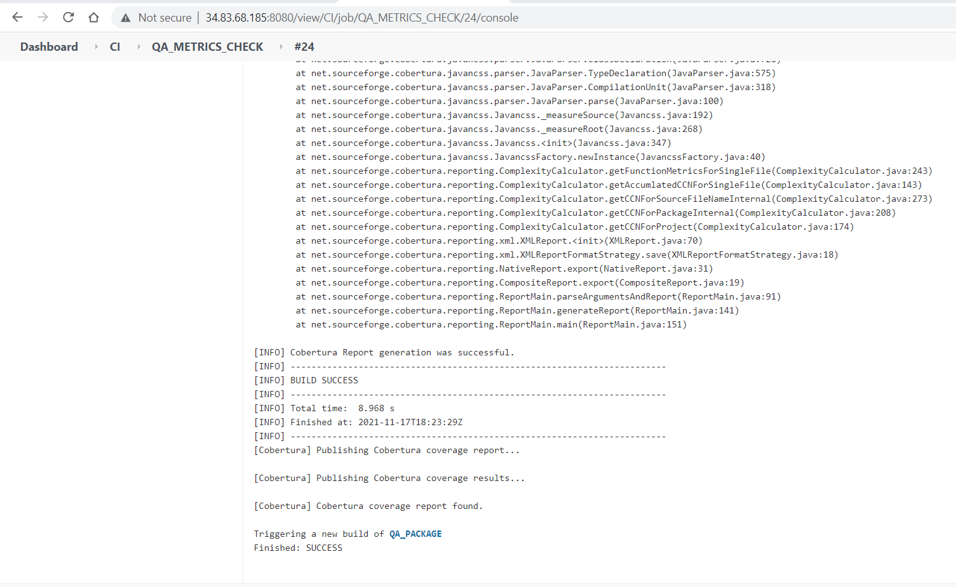

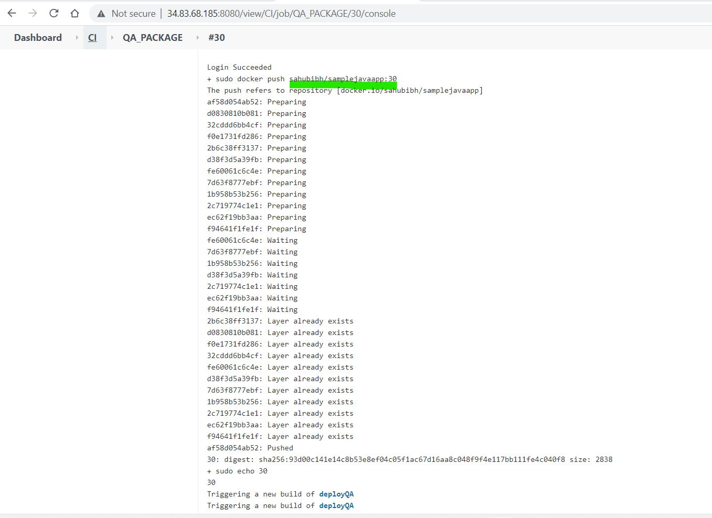

Image pushed to docker hub-

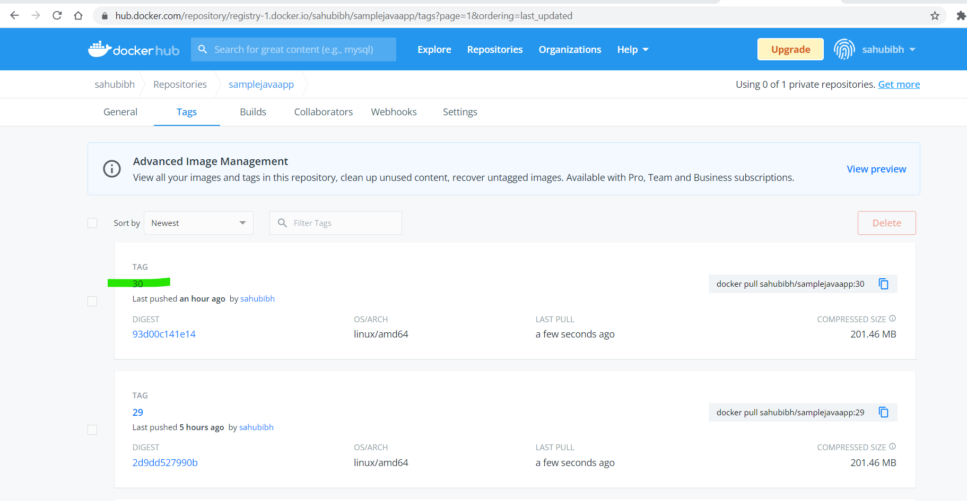

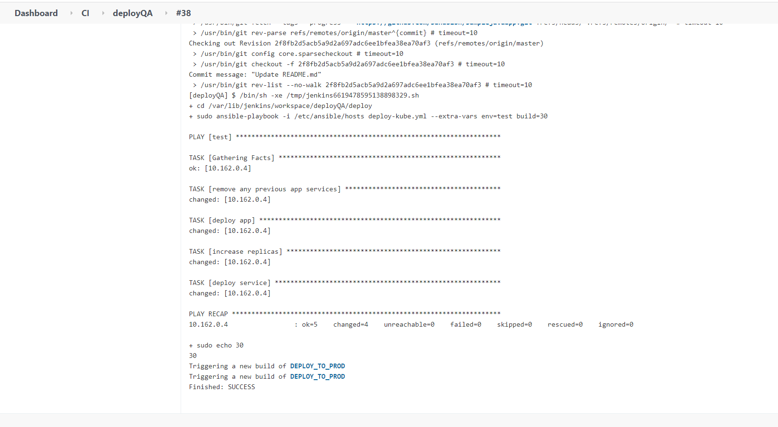

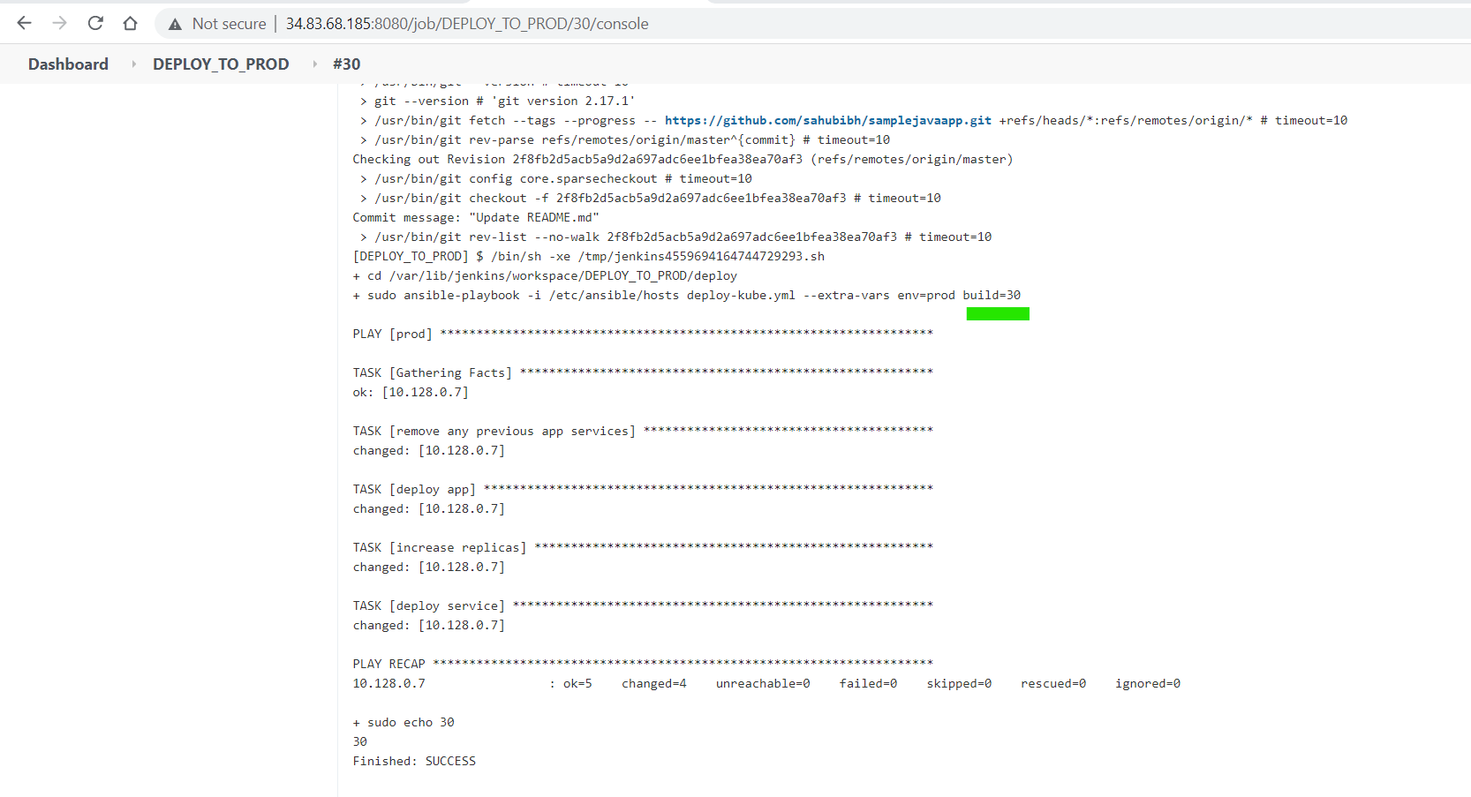

Prod k8s cluster post deployment-

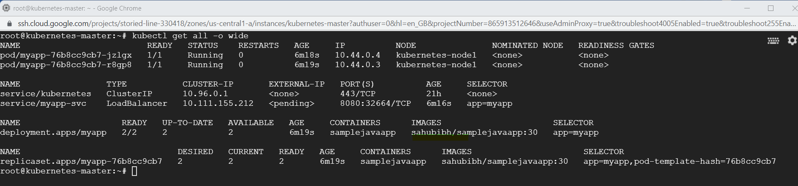

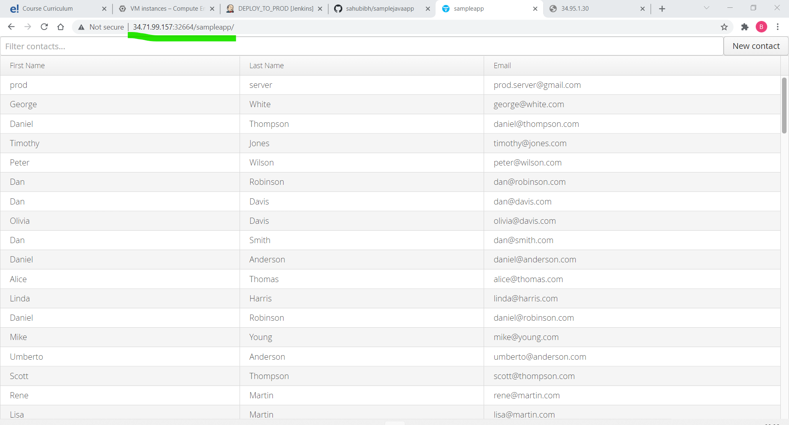

Test k8s cluster post deployment

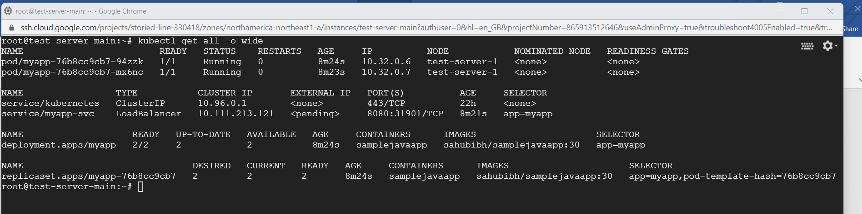

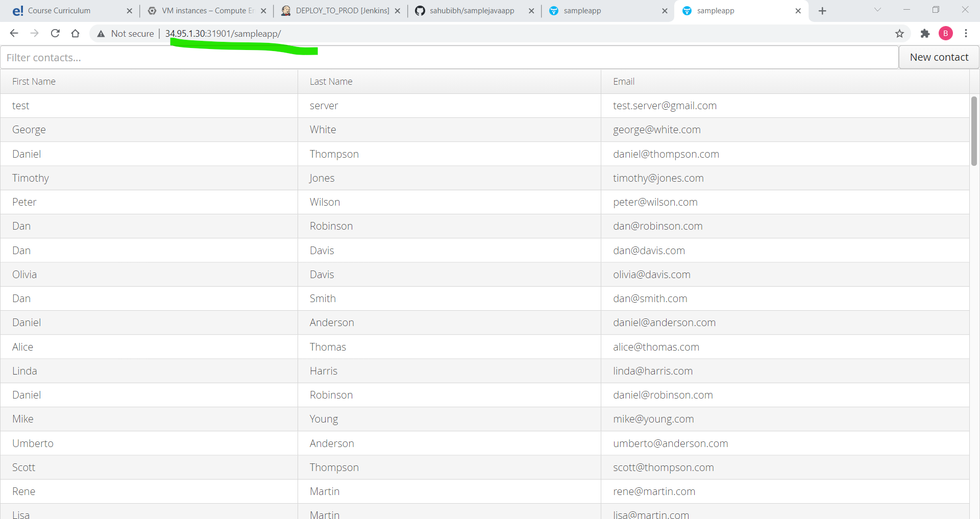

**Jenkin jobs Configuration-**

