**Experiment 6: Create an artificial intelligence powered ChatBot to mimic human interactions for e-commerce.**

**Requirement:** Laptop or Desktop with Python installed

**Theory**

A chatbot is a computer program that simulates conversation with human users to complete some sort of service.

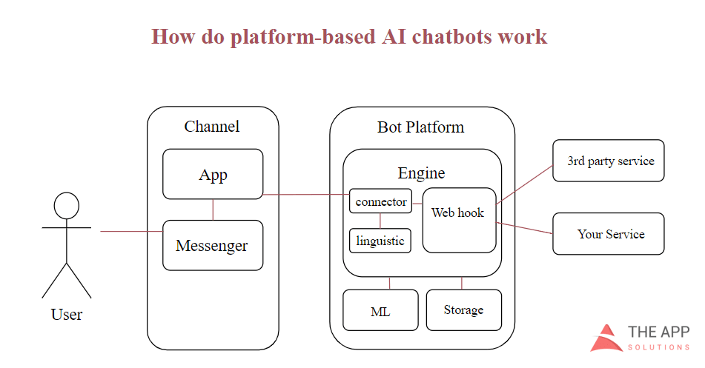

Figure 1: Workflow in sentiments detection

Chatbots for ecommerce companies are typically designed to:

* Complete buyers’ purchases
* Offer buyers product recommendations
* Provide customer support

The Types of Chatbots for E-Commerce

Script Bots. This is the simplest type of chatbots. Such bots operate on the base of predefined commands or scripts. They are programmed to recognize some words and answer basic questions. Nowadays, this is the most popular type of e-commerce chatbots. However, they aren't very flexible. Some online shops integrate bots with Natural Language Processing (NLP) technology to make interactions with customers more natural.

Smart bots. These chatbots are powered by AI (Artificial Intelligence). They provide more positive user experience since they interact with customers in a human-like way. Still, such bots are not perfect. Their work is not fully automated, and they need human intervention to be able to answer specific customer inquiries.

Intelligent Agent. This is the most advanced type of chatbots. They combine machine learning and AI technologies, which makes them entirely self-sufficient. The great examples of such bots are Amazon’s Alexa, IBM Watson, and Siri.

Define E-Commerce Chatbot Features

On this stage, you need to decide the purpose of your future chatbot since there are many options. Your future chatbot could perform as:

* Product finder
* Order status checker
* Customer service provider
* Offer notifications
* Personal shopping assistant

Alternatively, all of these purposes can be used in one chatbot since this technology has endless business use cases.

Below we share the most popular tasks performed by a chatbot on e-commerce websites. Please read it and pick the most useful one for your future chatbot feature list.

* Collect customer data
* Advertise and broadcast
* Handle online transactions
* Send notifications and reminders
* Provide access to information
* Upsell products
* Conduct market research by offering a quiz
* Give personalized recommendations
* Collect customer data and user feedback
* Provide customers support
* Automate business process

**Output**

