**Experiment 7: Create an artificial intelligence powered ChatBot to mimic human interactions for e-commerce.**

**Requirement:** Laptop or Desktop with Python installed

**Theory**

Individual learner differences like personality or cognitive engagement influence the learning behaviour. More effective tutoring in an online environment can be achieved by applying a cognitive model for each participant that can be used to predict his behaviour and performance. One deficiency is the difficulty to raise personal data for personalization. Online courses mostly have access to demographic data only. However, there are other items that have even more impact on the behaviour. Our solution is a system that uses an educational chatbot with which participants interact in context of the online course. Since chatbot technology can be used for learning and teaching as well we use this method to offer learners a dialogue based-system that teaches in a personalized way. The main question of concern is “How exactly should a dialogue system be designed to capture the described participant’s data?”

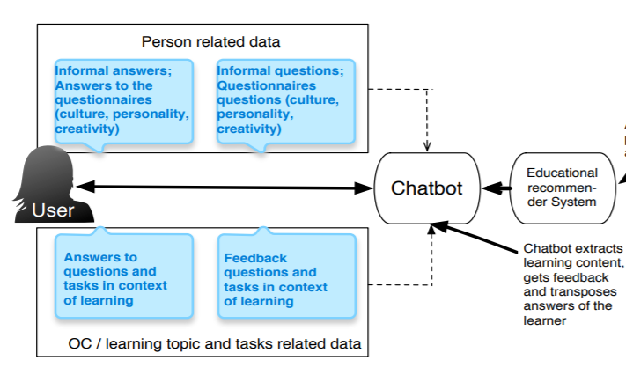

How can chatbots help educational institutes?

Let’s take a closer look at how these conversational programs can benefit academic institutions.

*#1 Improves Query Handling System*

People today expect fast online services with a timely response to their queries. They want complaints to be resolved quickly and expect companies to provide 24/7 customer support service. Millennials are even more eager. They expect you to reply instantly.

Here comes Chatbots. Chatbots can become a vital part of your admission counselling ecosystem. It can enhance user interaction with your educational enterprise resulting in good customer experience.

Besides the college website, the increasing number of students are tuning in to social media messaging to contact admission desk. While there are online and offline tools that will help you manage the inflow of students’ queries but sometimes they’re just not enough, particularly during the peak season of admission cycle.

Social media chatbots such as Facebook Messenger chatbot can share the influx of students messages by letting you automatically respond to their questions timely. They can be helpful in handling preliminary enquiries on courses offered, eligibility criteria, selection process and other frequently asked questions. This can help colleges to put their resources to handle other important concerns of prospective students thereby improving the overall productivity of the admission team.

*#2 Chatbot Marketing Give Boost to Admission*

Chatbots help educational brands to establish meaningful touchpoints of engagement to connect with a broader potential audience. Notification bot helps in sharing important updates with your target audience. Successful deployment of chatbots can give huge benefits to educational entities in optimizing admission marketing efforts.

Chatbots can be deployed as a standalone bot on your digital assets such as website, app or through social platforms like Fb / Messenger etc.

You can treat your chatbot as a powerful content marketing tool to engage the audience.

Online messenger bots are the best option to engage users on your digital platforms (website/mobile). Messenger bots can significantly improve counselling services offered by any academic institution. Messenger bots offer personalized messaging by recognizing users.

Visitors can be re-targeted by integrating it with your Ads giving a boost to your admission marketing drive. Leads captured can be reached out again with more targeted messaging next time.

*#3 Use Chatbots as Powerful PR Tool for Online Reputation Management (ORM)*

Chatbot marketing can be introduced in your college as a PR tool to take advantage of this fast and user-friendly medium of customer engagement.

A successful goal of this platform can be to create favourable connect between your audience and the institute. As a result of its longer-term benefit, it can help improve the overall brand image of your college.

Chatbots can be a huge asset for academic entities to handle online reputation marketing when the volume of queries is extremely high. This is especially needed in large universities and colleges offering multiple courses.

In this way, whether your prospective students are using a personal computer or a smartphone, they will remain accessible and hooked to your brand.

**Output**

