**Experiment 5: Derive insights from unstructured text using machine learning custom models to classify, extract, and detect sentiments.**

**Requirement:** Laptop or Desktop with Python installed

**Theory**

Sentiment analysis is a machine learning technique that detects polarity (e.g. a positive or negative opinion) within text, whether a whole document, paragraph, sentence, or clause.

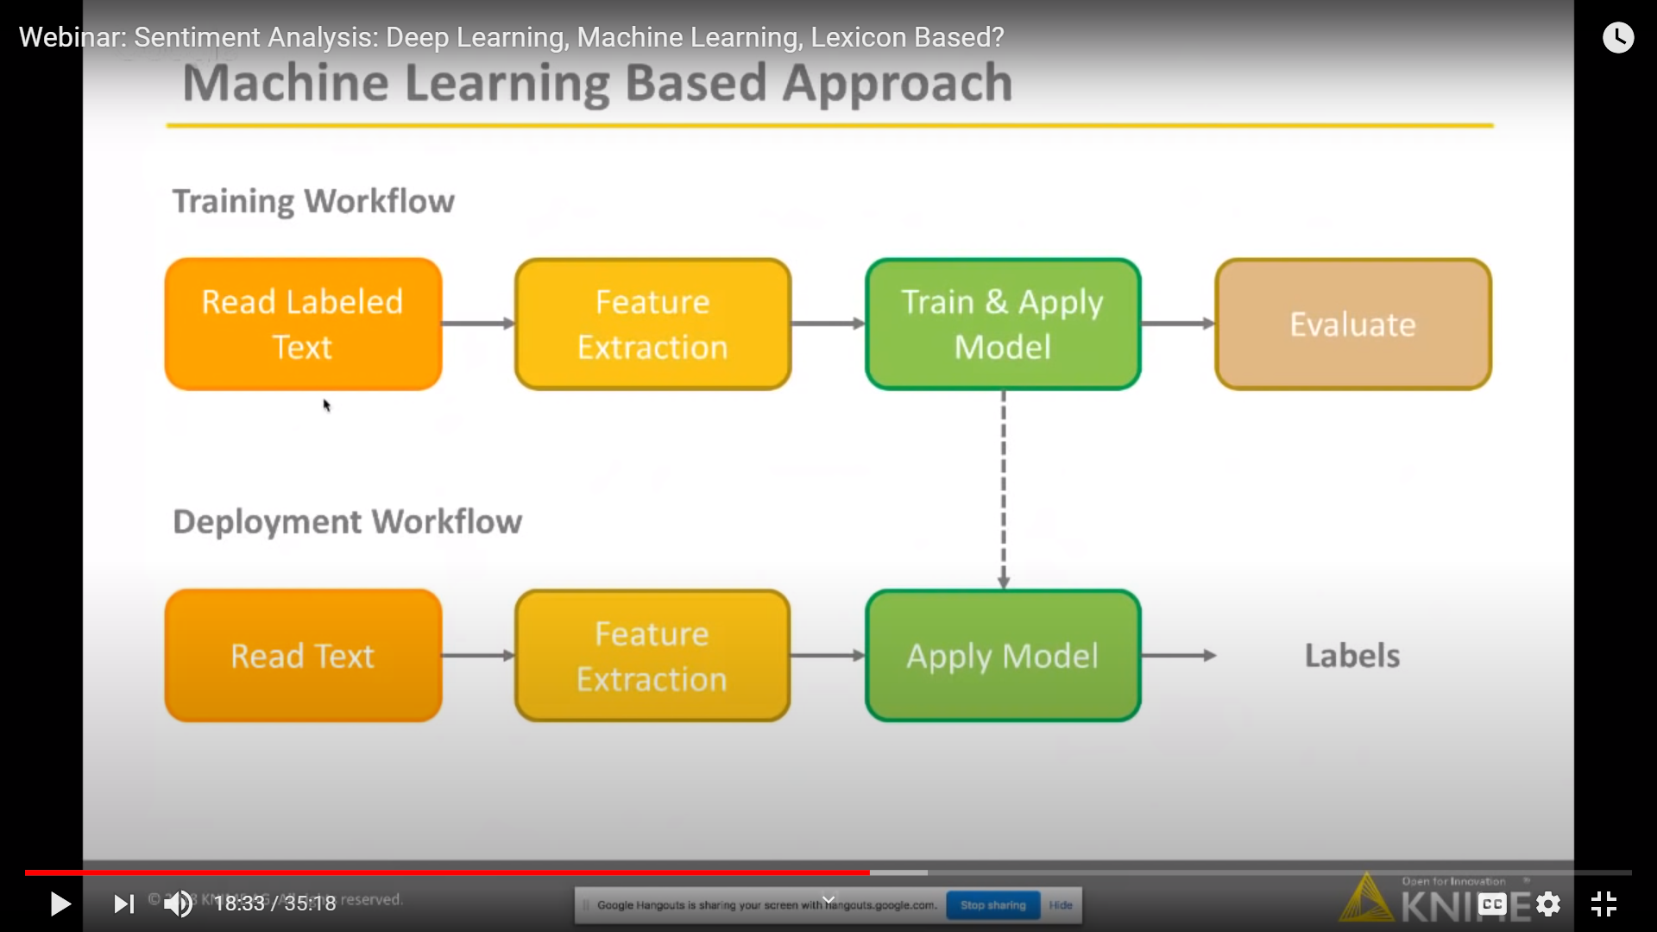

Figure 1: Workflow in sentiments detection

Understanding people’s emotions is essential for businesses since customers are able to express their thoughts and feelings more openly than ever before. By automatically analyzing customer feedback, from survey responses to social media conversations, brands are able to listen attentively to their customers, and tailor products and services to meet their needs.

For example, using sentiment analysis to automatically analyze 4,000+ reviews about your product could help you discover if customers are happy about your pricing plans and customer service.

Types of Sentiment Analysis

Sentiment analysis models focus on polarity (positive, negative, neutral) but also on feelings and emotions (angry, happy, sad, etc), and even on intentions (e.g. interested v. not interested).

Here are some of the most popular types of sentiment analysis:

**Fine-grained Sentiment Analysis**

If polarity precision is important to your business, you might consider expanding your polarity categories to include:

* Very positive
* Positive
* Neutral
* Negative
* Very negative

This is usually referred to as fine-grained sentiment analysis, and could be used to interpret 5-star ratings in a review, for example:

* Very Positive = 5 stars
* Very Negative = 1 star

**Emotion detection**

This type of sentiment analysis aims at detecting emotions, like happiness, frustration, anger, sadness, and so on. Many emotion detection systems use lexicons (i.e. lists of words and the emotions they convey) or complex machine learning algorithms.

One of the downsides of using lexicons is that people express emotions in different ways. Some words that typically express anger, like bad or kill (e.g. your product is so bad or your customer support is killing me) might also express happiness (e.g. this is bad ass or you are killing it).

**Aspect-based Sentiment Analysis**

Usually, when analyzing sentiments of texts, let’s say product reviews, you’ll want to know which particular aspects or features people are mentioning in a positive, neutral, or negative way. That's where aspect-based sentiment analysis can help, for example in this text: "The battery life of this camera is too short", an aspect-based classifier would be able to determine that the sentence expresses a negative opinion about the feature battery life.

**Multilingual sentiment analysis**

Multilingual sentiment analysis can be difficult. It involves a lot of pre-processing and resources. Most of these resources are available online (e.g. sentiment lexicons), while others need to be created (e.g. translated corpora or noise detection algorithms), but you’ll need to know how to code to use them.

Alternatively, you could detect language in texts automatically with MonkeyLearn’s language classifier, then train a custom sentiment analysis model to classify texts in the language of your choice. Sign up for free to try this model out.

Sentiment analysis uses various Natural Language Processing (NLP) methods and algorithms, which we’ll go over in more detail in this section.

The main types of algorithms used include:

* Rule-based systems that perform sentiment analysis based on a set of manually crafted rules.
* Automatic systems that rely on machine learning techniques to learn from data.
* Hybrid systems that combine both rule-based and automatic approaches.

**Output**

