**SEO:**

1. **STATIC WEBSITE:**

* Developer has to add the following tags manually in each page of the site.

<meta name="google-site-verification" content="" />

<meta name="description" content=""/>

<link rel="canonical" href="http://shelfierobot.com/"/>

<meta property="og:locale" content="en_US" />

<meta property="og:type" content="website" />

<meta property="og:title" content=" " />

<meta property="og:description" content=" " />

<meta property="og:url" content=" />

<meta property="og:site_name" content=" " />

<meta property="og:image" content=" " />

<meta name="twitter:card" content="summary_large_image" />

<meta name="twitter:description" content=" " />

<meta name="twitter:title" content=" "/>

<meta name="twitter:site" content " />

<meta name="twitter:image" content=" " />

<meta name="twitter:creator" content="@shelfierobot" />

1. DYNAMIC WEBSITES - WordPress

* Use PAID YOAST SEO plugin
* Firstly, Install YOAST plugin in the website
* Secondly, activate the website in Yoast website to integrate.

<https://my.yoast.com/>

* Back to the website, CONFIGURE YOAST SEO plugin.

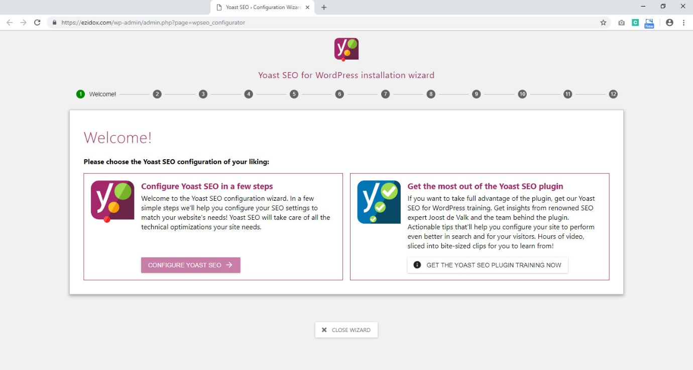

* Then, configure YOAST SEO setting in the WordPress admin

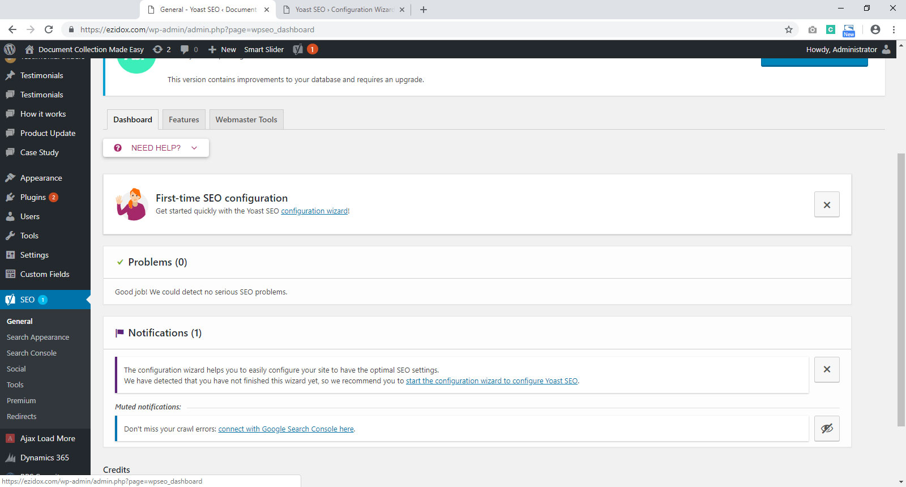

* After that, each page or post has four screens to add meta tags in the website. It’s the mandatory to add these infomation in each and every page and post in the website.
* Not compulsory to add the different title, description and image. But use the same title, description and image in all three screens.
* The First screen is title, description, slug and keywords.

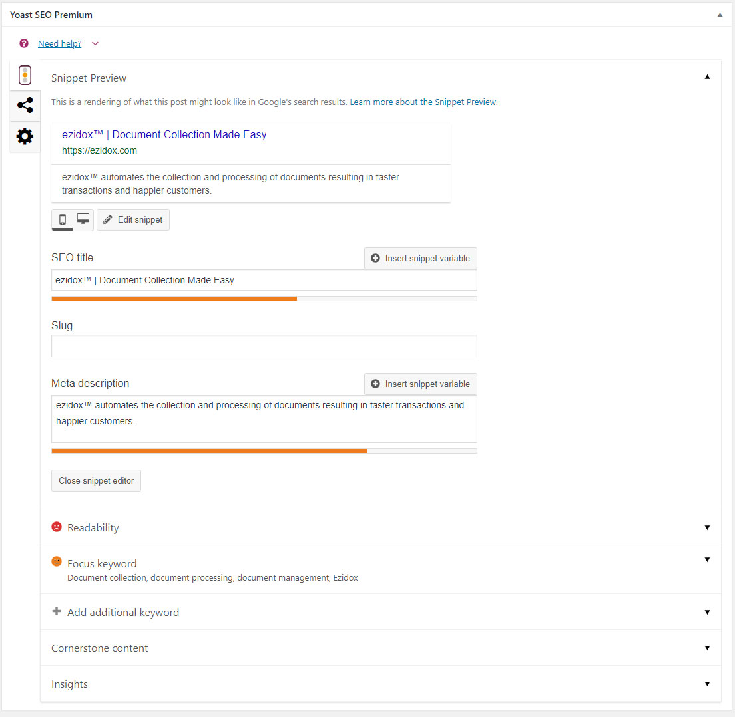

The Second screen is for adding title, description and image for FACEBOOK Sharing.

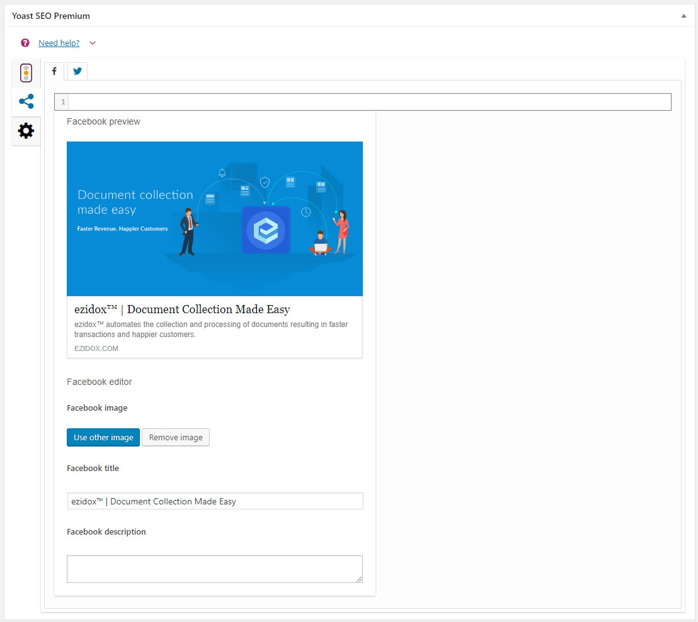

Recommend size of image:

Width = 1200px

Height= 630px

The Third screen is for adding title, description and image for Twitter Sharing.

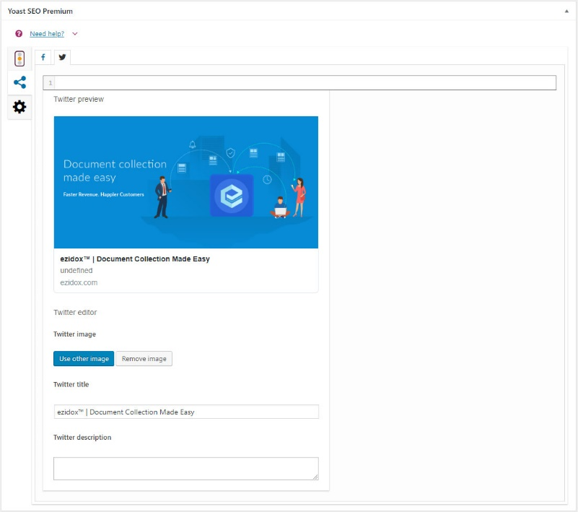

* Please create the following:

1. Sitemap
2. Robot
3. Google Knowledge Panel
4. Scheme
5. Google Analytical codes
6. Facebook Pixel (if using)
7. Webmaster Tool
8. Tag Manager Code
9. Meta Data
10. Optimize Website Speed

These files will be uploaded in the main root of the website by Developer.

* Marketing team must provide title and description for each page/post.
* Designer must create at least one image for each website or if possible, create multiple images to use in each page.
* Four screens - Advance setting

For search engine follow, Breadcrumbs title, Canonical URL and meta robot setting

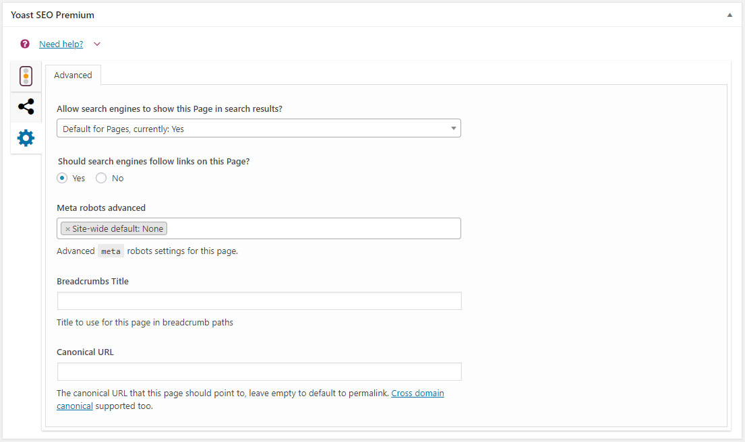

* **These steps are mandatory to follow after each change in SEO.**

1. FACEBOOK

Clear Facebook cache after each minor or major SEO change in the website.

URL: <https://developers.facebook.com/tools/debug/>

1. LINKEDIN

Clear Linkedin cache after each minor and major SEO change in the website.

URL: <https://www.linkedin.com/post-inspector/>

1. TWITTER

Clear Twitter cache after each minor and major SEO change in the website.

URL: <https://cards-dev.twitter.com/validator>

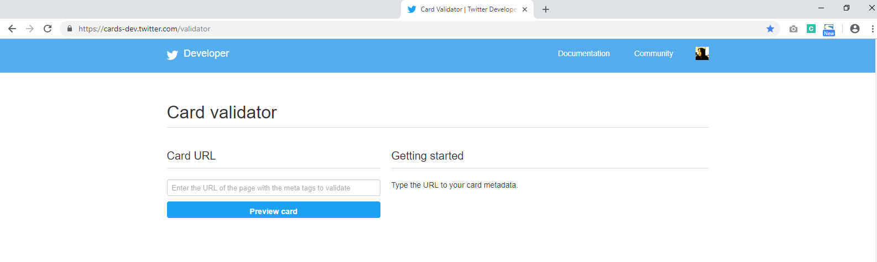

Figure: Card Validator for Twitter

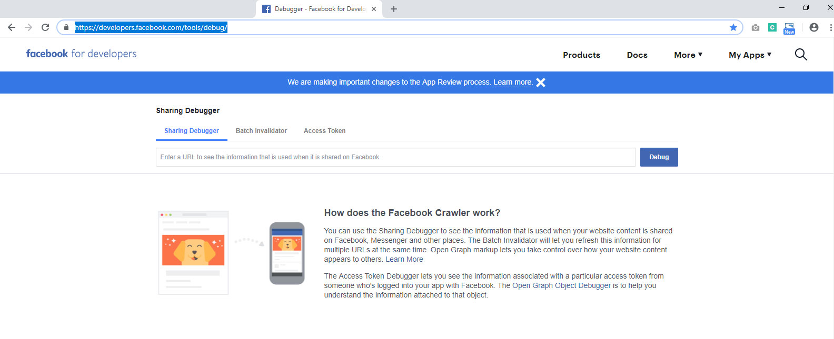

Figure: Facebook Debugger Tool

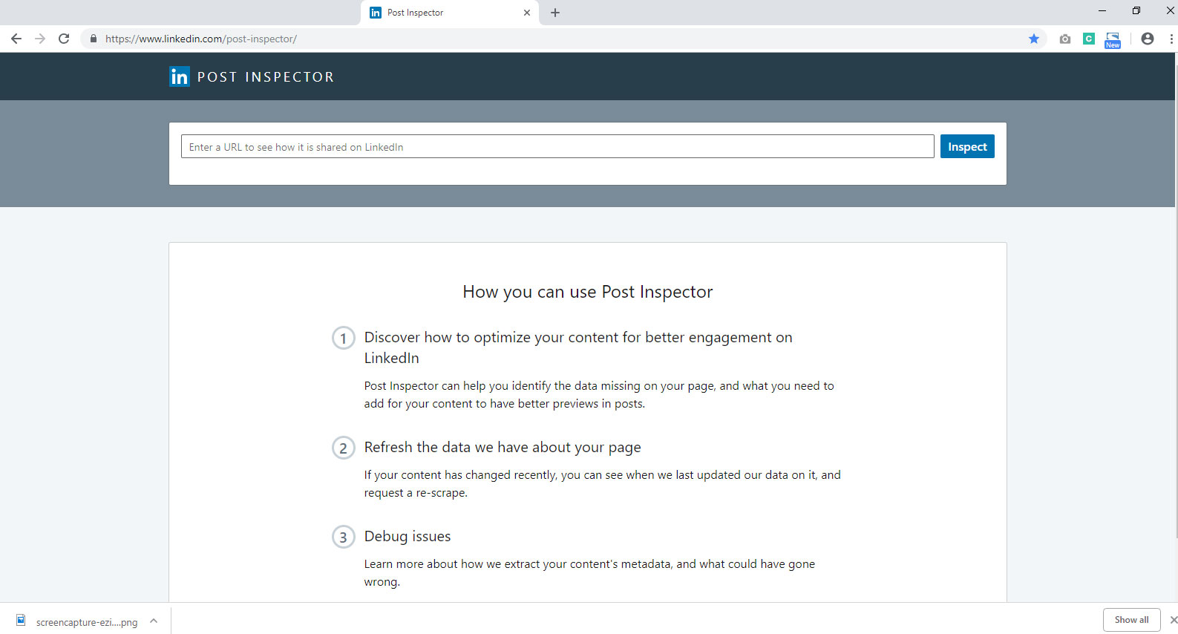

Figure: Post Inspector for Linkedin