My_first_Rmarkdown

Samuel Terkper Ahuno

11/14/2019

## R Markdown

# This is the beginning of the end

## But actually we left the middle out

### Probably we can call this the end; header with 3 harshes to see how it differs from the rest of the headrs above

This is an R Markdown document created by Samuel Ahuno to test R markdown utility. I’m not sure I’ve effective used this befpre, but i guess the journey of a 1000 miles begin with a step so I am open to the possibilities that comes with it. To learn more about this cecheck out the official R markdown website. to learn more about my project; check out my github page; wishing you the very best; Markdown is a simple formatting syntax for authoring HTML, PDF, and MS Word documents. For more details on using R Markdown see <http://rmarkdown.rstudio.com>.

When you click the **Knit** button a document will be generated that includes both content as well as the output of any embedded R code chunks within the document. You can embed an R code chunk like this:

summary(cars)

## speed dist   
## Min. : 4.0 Min. : 2.00   
## 1st Qu.:12.0 1st Qu.: 26.00   
## Median :15.0 Median : 36.00   
## Mean :15.4 Mean : 42.98   
## 3rd Qu.:19.0 3rd Qu.: 56.00   
## Max. :25.0 Max. :120.00

head(cars$speed)

## [1] 4 4 7 7 8 9

## Things i can use markdown for

* memo’s
* drafting messages for online forum; stackoverflow; biostars
* it will be cool if i can draft messages via meddium via R markdown

## Hummm? should there be space between harsh key and the begining of the heaeder; seem like it doesn’t work everywhere.

## Including Plots

You can also embed plots, for example:

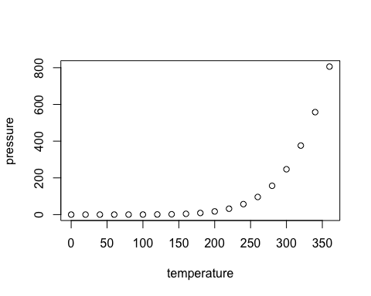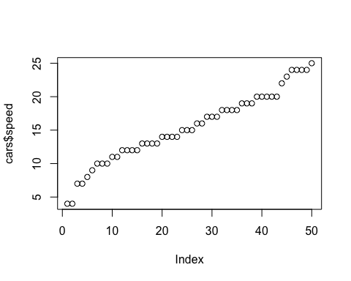

Note that the echo = FALSE parameter was added to the code chunk to prevent printing of the R code that generated the plot. Do you think it is good time to *sign off?* Yes! **Sir!**

[click here to find a good bye message](%22https://www.youtube.com/watch?v=DGQAJlvjaaE%22)