AWS
Cloud platform providing compute, storage, networking and managed services.

EC2 vs ECS

EC2 (Elastic Compute Cloud) provides virtual servers in AWS where you manage the operating system, application deployment, scaling, patching, and monitoring. [spring.io]
EC2 provides VMs.

ECS (Elastic Container Service) is AWS's container orchestration service that helps run, manage, and scale Docker containers without managing the underlying container orchestration infrastructure
ECS manages and orchestrates containers.

EC2
You manage:
  - Servers
  - OS patches
  - Scaling
  - Runtime

Pros
  - Full control
  - Flexible
Cons
  - More maintenance

ECS
AWS manages container orchestration.

Pros
  - Easier deployment
  - Better scaling
  - Less operational effort

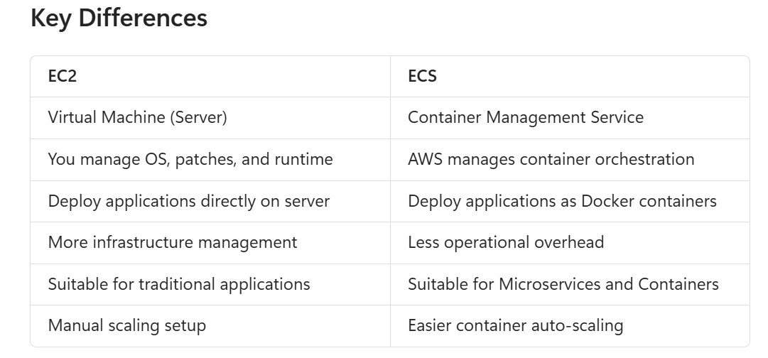

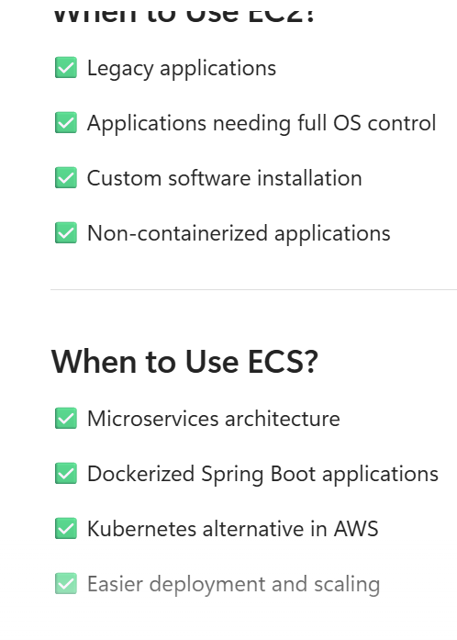

What is IAM?
Identity and Access Management manages users, roles, permissions, authentication, and access
policies.

Purpose of IAM
To ensure secure access to resources by controlling identities and permissions.

Roles, Permissions, and Entitlements
Roles are collections of permissions. Permissions define allowed actions. Entitlements represent
access rights assigned to users.

AWS EC2
Virtual machine service.

AWS ECR
Container image repository.
Amazon ECR (Elastic Container Registry) is a fully managed AWS service used to store, manage, and retrieve Docker container images. It acts as a private Docker registry for containerized applications.

AWS ECS
Container orchestration service.

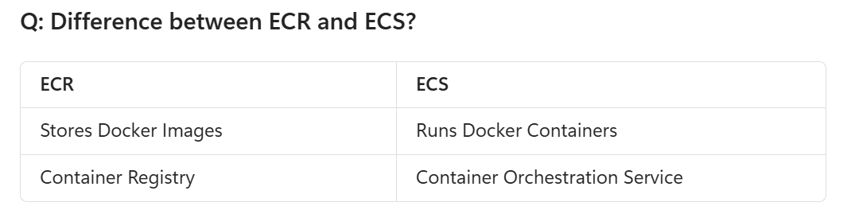

Explain Horizontal vs Vertical Scaling
Vertical Scaling
Add more resources to one server.
Pros
  - Easy
Cons
  - Hardware limits
  - Single point of failure

Horizontal Scaling
Add more servers.

Behind:
Load Balancer

Pros
  - Better scalability
  - Better availability
Cons
  - More complexity

  - EC2 (Elastic Compute Cloud) → Run virtual servers/applications in the cloud.
  - S3 (Simple Storage Service) → Store and retrieve files, images, backups, and logs.
  - RDS (Relational Database Service) → Managed relational databases like MySQL, PostgreSQL, Oracle.
  - DynamoDB → Fully managed NoSQL database with high scalability.
  - Lambda → Run code without managing servers (serverless computing), execute logic .
  - SQS (Simple Queue Service) → Decouple applications using message queues.
  - SNS (Simple Notification Service) → Send notifications via email, SMS, or to other AWS services.
  - API Gateway → Create and manage REST, HTTP, and WebSocket APIs.
  - ECS (Elastic Container Service) → Run and manage Docker containers.
  - EKS (Elastic Kubernetes Service) → Managed Kubernetes service on AWS.
  - CloudWatch → Monitor applications, logs, metrics, and alarms.
  - CloudTrail → Track and audit AWS account activities and API calls.
  - IAM (Identity and Access Management) → Manage users, roles, and permissions.
  - VPC (Virtual Private Cloud) → Create an isolated private network in AWS.
  - Route 53 → DNS management and domain routing service.
  - ELB (Elastic Load Balancer) → Distribute incoming traffic across multiple servers.
  - Auto Scaling → Automatically increase or decrease resources based on demand.
  - Secrets Manager → Securely store and manage passwords, API keys, and secrets.
  - Parameter Store (SSM) → Store configuration values and application parameters.
  - EFS (Elastic File System) → Shared file storage accessible by multiple EC2 instances.
  - CloudFront → Content Delivery Network (CDN) for fast content delivery worldwide.
  - Kinesis → Real-time data streaming and analytics.
  - Glue → ETL service for preparing and transforming data.
  - Redshift → Data warehouse for analytics and business intelligence.
  - Athena → Query S3 data using SQL without managing servers.
  - Step Functions → Orchestrate workflows between AWS services.
  - EventBridge → Event-driven integration between applications and AWS services.
  - CodeCommit → Git-based source code repository.
  - CodeBuild → Build and test application code.
  - CodeDeploy → Automate application deployments.
  - CodePipeline → End-to-end CI/CD pipeline automation.

  - EC2 – Virtual servers
  - ECS – Container orchestration
  - EKS – Kubernetes on AWS
  - Lambda – Serverless functions
  - ALB/NLB – Load balancing
  - S3 – Object storage
  - RDS – Relational databases
  - DynamoDB – NoSQL database
  - ElastiCache (Redis) – Caching
  - SQS – Message queues
  - SNS – Event notifications
  - API Gateway – API management
  - CloudWatch – Monitoring
  - IAM – Access management
  - Secrets Manager – Secret storage
  - Route 53 – DNS management
  - VPC – Network isolation

ECS
AWS-managed container platform.
Use When:
  - Running Dockerized Spring Boot microservices
  - Team doesn't need Kubernetes
  - Simpler operations

Spring Boot Containers
↓
ECS Fargate

Pros
  - Easy setup
  - AWS-native
  - Less operational overhead

EKS
Managed Kubernetes.
Use When:
  - Organization standardizes on Kubernetes
  - Multi-cloud strategy
  - Advanced orchestration required
Pros
  - Kubernetes ecosystem
  - Better portability
  - Advanced deployments
Cons
  - Higher complexity

Lambda
Serverless functions.
Use When:
  - Event-driven workloads
  - File processing
  - Scheduled jobs

How would you deploy Spring Boot microservices on AWS?

Developer
↓
GitHub
↓
CI/CD Pipeline
↓
Docker Image
↓
ECR
↓
ECS/EKS

Create docker image

FROM eclipse-temurin:17
COPY app.jar app.jar
ENTRYPOINT ["java","-jar","app.jar"]

  - Push image to ECR
  - Deploy to ECS/EKS
  - Expose through ALB
  - Configure Auto Scaling
  - Monitor using CloudWatch

Explain an AWS Architecture for a Highly Available Application

Components
  - Route53
  - Application Load Balancer
  - ECS/EKS across multiple AZs
  - RDS Multi-AZ
  - ElastiCache Redis
  - CloudWatch Monitoring
Benefits
  - No single point of failure
  - High availability
  - Automatic failover

How would you design AWS infrastructure across multiple AZs?

ALB
|
----------------
AZ1 AZ2
App1 App2
App3 App4
----------------
|
RDS Multi-AZ

Strategy
  - Deploy application instances in multiple AZs
  - Enable RDS Multi-AZ
  - Redis replication
  - Auto Scaling across AZs

ALB vs NLB
ALB (Application Load Balancer)
Layer 7.
Supports:
  - HTTP
  - HTTPS
  - Path routing
  - Host routing

Best For
Microservices and web applications.

NLB (Network Load Balancer)
Layer 4.
Supports:
  - TCP
  - UDP
Benefits
  - Very low latency
  - High throughput
Best For
Gaming, financial systems, TCP traffic.

How does Auto Scaling work?
Auto Scaling adjusts capacity based on metrics.

Metrics
  - CPU
  - Memory
  - Request count

CloudWatch Alarm
↓
Auto Scaling Group
↓
Launch New Instance

Auto Scaling continuously monitors metrics and automatically adds or removes instances to match demand.

RDS vs DynamoDB
RDS
Relational database.
Examples:
  - PostgreSQL
  - MySQL

Features:

ACID
Joins
Transactions

Best For
Order systems, banking, ERP.

DynamoDB
NoSQL database.

Features:
Key-Value
Massive Scale
Low Latency

Best For
User sessions, profiles, event data.

When would you use DynamoDB instead of PostgreSQL?
Choose DynamoDB when:
  - Millions of requests
  - Single-digit millisecond latency
  - Massive horizontal scaling
  - Flexible schema

Choose Postgre

Complex joins
ACID transactions
Reporting
Relational data

How would you use S3 in a Microservices Architecture?
Common Use Cases
File Storage

User Upload
↓
S3

Event Processing

File Uploaded
↓
S3 Event
↓
Lambda

Benefits
  - Durable
  - Cheap
  - Highly scalable

13. How would you secure AWS applications?
Network Security
  - VPC
  - Private Subnets
  - Security Groups
  - NACLs
Identity Security
  - IAM Roles
  - Least privilege principle
Data Security
  - Encryption at rest (KMS)
  - Encryption in transit (TLS)
Application Security
  - AWS WAF
  - API authentication
  - Secrets Manager

IAM Roles vs IAM Users
IAM User
Represents a person.

Developer
Admin
Support Engineer

IAM Role
Temporary AWS permissions.
Used by:

EC2
ECS
Lambda
EKS

ECS Task
↓
Assume IAM Role
↓
Access S3

How do you manage secrets?
Never hardcode secrets.
AWS Secrets Manager
Store:

Database Passwords
API Keys
JWT Secrets

Application fetches secrets at runtime.

Spring Boot
↓
Secrets Manager

16. How would you monitor production services in AWS?
CloudWatch
Monitor:
  - CPU
  - Memory
  - Disk
  - Application logs

App Monitoring

CloudWatch
+
Prometheus
+
Grafana

Distributed Tracing

AWS X-Ray
OpenTelemetry

Logging

Application Logs
↓
CloudWatch Logs
↓
Search & Alerts

Partitioning divides large tables within a database,
Database still manages all partitions.
One database.

while sharding distributes data across multiple database instances to achieve horizontal scalability.

Azure Important Services and Their Usage (1-Liners)
  - App Services → Host and run web applications, REST APIs, and mobile backends without managing servers.
  - Azure Functions → Execute event-driven serverless code on demand.
  - API Management (APIM) → Secure, publish, monitor, and manage APIs from a central gateway.
  - Service Bus → Reliable message broker for asynchronous communication between applications and microservices.
  - Event Hub → Ingest and process large volumes of real-time streaming events and telemetry data.
  - Storage Account → Store blobs, files, queues, tables, and disks in Azure.
  - Azure Database for PostgreSQL → Fully managed PostgreSQL database service with automatic maintenance and scaling.
  - Azure Monitor → Collect, analyze, and visualize metrics, logs, and performance data.
  - Application Insights → Monitor application performance, exceptions, dependencies, and distributed tracing.
  - Azure Key Vault → Securely store secrets, certificates, and encryption keys.
  - Azure Active Directory (Microsoft Entra ID) → Identity and access management for users and applications.
  - Azure Virtual Machine (VM) → Run Windows or Linux virtual servers in Azure.
  - Azure Kubernetes Service (AKS) → Managed Kubernetes platform for containerized applications.
  - Azure Container Registry (ACR) → Store and manage Docker container images.
  - Azure Logic Apps → Build workflow automation with minimal code.
  - Azure Event Grid → Event routing service for reactive and event-driven architectures.
  - Azure Load Balancer → Distribute incoming traffic across multiple backend resources.
  - Azure Front Door → Global application delivery and load balancing service.
  - Azure Cosmos DB → Globally distributed NoSQL database with low latency.
  - Azure DevOps → CI/CD, source control, work tracking, and release management platform.

Quick Interview Answers
App Service ↔ Elastic Beanstalk
Used to deploy and host web applications and REST APIs without managing underlying servers.
Azure Functions ↔ AWS Lambda
Executes serverless code in response to events and scales automatically.
APIM ↔ API Gateway
Secures, publishes, throttles, and monitors APIs through a centralized gateway.
Service Bus ↔ SQS/SNS
Enables asynchronous communication between microservices using queues and topics.
Event Hub ↔ Kinesis
Processes millions of real-time events, telemetry, or log streams.
Storage Account ↔ S3
Stores unstructured data such as files, images, backups, and documents.
PostgreSQL ↔ RDS PostgreSQL
Managed relational database service with high availability and automated backups.
Azure Monitor ↔ CloudWatch
Collects metrics, logs, alerts, and performance data from applications and infrastructure.
Application Insights ↔ X-Ray
Provides distributed tracing, dependency tracking, and application performance monitoring.
Key Vault ↔ Secrets Manager
Securely stores passwords, API keys, certificates, and encryption keys

Azure Services ↔ AWS Equivalent Services (Interview-Friendly Mapping)
Azure Service | Purpose | AWS Equivalent
App Service | Host web apps and APIs without managing infrastructure | Elastic Beanstalk, ECS Fargate, Lambda + API Gateway
Azure Functions | Serverless event-driven code execution | AWS Lambda
API Management (APIM) | API Gateway, security, throttling, analytics | Amazon API Gateway
Service Bus | Enterprise messaging with queues/topics | Amazon SQS + SNS
Event Hub | Real-time event ingestion and streaming | Amazon Kinesis Data Streams
Storage Account (Blob Storage) | Store files, documents, images, videos | Amazon S3
Azure Database for PostgreSQL | Managed PostgreSQL database | Amazon RDS for PostgreSQL
Azure Monitor | Infrastructure and application monitoring | Amazon CloudWatch
Application Insights | APM, distributed tracing, application diagnostics | AWS X-Ray + CloudWatch Application Insights
Azure Key Vault | Store secrets, certificates, keys | AWS Secrets Manager + KMS
Microsoft Entra ID (Azure AD) | Identity and access management | AWS IAM + AWS Identity Center
AKS (Azure Kubernetes Service) | Managed Kubernetes | Amazon EKS
Azure Container Registry (ACR) | Docker image repository | Amazon ECR
Azure Virtual Machines | Virtual servers | Amazon EC2
Azure Event Grid | Event routing and event-driven architecture | Amazon EventBridge
Azure Logic Apps | Workflow automation and integrations | AWS Step Functions
Azure Cosmos DB | Globally distributed NoSQL database | Amazon DynamoDB
Azure Front Door | Global load balancing and CDN | CloudFront + Global Accelerator
Azure Load Balancer | Distribute application traffic | Elastic Load Balancer (ELB)
Azure DevOps Pipelines | CI/CD pipelines | CodePipeline + CodeBuild + CodeDeploy

S3 Classes
  - Standard = frequently used
  - Intelligent-Tiering = AWS optimizes cost automatically
  - IA = infrequently accessed but quickly retrievable
  - One Zone-IA = cheaper, single Availability Zone
  - Glacier Instant = archive + instant access
  - Glacier Flexible = archive + retrieval in minutes/hours
  - Deep Archive = cheapest, retrieval in hours

Lambda
Interview Questions
Q: Why use Lambda Layers?
To share dependencies across multiple Lambda functions, reduce deployment package size, and simplify maintenance.
Q: Where are layer contents mounted?
In the /opt directory during function execution.
Q: How many layers can a Lambda function have?
Up to 5 layers.
Q: Are layer versions mutable?
No. Once published, a layer version is immutable.
Q: What is the difference between a Lambda Layer and a deployment package?
Deployment package contains function code; layers contain reusable dependencies and libraries that can be shared among functions.

How to share layers across accounts?Can layers include binaries?How to update a layer version?

FilesFiles

Lambda Versioning allows you to create immutable snapshots of a Lambda function. Each version captures the function code and most configuration settings at the time the version is published. Once published, a version cannot be modified.

Why Use Versions?
  - Track releases of your Lambda function.
  - Roll back to a previous stable version.
  - Enable safe deployments.
  - Support aliases for blue-green and canary deployments.

What is Message Visibility Timeout? In SQS
Answer: 30 sec
When a consumer receives a message, it becomes temporarily invisible to other consumers for a specified period called the Visibility Timeout.

5. What happens if a consumer crashes before deleting a message?
Answer:
After the visibility timeout expires, the message becomes available again for processing by another consumer.
This ensures fault tolerance.

Azure AWS

APIM <----> API Gateway

App Service <----> ECS/Elastic Beanstalk

Azure Functions <----> Lambda

Service Bus <----> SQS/SNS

Event Hub <----> Kinesis

PostgreSQL <----> RDS PostgreSQL

Storage Account <----> S3

Application Insights <----> X-Ray

Azure Monitor <----> CloudWatch

Key Vault <----> Secrets Manager

AKS <----> EKS

Step 1: Producer Publishes Event
Spring Boot application sends event to Event Hub:

EventDataBatch batch = producer.createBatch();
batch.tryAdd(new EventData(alarmMessage));
producer.send(batch);

Step 2: Event Stored in Event Hub
Event Hub acts like a streaming platform.

Partition-0
Event1
Event2

Partition-1
Event3
Event4

Events remain available for configured retention period.

Step 3: Azure Function Trigger
Function automatically listens to Event Hub.

@FunctionName("ProcessAlarm")
public void processAlarm(
@EventHubTrigger(
name = "message",
eventHubName = "alarmhub",
connection = "EventHubConnection")
String message,
final ExecutionContext context) {

context.getLogger().info(message);

// Business logic
}

Step 4: Business Processing
Inside function:

if(alarm.getSeverity().equals("HIGH")) {

notificationService.sendEmail();

ticketService.createIncident();
}

Lambda

import com.amazonaws.services.lambda.runtime.Context;
import com.amazonaws.services.lambda.runtime.RequestHandler;
import com.amazonaws.services.lambda.runtime.events.SQSEvent;

public class AlarmLambdaHandler
implements RequestHandler<SQSEvent, String> {

@Override
public String handleRequest(
SQSEvent event,
Context context) {

event.getRecords().forEach(record -> {

String message = record.getBody();

context.getLogger().log(
"Received Alarm: " + message);

// Business Logic
processAlarm(message);
});

return "SUCCESS";
}

private void processAlarm(String alarm) {

System.out.println("Processing Alarm : " + alarm);

// Save to DB
// Call API
// Send Notification
}
}

How is Lambda triggered?
Answer: SQS is configured as an event source for Lambda. Whenever messages arrive in the queue, AWS automatically polls SQS and invokes the Lambda function.

Q: What happens if Lambda fails?
Answer: The message remains in the queue and becomes visible again after the visibility timeout. Lambda retries processing. Failed messages can be moved to a Dead Letter Queue (DLQ).

Pipeline Configuration
Checkout, Build, Unit Test, Sonar Scan, Security Scan, Docker Build, Push to ECR, Deploy.

