Docker is a containerization platform that packages an application along with its dependencies, libraries, and configurations into a container.
Without Docker
- Application works on your machine.
- Fails on QA/Production due to environment differences.
- Dependency/version conflicts.
With Docker
- Application runs the same everywhere.
- Portable and lightweight.
- Easy deployment and scaling.

Package the application and everything it needs into a box, then run the same box anywhere.

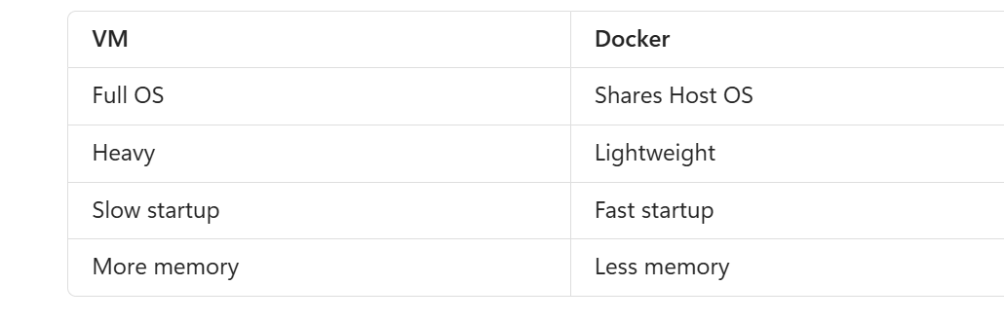

Dockerfile
A file containing instructions to build an image.

FROM openjdk:17
COPY app.jar app.jar
ENTRYPOINT ["java","-jar","app.jar"]

Docker compose

version: '3'

services:

mysql:
image: mysql:8
environment:
MYSQL_ROOT_PASSWORD: root
MYSQL_DATABASE: employee_db
ports:
- "3306:3306"

app:
build: .
ports:
- "8080:8080"
depends_on:
- mysql

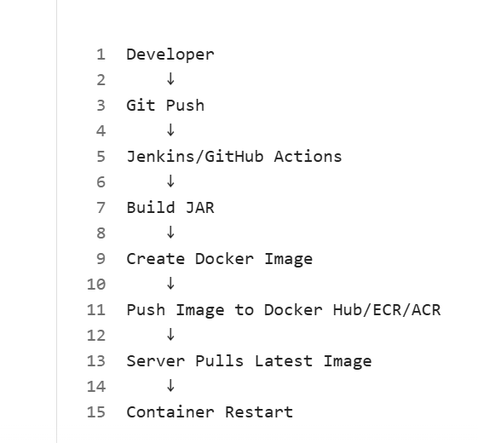

Typical CI/CD

Developer
↓
Git Commit & Push
↓
Jenkins / Azure DevOps / GitHub Actions
↓
Build Application (Maven/Gradle)
↓
Run Unit Tests
↓
SonarQube Code Quality Check
↓
Build Docker Image
↓
Push Image to Registry
(Docker Hub/ECR/ACR)
↓
Deploy to Dev Environment
↓
UAT Approval
↓
Deploy to Production

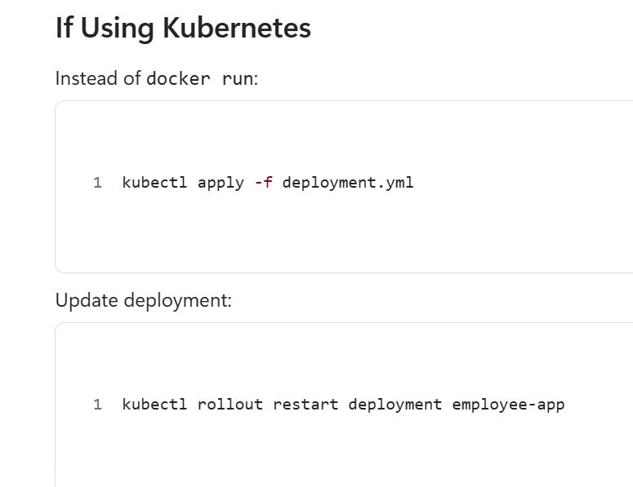

New instances are deployed gradually without downtime.

What is Rolling Deployment?

If deployment fails

kubectl rollout undo deployment employee-app

