One-to-One, One-to-Many, Many-to-One and Many-to-Many relationships

  - One-to-One: One person has one passport, and each passport belongs to one person.
  - One-to-Many: One department has many employees, but each employee belongs to one department.
OneToMany Fetch Type
Default is LAZY.

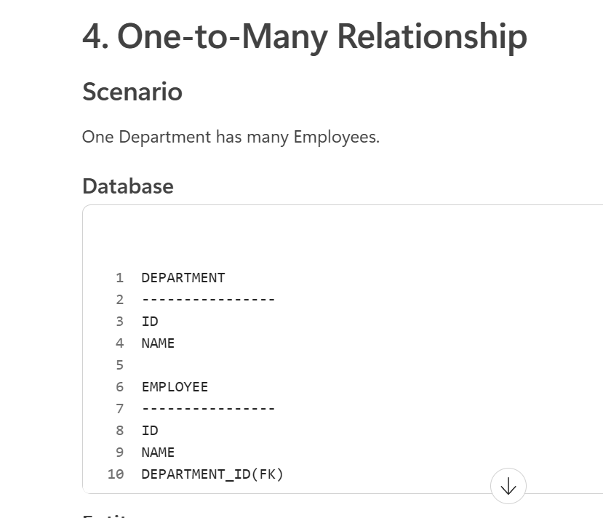

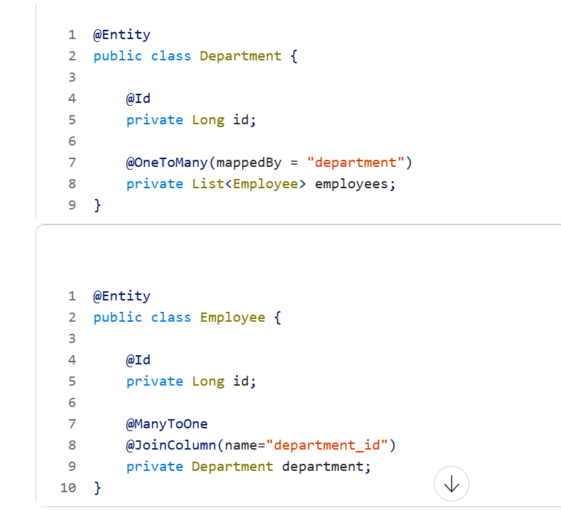

Who owns the relationship?
Answer:
Employee
because it contains:
@JoinColumn

  - Many-to-One: Many employees work in one department.
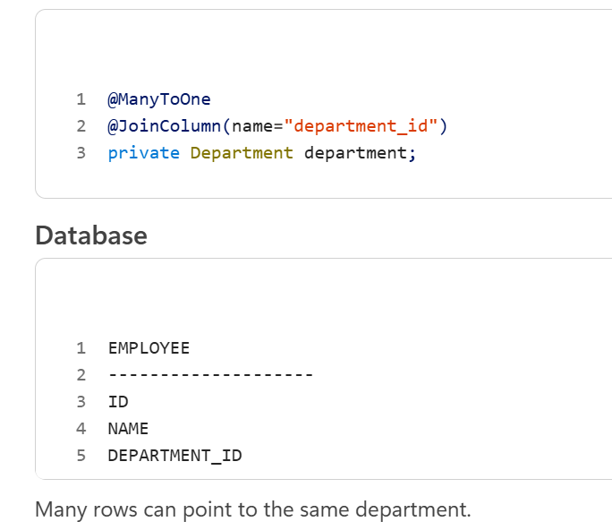

  - Many-to-Many: Many students enroll in many courses, and each course has many students.

Why Use mappedBy?
@OneToMany(mappedBy = "employee",
cascade = CascadeType.ALL,
fetch = FetchType.LAZY)
private List<Address> addresses;

  - Prevents creation of an extra join table.
  - Makes Department the owning side of the relationship.

Employee and Address typically have a One-to-Many relationship, where one employee can have multiple addresses, and each address belongs to exactly one employee. The foreign key is usually maintained in the Address table using @ManyToOne.

Foregin Key
@ManyToOne
@JoinColumn(name = "dept_id") // Foreign Key

private Department department;

}

In @OneToMany, what is the default Fetch Type?

@OneToMany

private List<Employee> employees;

FetchType.LAZY

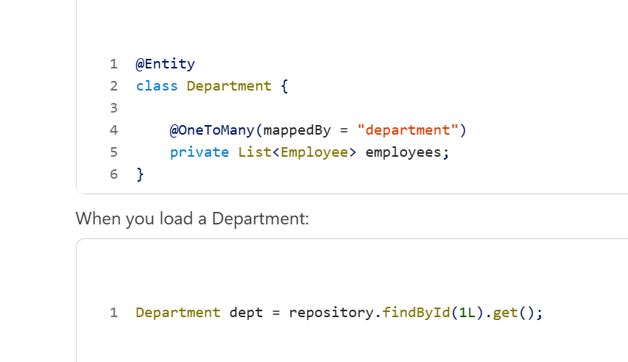

Hibernate loads:
Department data only

Employee list is not loaded immediately.
Only when:
dept.getEmployees();
then Hibernate fires another query. This is called Lazy Loading.

@ManyToMany- LAZY
@OneToOne- EAGER
@ManyToOne- EAGER

What is ORM?
ORM (Object Relational Mapping) is a technique used to map Java objects to database tables.

  - JPA (Java Persistence API) is a specification.
  - Hibernate is the most popular implementation of JPA.
  - Spring Boot uses Hibernate as the default JPA provider

Advantages of ORM
  - Reduces boilerplate JDBC code
  - Converts Java objects to database records automatically
  - Database-independent programming
  - Supports caching
  - Supports relationships (OneToOne, OneToMany, ManyToMany)
  - Easier maintenance

Different Method
Commonly used methods inherited:

Java

save()
saveAll()

findById()

findAll()

existsById()

count()

delete()

deleteById()

deleteAll()
flush()

What is the use of persist() method?
persist() is used to make a transient object persistent.

Employee emp = new Employee();

emp.setName("Princy");
entityManager.persist(emp);
After persist():

Transient State

↓

Persistent State

When the transaction commits, Hibernate inserts the record into the database.

SQL

INSERT INTO EMPLOYEE ...

Important Point
persist() is a JPA method.

EntityManager.persist(entity);
It does not return any value.

23. When is persist() mandatory and when is it not mandatory?
Mandatory
When you're working directly with:

EntityManager
and want to save a new entity.

@PersistenceContext

private EntityManager entityManager;
entityManager.persist(employee);
Without calling persist(), Hibernate won't manage the object.

Not Mandatory
When using Spring Data JPA repositories.

employeeRepository.save(employee);

Here Spring Data JPA internally handles persistence.
You don't explicitly call:

entityManager.persist()
or

sesion.save()
Example
Using EntityManager

entityManager.persist(employee);

Using Repository

employeeRepository.save(employee);

No need for persist().

24. Use Case of persist() and save()
persist()

entityManager.persist(employee);
Characteristics
  - JPA standard method.
  - Returns void.
  - Used with EntityManager.
  - Makes entity managed by persistence context.
  - Preferred in JPA applications.

save()

session.save(employee);
Characteristics
  - Hibernate-specific method.
  - Returns generated ID.

Long id = (Long) session.save(employee);
  - Not part of JPA specification.

