Advantages of Microservices

Works around business capabilities
Independent deployment, scalability, technology flexibility, fault isolation, faster development, and
better team autonomy.

RestTemplate
  - Synchronous communication.
  - One service directly calls another service.
  - Older approach in Spring.

RestTemplate restTemplate = new RestTemplate();

Employee emp = restTemplate.getForObject(
"http://employee-service/employees/1",
Employee.class);

2. Feign Client
  - Declarative REST Client.
  - We write only an interface.
  - Spring generates the implementation.

@FeignClient(name = "employee-service")
public interface EmployeeClient {

@GetMapping("/employees/{id}")
Employee getEmployee(@PathVariable Long id);
}

3. Kafka
  - Asynchronous communication.
  - Message Broker/Event-Driven Architecture.

Producer

kafkaTemplate.send("orders", order);

Consumer

@KafkaListener(topics = "orders")
public void consume(Order order) {
System.out.println(order);
}

When Would You Use Each?
Use RestTemplate
  - Legacy Spring applications.
  - Simple service-to-service calls.

Use Feign Client
  - Modern Spring Cloud microservices.
  - Service discovery with Eureka.
  - Cleaner code than RestTemplate.

Use Kafka
  - Event-driven architecture.
  - Notifications, orders, payments, audit logs.
  - High-volume asynchronous processing.

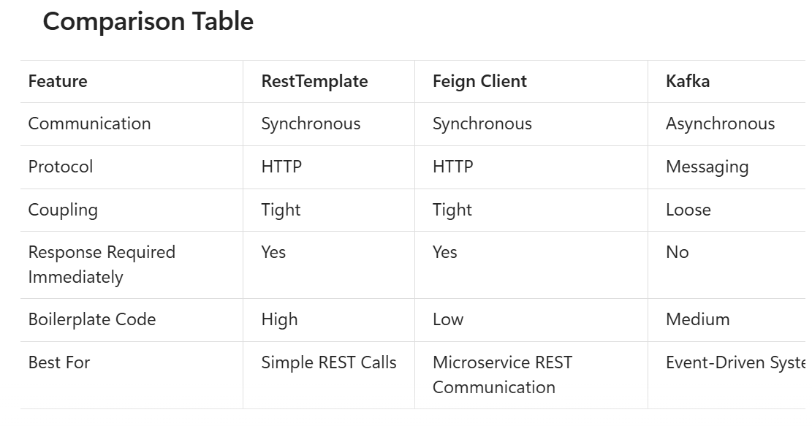

Circuit Breaker Pattern

A Circuit Breaker automatically stops calling a failing service after a threshold of failures and returns a fallback response until the service recovers.

Issue
Every request keeps hitting the failed service, wasting resources.

How Circuit Breaker Works
1. Closed State (Normal)
  - All requests go through.
  - Failures are monitored.

2. Open State (Failure Detected)

  - After a configured number of failures.
  - No calls sent to the failing service.
  - Immediate fallback response returned.

3. Half-Open State (Recovery Check)

  - Allows limited requests.
  - If successful → Circuit closes.
  - If failed → Circuit opens again.

@CircuitBreaker(
name = "paymentService",
fallbackMethod = "fallbackPayment"
)
public String processPayment() {

return paymentClient.makePayment();
}

public String fallbackPayment(Exception ex) {

return "Payment Service Unavailable";
}

Config

resilience4j:
circuitbreaker:
instances:
paymentService:
failure-rate-threshold: 50
minimum-number-of-calls: 5
wait-duration-in-open-state: 10s

What happens when the circuit is open?
Answer:
Requests are not sent to the downstream service and a fallback response is returned immediately.

21. What is Rate Limiting?
A technique that restricts the number of requests a client can make within a specific time period.

22. Why Use Rate Limiting?
To prevent abuse, DDoS attacks, resource exhaustion, and ensure fair usage.

23. Tools Used for Rate Limiting
Kong API Gateway, NGINX, Spring Cloud Gateway, AWS API Gateway, Apigee, and Istio.

Distributed tracing
In a microservices architecture, distributed tracing tracks a request across multiple services using a unique Trace ID. Each service creates spans that record execution details. This helps monitor request flow, identify bottlenecks, and quickly troubleshoot failures. Common tools include OpenTelemetry, Zipkin, Jaeger, and Micrometer Tracing in Spring Boot 3.

Modern Approach (Spring Boot 3+)
Spring Cloud Sleuth is deprecated.
Use:

<dependency>
<groupId>io.micrometer</groupId>
<artifactId>micrometer-tracing-bridge-brave</artifactId>
</dependency>

or OpenTelemetry.

Arch

Client
|
v
Service A
|
v
Service B
|
v
Service C

Trace Data
|
v
Zipkin
Jaeger
Grafana Tempo

When a request executes, traces are sent to Zipkin.

<dependency>
<groupId>io.zipkin.reporter2</groupId>
<artifactId>zipkin-reporter-brave</artifactId>
</dependency>

App.yml

management:
tracing:
enabled: true
sampling:
probability: 1.0

zipkin:
tracing:
endpoint: http://localhost:9411/api/v2/spans

Micrometer automatically propagates: parent to downstream services

Access Current Trace Programmatically
Inject Tracer.

import io.micrometer.tracing.Tracer;

@Service
@RequiredArgsConstructor
public class OrderService {

private final Tracer tracer;

public void createOrder() {

String traceId =
tracer.currentSpan().context().traceId();

String spanId =
tracer.currentSpan().context().spanId();

System.out.println("TraceId: " + traceId);
System.out.println("SpanId: " + spanId);
}
}

