IOC (Inversion of Control) is a design principle in which the responsibility of creating and managing objects is transferred from application code to the Spring IOC Container.

Dependency Injection is the mechanism Spring uses to implement IOC.

IOC Container
The Spring IOC Container is responsible for:
  - Creating objects (Beans)
  - Managing bean lifecycle
  - Injecting dependencies
  - Configuring beans

Two main containers:
  - BeanFactory
    - Basic IOC container

  - ApplicationContext
  - Advanced IOC container
    - Most commonly used

IOC = What

DI = How

Ex
Think of a restaurant. A customer only places an order and receives the food. The restaurant manages preparation and delivery.
Similarly, in Spring IOC, classes only declare their dependencies, and the Spring Container creates and injects those dependencies. This reduces coupling and improves maintainability.

Dependency Injection is a design pattern in which the dependencies of a class are provided by an external source rather than being created inside the class, promoting loose coupling, testability, and maintainability.

Benefits of Dependency Injection
  - Loose Coupling: Components depend on abstractions, not concrete implementations.
  - Better Testability: Mock dependencies during unit testing.
  - Maintainability: Easier to replace implementations.
  - Scalability: Supports growing applications with multiple services.

@PathVariable

  - Used to extract values from the URL path.
  - Typically used to identify a specific resource.

@GetMapping("/employees/{id}")
GET /employees/101

When the value is mandatory and identifies a specific resource (e.g., employeeId, orderId) .
Use @PathVariable when the parameter is part of the resource's identity.

Use @RequestParam
  - Used to extract values from query parameters in the URL.
  - Typically used for filtering, sorting, or optional inputs.

When the value is used for filtering, searching, sorting, or pagination.

GET /employees?department=IT

Use @RequestParam when the parameter modifies or filters the result, not identifies the resource.

Native Query vs Named Query
Native Query uses database-specific SQL.
Named Query is predefined and usually JPQL-based, improving maintainability.

@Primary vs @Qualifier

When multiple beans of the same type are available, Spring gets confused about which bean to inject.

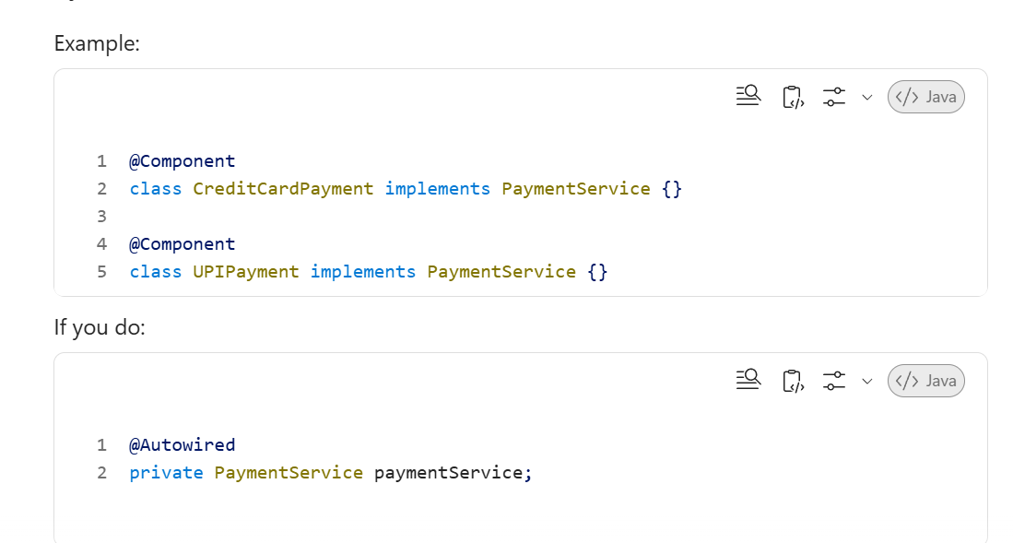

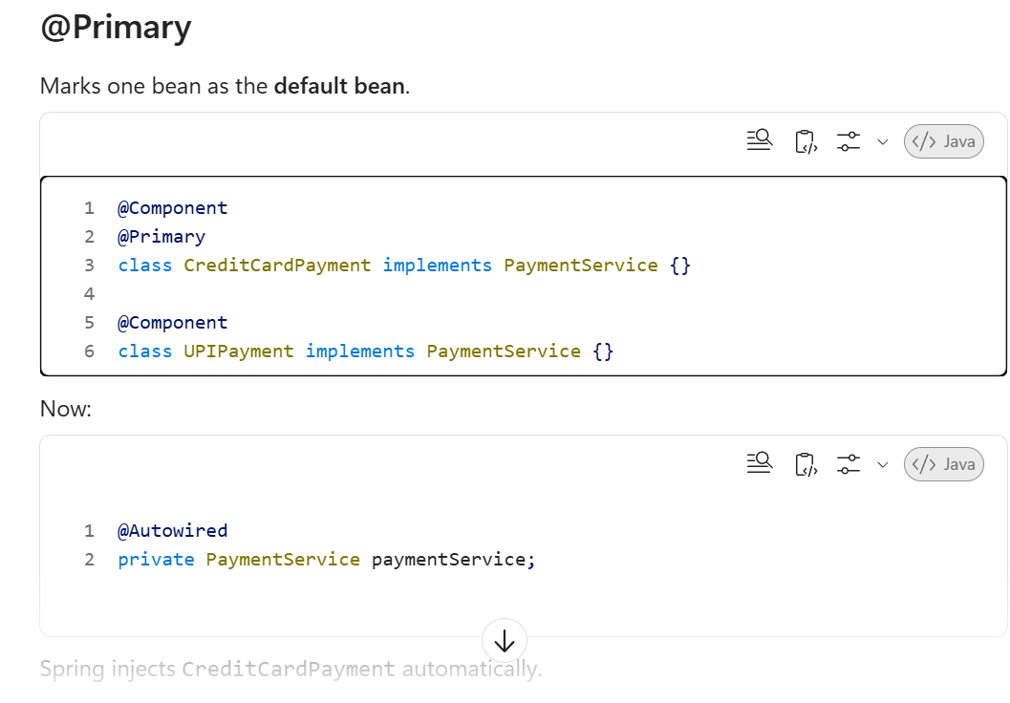

Use @Primary when one bean should be the default choice

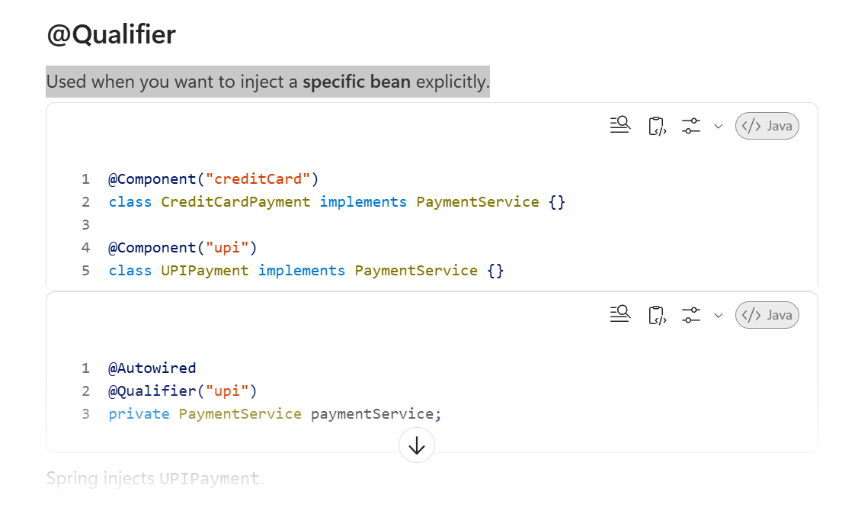

@Qualifier is used to specify exactly which bean should be injected when multiple beans of the same type are available.

Use @Qualifier when you need a specific bean

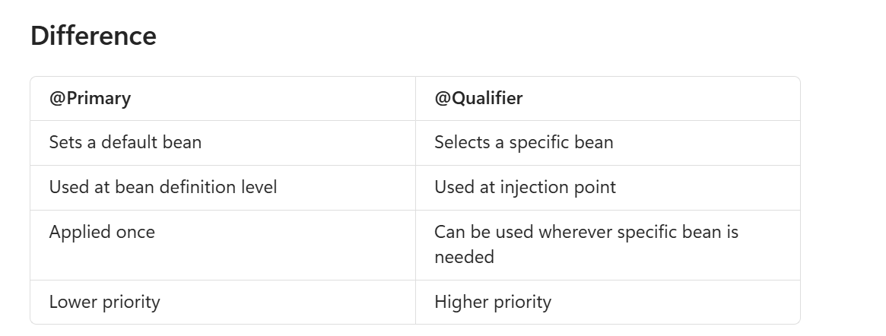

If both are used, @Qualifier takes precedence over @Primary.

Constructor Injection (Recommended)
Advantages
✅ Dependency is mandatory and cannot be null.
✅ Better for unit testing.
✅ Supports immutable objects using final.
✅ Spring recommends constructor injection.
✅ Makes dependencies explicit.

Field Injection
Advantages
✅ Less code.
✅ Easy to write.
Disadvantages
❌ Difficult to unit test.
❌ Dependency is hidden.
❌ Cannot make fields final.
❌ Object can be created without required dependencies.
❌ Uses reflection internally.

Spring 4.3+ Feature
If a class has only one constructor, @Autowired is optional.

Spring bean lifecycle consists of instantiation, dependency injection, initialization, usage, and destruction. Methods annotated with @PostConstruct and @PreDestroy can be used for initialization and cleanup.

@Transactional

@Transactional ensures data consistency by treating multiple database operations as a single transaction.
@Transactional is used to manage database transactions in Spring. It ensures that a group of database operations either all succeed (commit) or all fail (rollback) as a single unit.

@Transactional ensures ACID properties by automatically committing all successful database operations or rolling back everything if any operation fails.

Will it rollback for Checked Exceptions?
Answer: No, by default checked exceptions do not trigger rollback.

To rollback:

@Transactional(rollbackFor = Exception.class)
public void test() throws Exception {
throw new Exception();
}

Where can we use @Transactional?
  - Method level ✅
  - Class level ✅

Can we use @Transactional on private methods?
Answer: No.

What is Propagation?
Propagation defines how transactions behave when one transactional method calls another.

@Transactional(propagation = Propagation.REQUIRED)

REQUIRED is the default propagation and joins the current transaction if one already exists.

Propagation Types
REQUIRED, REQUIRES_NEW, SUPPORTS, MANDATORY, NEVER, NOT_SUPPORTED,
NESTED.

What is Isolation?
@Transactional(isolation = Isolation.READ_COMMITTED)
Isolation controls how concurrent transactions interact.
  - READ_UNCOMMITTED
  - READ_COMMITTED
  - REPEATABLE_READ
  - SERIALIZABLE

ACID
1. Atomicity (All or Nothing)
A transaction is treated as a single unit. Either all operations succeed or all fail.
Example: Transferring ₹1000 from Account A to Account B.

2. Consistency
A transaction must move the database from one valid state to another valid state.
The business rule remains valid.

3. Isolation
Multiple transactions running simultaneously should not interfere with each other.

4. Durability
Once a transaction is committed, the data is permanently saved even if the system crashes.

Singleton Scope
  - Only one object is created for the entire Spring Container.
  - Same instance is returned every time.

@Component
@Scope("singleton")
public class EmployeeService {
}

EmployeeService e1 = context.getBean(EmployeeService.class);
EmployeeService e2 = context.getBean(EmployeeService.class);

System.out.println(e1 == e2); //true

Ex-
  - Service classes
  - Repository classes
  - Utility classes
Reason: No need to create multiple copies.

Prototype Scope
  - A new object is created every time the bean is requested.

@Component
@Scope("prototype")
public class EmployeeService {
}

EmployeeService e1 = context.getBean(EmployeeService.class);
EmployeeService e2 = context.getBean(EmployeeService.class);

System.out.println(e1 == e2);// false

Ex-
  - Report generation
  - Shopping cart
  - User-specific temporary objects
Reason: Each user/task needs a separate object.

For millions of records, I use indexing, pagination, partitioning, read replicas, and data archival strategies to ensure queries remain performant.

