* **Homoscedasticity:**
  + **Homoscedastic**, which means "same stretch": the spread of the residuals should be the same in any thin vertical strip.
  + The residuals are **heteroscedastic** if they are not homoscedastic.
* Here are six residual plots and their interpretations:

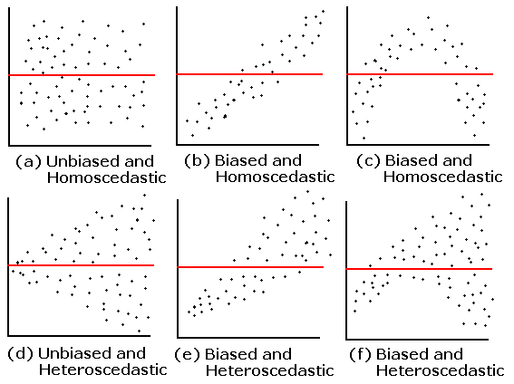

* **Autocorrelation:**
  + Significant collinearity if you regress dependent variable against itself with some time lag.

Yt = a+ b yt-1+cyt-2+e

* **Normal Distribution:**
  + Normal Distribution The normal distribution has several advantages over the other distributions. a. The normal distribution and distributions associated with it are very tractable and analytically. b. The normal distribution has the familiar bell shape, whose symmetry makes it an appealing choice for many popular models.
* **Multicollinearity:**
  + **Multicollinearity** (also **collinearity**) is a phenomenon in which two or more predictor [variables](https://en.wikipedia.org/wiki/Variable_(mathematics)) in a [multiple regression](https://en.wikipedia.org/wiki/Multiple_regression) model are highly [correlated](https://en.wikipedia.org/wiki/Correlation_and_dependence), meaning that one can be linearly predicted from the others with a substantial degree of accuracy. In this situation the [coefficient estimates](https://en.wikipedia.org/wiki/Regression_coefficient) of the multiple regression may change erratically in response to small changes in the model or the data. Multicollinearity does not reduce the predictive power or reliability of the model as a whole, at least within the sample data set; it only affects calculations regarding [individual predictors](https://en.wikipedia.org/wiki/Dependent_and_independent_variables#Use_in_statistics). That is, a multiple regression model with correlated predictors can indicate how well the entire bundle of predictors predicts the [outcome variable](https://en.wikipedia.org/wiki/Dependent_variable#Use_in_statistics), but it may not give valid results about any individual predictor, or about which predictors are redundant with respect to others.