**A**

**Project Documentation**

**on**

**Hospital Management System**

**Project Report**

## Submitted to

**Savitribai Phule Pune University, Pune In Partial Fulfillment of**

## Master of Computer Application

## (MCA-1 Sem-I)

**Submitted by**

## SAMEER SHAUKAT SAYYAD

**Under the Guidance of**

## Prof. TAKLE S.B.

**Through**



**Dattakala Shikshan Sanstha’s**

DATTAKALA GROUP OF INSTITUTIONS, FACULTY OF MANAGEMENT



MASTER OF COMPUTER APPLICATION

SWAMI-CHINCHOLI(BIGWAN), TAL-DAUND,

DIST-PUNE 413130

# Certificate

# 

This is to certify that Mr. Sameer Sayyad, has successfully & satisfactorily completed & submitted the documentation of **Hospital Management System**. In Partial fulfillment for the degree course in Master of Computer Application prescribed by University of Pune, under the guidance of Prof. Takale S.B For academic year **2023 – 24.**

### Prof. In-Charge Examiner H.O.D of Dept

##### DECLARATION

###### I, the undersigned hereby declare that the project entitle “Hospital Management System”, being submitted for the award of degree of Master of Computer Application (MCA – I, Sem – I) by me to Dattakala Group of Institutions Faculty of Management, Swami-Chincholi,Tal-Daund Dist-Pune affiliated to Savitribai Phule Pune University, Pune is the result of an independent work carried out under the guidance of Prof. Takale S.B. Is my original work. Further, I declare that this project has not been submitted to this or any institution for the award of any degree.

**SAMEER SHAUKAT SAYYAD**

###### STUDENT NAME

###### Date: 23/12/2023

###### Place: Swami-Chincholi.

##### ACKNOWLEDGEMENT

###### The project developed for the MCA was not possible without the persons and organizations that helped me in completing this. I am deeply grateful to all whose enthusiasm and energy transformed my vision of this study into reality.

I extend my sincere thanks to Prof. Takale S. B. for making it easy to work in the Institute and providing me needed guidance throughout the project keeping it focused and on the track. I am thankful to him/her for the extended knowledge imparted to me during the course of project development.

**Thank You.**

**Project Title: Hospital Management System**

**Project Guide : Prof.Takale S.B.**

**Project By**

**SAMEER SHAUKAT SAYYAD**

**MCA-1 SEM(I) SEAT NO:-8198**



# INDEX

|  |  |  |  |
| --- | --- | --- | --- |
| **Chapter** |  | **Details** | **Page** |
| **1** |  | **Introduction** | **8** |
| **1.1** | Existing System and Need for System | **9** |
| **1.2** | Scope of System | **10** |
| **1.3** | Operating Environment - Hardware and Software | **11-14** |
| **2** |  | **Proposed System** | **15** |
|  | **2.1** | Feasibility Study | **15** |
|  | **2.2** | Objectives of Proposed System | **16** |
|  | **2.3** | Users of System | **17** |
| **3** |  | **Analysis and Design** | **18** |
|  | **3.1** | System Requirements (Functional and Non-Functional requirements) | **18-19** |
|  | **3.2** | Entity Relationship Diagram (ERD) | **20** |
|  | **3.3** | Table Structure | **21-23** |
|  | **3.4** | Use Case Diagrams | **24** |
|  | **3.5** | Class Diagram | **25** |
|  | **3.6** | Activity Diagram | **26** |
|  | **3.7** | Sequence Diagrams | **27** |
| **4** |  | **Testing** | **-** |
|  | **4.1** | Sample Input and Output Screens (Screens must have valid data.) | **28-35** |
| **5** |  | **Limitations of Proposed System** | **36** |
| **6** |  | **Proposed Enhancements** | **37** |
| **7** |  | **Conclusion** | **38** |
| **8** |  | **Bibliography** | **39** |

## Introduction

## Abstract

In this technical world, humans are trying to convert manual processes into automation in order to save time and money. The Hospital Management System is a solution for hospitals there are many employees are working with doctors, nurses, staff members. This application is a web platform to handle and manage all the activity and maintain and centralize a database about the information that will be easily available with just one click on the web. Another key part of this application is patient or you can say end-user of the application. So the system provides functionality to manage the end-user as well according to the relation of the work with a patient means Doctors, Staff or Nurse or Admin can manage the patients.

#### Existing System & Need for System

Before this, the management of the hospital is done manually. There are some problem arise especially for the data retrieval. Hospital has a problem of loss of patient data. There is also redundant patient data if the patient not sure whether they have come to the hospital before. So the clerk consider the patient as a new patient and add new data. Currently, the inventory for the medicine is done manually. The management of the hospital also have to takes times to check for the medicine inventory. Hospital Management System is developed to support and automate the hospital daily operation.

Hospital Management System is a system that can help the hospital to manage their daily activity. This system will involve all the hospital operation starting from patient registration until billing the patient. Here the patients can register through online and get their appointment. This system help reduce the problems occur when using the manual system. The important thing is it will become easier for the data record and retrieval. This software also stores all the patient details, patients lab reports, bill calculation, billing, monthly reports, daily reports.

The system enables doctors and hospital assistant to manage patient records, medicine stock, and appointment and produce reports. This system will be able to generate report regarding the hospital operation. User can enter the patient details. Whatever treatment he has taken will also be saved in the database. Other than that, the system is user friendly and it can help the hospital to manage their activity.

#### Scope of System

The scope of the product is to change from manual system to computerized store management system, which is allowing easy communication between staff, doctors and patient. In hospital system use database system for all information that make the process of work going easily. In the Hospital Management System is easy to add, modify and delete records instead of changing or destroying the whole file. Also the interface of the system is much user friendly. By this software the searching will be easily by simply typing the letters that much them. In the computerized system you can easily keep your data save, for example by creating another copy of whole system and save it as a backup. When any failure happens to your system then you will have another copy of it.

* + - **Register:** will help patient to easy register in hospital. Also it will know directly the new patient and old patient
    - **Bills:** The patients can payment the money.
    - **Staff:** will enter patient information.
    - **Patient:** will be rejecter for the system.
    - **Medicine:** that will be given for the patient.
    - **Supplier:** will provide the medicines.

#### 1.4. Operating Environment - Hardware and Software

The operating environment for a Hospital Management System can vary depending on the specific software and hardware requirements of the system.

##### Hardware:

1. **Processor:** The desktop computer should have a modern processor that meets the minimum system requirements of the Hospital Management System.

i3 Processor minimum.

1. **RAM:** The desktop computer should have sufficient RAM to run the Hospital Management System. The minimum RAM requirement can depend on the specific requirements of the system, but typically ranges from 2GB to 8GB.
2. **Hard Disk:** The desktop computer should have enough hard disk space to install and run the Hospital Management System. The minimum hard disk requirement can depend on the specific requirements of the system, but typically ranges from 500MB to 2GB.
3. **Display:** The desktop computer should have a display with sufficient resolution and size to view the Hospital Management System interface clearly.

##### Software:

1. **Operating System:** The Hospital Management System can be designed to work with various operating systems, such as Windows, MacOS, or Linux. The system should be compatible with the specific version of the operating system that the desktop computer is running.
2. **Database Management System:** The Hospital Management System typically requires a database management system for storing and managing the data. The database management system used is MySQL. Using MySQL workbench.
3. **Programming Language and Framework:** The Hospital Management System can be developed using a programming language Java.
4. **Other Software:** The Hospital Management System requires additional software components Apache NetBeans IDE and Windows 11 Operating System.

Overall, the hardware and software requirements for a desktop-based Hospital Management System can vary depending on the specific needs and requirements of the application. The system should be designed and developed to be compatible with the existing hardware and software infrastructure of the school, while also meeting the functional and performance requirements of the system

**1.5. Brief Description of Technology Used.**

**1.5.1 Operating System**

Project is developed in Windows 10 operation system platform. This is very simple operation system to operate computer system. Its graphical user interface is very powerful. This operating system is easily available to any person in market. GUI of this system is very powerful and this is also multitasking operating system, we can run multiple task at a time, so we chose this system.

**1.5.2 Technology**

I used MySQL RDMBS database tool to store data. It is open source database. We don’t need to pay any cost of amount to use it so that. MySQL Database is very powerful and fast RDBS database system to store and retrieve data from database tables. It also support all the functionality of SQl. It is freely available into market, no need to pay any amount to use MySQL Database system, so we choose this product.

## Proposed System

###### Feasibility Study

The feasibility study is major factor, which contributes to the analysis and development of the system. The decision of the system analyst whether to design a particular system or not depends on its feasibility study.

###### Operational Feasibility

Evaluate the operational feasibility of the system by considering how it will integrate with existing business processes, any potential changes in workflows, and Any potential training needs for employees or users.

###### Technical Feasibility

Assess the technical feasibility of the system by evaluating the hardware, software, and network requirements, as well as any potential technological limitations or constraints.

###### Economical Feasibility

Evaluate the economic feasibility of the system by analyzing the costs of development, implementation, and maintenance. Consider the revenue potential, potential return on investment, and any potential risks associated with the system.

###### Behavioral Feasibility

This includes the following questions:

* + - * Is there sufficient support for the users?
      * Will the proposed system cause harm?

The project would be beneficial because it satisfies the objectives when developed and installed. All behavioral aspects are considered carefully and conclude that the project is behaviorally feasible.

* 1. **Objective of Proposed System**
     + The project hospital management is software developed to simplify the communication process between the doctor and the receptionist.
     + The software would be operated by two users one is doctor and the other is receptionist.
     + Receptionist would be responsible for assigning token numbers to the patient visiting the hospital and save it in the database along with their details. These token numbers along with respective patient details are sent to doctor. The doctor can thus view patient details and after checking up the patient, the recommended medicines for the particular patient are fed into the database by the doctor and are sent to receptionist.
     + The receptionist can then generate bill and feed into the database. The system also maintains patient’s history so that doctor or receptionist can view them anytime. The system can thus reduce complexity in maintaining patient’s records. The project is developed on Net Beans platform and is supported by a SQL database to store user specific details

The aim of the proposed system is to develop a system of improved facilities.

* + - * Security of data.
      * Ensure data accuracy.
      * Greater efficiency.
      * Better services.
      * User friendliness and interactive.
      * Minimum time required for searching
  1. **Users of System**
     + DOCTORS
     + STAFFS
     + ADMIN

2.3.1. Doctors : Doctors have only permission for give the prescription to patient. Doctor can change password of himself for login, also doctors can be view patient history.

2.3.2 Staff: Staff can be login as staff or Receptionist. He has permission of Register a patient, View Patient Details and He can book appointment of Patient.

2.3.3 Admin: Admin have all the permissions, can change any users password, or deletes user and add user.

## Analysis and Design

#### System Requirement (Functional & Non-Functional Requirement)

###### Functional Requirements:

* + - * **Login Module:-**
        + The system only can access by the authority user which is an official hospital staff who is registered.
        + The authority user must use username and password to login to the system.
        + Validation on username and password that input is required to deny the invalid user login to the system
      * **REGISTER NEW PATIENT:-**
        + System must be able to verify and validate information.
        + The system must encrypt the password of the user
      * **Patient Record Module:-**
        + Patient medical history is a confidential data which supposed to view by doctor only. So only doctor can add and update the patient medical history.
        + Staff level user could only add new patient record and update patient record with patient basic information such as contact detail.
      * **Report Module:-**
        + The basic report that usually needed to be carried out during business operation is required to prepare for the staff.
        + The detail that going to display on the report must decide by the user.

###### Non-functional Requirements:

* + - * **Usability Requirement:-**
* The system will decrease the amount of text box that input by the user and increase the selection input method such as combo box and radio button.
* Within this will eliminate the possibility of entry error that made by the user when they enter record into the system.
  + - * **Efficiency Requirement:-**
* The system must allow the staff to search the patient record in an easy and efficient way from a large amount of data.
* The system response time must be fast and the system should allow the user to open several task at one time when they using it.
  + - * **Reliability Requirement:-**
* Make sure there is an additional server to back up the hospital data in case when the server is down, there is still a backup server to support the system to continue running the daily business.
  + - * **Security Requirement:-**
* The system must provide a highly security on protecting the patient privacy.
* Some confidential data should restrict to only authorize user to access it.
  1. **Entity Relationship Diagram(ERD)**

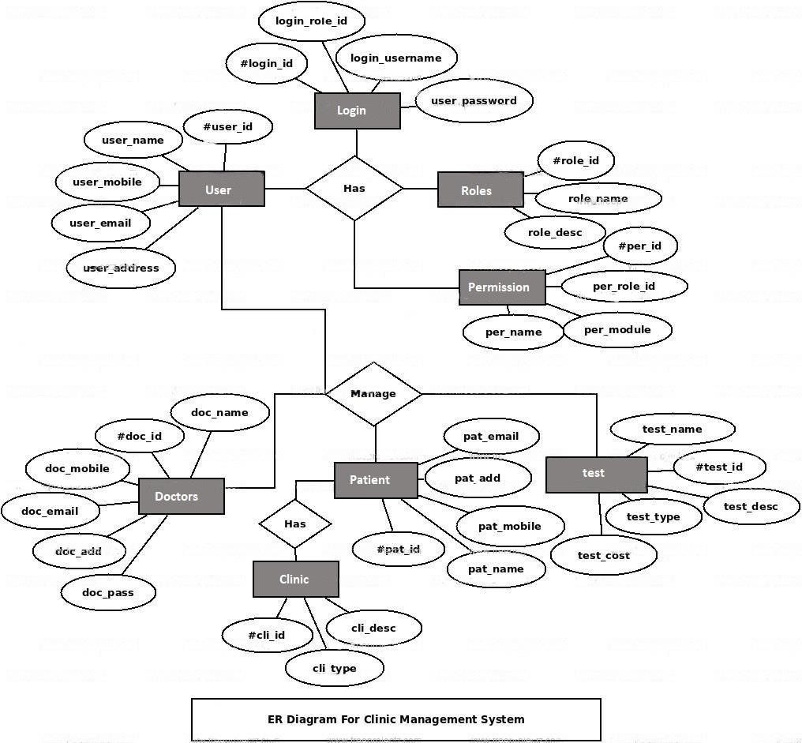

ER Diagram for Hospital Management System

* 1. **Table Structure:**
     1. **Admin table**

|  |  |  |
| --- | --- | --- |
| Field | Data Type | Constraint |
| username | varchar(15) | Primary key |
| Password | varchar(15) | Not Null |

* + 1. **Doctor Table**

|  |  |  |
| --- | --- | --- |
| Field | Data Type | Description |
| Id | Varchar(10) | Not Null |
| Name | Varchar(30) | Not Null |
| Age | Int(5) | Not Null |
| Gender | Varchar(8) | Not Null |
| Phone | Varchar(15) | Not Null |
| Address | Varchar(20) | Not Null |

###### Patient table

|  |  |  |
| --- | --- | --- |
| Field | Data Type | Description |
| Id | Varchar(10) | Not Null |
| Name | Varchar(30) | Not Null |
| Age | Int(5) | Not Null |
| Gender | Varchar(10) | Not Null |
| Address | Varchar(20) | Not Null |
| Phone | Varchar(20) | Not Null |
| Status | Varchar(10) | Not Null |
| Disease | Varchar(20) | Not Null |
| Room | int (11) | Not Null |

* + 1. **Receptionist table**

|  |  |  |
| --- | --- | --- |
| Field | Data Type | Description |
| Count | int(11) | Primary key |
| Joining | Varchar(15) | Not Null |
| Id | Varchar(15) | Not Null |
| Name | Varchar(30) | Not Null |
| Age | Int(5) | Not Null |
| Gender | Varchar(10) | Not Null |
| Blood | Varchar(4) | Not Null |
| Email | Varchar(40) | Not Null |
| Phone | Varchar(17) | Not Null |
| Address | Varchar(30) | Not Null |
| Status | Varchar(10) | Not Null |
| Username | Varchar(20) | Not Null |
| Password | Varchar(30) | Not Null |

* + 1. **Prescription Table**

|  |  |  |
| --- | --- | --- |
| Field | Data Type | Description |
| Id | Int | Not Null |
| appid | Int | Not Null |
| Patientid | int | Not Null |
| presciption | Varchar(30) | Not Null |
| times | Int | Not Null |
| type | Varchar(10) | Not Null |

* + 1. **Appointment Table**

|  |  |  |
| --- | --- | --- |
| Field | Data Type | Description |
| Id | Int | Not Null |
| patientid | int | Not Null |
| appdate | Varchar(30) | Not Null |
| apptime | Varchar(10) | Not Null |

* 1. **Use case Diagram**

Use case Diagram of Hospital Management System

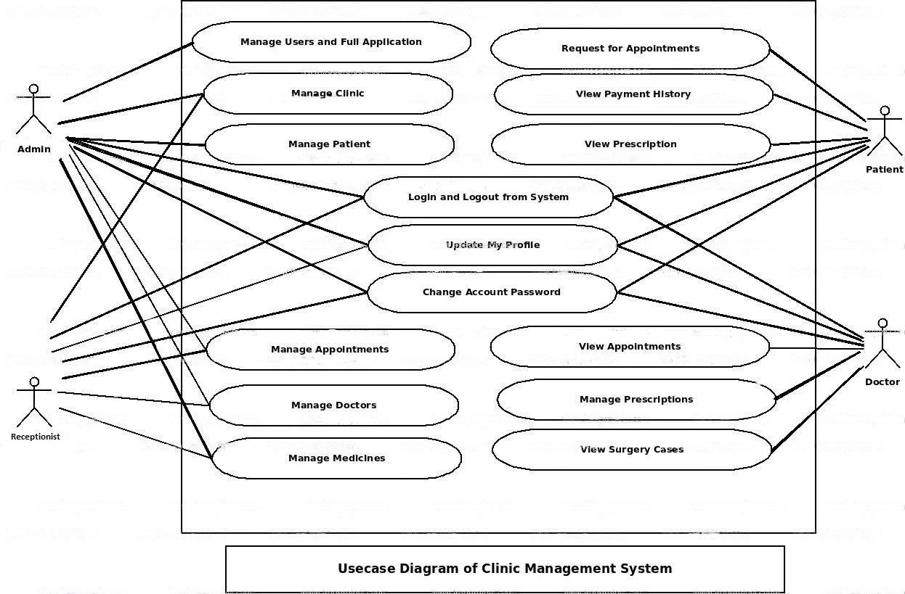

* 1. **Class Diagram**

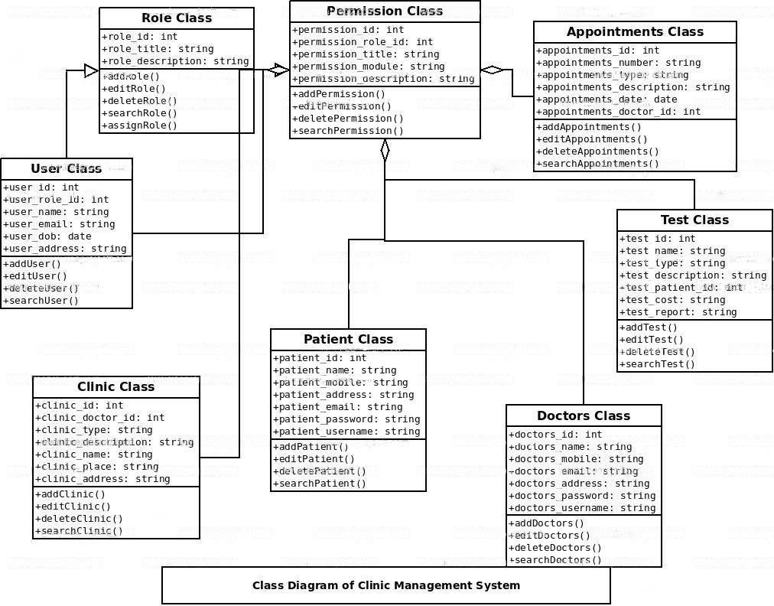

Class Diagram of Hospital Management System

#### Activity Diagram

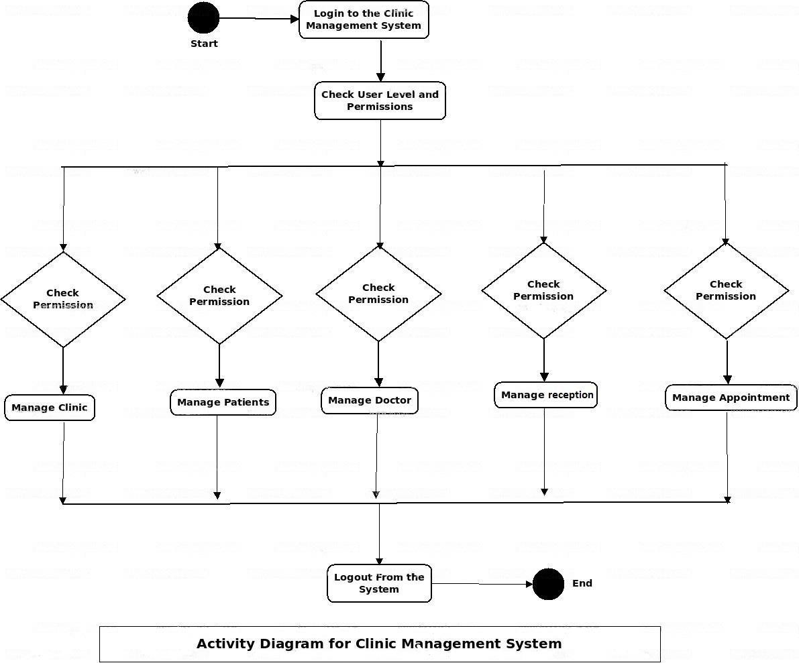

Activity Diagram of Hospital Management System

**3.7 Sequence Diagram**

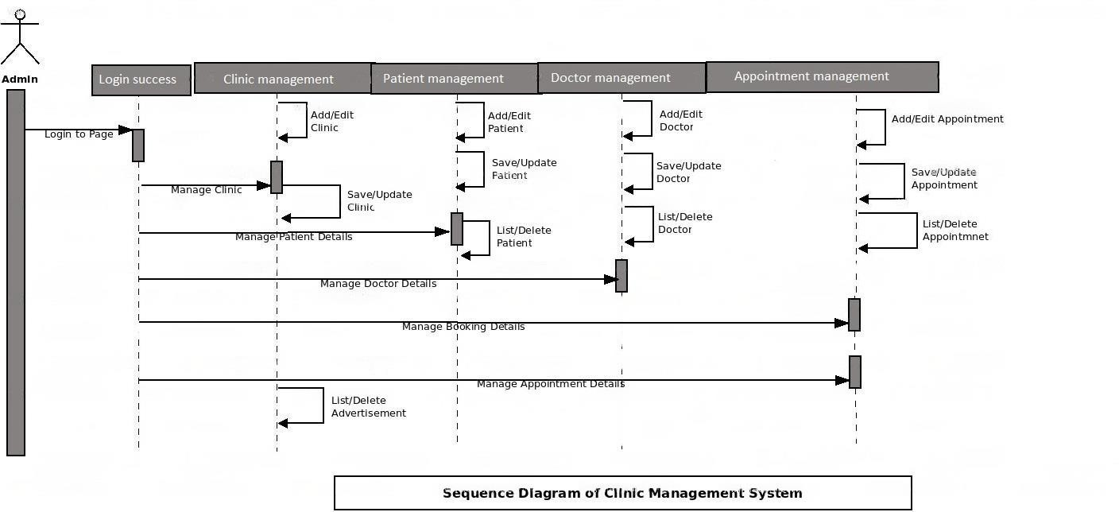

Sequence Diagram of Hospital Management System

1. **Sample Input and Output Screens**

**4.1 Login Screen**

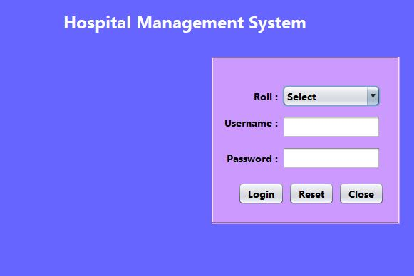

Here, we can Login into the system, by using their role, username and password, if any this is not match it will generates error message and Login stage is prevented there to Login into the system.

4.2 Home Page

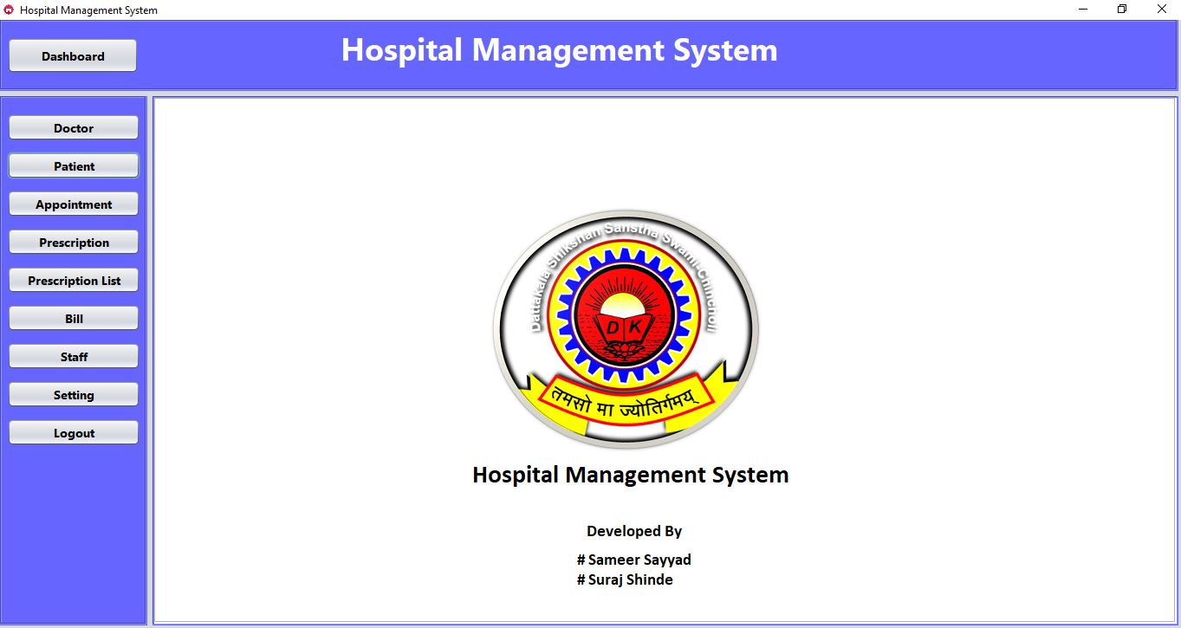

This screen shows all the menus of the software applications. It is main dashboard Hospital System.

4.3 Doctor Panel

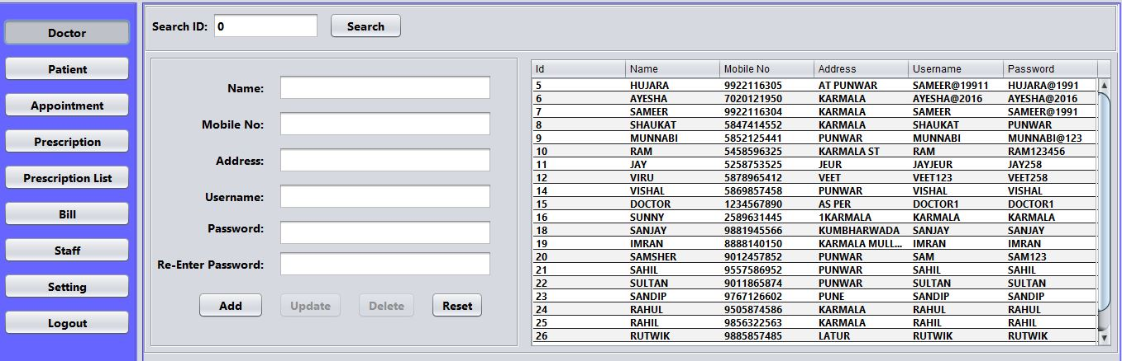

Here admin can add, update and delete patiement.

**4.4 Patient Panel**

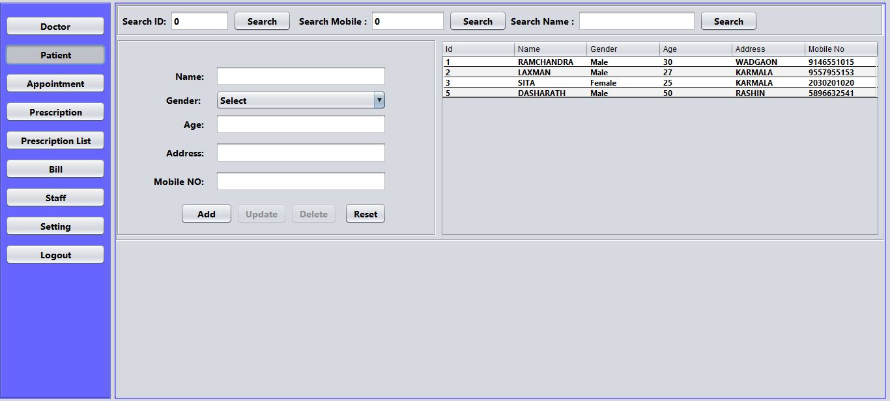

Here we can add new patients and list patients, update and delete patient.

**4.5 Prescription Panel**

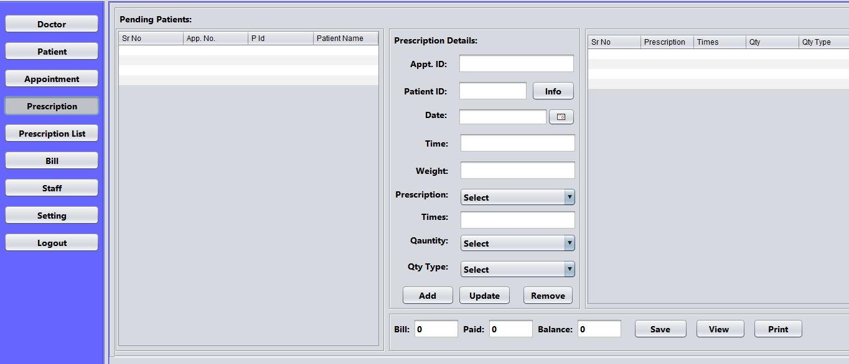

Here we can add prescriptions. We can manage all prescriptions of patients.

**4.6 Prescription List Panel**

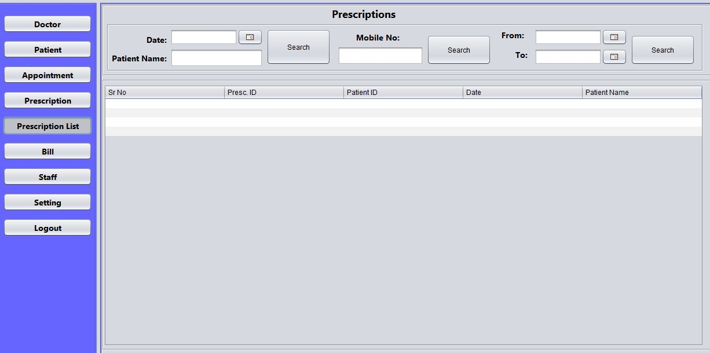

Here we can view list of prescriptions in deferent criteria’s, prescription is, name.

4.7 Appointment Panel

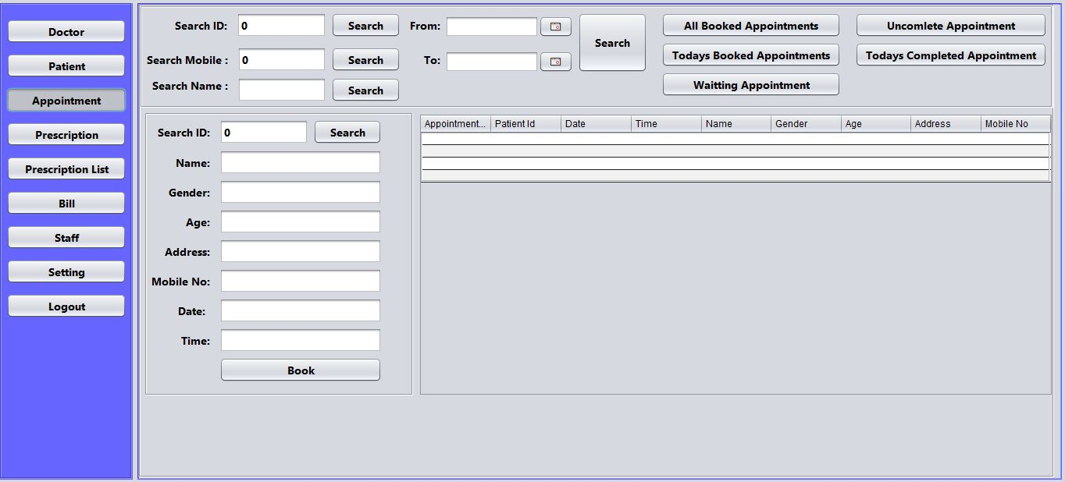

Here we can book appointments and view appointments.

4.8 Staff Panel

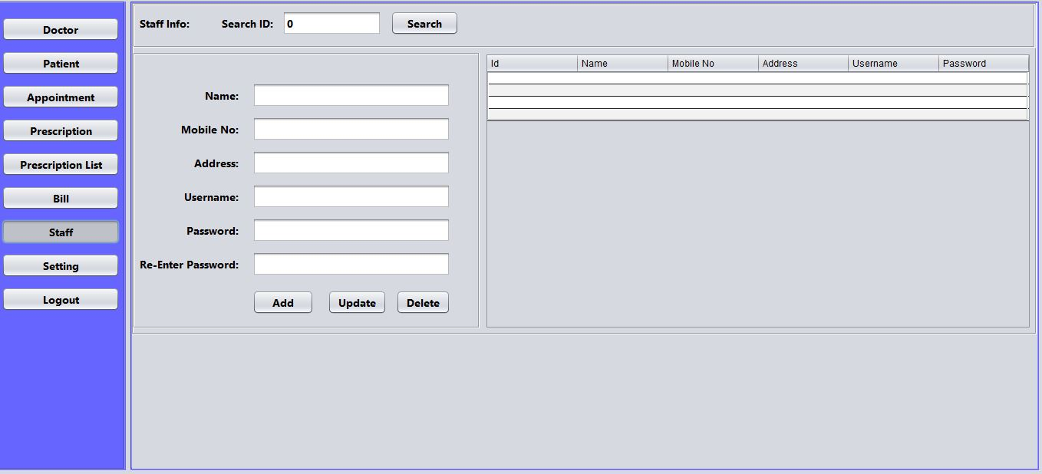

Here we can add staff , update, view and delete staff.

### 5. Limitations of Proposed System

Limitations & Future

* Excel export has not been developed for Hospital, Doctor due to some criticality.
* The transactions are executed in off-line mode, hence on-line data for Patient. Appointment capture and modification is not possible.
* Off-line reports of Hospital, Tests, and Patient cannot be generated due to batch mode execution.

Advantages

The system is very simple in design and to implement. The system requires very low system resources and will work in almost all configurations. It has got following advantages

* + User friendly application.
  + Secured database.
  + Fast processing.
  + Record can be updated easily. • Can stored number of records.
  + Any record can be retrieved when required.
  + System reduces manual workload.
  + Redundancy of data is avoided.
  + Records can be searched and sorted easily.

### 6. Proposed Enhancements

In a nutshell, it can be summarized that the future scope of the project circles around maintaining information regarding:

* We can add printer in future.
* We can give more advance software for Hospital Management System including more facilities
* We will host the platform on online servers to make it accessible worldwide
* Integrate multiple load balancers to distribute the loads of the system
* Create the master and slave database structure to reduce the overload of the database queens
* Implement the backup mechanism for taking backup of codebase and database on regular basis on different servers

The above mentioned points are the enhancements which can be done to increase the applicability and usage of this project. Here we can maintain the records of Hospital and Doctor.

### Conclusion

Finally, in the Hospital management service, the outcome of all the-the hard work done for the Hospital Management System is here. It is software that helps the user to work with the hospitals easily. This software reduces the amount of manual data entry and gives greater efficiency. The User Interface of it is very friendly and can be easily used by anyone.

It also decreases the amount of time taken to write patient details and other modules. In the end, we can say that this software is performing all the tasks accurately and is doing the work for which it is made.

The central issuer for controlling and handling the task by the doctor is therefore solved. Before this it was quite hectic for handling the timetable and to keep in touch with day to day agenda. But by creating this software the administrator can now handle the task easily and also save his/her time. The quality time of the doctor is also saved and the manual man power is also saved, the data can be retrieved timely and also whenever it is required by the user.

The adequate application of the task by distributing it and by allocating the exact outputs. The storage facility will make the task easy of the handler. Therefore the proposed system will be accessible to the doctor by making his/her task easy.

### Bibliography

The following website were referred during the analysis and execution phase of the project.

###### W3 SCHOOL

* **YOU TUBE**

###### JAVATPOINT

* [**www.Geeksforgeeks.com**](http://www.Geeksforgeeks.com/)
* **JAVATUTORILAS**
* **CODEWITH DURGESH**

References Java Server Programming Java EE7 Black Book