Project Design Phase-II
Data Flow Diagram & User Stories

Date | 31 January 2025
Team ID | LTVIP2026TMIDS54144
Project Name | ShopSmart – Digital Grocery Web Application
Maximum Marks | 4 Marks

Data Flow Diagrams:
A Data Flow Diagram (DFD) is a traditional visual representation of the information flows within a system. A neat and clear DFD can depict the right amount of the system requirement graphically. It shows how data enters and leaves the system, what changes the information, and where data is stored.
Example: DFD Level 0 (Industry Standard)
Example: (Simplified)
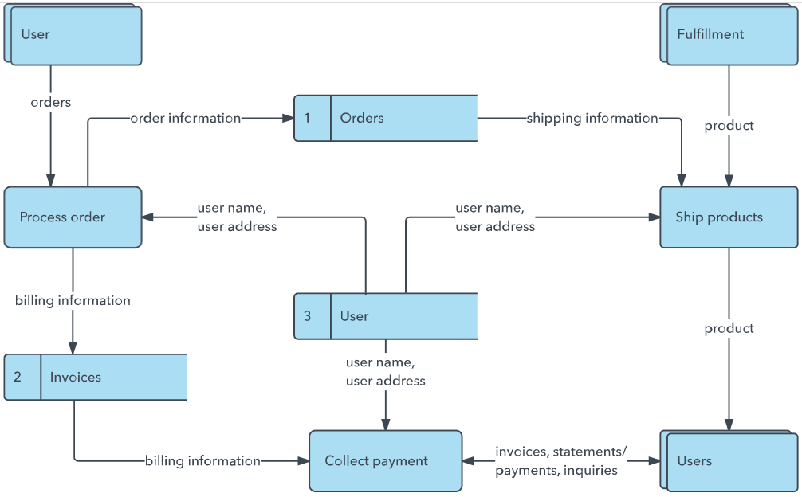


User Stories
Use the below template to list all the user stories for the product.
User Type | Functional Requirement (Epic) | User Story Number | User Story / Task | Acceptance criteria | Priority | Release
Customer | Registration | USN-1 | As a Customer, I want to register using my email and password so I can access my account. | Successfully creates account and redirects to login. | High | Sprint-1
Customer | Login | USN-2 | As a Customer, I want to log in using my credentials so I can use the application. | Successful authentication generates JWT token. | High | Sprint-1
Customer | Browse Products | USN-3 | As a Customer, I want to browse products by category so I can find what I need. | Displays a list of products accurately. | High | Sprint-1
Customer | Search Products | USN-4 | As a Customer, I want to search products by name so I can find specific items quickly. | Search bar returns relevant product results. | Medium | Sprint-1
Customer | View Product Details | USN-5 | As a Customer, I want to view product details so I can see price, description, and stock. | Product page shows accurate details and images. | High | Sprint-1
Customer | Add to Cart | USN-6 | As a Customer, I want to add items to my cart so I can purchase multiple products. | Cart count updates and session stores the items. | High | Sprint-1
Customer | Update Cart Quantity | USN-7 | As a Customer, I want to update item quantities in my cart so I can adjust my purchase. | Cart total dynamically calculates on quantity change. | High | Sprint-1
Customer | Remove from Cart | USN-8 | As a Customer, I want to remove items from my cart if I change my mind. | Item is successfully removed from cart list. | Medium | Sprint-1
Customer | Place Order | USN-9 | As a Customer, I want to place an order by providing my shipping address. | Creates an order record in the database with status Pending. | High | Sprint-2
Customer | Make Payment | USN-10 | As a Customer, I want to pay securely via Stripe so my order is confirmed. | Stripe processes payment and returns success response. | High | Sprint-2
Customer | View Order History | USN-11 | As a Customer, I want to view my past orders to track my purchases. | Displays a list of previous orders with status. | Medium | Sprint-2
Customer | Order Tracking | USN-12 | As a Customer, I want to see the current status of my active order. | Status correctly reflects Processing, Shipped, or Delivered. | Medium | Sprint-2
Administrator | Add Product | USN-13 | As an Admin, I want to add new products to the catalog. | New product is saved to MongoDB and appears on frontend. | High | Sprint-1
Administrator | Update Product | USN-14 | As an Admin, I want to edit product details like price and stock. | Product details are updated correctly in the database. | High | Sprint-1
Administrator | Delete Product | USN-15 | As an Admin, I want to remove products that are no longer available. | Product is deleted or marked inactive. | High | Sprint-1
Administrator | View Orders | USN-16 | As an Admin, I want to view all user orders to manage fulfillments. | Admin dashboard displays all orders logically. | High | Sprint-2
Administrator | Update Order Status | USN-17 | As an Admin, I want to update order statuses to notify customers. | Order status changes successfully and updates DB. | Medium | Sprint-2
Administrator | Manage Users | USN-18 | As an Admin, I want to view and manage registered users. | Admin can view list of users and their roles. | Medium | Sprint-2
Administrator | Generate Reports | USN-19 | As an Admin, I want to generate sales reports to analyze revenue. | System gathers sales data and exports/displays a summary. | Low | Sprint-2

DFD Level 0 (Context Diagram)
Entities: Customer, Admin, Payment Gateway, MongoDB Database
Main Process: ShopSmart Grocery System
Data Flows:
- User Registration Data
- Login Credentials
- Product Search Request
- Cart Data
- Order Details
- Payment Details
- Admin Product Updates
Explanation:
Data flows from the user (Customer/Admin) to the ShopSmart Grocery System via web requests. The system processes these requests and interacts with the MongoDB Database to read/write data such as user profiles, products, and orders. During checkout, the system securely transmits payment details to the Payment Gateway and receives authorization status.

DFD Level 1
The system is broken into the following sub-modules:
1. Authentication Module
2. Product Management Module
3. Cart Module
4. Order Processing Module
5. Payment Processing Module
Explanation:
The Authentication Module handles login and registration, generating JWT tokens. The Product Management Module enables product browsing and admin catalog updates. The Cart Module manages session-based or database-stored cart items. The Order Module calculates totals, applies discounts, and finalizes orders. The Payment Processing Module communicates with Stripe for transaction clearance.

