M.Tech Project (MTP-1) · Progress report
TinyGPU on FPGA: Current Setup and Multi-Core Scaling
Phase 1 (setup documentation) and Phase 2 (core-count scaling experiment)
Student: Srinivas · Date: 2 November 2026
Board: Digilent Nexys 4 DDR (Xilinx Artix-7 XC7A100T-1CSG324C) · Tools: Vivado 2024.2, xsim, Python

Summary
This report documents the current FPGA setup and the multi-core scaling experiment before the scheduler / workload-sharing phase. All hardware numbers were measured on the board from timing-clean builds, and every cycle count matches RTL simulation exactly.
- Important: The CNN currently runs on a separate fixed-function CNN accelerator, not on TinyGPU. TinyGPU runs three benchmark kernels (vector add, 8×8 matrix multiply, ALU loop). Porting the CNN to TinyGPU is the next major task (Section 6).
- CNN accelerator: Bit-exact with the Python golden model; 2,542 cycles (50.8 µs) per inference at 50 MHz; accuracy 50 % → 97 % on the training set after 5 epochs, 95.6 % on held-out images.
- Core count: Stock TinyGPU meets 50 MHz up to 8 cores (12,904 LUTs). The largest timing-clean builds are 16 cores at 40 MHz and 32 cores at 25 MHz.
- Speedup: Stock TinyGPU's speedup saturates at 2.2–2.7× regardless of core count, because all cores fetch instructions through one program-memory channel. With one instruction port per core, compute scales to 7.9× (8 cores) and 15.2× in cycles (16 cores), which is 12.1× in execution time at the 40 MHz the 16-core build reaches.
- Limits found: Instruction-fetch bandwidth, data-memory bandwidth (likely including the single write port), memory-interconnect area/clock, and dispatcher logic depth. A follow-up synthesis experiment shows that most of the 16-core area growth came from how the test memory was modelled, not from TinyGPU itself (Section 4.4).

1. Current working setup

1.1 What runs where
There are two separate designs in the project at present:
Table 1. The two designs
 | CNN accelerator (cnn_fpga/) | TinyGPU (tinygpu_fpga/)
What it is | Fixed-function CNN engine: one FSM, one shared multiply-accumulate unit | Programmable SIMT GPU (adam-maj/tiny-gpu) executing kernels from program memory
Runs the CNN? | Yes – training and evaluation, on the board | Not yet – runs vecadd, matmul and compute kernels
Reason | – | Stock TinyGPU is 8-bit with 256 B of data memory, an 8-bit truncating multiply and no shift or branch divergence; the Q4.12 CNN needs 16-bit data, a wide accumulator and more memory

The CNN accelerator therefore serves as the correctness reference and performance baseline for the future TinyGPU CNN kernel.

1.2 Setup documentation
Table 2. Current setup
Item | CNN accelerator | TinyGPU
Repository / version | Own RTL (cnn_core.v, cnn_top.v), bit-exact with golden_model.py | github.com/adam-maj/tiny-gpu @ 02b6c2c + changes in 1.3
FPGA / board | XC7A100T-1CSG324C, Nexys 4 DDR | Same
Number of cores | 1 engine, 1 MAC | Stock: 2 cores × 4 threads; swept 1–32 cores
Network | 8×8 input → Conv3×3 (1→2) + ReLU → Conv2×2 (2→2) → global avg pool → 2 logits; 38 parameters | –
Data type | Q4.12 16-bit fixed point, 40-bit accumulator, 512-entry sigmoid LUT | 8-bit integer
Inference / training | Both: on-chip SGD (batch 1, lr 2⁻³) and evaluation | Kernel execution only
Dataset | sklearn digits, class 0 vs 1: 200 training images + 160 held-out images | –
LUT / FF / BRAM / DSP | 2,435 / 1,164 / 8.5 / 4 | 1 core: 1,877 / 1,520 / 3.5 / 0
Clock / Fmax | 50 MHz; WNS +4.92 ns → Fmax ≈ 66 MHz | 50 MHz (40 or 25 MHz where needed); Fmax ≈ 53 MHz at 1 core
Power (Vivado est.) | 0.222 W on-chip | 0.218 W (1 core) – 0.317 W (16 cores)

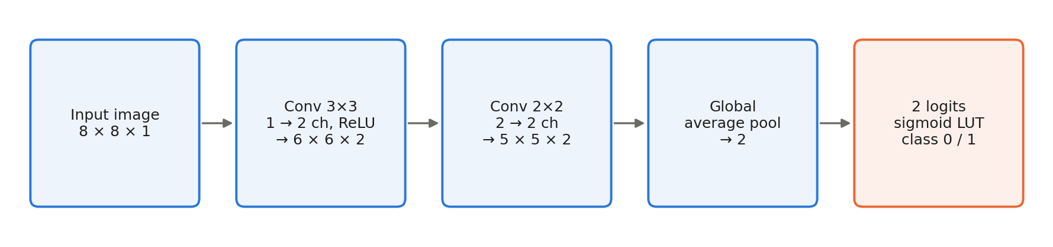
Figure 1. CNN architecture implemented on the CNN accelerator (38 trainable parameters).

1.3 Changes made
CNN accelerator (designed from scratch):
- Fixed the label-file path (a missing “/”). Vivado had silently built the earlier bitstream without labels (CRITICAL WARNING Synth 8-4445), so earlier hardware accuracy numbers were invalid.
- Fixed two testbench bugs (a 32-bit timeout overflow and a relative file path).
- Added hardware cycle counters reported over UART.
TinyGPU (modified copy in tinygpu_fpga/rtl/):
- Earlier: dispatcher start-latch fix, Vivado 2024 syntax fixes, controller array initialisation.
- scheduler.sv: the any_lsu_waiting flag used a static initialiser and could stick at 1; now assigned every cycle.
- gpu.sv: tied off the floating write-valid input of the read-only program-memory controller.
- New dispatch_rr.sv: assigns and retires one block per cycle using priority encoders instead of the stock serial loop. Cycle counts match the stock dispatcher (one case differs by +6 cycles). Despite the name, it uses fixed priority, not round-robin.
- New SoC wrapper gpu_soc_top.sv (Figure 2): on-chip program and data memories with a configurable number of ports, kernel ROMs (built into the bitstream) with a loader, a hardware cycle counter, a checker that compares all 256 data bytes with the expected result, and a UART report.
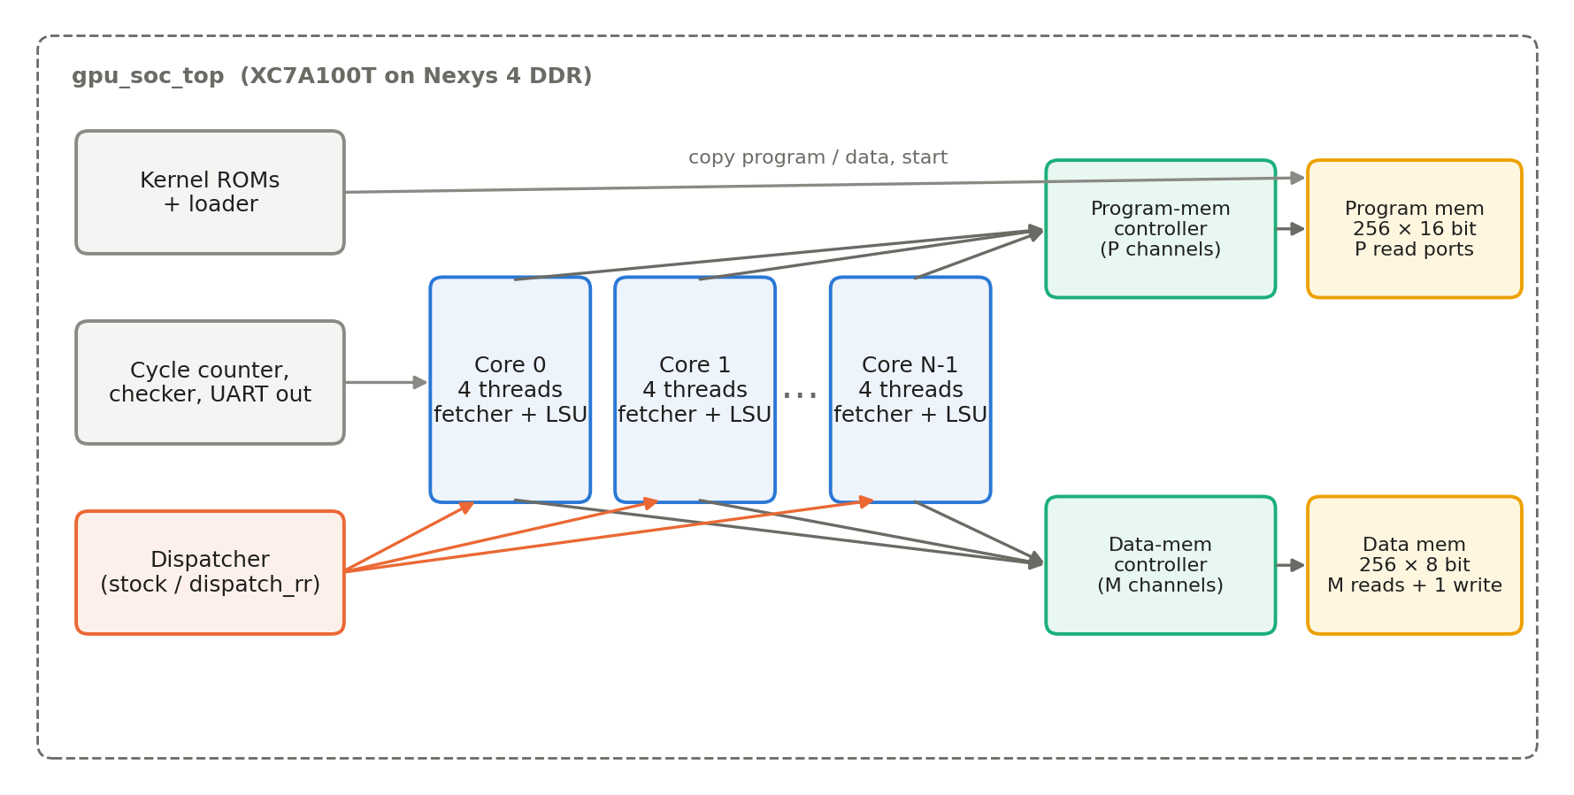
Figure 2. Test SoC used for the scaling experiment. P = program-memory channels, M = data-memory read channels; the data memory accepts one write per cycle.

2. CNN accelerator results (board)
Table 3. CNN accelerator performance at 50 MHz (board = simulation)
Metric | Value
Inference latency | 2,542 cycles = 50.8 µs (including loading the 64-pixel image)
Inference throughput | 19,670 images/s (1,048 MACs per image ≈ 20.6 MMAC/s)
Training step (forward + backward + update) | 6,154 cycles = 123.1 µs → 8,125 samples/s
Full run (6 evaluations + 5 epochs) | 9,204,406 cycles = 184.1 ms
Training-set accuracy, epochs 0–5 | 100, 132, 160, 179, 189, 194 out of 200 (50 % → 97 %), identical to the golden model
Held-out accuracy after epoch 5 | 95.6 % (160 images not used in training)

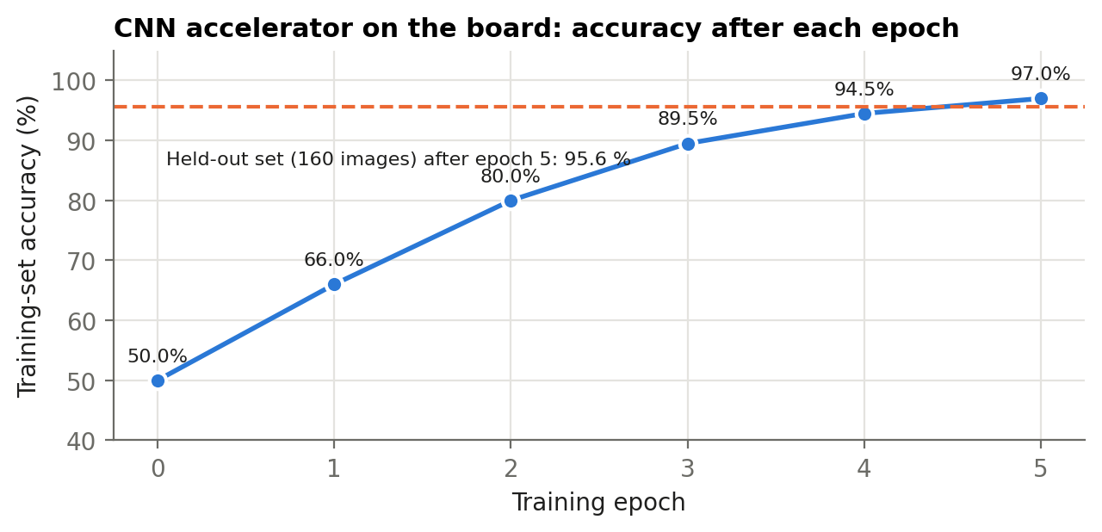
Figure 3. Accuracy measured on the board after each training epoch, with the held-out accuracy after training.
Verification: the hardware matches the golden model on all 38 parameters after each of 1,000 training steps (tb_core, bit-exact), and the board's per-epoch accuracy matches the golden model exactly. Note that 0-vs-1 digit classification is an easy task (a plain logistic regression reaches 99.4 % on the same split), so this network is a functional benchmark rather than a strong classifier.

3. Multi-core scaling experiment: method
- Configurations: Stock TinyGPU corresponds to P = 1, M = 4. Three series were built: A = stock memory system (P = 1, M = 4); B = one program port per core (P = N, M = 4); C = one program port and one data port per core (P = M = N).
- Kernels: vecadd A[i] += B[i] (128 threads, memory-bound); matmul 8×8 (64 threads, mixed); compute x ← x² + i, 16 iterations (128 threads, ALU-bound). All 256 data bytes are checked after every run.
- Work distribution: TinyGPU's dispatcher assigns thread blocks (4 threads each) to whichever core is free. Kernels are written once in SIMT style and are identical for every core count.
- Measurement: A hardware counter from start to done, in core clock cycles. Speedup = cycles(1 core) / cycles(N cores); execution time = cycles / clock frequency.
- Timing: Each configuration is first implemented at 50 MHz. If it fails timing it is rebuilt at 40 or 25 MHz, so every reported hardware result comes from a timing-clean build. Fmax estimate = 1 / (T − WNS).

4. Results

4.1 Resources and timing
Table 4. Post-route implementation results (XC7A100T: 63,400 LUTs, 126,800 FFs, 135 BRAM, 240 DSP)
Cores | P | M | Disp. | MHz | LUT | FF | BRAM | WNS (ns) | Met | Fmax | Critical path
1 | 1 | 4 | stock | 50 | 1,877 (3.0 %) | 1,520 | 3.5 | +1.089 | yes | 52.9 | ALU divider
2 | 1 | 4 | stock | 50 | 3,259 (5.1 %) | 2,489 | 3.5 | +1.394 | yes | 53.7 | ALU divider
4 | 1 | 4 | stock | 50 | 6,253 (9.9 %) | 4,400 | 3.5 | +1.535 | yes | 54.2 | ALU divider
8 | 1 | 4 | stock | 50 | 12,904 (20.4 %) | 8,226 | 3.5 | +0.127 | yes | 50.3 | Dispatcher
16 | 1 | 4 | stock | 50 | 29,416 (46.4 %) | 15,883 | 3.5 | −28.094 | no | 20.8 | Dispatcher
16 | 1 | 4 | rr | 40 | 25,448 (40.1 %) | 15,869 | 3.5 | +0.772 | yes | 41.3 | Data arbiter
32 | 1 | 4 | rr | 25 | 51,851 (81.8 %) | 31,202 | 3.5 | +0.604 | yes | 25.4 | Data arbiter
2 | 2 | 4 | rr | 50 | 3,300 (5.2 %) | 2,503 | 4.0 | +1.269 | yes | 53.4 | ALU divider
4 | 4 | 4 | rr | 50 | 6,463 (10.2 %) | 4,458 | 5.0 | +1.226 | yes | 53.3 | ALU divider
8 | 8 | 4 | rr | 50 | 13,709 (21.6 %) | 8,344 | 7.0 | +0.531 | yes | 51.4 | Data arbiter
16 | 16 | 4 | rr | 40 | 49,005 (77.3 %) | 21,075 | 3.0 | +0.165 | yes | 40.3 | Prog. arbiter
8 | 8 | 8 | rr | 40 | 17,654 (27.8 %) | 8,501 | 9.0 | +0.492 | yes | 40.8 | Data arbiter

DSP usage is 0 in every TinyGPU build (the 8-bit multiplier and divider map to LUTs). Fmax is estimated from the 50 MHz-constrained build where one exists and should be read as ±10 %. Builds that failed at 50 MHz and were rebuilt at a lower clock are listed only at the lower clock here.
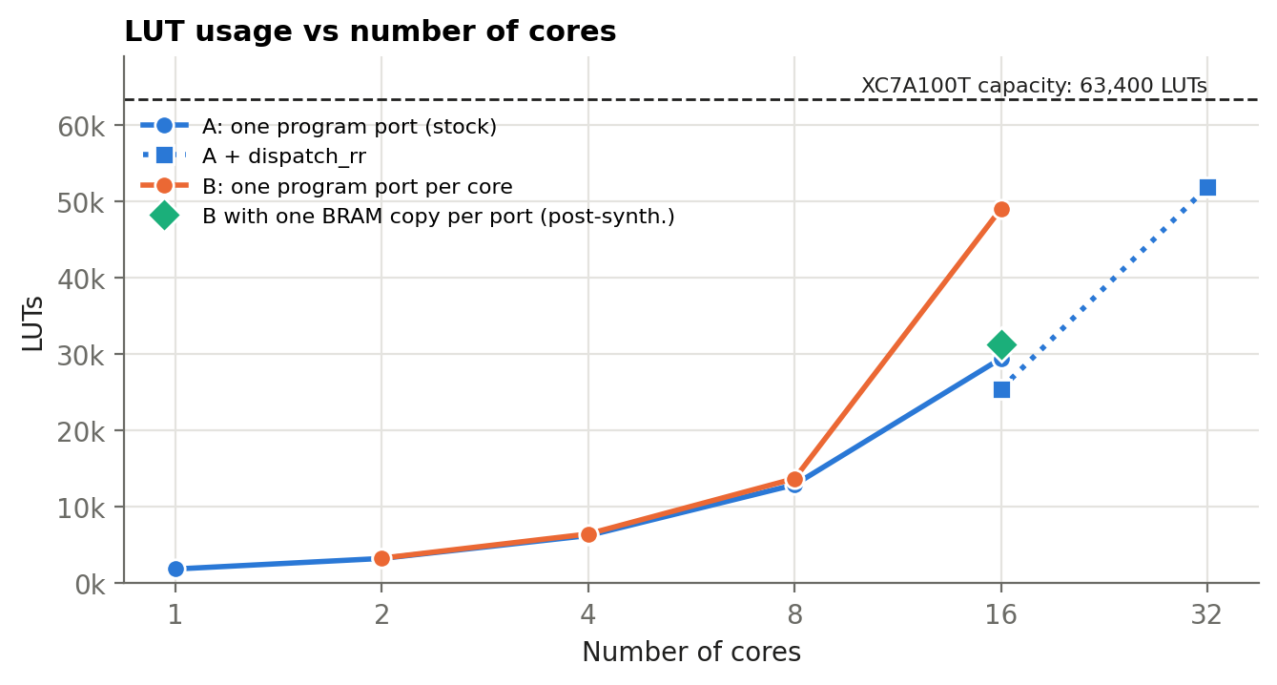
Figure 4. LUT usage vs core count. The green point is the follow-up experiment of Section 4.4 (post-synthesis estimate).
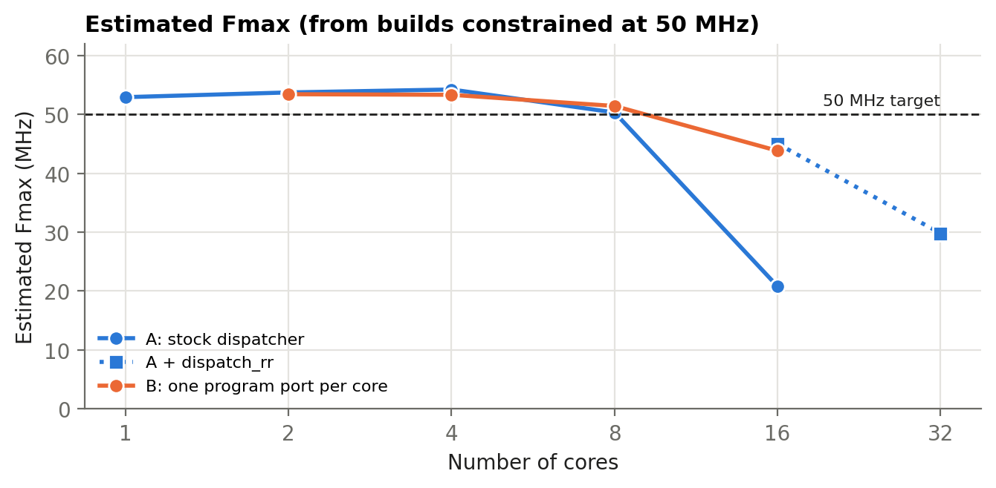
Figure 5. Estimated Fmax vs core count. Above 8 cores the stock dispatcher and then the memory arbiters limit the clock.

4.2 Execution time and speedup (board)
Table 5. Measured cycles and execution time, timing-clean builds (speedup vs 1 core: cycles / time)
Cores, series | MHz | vecadd | matmul | compute | compute speedup
1, A (stock) | 50 | 4,035 · 80.7 µs | 20,131 · 402.6 µs | 31,395 · 627.9 µs | 1.0 / 1.0
2, A (stock) | 50 | 2,073 · 41.5 µs | 10,209 · 204.2 µs | 15,721 · 314.4 µs | 2.00 / 2.00
4, A (stock) | 50 | 1,508 · 30.2 µs | 8,364 · 167.3 µs | 14,284 · 285.7 µs | 2.20 / 2.20
8, A (stock) | 50 | 1,473 · 29.5 µs | 8,491 · 169.8 µs | 14,181 · 283.6 µs | 2.21 / 2.21
16, A (rr) | 40 | 1,479 · 37.0 µs | 8,537 · 213.4 µs | 14,196 · 354.9 µs | 2.21 / 1.77
32, A (rr) | 25 | 1,495 · 59.8 µs | 8,537 · 341.5 µs | 14,192 · 567.7 µs | 2.21 / 1.11
2, B | 50 | 2,026 · 40.5 µs | 10,074 · 201.5 µs | 15,706 · 314.1 µs | 2.00 / 2.00
4, B | 50 | 1,032 · 20.6 µs | 5,056 · 101.1 µs | 7,872 · 157.4 µs | 3.99 / 3.99
8, B | 50 | 801 · 16.0 µs | 2,648 · 53.0 µs | 3,976 · 79.5 µs | 7.90 / 7.90
16, B | 40 | 769 · 19.2 µs | 2,512 · 62.8 µs | 2,070 · 51.8 µs | 15.17 / 12.13
8, C (8 data) | 40 | 548 · 13.7 µs | 2,550 · 63.8 µs | 3,961 · 99.0 µs | 7.93 / 6.34

All runs in this table produced correct results and the board cycle counts equal simulation. The stock 16-core build (not shown) fails timing by 28 ns and times out on the board.
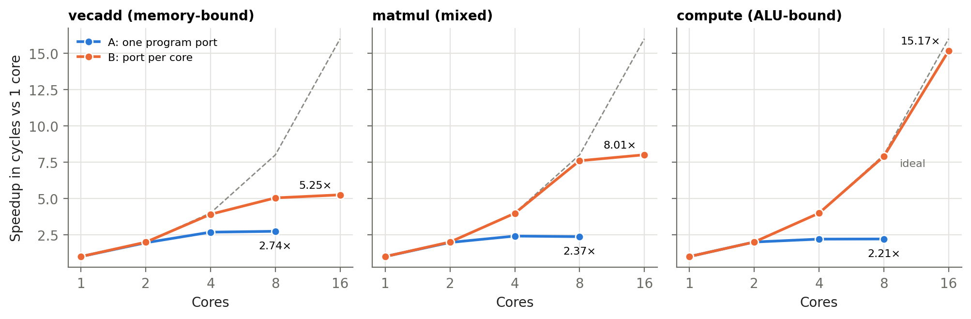
Figure 6. Speedup in clock cycles. With a single shared program port (A) every kernel saturates by 4 cores; with one port per core (B) compute scales almost ideally.
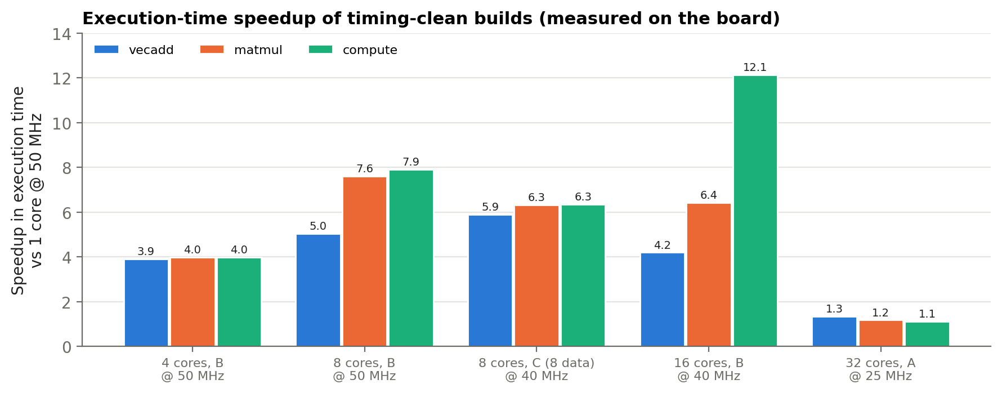
Figure 7. Speedup in execution time, including the lower clock that larger builds need. For vecadd and matmul, 8 cores at 50 MHz are faster than 16 cores at 40 MHz.

4.3 Simulation-only configurations
Configurations that do not fit or were not built were simulated (cycle counts only, no clock):
Table 6. Simulated speedup in cycles vs 1 core
Configuration | vecadd | matmul | compute
8 cores, P = 1, M = 32 | – | – | 2.21× (more data ports do not help a single program port)
16 cores, P = 16, M = 16 | 12.53× | 15.24× | 15.48×
32 cores, P = 32, M = 4 | – | – | 26.14×
32 cores, P = 32, M = 32 | 15.58× (253 cycles) | 15.24× | 28.33× (1,108 cycles)

matmul has only 16 thread blocks, so it cannot use more than 16 cores (workload granularity).

4.4 Where scaling becomes limited
1. Instruction-fetch bandwidth (from 2 cores). All cores share one program-memory channel in stock TinyGPU. Each fetch holds the channel for about 5 cycles (request, memory, relay, release), so the speedup plateaus at 2.2–2.7× from 4 cores on. One program port per core removes this limit.
2. Data-memory bandwidth (memory-bound kernels). With 4 data channels, vecadd saturates at about 5× (5.04× at 8 cores, 5.25× at 16). Eight data ports raise it to 7.36× at 8 cores. The SoC data memory also accepts only one write per cycle, and this was not varied: at 32 cores with 32 ports, vecadd takes 253 cycles, which is roughly one block (≈126 cycles) plus 127 cycles for 128 serialised writes, and compute fits the same pattern (1,108 ≈ 981 + 127). The write port is therefore the likely next limit; this is inferred from the cycle counts and still needs a direct experiment.
3. Memory-interconnect area and clock (from 8 cores). TinyGPU's memory controller lets every channel serve every requester and searches requesters serially. The data arbiter grows from 9.0k LUTs (16 cores) to 20k LUTs (32 cores), its logic depth from 23 to 37 levels, and it is the critical path from 8 cores on.
4. Dispatcher logic depth (16 cores). At 16 cores the stock dispatcher's loop over cores becomes a 75-level chain (20.8 MHz). dispatch_rr removes it with no cycle penalty.
Correction to the earlier analysis: program-memory area. In the 16-core, P = 16 build the program-memory controller used 23.4k LUTs, more than the 16 cores themselves, which first suggested that the instruction arbiter grows quadratically and that 32 such cores cannot fit. The Vivado log shows a different cause: with 16 read ports the shared program-memory array exceeds what block RAM supports, so Vivado implemented it in registers and multiplexers (“RAM dissolved into registers”; BRAM drops from 7 to 3 tiles), and that logic was counted in the controller. To test this, the same configuration was re-synthesised with one block-RAM copy of the program memory per port. Simulated cycle counts are unchanged (769 / 2,512 / 2,070).
Table 7. 16 cores, P = 16, M = 4, 40 MHz: original vs one BRAM copy per program port
 | Original build | One BRAM copy per port
Total LUTs | 49,534 post-synth. (78 %); 49,005 post-route | 31,290 post-synth. (49 %)
Program-memory controller LUTs | 23,362 (post-route) | 5,386 (post-synth.)
Flip-flops | 21,072 | 16,126
BRAM tiles | 3 | 11
Timing at 40 MHz | WNS +0.165 ns (post-route) | WNS +2.675 ns (post-synth. estimate)

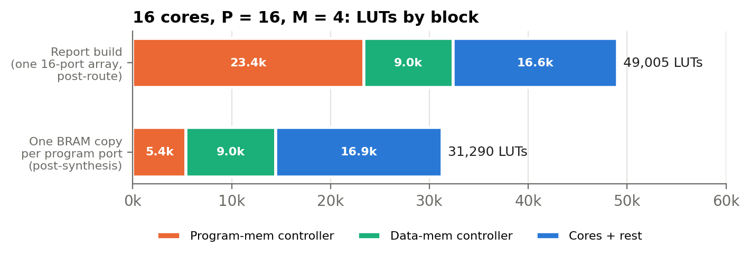
Figure 8. LUTs by block for the 16-core, P = 16 configuration. Most of the program-memory controller's area came from the memory model, not the arbiter.
So the steep area growth at 16 cores came mostly from how the test memory was modelled rather than from TinyGPU. This result is post-synthesis only; it still has to be placed, routed and run on the board, and it reopens the question of whether 32 cores with private instruction ports fit on the XC7A100T (simulation predicts 26× for compute).

5. Status against the plan
Table 8. Progress against the plan
Requested item | Status | Notes
Document the current setup | Done | Section 1. CNN metrics are for the CNN accelerator, since the CNN does not yet run on TinyGPU
Scale cores (1, 2, 4, 8, …) and record resources/timing | Done | 1–32 cores, 16 builds, all measured on the board
Find how many cores fit while meeting timing | Done | 8 @ 50 MHz, 16 @ 40 MHz, 32 @ 25 MHz; 32 with private ports to be rebuilt
Execution time and speedup vs one core | Done for benchmark kernels | Table 5, Figures 6–7
Limits: resources, memory bandwidth, communication | Partly done | Inferred from P/M sweeps; no per-core stall counters yet
Run the CNN on TinyGPU | Not started | Prerequisite for CNN workload sharing
Automatic CNN workload sharing (scheduler) | Not started | Waiting for review of this report, as requested
ASIC evaluation | Not started | Later phase

6. Proposed next steps
1. Memory system. Rebuild with private instruction memory per core (BRAM copy per core, or a small instruction buffer), place and route 16 and 32 cores, and run them on the board. Add per-core busy/stall counters so communication overhead is measured directly, and vary the number of data-memory write ports.
2. CNN on TinyGPU. Widen TinyGPU to 16-bit Q4.12 data with a 32/40-bit MAC accumulator, add arithmetic shift and ReLU/MAX (no branch divergence needed) and a 16-bit address space. Run conv1 (72 output pixels = 72 threads) and conv2 (50 threads) as kernels and check them against the CNN accelerator and the golden model, which are already bit-exact references.
3. Workload sharing and scaling study. Partition the CNN layers across cores automatically (16-bit block IDs, a kernel queue for conv1 → conv2 → pool, fix for partially filled blocks), then measure speedup vs one core and the limits from resources, memory bandwidth and communication.
4. ASIC evaluation. Run the OpenLane flow on the final multi-core configuration.

7. Re-running the setup on the board
This section explains what happens on the Nexys 4 DDR when each design runs, how to re-run the measurements, and how to check that a re-run reproduces the results in this report. Both designs are self-contained: the inputs, programs and expected results are built into the bitstream, so the board needs only the USB cable (power, JTAG programming and serial output all go through it).

7.1 Requirements
- Nexys 4 DDR connected by USB; the Digilent USB-UART appears as a COM port (FTDI 0403:6010).
- Vivado 2024.2 installed at C:\Xilinx\Vivado\2024.2 (the scripts call it from there).
- Python 3 with pyserial (pip install pyserial).
- The scripts contain absolute paths for this laptop; on another machine, update the Vivado path in scripts/uart_capture.py and the paths in the build scripts.

7.2 What happens on the board: CNN accelerator
1. Configure. Vivado programs the FPGA with cnn_top.bit. The 200 training images, labels, initial weights and the sigmoid table are stored in block RAM inside the bitstream. The 100 MHz board clock is converted to 50 MHz.
2. Evaluate. The design first evaluates all 200 images with the initial weights (epoch 0).
3. Train. It then trains for 5 epochs (SGD, one weight update per image) and evaluates again after each epoch.
4. Report. Each evaluation, each training epoch and the end of the run print one UART line (115200 baud) and update the LEDs. The whole run takes 184 ms. Pressing BTNC restarts it.
Table 9. Reading the CNN accelerator's UART output (lines from cnn_fpga/results/board_run.txt)
UART line | Meaning
E0 100 0007C1F0 | Evaluation before training: 100 / 200 correct; 0x7C1F0 = 508,400 cycles = 200 images × 2,542 cycles
T1 000 0012C7D0 | Training epoch 1: 0x12C7D0 = 1,230,800 cycles = 200 steps × 6,154 cycles
E5 194 0007C1F0 | Evaluation after epoch 5: 194 / 200 correct (97 %)
D0 000 008C72B6 | Done: 0x8C72B6 = 9,204,406 cycles in total = 184.1 ms at 50 MHz

Table 10. CNN accelerator LEDs
LED | Meaning
LD0–LD7 | Number of correct images (out of 200) in the latest evaluation, in binary (194 = 1100 0010)
LD8–LD10 | Epoch of that evaluation (0–5)
LD14 | On while the design is running
LD15 | On when all epochs have finished

7.3 What happens on the board: TinyGPU scaling experiment
Each bitstream contains one TinyGPU configuration (N cores, P program channels, M data channels) inside the test SoC of Figure 2. The SoC runs the three kernels one after the other and repeats the sequence every 0.5 s:
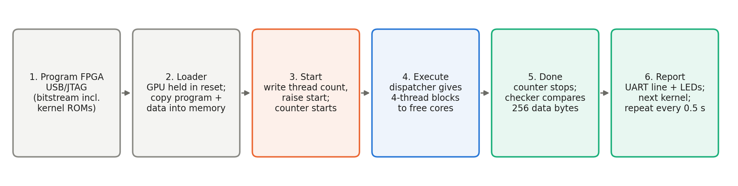
Figure 9. Sequence executed by the test SoC for each kernel on the board.
Because the cycle counter only counts from start to done, the cycle numbers do not depend on the clock frequency. The same configuration therefore gives the same cycle count at 50, 40 or 25 MHz; only the execution time (cycles ÷ clock) changes.
Table 11. Reading the TinyGPU UART line
Field | Example | Meaning
K | K0 | Kernel: 0 = vecadd, 1 = matmul, 2 = compute
N | N08 | Number of cores
T | T4 | Threads per block
P | P08 | Program-memory channels
M | M04 | Data-memory channels
C | C00000321 | Cycles from start to done, hex (0x321 = 801)
E | E0000 | Number of wrong bytes out of 256 (must be 0)
R | R00 | Round number (increments every 0.5 s)

Table 12. TinyGPU SoC LEDs
LED | Meaning
LD0, LD1, LD2 | vecadd / matmul / compute passed in the last round
LD14 | Heartbeat (blinks while the design is alive)
LD15 | All three kernels passed

7.4 Re-running the measurements
CNN accelerator (from the MTP-1 folder): program the existing bitstream and capture the output until the final line.
python scripts\uart_capture.py cnn_fpga\build\cnn_top.bit --until "^D0 " --log cnn_rerun.txt
One TinyGPU configuration (from tinygpu_fpga): give the build folder name. The script programs the board, records the second complete round, compares the cycles with simulation and updates results/board_runs.csv and results/board_logs/<tag>.txt.
python scripts\run_board.py N8_P8_M4_T4_rr
All TinyGPU configurations, then regenerate the CSV files, tables and plots:
python scripts\run_board.py
python scripts\analyze.py
Rebuilding a bitstream (only needed after RTL changes; one build takes from minutes to over an hour):
cd cnn_fpga && vivado -mode batch -source scripts\build_cnn.tcl
cd tinygpu_fpga && python scripts\sweep.py build 8,8,4,rr 16,16,4,rr,40
python scripts\sweep.py report
The build argument is N,P,M[,stock|rr[,MHz]]; the build folder is named N<N>_P<P>_M<M>_T4[_rr][_f<MHz>].
Simulation only (no board; Git Bash, from tinygpu_fpga): arguments are cores, program channels, data channels, threads per block and dispatcher.
sim/run_sim.sh 8 8 4 4 rr

7.5 Expected values for a successful re-run
Table 13. Reference values to compare a re-run against
Design / build folder | Clock | Expected output
CNN accelerator (cnn_top.bit) | 50 MHz | E0–E5: 100, 132, 160, 179, 189, 194 correct; D0 cycles 008C72B6
N1_P1_M4_T4 (1 core) | 50 MHz | C = 4,035 / 20,131 / 31,395 cycles, E0000, LD15 on
N8_P1_M4_T4 (8 cores, stock) | 50 MHz | C = 1,473 / 8,491 / 14,181, E0000
N8_P8_M4_T4_rr (8 cores, B) | 50 MHz | C = 801 / 2,648 / 3,976, E0000
N16_P16_M4_T4_rr_f40 (16 cores, B) | 40 MHz | C = 769 / 2,512 / 2,070, E0000
N32_P1_M4_T4_rr_f25 (32 cores, A) | 25 MHz | C = 1,495 / 8,537 / 14,192, E0000
N16_P1_M4_T4 (16 cores, stock) | 50 MHz | Fails timing by 28 ns: expect timeouts / errors (this is the known failing build)

Cycle counts are deterministic, so a correct re-run must match these values exactly. A different count or a non-zero E field indicates a wrong bitstream, a failing timing build or a hardware problem.

7.6 Notes
- Only builds that meet timing count as results. Builds that miss timing may still run correctly at room temperature, but this is not guaranteed (the stock 16-core build does not).
- The program-memory experiment of Section 4.4 (one BRAM copy per port) is synthesis-only. It has no bitstream yet; it must be placed, routed and re-run on the board before its numbers are reported as measured.
- The board was not connected during the latest review, so the board numbers in this report come from the measurement runs of 21 October 2026; simulation and golden-model re-runs were repeated and matched.

Appendix: data and reproduction
Raw data: tinygpu_fpga/results/fpga_sweep.csv, board_runs.csv, scaling.csv, board_logs/; per-build Vivado reports in tinygpu_fpga/build/<config>/; CNN board log in cnn_fpga/results/board_run.txt. Scripts: tinygpu_fpga/scripts/sweep.py (build), run_board.py (program and measure), analyze.py (tables and plots); simulation in tinygpu_fpga/sim/.
Cross-checks performed for this report: board cycle counts match the raw UART logs; six configurations were re-simulated and reproduce the stored cycle counts exactly; the golden model was re-run and reproduces the parameter log exactly; Vivado resource and timing numbers were re-parsed from the reports.

