ADBMS PRACTICAL JOURNAL Saiganesh

29/08/2023: Content Beyond Syllabus

**CREATE TABLE EMPLOYEE29 (emp_no INTEGER, emp_name VARCHAR(15), salary INTEGER);**

Table created.

**INSERT INTO EMPLOYEE29 VALUES (101, 'Alex', 65000);**

1 row created

**INSERT INTO EMPLOYEE29 VALUES (&EMP_NO, '&EMP_NAME', &SALARY);**

Enter value for emp_no: 102

Enter value for emp_name: Adam

Enter value for salary: 56000

**SELECT * FROM EMPLOYEE29;**

EMP_NO EMP_NAME SALARY

---------- --------------- ----------

101 Alex 65000

102 Adam 56000

103 Eve 58000

104 Phil 48000

105 Claire 59000

106 Joe 100000

**INSERT ALL**

**2 INTO EMPLOYEE29 VALUES (107,'Gloria', 150000)**

**3 INTO EMPLOYEE29 VALUES (108,'Luke', 20000)**

**4 SELECT * FROM EMPLOYEE29;**

**SELECT * EMPLOYEE29;**

EMP_NO EMP_NAME SALARY

---------- --------------- ----------

107 Gloria 150000

108 Luke 20000

**ALTER TABLE EMPLOYEE29 ADD comm INTEGER;**

Table altered.

**SELECT * FROM EMPLOYYE29;**

EMP_NO EMP_NAME SALARY COMM

---------- --------------- ---------- ----------

101 Alex 65000

102 Adam 56000

103 Eve 58000

104 Phil 48000

105 Claire 59000

106 Joe 100000

107 Gloria 150000

**CREATE TABLE empone (emp_no INTEGER, salary INTEGER);**

Table created.

**ALTER TABLE empone ADD CONSTRAINT pk1 PRIMARY KEY(emp_no);**

Table altered.

**ALTER TABLE empone ADD CONSTRAINT CHECK1 CHECK(salary>25000 AND salary<=10000);**

Table altered.

PRACTICAL 1: Range Partitioning Date: 31/08/2023

Note: Range partitioning happens on numeric columns

Creating Partitions:

* **CREATE TABLE sal_range101(salesman_id NUMBER(5), salesman_name VARCHAR2(30), sales_amount NUMBER(10), sales_date DATE)**

**2 PARTITION BY RANGE (sales_date)(**

**3 PARTITION sales_jan2000 VALUES LESS THAN (TO_DATE('01/02/2000','DD/MM/YYYY')),**

**4 PARTITION sales_feb2000 VALUES LESS THAN (TO_DATE('01/03/2000','DD/MM/YYYY')),**

**5 PARTITION sales_march2000 VALUES LESS THAN (TO_DATE ('01/04/2000', 'DD/MM/YYYY')),**

**6 PARTITION sales_apr2000 VALUES LESS THAN (TO_DATE ('01/05/2000','DD/MM/YYYY'))**

**7 );**

Table created.

To check if partitions are built correctly:

**SELECT TABLE_NAME, PARTITION_NAME FROM USER_TAB_PARTITIONS WHERE TABLESPACE_NAME = 'USERS';**

TABLE_NAME PARTITION_NAME

------------------------------ ------------------------------

SAL_RANGE101 SALES_JAN2000

SAL_RANGE101 SALES_FEB2000

SAL_RANGE101 SALES_MARCH2000

SAL_RANGE101 SALES_APR2000

Insert date in sal_range101 table:

**INSERT INTO sal_range101 VALUES( 1,'James Bond',5000,TO_DATE('23/02/2000','DD/MM/YYYY'));**

1 row created.

Display Data from sal_range101 table:

**SELECT * FROM sal_range101;**

SALESMAN_ID SALESMAN_NAME SALES_AMOUNT SALES_DAT

----------- ------------------------------ ------------ ---------

4 Samuel 4500 09-JAN-00

6 Indira 4300 24-JAN-00

8 Rahul 8920 15-JAN-00

1 James Bond 5000 23-FEB-00

10 Robert 8920 15-FEB-00

3 Sasha 4000 12-MAR-00

5 Scarlett 4300 14-MAR-00

9 Priyanka 8920 15-MAR-00

2 Margaret 5000 23-APR-00

7 Rajiv 8920 24-APR-00

10 rows selected.

Another Example:

**CREATE TABLE emp101(emp_no INTEGER PRIMARY KEY, emp_name VARCHAR2(10),**

**2 salary INTEGER)**

**3 PARTITION BY RANGE(emp_no)(**

**4 PARTITION E1 VALUES LESS THAN (103),**

**5 PARTITION E2 VALUES LESS THAN (104)**

**6 );**

Table created.

Check to see if the partitions are correctly built:

**SELECT TABLE_NAME, PARTITION_NAME FROM USER_TAB_PARTITIONS WHERE TABLESPACE_NAME = 'USERS';**

TABLE_NAME PARTITION_NAME

------------------------------ ------------------------------

EMP101 E1

EMP101 E2

**INSERT INTO emp101 VALUES(102,'SITA',31000);**

1 row created.

**SELECT * FROM EMP101;**

EMP_NO EMP_NAME SALARY

---------- ---------- ----------

101 RAM 25000

102 SITA 31000

103 RAVAN 35000

**SELECT * FROM EMP101 PARTITION(E1);**

EMP_NO EMP_NAME SALARY

---------- ---------- ----------

101 RAM 25000

102 SITA 31000

**SELECT * FROM EMP101 PARTITION(E2);**

EMP_NO EMP_NAME SALARY

---------- ---------- ----------

103 RAVAN 35000

List Partitioning:

When a column can be grouped based on a category. Usually a column with VARCHAR2 datatype.

**CREATE TABLE SAL_REGION101(**

**2 product_id NUMBER(6),**

**3 sales_date DATE,**

**4 state VARCHAR2(30))**

**5 PARTITION BY LIST (state)(**

**6 PARTITION region_north VALUES('Himachal Pradesh','Haryana','Punjab'),**

**7 PARTITION region_south VALUES('Karnataka','Tamil Nadu','Telangana'),**

**8 PARTITION region_east VALUES('West Bengal','Odisha','Jharkhand'),**

**9 PARTITION region_west VALUES('Goa','Gujarat','Maharshtra'),**

**10 PARTITION region_other VALUES(DEFAULT))**

**11 enable row movement;**

Table created.

**SELECT TABLE_NAME, PARTITION_NAME FROM USER_TAB_PARTITIONS WHERE TABLESPACE_NAME = 'USERS';**

TABLE_NAME PARTITION_NAME

------------------------------ ------------------------------

SAL_REGION101 REGION_NORTH

SAL_REGION101 REGION_SOUTH

SAL_REGION101 REGION_EAST

SAL_REGION101 REGION_WEST

SAL_REGION101 REGION_OTHER

**INSERT INTO sal_region101 VALUES(12,TO_DATE('14/04/2000','DD/MM/YYYY'),'Maharashtra');**

1 row created.

**SELECT * FROM sal_region101;**

PRODUCT_ID SALES_DAT STATE

---------- --------- ------------------------------

12 12-DEC-00 Himachal Pradesh

12 12-JAN-00 Telangana

14 14-NOV-00 West Bengal

12 14-APR-00 Goa

12 14-APR-00 Uttarakhand

12 14-APR-00 Maharashtra

6 rows selected.

**SELECT * FROM sal_region101 PARTITION(region_west);**

PRODUCT_ID SALES_DAT STATE

---------- --------- ------------------------------

12 14-APR-00 Goa

**SELECT * FROM sal_region101 PARTITION(region_other);**

PRODUCT_ID SALES_DAT STATE

---------- --------- ------------------------------

12 14-APR-00 Uttarakhand

12 14-APR-00 Maharashtra

Hash Partitioning: (Out of Syllabus – sometimes asked in practical exam)

Hash Partitioning is performed by system (Implicit); Best when there is no numeric column to partition by range or a column that can’t be grouped based on a category.

**CREATE TABLE sales_hash101( salesman_id NUMBER(5), salesman_name VARCHAR2(30),sales_amount NUMBER(10), week_no NUMBER(2))**

**PARTITION BY HASH(salesman_id)**

**PARTITIONS 4;**

Table created.

Check to see if the partitions are correctly built:

**SELECT TABLE_NAME, PARTITION_NAME FROM USER_TAB_PARTITIONS WHERE TABLESPACE_NAME = 'USERS';**

TABLE_NAME PARTITION_NAME

------------------------------ ------------------------------

SALES_HASH101 SYS_P21

SALES_HASH101 SYS_P22

SALES_HASH101 SYS_P23

SALES_HASH101 SYS_P24

4 rows selected.

**INSERT ALL**

**INTO sales_hash101 VALUES(101,'John',44000,12)**

**INTO sales_hash101 VALUES(102,'Alice',54000,13)**

**INTO sales_hash101 VALUES(103,'Drake',64000,14)**

**INTO sales_hash101 VALUES(104,'Robert',74000,15)**

**INTO sales_hash101 VALUES(105,'Julie',94000,13)**

**INTO sales_hash101 VALUES(106,'James',34000,14)**

**INTO sales_hash101 VALUES(107,'Kennedy',24000,12)**

**SELECT * FROM DUAL;**

7 rows created.

**SELECT * FROM sales_hash101;**

SALESMAN_ID SALESMAN_NAME SALES_AMOUNT WEEK_NO

----------- ------------------------------ ------------ ----------

104 Robert 74000 15

102 Alice 54000 13

103 Drake 64000 14

105 Julie 94000 13

107 Kennedy 24000 12

101 John 44000 12

106 James 34000 14

7 rows selected.

Practical 2: Execution of OLAP & OLTP

Analytical Function:

**CREATE TABLE ssb101 ( emp_no INTEGER, dep_no INTEGER, bdate DATE, sal INTEGER, comm INTEGER, job VARCHAR2(10));**

Table created.

**INSERT ALL**

**INTO ssb101 VALUES(101,10,TO_DATE('12-JAN-82','DD-MON-YY'),22000,1000,'CLERK')**

**INTO ssb101 VALUES(102,10,TO_DATE('13-FEB-83','DD-MON-YY'),33000,2000,'CLERK')**

**INTO ssb101 VALUES(103,10,TO_DATE('14-MAR-84','DD-MON-YY'),44000,200,'CLERK')**

**INTO ssb101 VALUES(104,20,TO_DATE('15-APR-87','DD-MON-YY'),55000,3000,'MANAGER')**

**INTO ssb101 VALUES(105,20,TO_DATE('14-JUN-82','DD-MON-YY'),38000,4500,'MANAGER')**

**INTO ssb101 VALUES(106,20,TO_DATE('15-AUG-88','DD-MON-YY'),44000,500,'MANAGER')**

**INTO ssb101 VALUES(107,10,TO_DATE('31-DEC-81','DD-MON-YY'),58000,8000,'MANAGER')**

**INTO ssb101 VALUES(108,20,TO_DATE('25-JUL-88','DD-MON-YY'),49000,700,'CLERK')**

**INTO ssb101 VALUES(109,20,TO_DATE('22-JUN-84','DD-MON-YY'),49500,2700,'CLERK')**

**INTO ssb101 VALUES(110,10,TO_DATE('29-JAN-82','DD-MON-YY'),56000,1700,'MANAGER')**

**SELECT * FROM DUAL;**

10 rows created.

**SELECT * FROM ssb101;**

EMP_NO DEP_NO BDATE SAL COMM JOB

---------- ---------- --------- ---------- ---------- ----------

101 10 12-JAN-82 22000 1000 CLERK

102 10 13-FEB-83 33000 2000 CLERK

103 10 14-MAR-84 44000 200 CLERK

104 20 15-APR-87 55000 3000 MANAGER

105 20 14-JUN-82 38000 4500 MANAGER

106 20 15-AUG-88 44000 500 MANAGER

107 10 31-DEC-81 58000 8000 MANAGER

108 20 25-JUL-88 49000 700 CLERK

109 20 22-JUN-84 49500 2700 CLERK

110 10 29-JAN-82 56000 1700 MANAGER

10 rows selected.

ROLLUP:

**SELECT dep_no, job,COUNT(*), sum(SAL) FROM ssb101**

**2 GROUP BY ROLLUP(dep_no,job);**

DEP_NO JOB COUNT(*) SUM(SAL)

---------- ---------- ---------- ----------

10 CLERK 3 99000

10 MANAGER 2 114000

10 5 213000

20 CLERK 2 98500

20 MANAGER 3 137000

20 5 235500

10 448500

7 rows selected.

Partial ROLLUP:

**SELECT dep_no, job, sum(SAL) FROM ssb101 WHERE dep_no IN(10,20)**

**2 GROUP BY dep_no, ROLLUP(job);**

DEP_NO JOB SUM(SAL)

---------- ---------- ----------

10 CLERK 99000

10 MANAGER 114000

10 213000

20 CLERK 98500

20 MANAGER 137000

20 235500

6 rows selected.

RANK ():

**SELECT emp_no,dep_no,sal,comm,RANK() OVER(PARTITION BY dep_no ORDER BY sal) AS RANK**

**2 FROM ssb101;**

EMP_NO DEP_NO SAL COMM RANK

---------- ---------- ---------- ---------- ----------

101 10 22000 1000 1

102 10 33000 2000 2

103 10 44000 200 3

110 10 56000 1700 4

107 10 58000 8000 5

105 20 38000 4500 1

106 20 44000 500 2

108 20 49000 700 3

109 20 49500 2700 4

104 20 55000 3000 5

10 rows selected.

DENSE_RANK ():

**SELECT emp_no,dep_no,sal,comm,DENSE_RANK() OVER(PARTITION BY dep_no ORDER BY sal) AS RANK**

**2 FROM ssb101;**

EMP_NO DEP_NO SAL COMM RANK

---------- ---------- ---------- ---------- ----------

101 10 22000 1000 1

102 10 33000 2000 2

103 10 44000 200 3

110 10 56000 1700 4

107 10 58000 8000 5

105 20 38000 4500 1

106 20 44000 500 2

108 20 49000 700 3

109 20 49500 2700 4

104 20 55000 3000 5

10 rows selected.

LEAD:

**SELECT emp_no,bdate,LEAD(bdate,1) OVER(ORDER BY bdate) AS "next"**

**2 FROM ssb101;**

EMP_NO BDATE next

---------- --------- ---------

107 31-DEC-81 12-JAN-82

101 12-JAN-82 29-JAN-82

110 29-JAN-82 14-JUN-82

105 14-JUN-82 13-FEB-83

102 13-FEB-83 14-MAR-84

103 14-MAR-84 22-JUN-84

109 22-JUN-84 15-APR-87

104 15-APR-87 25-JUL-88

108 25-JUL-88 15-AUG-88

106 15-AUG-88

10 rows selected.

LAG:

**SELECT emp_no,bdate,LAG(bdate,1) OVER(ORDER BY bdate) AS "previous"**

**2 FROM ssb101;**

EMP_NO BDATE previous

---------- --------- ---------

107 31-DEC-81

101 12-JAN-82 31-DEC-81

110 29-JAN-82 12-JAN-82

105 14-JUN-82 29-JAN-82

102 13-FEB-83 14-JUN-82

103 14-MAR-84 13-FEB-83

109 22-JUN-84 14-MAR-84

104 15-APR-87 22-JUN-84

108 25-JUL-88 15-APR-87

106 15-AUG-88 25-JUL-88

10 rows selected.

FIRST:

**SELECT dep_no,sal,MAX(sal)KEEP(DENSE_RANK FIRST ORDER BY sal DESC)**

**2 OVER(PARTITION BY dep_no)"max"**

**3 FROM ssb101;**

DEP_NO SAL max

---------- ---------- ----------

10 22000 58000

10 44000 58000

10 58000 58000

10 33000 58000

10 56000 58000

20 49500 55000

20 49000 55000

20 44000 55000

20 55000 55000

20 38000 55000

10 rows selected.

LAST:

**SELECT dep_no,sal,MIN(sal)KEEP(DENSE_RANK LAST ORDER BY sal DESC)**

**2 OVER(PARTITION BY dep_no)"min"**

**3 FROM ssb101;**

DEP_NO SAL min

---------- ---------- ----------

10 22000 22000

10 44000 22000

10 58000 22000

10 33000 22000

10 56000 22000

20 49500 38000

20 49000 38000

20 44000 38000

20 55000 38000

20 38000 38000

10 rows selected.

**CREATE TYPE type_name101 AS OBJECT (**

**fname VARCHAR(20),**

**mname VARCHAR(20),**

**lname VARCHAR(20));**

**/**

Type created.

**CREATE TYPE typ_address101 AS OBJECT(**

**street VARCHAR(20),**

**city VARCHAR(20),**

**pincode NUMBER(10));**

**/**

Type created.

**CREATE TABLE cust101 (**

**c_id NUMBER(5) PRIMARY KEY,**

**c_name type_name101, 🡨 here c_name is the object of typ_name**

**c_add typ_address101,**

**c_phno NUMBER(10));**

Type Created.

**INSERT INTO cust101 VALUES(1,type_name101('John','F','Kennedy'),**

**typ_address101('White House', 'Washington',123),1256468);**

1 row created.

**INSERT INTO cust101 VALUES(2,type_name101('John','Q','Adams'),**

**typ_address101('White House', 'Washington',123),0354688);**

1 row created.

**INSERT INTO cust101 VALUES(3,type_name101('William','H','Harrison'),**

**typ_address101('White House', 'Washington',123),13546846);**

1 row created.

**INSERT INTO cust101 VALUES(4,type_name101('James','K','Polk'),**

**typ_address101('White House', 'Washington',123),467765464);**

1 row created.

**INSERT INTO cust101 VALUES(5,type_name101('Donald','J','Trump'),**

**typ_address101('White House', 'Washington',123),13848463);**

1 row created.

**desc cust101;**

Name Null? Type

----------------------------------------- -------- ----------------------------

C_ID NOT NULL NUMBER(5)

C_NAME TYPE_NAME101

C_ADD TYP_ADDRESS101

C_PHNO NUMBER(10)

**set describe depth 2;**

**desc cust101;**

Name Null? Type

----------------------------------------- -------- ----------------------------

C_ID NOT NULL NUMBER(5)

C_NAME TYPE_NAME101

FNAME VARCHAR2(20)

MNAME VARCHAR2(20)

LNAME VARCHAR2(20)

C_ADD TYP_ADDRESS101

STREET VARCHAR2(20)

CITY VARCHAR2(20)

PINCODE NUMBER(10)

C_PHNO NUMBER(10)

**SELECT * FROM cust101;**

C_ID

----------

C_NAME(FNAME, MNAME, LNAME)

--------------------------------------------------------------------------------

C_ADD(STREET, CITY, PINCODE)

--------------------------------------------------------------------------------

C_PHNO

----------

1

TYPE_NAME101('John', 'F', 'Kennedy')

TYP_ADDRESS101('White House', 'Washington', 123)

1256468

C_ID

----------

C_NAME(FNAME, MNAME, LNAME)

--------------------------------------------------------------------------------

C_ADD(STREET, CITY, PINCODE)

--------------------------------------------------------------------------------

C_PHNO

----------

2

TYPE_NAME101('John', 'Q', 'Adams')

TYP_ADDRESS101('White House', 'Washington', 123)

354688

C_ID

----------

C_NAME(FNAME, MNAME, LNAME)

--------------------------------------------------------------------------------

C_ADD(STREET, CITY, PINCODE)

--------------------------------------------------------------------------------

C_PHNO

----------

3

TYPE_NAME101('William', 'H', 'Harrison')

TYP_ADDRESS101('White House', 'Washington', 123)

13546846

C_ID

----------

C_NAME(FNAME, MNAME, LNAME)

--------------------------------------------------------------------------------

C_ADD(STREET, CITY, PINCODE)

--------------------------------------------------------------------------------

C_PHNO

----------

4

TYPE_NAME101('James', 'K', 'Polk')

TYP_ADDRESS101('White House', 'Washington', 123)

467765464

C_ID

----------

C_NAME(FNAME, MNAME, LNAME)

--------------------------------------------------------------------------------

C_ADD(STREET, CITY, PINCODE)

--------------------------------------------------------------------------------

C_PHNO

----------

5

TYPE_NAME101('Donald', 'J', 'Trump')

TYP_ADDRESS101('White House', 'Washington', 123)

13848463

**select c_id from cust101;**

C_ID

----------

1

2

3

4

5

SQL> **select c_name from cust101;**

C_NAME(FNAME, MNAME, LNAME)

--------------------------------------------------------------------------------

TYPE_NAME101('John', 'F', 'Kennedy')

TYPE_NAME101('John', 'Q', 'Adams')

TYPE_NAME101('William', 'H', 'Harrison')

TYPE_NAME101('James', 'K', 'Polk')

TYPE_NAME101('Donald', 'J', 'Trump')

SQL> **select c_add from cust101;**

C_ADD(STREET, CITY, PINCODE)

--------------------------------------------------------------------------------

TYP_ADDRESS101('White House', 'Washington', 123)

TYP_ADDRESS101('White House', 'Washington', 123)

TYP_ADDRESS101('White House', 'Washington', 123)

TYP_ADDRESS101('White House', 'Washington', 123)

TYP_ADDRESS101('White House', 'Washington', 123)

SQL> **select c_phno from cust101;**

C_PHNO

----------

1256468

354688

13546846

467765464

13848463

**CREATE TABLE emp101**

**(**

**emp_no NUMERIC(5),**

**fname VARCHAR2 (10),**

**lname VARCHAR2(10),**

**salary NUMERIC(5),**

**comm NUMERIC(5)**

**);**

1 table created

INSERT INTO emp101 VALUES (&emp_no,'&fname','&lname',&salary,&comm);

>>inserted 10 values

**select * from emp101;**

EMP_NO FNAME LNAME SALARY COMM

---------- ---------- ---------- ---------- ----------

101 Donald Trump 50000 5600

102 Jason Mamoa 45000 560

103 John Adams 52000 21

104 George Washington 89000 2500

105 James Monroe 80000 5600

106 Andrew Jackson 14000 560

107 William Harrison 59000 650

108 John Tyler 75000 450

109 James Polk 56222 226

110 James Buchanan 85444 444

10 rows selected.

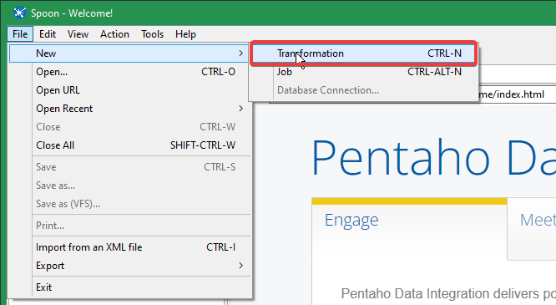

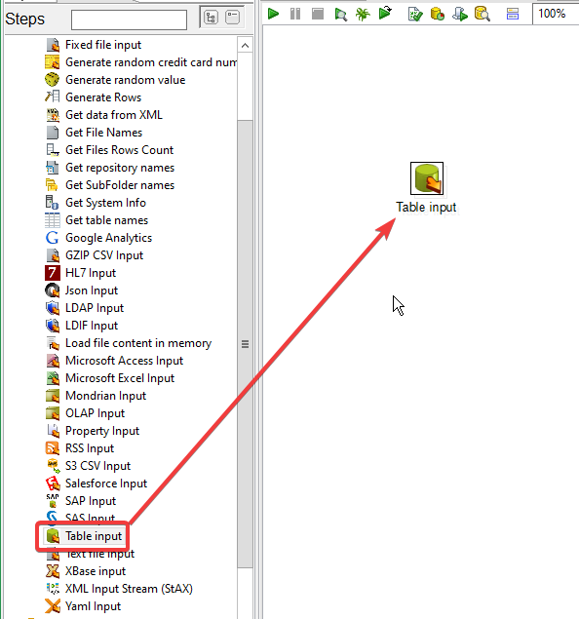

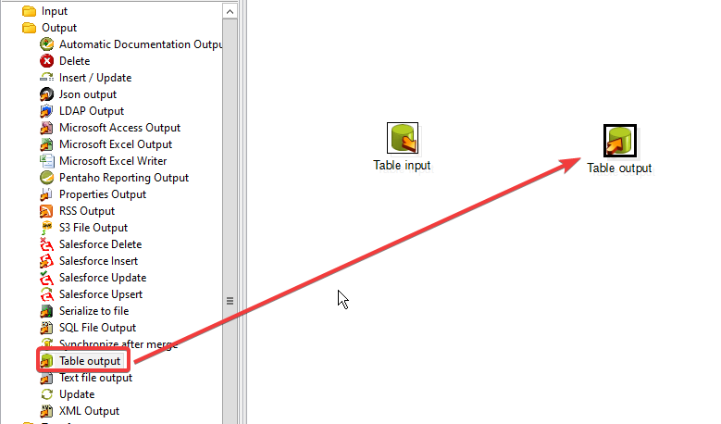

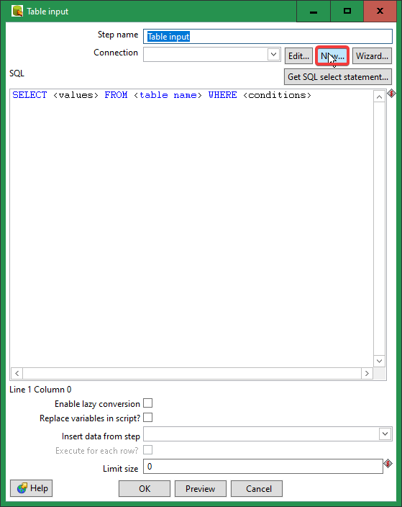

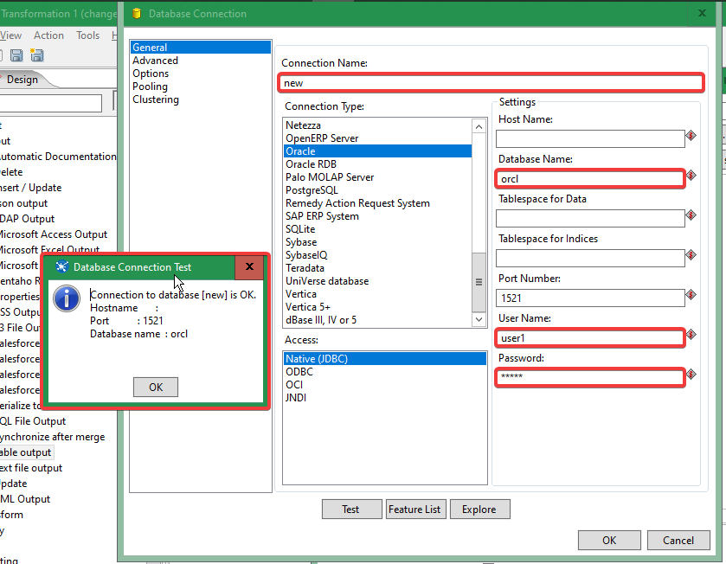

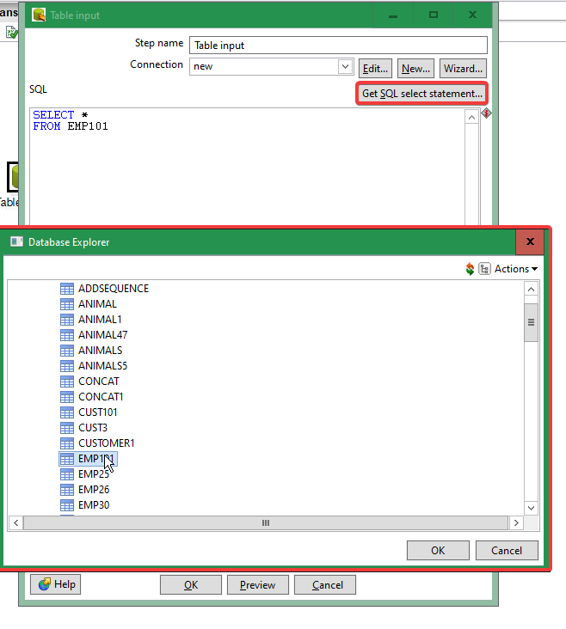

In the new pop-up click yes for including fields.

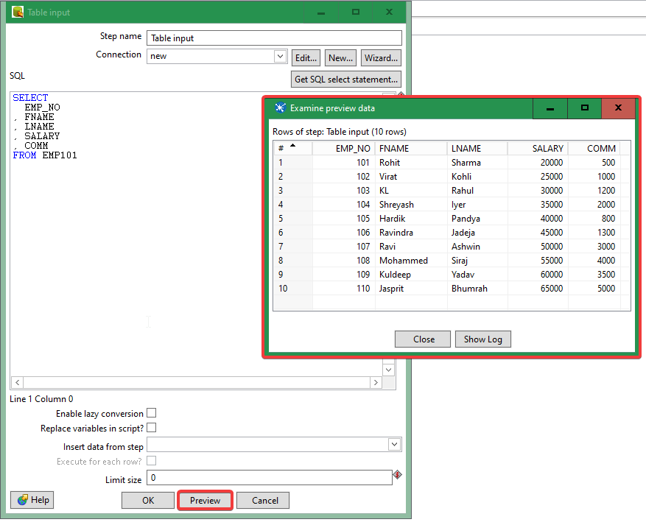

FOR SORT ROWS

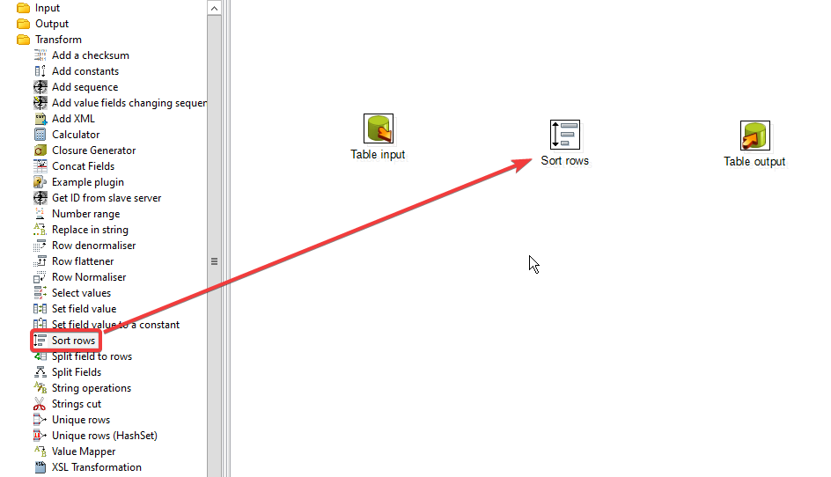

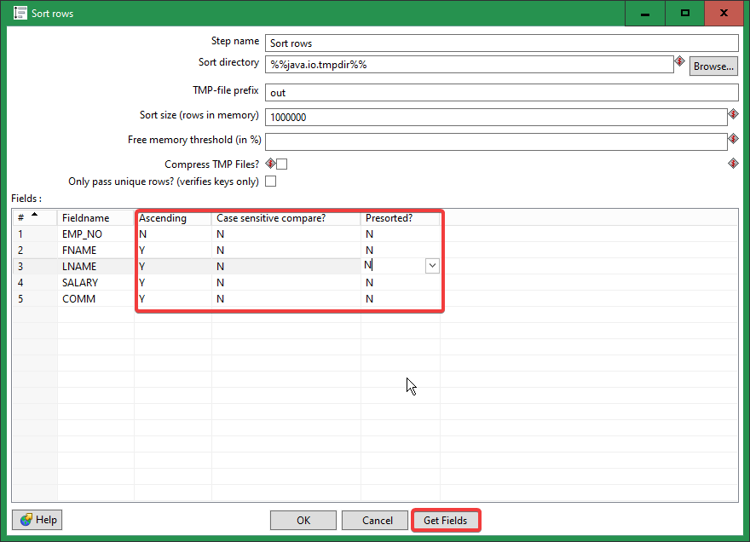

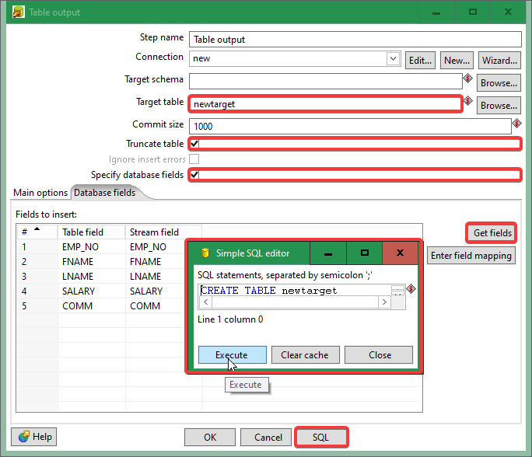

SQL> select * from newtarget;

EMP_NO FNAME LNAME SALARY COMM

---------- ---------- ---------- ---------- ----------

110 Jasprit Bhumrah 65000 5000

109 Kuldeep Yadav 60000 3500

108 Mohammed Siraj 55000 4000

107 Ravi Ashwin 50000 3000

106 Ravindra Jadeja 45000 1300

105 Hardik Pandya 40000 800

104 Shreyash Iyer 35000 2000

103 KL Rahul 30000 1200

102 Virat Kohli 25000 1000

101 Rohit Sharma 20000 500

10 rows selected.

Adding sequence:

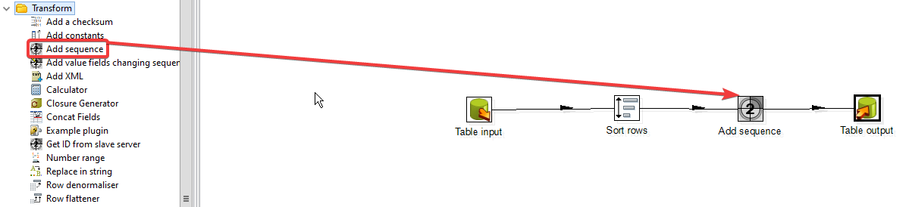

Sequence setting:

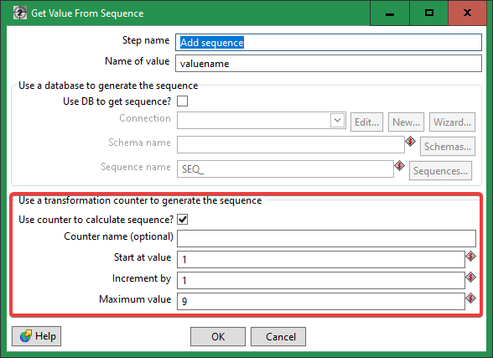

Table Input setting:



Sort rows setting:



Table Output setting:



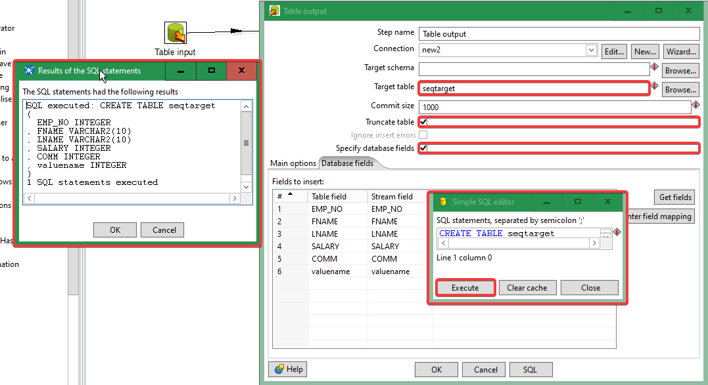

O/P:

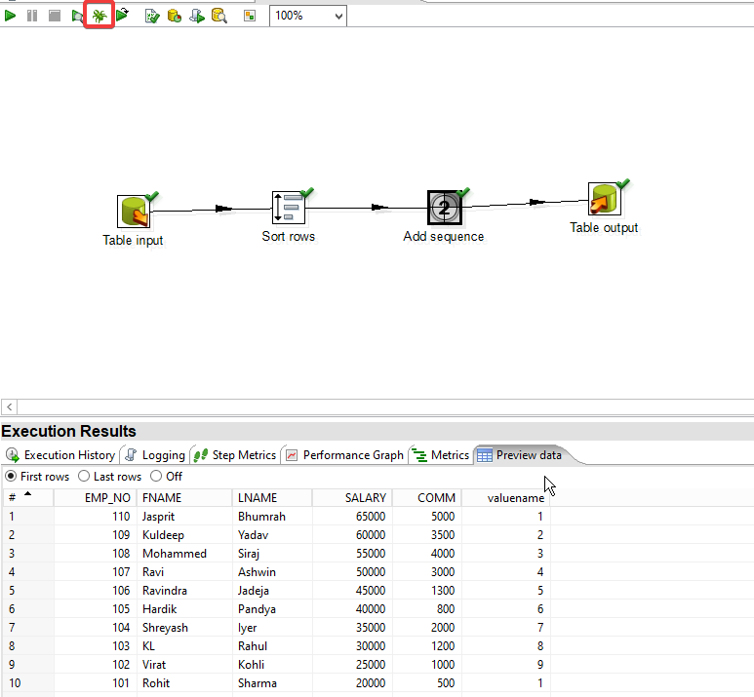

Calculator Operation:

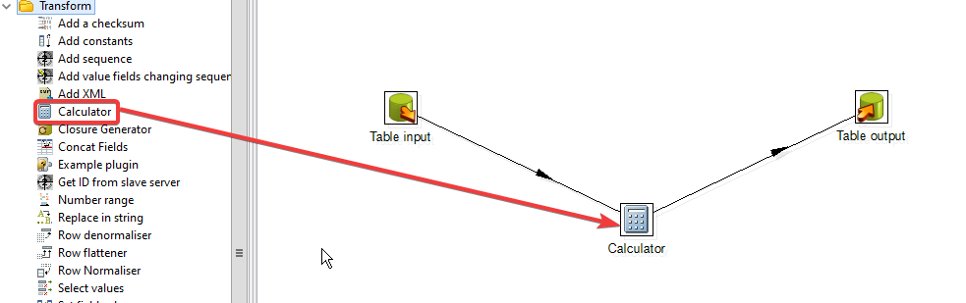

Table Input setting:



Table OutPut setting:





Calculator Setting:

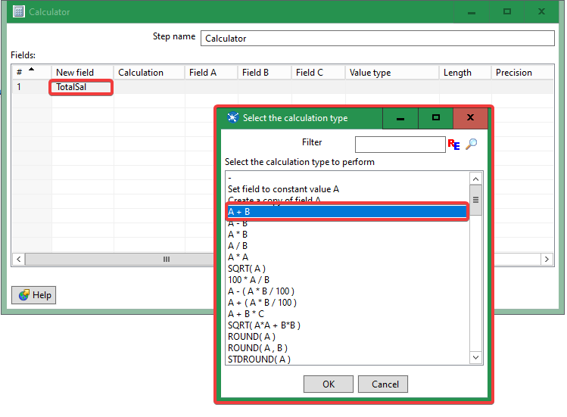

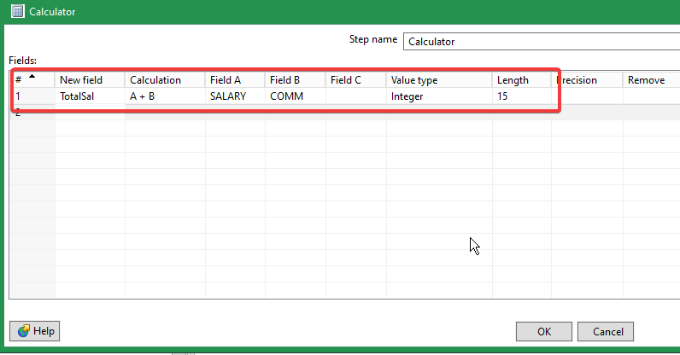

Table Output setting:

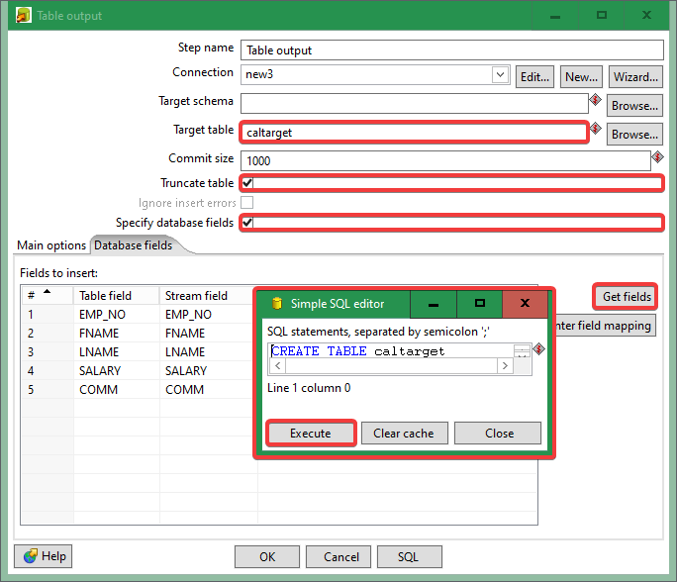

O/P:

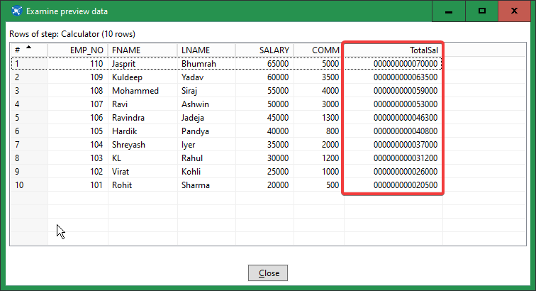

Concatenation:

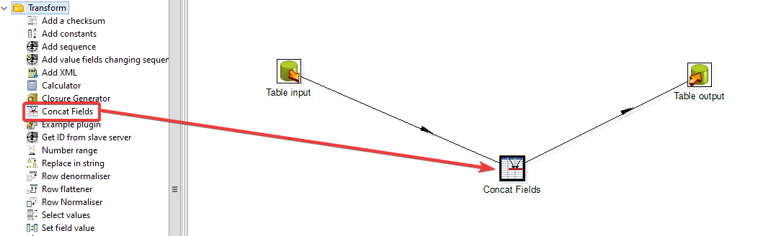

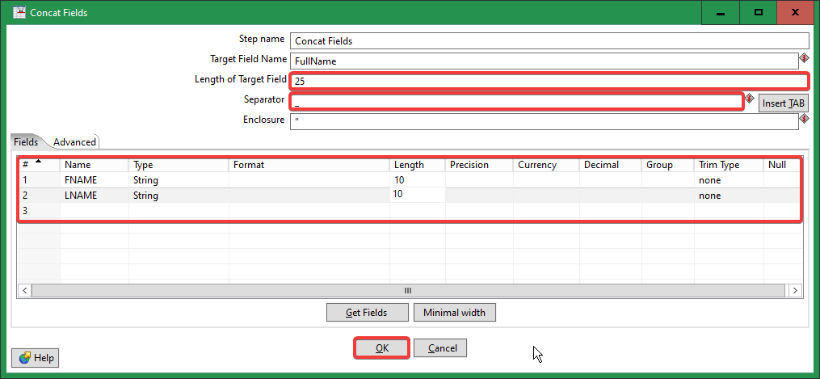

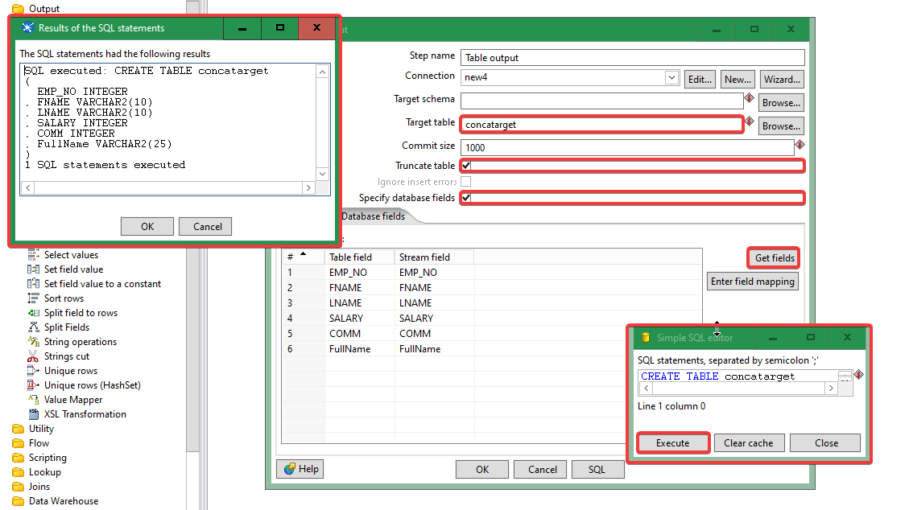

Splitting:

