DS PRACTICAL JOURNAL

Saiganesh

Date:28/08/23

Bubble Sort

#include <iostream>

using namespace std;

int main()

{

int i,j, temp;

int a[5];

cout<<"Saiganesh---Bubble Sort\n\n";

cout<<"Enter 5 Element ";

for(int i=0; i<5;i++)

{

cin>>a[i];

}

cout << "Input list ...\n";

for(i=0;i<5;i++)

{

cout <<a[i]<<"\t";

}

cout<<endl;

for(i=0;i<5;i++)

{

for(j=i+1;j<5;j++)

{

if(a[j]<a[i])

{

temp = a[i];

a[i]=a[j];

a[j]=temp;

}

}

}

cout<<"Sorted Element list...\n";

for(i=0;i<5;i++)

{

cout<<a[i]<<"\t";

}

}

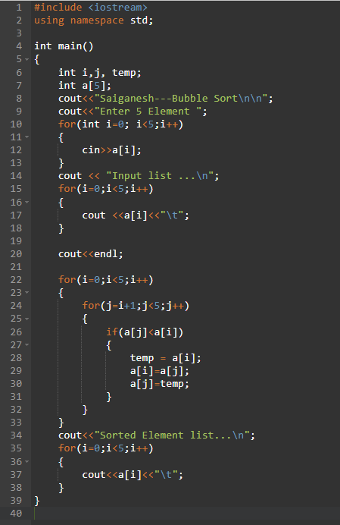

O/P:

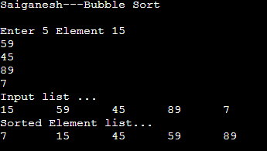

Insertion Sort

Date:01/09/23

Code:

#include<iostream>

using namespace std;

int main(){

int i, j,temp;

int a[5];

cout<<"Saiganesh---Insertion Sort\n\n";

cout<<"Enter 5 Element ";

for(int i=0; i<5;i++)

{

cin>>a[i];

}

cout << "Input list ...\n";

for(i=0;i<5;i++)

{

cout <<a[i]<<"\t";

}

cout<<endl;

for (i=1;i<5;i++){

temp = a[i];

j = i -1;

while (temp <a[j] && j>=0){

a[j+1] = a[j];

j = j-1;

}

a[j+1]=temp;

}

cout<<"Sorted Element list...\n";

for(i=0;i<5;i++)

{

cout<<a[i]<<"\t";

}

}

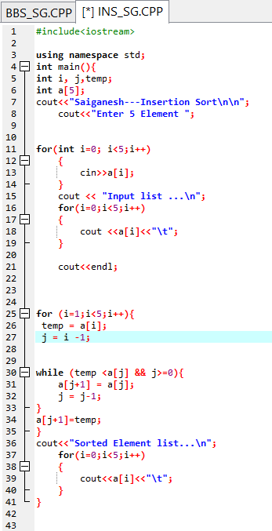

O/P:

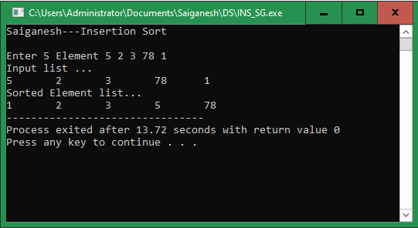

Sequential Sort:

#include<iostream>

using namespace std;

void printarray(int arr[],int SIZE){

for(int i=0;i<SIZE;i++){

cout<<arr[i]<<"\t";

}

cout<<endl;

}

// function to swap

void swap(int *a,int *b){

int temp=*a;

*a=*b;

*b=temp;

}

void selectionsort(int arr[],int SIZE){

int i,j,min_index;

//One by one move boundary of

// unsorted subarray

for(i=0;i<SIZE-1;i++){

min_index=i;

for(j=i+1;j<SIZE;j++){

if(arr[j]<arr[min_index]){

min_index=j;

}

}

swap(&arr[min_index],&arr[i]);

}

}

void takeinputfromuser(int arr[],int SIZE){

for(int i=0;i<SIZE;i++){

cin>>arr[i];

}

cout<<endl;

}

int main(){

cout<<"Saiganesh----Sequential Search"<<endl;

int SIZE =5;

int data[SIZE];

cout<<"Enter 5 Numbers "<<endl;

takeinputfromuser(data,SIZE);

cout<<"Input List.......\n";

printarray(data,SIZE);

selectionsort(data,SIZE);

cout<<"The Sorted Array Using Selection Sort..."<<endl;

printarray(data,SIZE);

return 0;

}

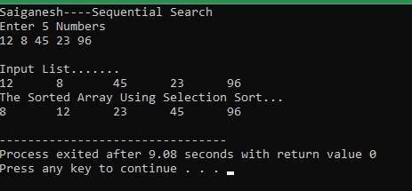

Binary Search: