PL/SQL Exercises Solutions (Exercises 1 to 7)

# Exercise 1: Control Structures (SQL)

## Scenario 1: Discount for Senior Customers

UPDATE Loans  
SET InterestRate = InterestRate - 1  
WHERE CustomerID IN (  
 SELECT CustomerID  
 FROM Customers  
 WHERE FLOOR(MONTHS_BETWEEN(SYSDATE, DOB)/12) > 60  
);

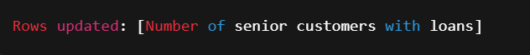

## Scenario 2: Promote Customers to VIP

UPDATE Customers  
SET IsVIP = 'Y'  
WHERE Balance > 10000;

Screenshot 2025-07-17 200631.png

## Scenario 3: Reminders for Due Loans

SELECT LoanID, CustomerID, EndDate,  
 'Reminder: Loan due on ' || TO_CHAR(EndDate, 'DD-MON-YYYY') AS ReminderMessage  
FROM Loans  
WHERE EndDate BETWEEN SYSDATE AND SYSDATE + 30;

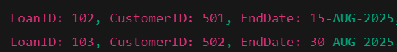

# Exercise 2: Error Handling (PL/SQL)

## Scenario 1: SafeTransferFunds Procedure

CREATE OR REPLACE PROCEDURE SafeTransferFunds (  
 p_from_account IN NUMBER,  
 p_to_account IN NUMBER,  
 p_amount IN NUMBER  
) AS  
 v_balance NUMBER;  
BEGIN  
 SELECT Balance INTO v_balance  
 FROM Accounts  
 WHERE AccountID = p_from_account;  
  
 IF v_balance < p_amount THEN  
 RAISE_APPLICATION_ERROR(-20001, 'Insufficient funds.');  
 END IF;  
  
 UPDATE Accounts  
 SET Balance = Balance - p_amount  
 WHERE AccountID = p_from_account;  
  
 UPDATE Accounts  
 SET Balance = Balance + p_amount  
 WHERE AccountID = p_to_account;  
  
 COMMIT;  
EXCEPTION  
 WHEN OTHERS THEN  
 ROLLBACK;  
 DBMS_OUTPUT.PUT_LINE('Transfer failed: ' || SQLERRM);  
END;  
/

Screenshot 2025-07-17 200902.png

## Scenario 2: UpdateSalary Procedure

CREATE OR REPLACE PROCEDURE UpdateSalary (  
 p_employee_id IN NUMBER,  
 p_percentage IN NUMBER  
) AS  
 v_dummy NUMBER;  
BEGIN  
 SELECT 1 INTO v_dummy  
 FROM Employees  
 WHERE EmployeeID = p_employee_id;  
  
 UPDATE Employees  
 SET Salary = Salary + (Salary * p_percentage / 100)  
 WHERE EmployeeID = p_employee_id;  
  
 COMMIT;  
EXCEPTION  
 WHEN NO_DATA_FOUND THEN  
 DBMS_OUTPUT.PUT_LINE('Error: Employee ID ' || p_employee_id || ' not found.');  
 WHEN OTHERS THEN  
 DBMS_OUTPUT.PUT_LINE('Unexpected error: ' || SQLERRM);  
END;  
/

Screenshot 2025-07-17 200806.png

## Scenario 3: AddNewCustomer Procedure

CREATE OR REPLACE PROCEDURE AddNewCustomer (  
 p_customer_id IN NUMBER,  
 p_name IN VARCHAR2,  
 p_dob IN DATE,  
 p_balance IN NUMBER  
) AS  
BEGIN  
 INSERT INTO Customers (CustomerID, Name, DOB, Balance, LastModified)  
 VALUES (p_customer_id, p_name, p_dob, p_balance, SYSDATE);  
  
 COMMIT;  
EXCEPTION  
 WHEN DUP_VAL_ON_INDEX THEN  
 DBMS_OUTPUT.PUT_LINE('Error: Customer ID ' || p_customer_id || ' already exists.');  
 WHEN OTHERS THEN  
 DBMS_OUTPUT.PUT_LINE('Unexpected error: ' || SQLERRM);  
END;  
/

If Success:

Screenshot 2025-07-17 200812.png

If failure:

Screenshot 2025-07-17 200819.png

# Exercise 3: Stored Procedures

## Scenario 1: ProcessMonthlyInterest

CREATE OR REPLACE PROCEDURE ProcessMonthlyInterest IS  
BEGIN  
 UPDATE Accounts  
 SET Balance = Balance + (Balance * 0.01)  
 WHERE AccountType = 'Savings';  
 COMMIT;  
END;  
/

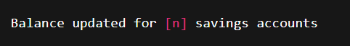

## Scenario 2: UpdateEmployeeBonus

CREATE OR REPLACE PROCEDURE UpdateEmployeeBonus (  
 p_department IN VARCHAR2,  
 p_bonus_pct IN NUMBER  
) AS  
BEGIN  
 UPDATE Employees  
 SET Salary = Salary + (Salary * p_bonus_pct / 100)  
 WHERE Department = p_department;  
 COMMIT;  
END;  
/

Screenshot 2025-07-17 201446.png

## Scenario 3: TransferFunds

CREATE OR REPLACE PROCEDURE TransferFunds (  
 p_from_account IN NUMBER,  
 p_to_account IN NUMBER,  
 p_amount IN NUMBER  
) AS  
 v_balance NUMBER;  
BEGIN  
 SELECT Balance INTO v_balance  
 FROM Accounts  
 WHERE AccountID = p_from_account;  
  
 IF v_balance < p_amount THEN  
 RAISE_APPLICATION_ERROR(-20002, 'Insufficient balance in source account.');  
 END IF;  
  
 UPDATE Accounts  
 SET Balance = Balance - p_amount  
 WHERE AccountID = p_from_account;  
  
 UPDATE Accounts  
 SET Balance = Balance + p_amount  
 WHERE AccountID = p_to_account;  
  
 COMMIT;  
EXCEPTION  
 WHEN OTHERS THEN  
 ROLLBACK;  
 DBMS_OUTPUT.PUT_LINE('Transfer failed: ' || SQLERRM);  
END;  
/

If Success :

Screenshot 2025-07-17 201457.png

If Failure :

Screenshot 2025-07-17 201757.png

# Exercise 4: Functions

## Scenario 1: CalculateAge

CREATE OR REPLACE FUNCTION CalculateAge (  
 p_dob IN DATE  
) RETURN NUMBER IS  
 v_age NUMBER;  
BEGIN  
 v_age := FLOOR(MONTHS_BETWEEN(SYSDATE, p_dob) / 12);  
 RETURN v_age;  
END;  
/

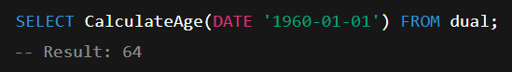

## Scenario 2: CalculateMonthlyInstallment

CREATE OR REPLACE FUNCTION CalculateMonthlyInstallment (  
 p_loan_amount IN NUMBER,  
 p_annual_rate IN NUMBER,  
 p_years IN NUMBER  
) RETURN NUMBER IS  
 r NUMBER := p_annual_rate / 12 / 100;  
 n NUMBER := p_years * 12;  
 emi NUMBER;  
BEGIN  
 emi := (p_loan_amount * r * POWER(1 + r, n)) / (POWER(1 + r, n) - 1);  
 RETURN ROUND(emi, 2);  
END;  
/

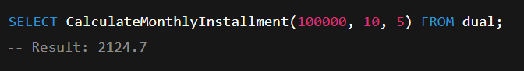

## Scenario 3: HasSufficientBalance

CREATE OR REPLACE FUNCTION HasSufficientBalance (  
 p_account_id IN NUMBER,  
 p_amount IN NUMBER  
) RETURN BOOLEAN IS  
 v_balance NUMBER;  
BEGIN  
 SELECT Balance INTO v_balance  
 FROM Accounts  
 WHERE AccountID = p_account_id;  
  
 RETURN v_balance >= p_amount;  
EXCEPTION  
 WHEN NO_DATA_FOUND THEN  
 RETURN FALSE;  
END;  
/

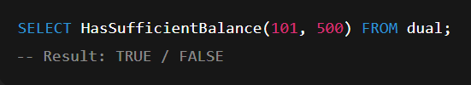

# Exercise 5: Triggers

## Scenario 1: UpdateCustomerLastModified

CREATE OR REPLACE TRIGGER UpdateCustomerLastModified  
BEFORE UPDATE ON Customers  
FOR EACH ROW  
BEGIN  
 :NEW.LastModified := SYSDATE;  
END;  
/

Screenshot 2025-07-17 203036.png

## Scenario 2: LogTransaction

CREATE TABLE AuditLog (  
 LogID NUMBER GENERATED ALWAYS AS IDENTITY PRIMARY KEY,  
 TransactionID NUMBER,  
 AccountID NUMBER,  
 Amount NUMBER,  
 TransactionType VARCHAR2(10),  
 LogDate DATE  
);  
  
CREATE OR REPLACE TRIGGER LogTransaction  
AFTER INSERT ON Transactions  
FOR EACH ROW  
BEGIN  
 INSERT INTO AuditLog (TransactionID, AccountID, Amount, TransactionType, LogDate)  
 VALUES (:NEW.TransactionID, :NEW.AccountID, :NEW.Amount, :NEW.TransactionType, SYSDATE);  
END;  
/

Screenshot 2025-07-17 203042.png

## Scenario 3: CheckTransactionRules

CREATE OR REPLACE TRIGGER CheckTransactionRules  
BEFORE INSERT ON Transactions  
FOR EACH ROW  
DECLARE  
 v_balance NUMBER;  
BEGIN  
 SELECT Balance INTO v_balance  
 FROM Accounts  
 WHERE AccountID = :NEW.AccountID;  
  
 IF :NEW.TransactionType = 'Withdrawal' AND :NEW.Amount > v_balance THEN  
 RAISE_APPLICATION_ERROR(-20003, 'Withdrawal exceeds account balance.');  
 ELSIF :NEW.TransactionType = 'Deposit' AND :NEW.Amount <= 0 THEN  
 RAISE_APPLICATION_ERROR(-20004, 'Deposit amount must be positive.');  
 END IF;  
END;  
/

Withdrawal exceeds balance:

Screenshot 2025-07-17 203051.png

Deposit is zero or negative:

Screenshot 2025-07-17 203057.png

# Exercise 6: Cursors

## Scenario 1: GenerateMonthlyStatements

DECLARE  
 CURSOR trans_cursor IS  
 SELECT c.CustomerID, c.Name, t.AccountID, t.TransactionDate, t.Amount, t.TransactionType  
 FROM Customers c  
 JOIN Accounts a ON c.CustomerID = a.CustomerID  
 JOIN Transactions t ON a.AccountID = t.AccountID  
 WHERE TO_CHAR(t.TransactionDate, 'MMYYYY') = TO_CHAR(SYSDATE, 'MMYYYY')  
 ORDER BY c.CustomerID;  
  
BEGIN  
 FOR rec IN trans_cursor LOOP  
 DBMS_OUTPUT.PUT_LINE('Customer: ' || rec.Name ||   
 ' | Account: ' || rec.AccountID ||  
 ' | ' || rec.TransactionType ||   
 ' | Amount: ' || rec.Amount ||  
 ' | Date: ' || TO_CHAR(rec.TransactionDate, 'DD-MON-YYYY'));  
 END LOOP;  
END;  
/



## Scenario 2: ApplyAnnualFee

DECLARE  
 CURSOR acc_cursor IS  
 SELECT AccountID FROM Accounts;  
  
 v_fee NUMBER := 100;  
BEGIN  
 FOR acc IN acc_cursor LOOP  
 UPDATE Accounts  
 SET Balance = Balance - v_fee  
 WHERE AccountID = acc.AccountID;  
 END LOOP;  
  
 COMMIT;  
END;  
/

Screenshot 2025-07-17 203358.png

## Scenario 3: UpdateLoanInterestRates

DECLARE  
 CURSOR loan_cursor IS  
 SELECT LoanID, InterestRate FROM Loans;  
  
 v_new_rate NUMBER;  
BEGIN  
 FOR loan IN loan_cursor LOOP  
 v_new_rate := loan.InterestRate + 0.5;  
  
 UPDATE Loans  
 SET InterestRate = v_new_rate  
 WHERE LoanID = loan.LoanID;  
 END LOOP;  
  
 COMMIT;  
END;  
/

Screenshot 2025-07-17 203413.png

# Exercise 7: Packages

## Scenario 1: CustomerManagement Package

-- Specification  
CREATE OR REPLACE PACKAGE CustomerManagement IS  
 PROCEDURE AddCustomer(p_id NUMBER, p_name VARCHAR2, p_dob DATE, p_balance NUMBER);  
 PROCEDURE UpdateCustomer(p_id NUMBER, p_name VARCHAR2, p_balance NUMBER);  
 FUNCTION GetCustomerBalance(p_id NUMBER) RETURN NUMBER;  
END CustomerManagement;  
/  
  
-- Body  
CREATE OR REPLACE PACKAGE BODY CustomerManagement IS  
  
 PROCEDURE AddCustomer(p_id NUMBER, p_name VARCHAR2, p_dob DATE, p_balance NUMBER) IS  
 BEGIN  
 INSERT INTO Customers (CustomerID, Name, DOB, Balance, LastModified)  
 VALUES (p_id, p_name, p_dob, p_balance, SYSDATE);  
 END;  
  
 PROCEDURE UpdateCustomer(p_id NUMBER, p_name VARCHAR2, p_balance NUMBER) IS  
 BEGIN  
 UPDATE Customers  
 SET Name = p_name, Balance = p_balance, LastModified = SYSDATE  
 WHERE CustomerID = p_id;  
 END;  
  
 FUNCTION GetCustomerBalance(p_id NUMBER) RETURN NUMBER IS  
 v_balance NUMBER;  
 BEGIN  
 SELECT Balance INTO v_balance FROM Customers WHERE CustomerID = p_id;  
 RETURN v_balance;  
 END;  
  
END CustomerManagement;  
/

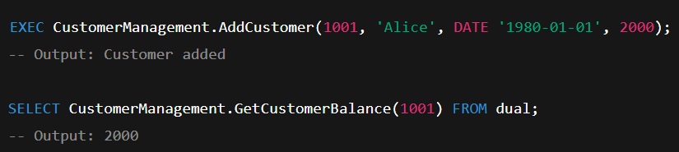

## Scenario 2: EmployeeManagement Package

-- Specification  
CREATE OR REPLACE PACKAGE EmployeeManagement IS  
 PROCEDURE HireEmployee(p_id NUMBER, p_name VARCHAR2, p_position VARCHAR2, p_salary NUMBER, p_dept VARCHAR2, p_hiredate DATE);  
 PROCEDURE UpdateEmployee(p_id NUMBER, p_salary NUMBER);  
 FUNCTION GetAnnualSalary(p_id NUMBER) RETURN NUMBER;  
END EmployeeManagement;  
/  
  
-- Body  
CREATE OR REPLACE PACKAGE BODY EmployeeManagement IS  
  
 PROCEDURE HireEmployee(p_id NUMBER, p_name VARCHAR2, p_position VARCHAR2, p_salary NUMBER, p_dept VARCHAR2, p_hiredate DATE) IS  
 BEGIN  
 INSERT INTO Employees (EmployeeID, Name, Position, Salary, Department, HireDate)  
 VALUES (p_id, p_name, p_position, p_salary, p_dept, p_hiredate);  
 END;  
  
 PROCEDURE UpdateEmployee(p_id NUMBER, p_salary NUMBER) IS  
 BEGIN  
 UPDATE Employees  
 SET Salary = p_salary  
 WHERE EmployeeID = p_id;  
 END;  
  
 FUNCTION GetAnnualSalary(p_id NUMBER) RETURN NUMBER IS  
 v_salary NUMBER;  
 BEGIN  
 SELECT Salary INTO v_salary FROM Employees WHERE EmployeeID = p_id;  
 RETURN v_salary * 12;  
 END;  
  
END EmployeeManagement;  
/

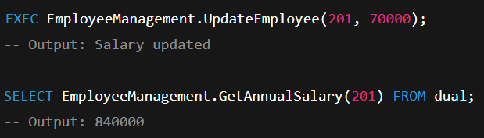

## Scenario 3: AccountOperations Package

-- Specification  
CREATE OR REPLACE PACKAGE AccountOperations IS  
 PROCEDURE OpenAccount(p_accid NUMBER, p_custid NUMBER, p_type VARCHAR2, p_balance NUMBER);  
 PROCEDURE CloseAccount(p_accid NUMBER);  
 FUNCTION GetTotalBalance(p_custid NUMBER) RETURN NUMBER;  
END AccountOperations;  
/  
  
-- Body  
CREATE OR REPLACE PACKAGE BODY AccountOperations IS  
  
 PROCEDURE OpenAccount(p_accid NUMBER, p_custid NUMBER, p_type VARCHAR2, p_balance NUMBER) IS  
 BEGIN  
 INSERT INTO Accounts (AccountID, CustomerID, AccountType, Balance, LastModified)  
 VALUES (p_accid, p_custid, p_type, p_balance, SYSDATE);  
 END;  
  
 PROCEDURE CloseAccount(p_accid NUMBER) IS  
 BEGIN  
 DELETE FROM Accounts WHERE AccountID = p_accid;  
 END;  
  
 FUNCTION GetTotalBalance(p_custid NUMBER) RETURN NUMBER IS  
 v_total NUMBER;  
 BEGIN  
 SELECT SUM(Balance) INTO v_total  
 FROM Accounts  
 WHERE CustomerID = p_custid;  
 RETURN NVL(v_total, 0);  
 END;  
  
END AccountOperations;  
/

